Logos4 Wiki
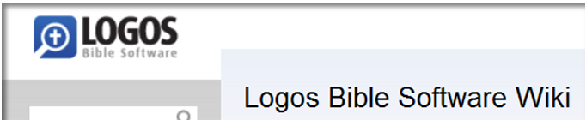

This is a Personal Book (PB) for the Logos 4 Wiki which is found here on the internet. The layout for this PB tries to mimic the TOC (table of contents) wiki page.

Features

- In your PB, please notice that it has TOC entries.

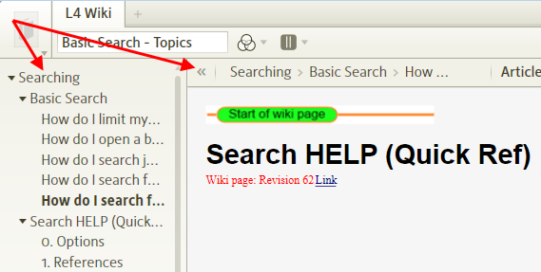

You can use this to help you navigate the Wiki PB.

- Also notice the green bar in the above image, the PB is marked with this to help you know when you have scrolled into a new wiki page.

- The PB also is marked with milestones for the TOC entries. You will see these in the Reference box in your PB. You can also use this to navigate to different wiki pages in your PB. (e.g. In the Reference box start typing the first word of a TOC entry, L4 will show you a drop down list of headings under wiki pages)

- Since this is a PB, you can use Logos4’s Search to search through your Wiki PB for items of interest.

Searching
[[@Headword: Search ]]
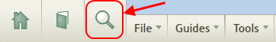

Basic Search
[[@Headword:Basic Search ]]Wiki page: Revision 22 Link

Videos
Logos Tutorial Video #4 – Searching
Logos Faster Searching – entire Library
Logos videos
See Also
Quick Reference
Detailed Search Help
Search Fields List
Morphological Search
BDAG Search
Syntax Search

How do I limit my search to a particular book or collection?
[[@Headword:Basic Search – Limit a search ]]
Click on the Blue link (default is Entire Library) and select from the pull-down list. You may also type in the search box the name of a resource or collection.

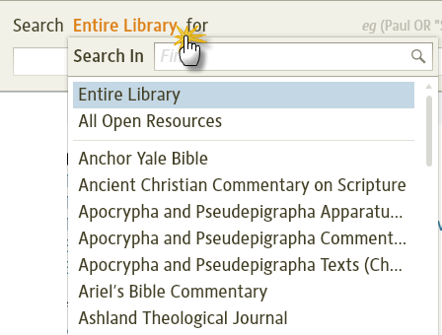

How do I open a book directly to search results? (Or to the beginning of an article?)
[[@Headword:Basic Search – Open a book ]]
To open an article (1) click the blue text. To open directly to the search result (2) click on the highlighted word in the sample text.

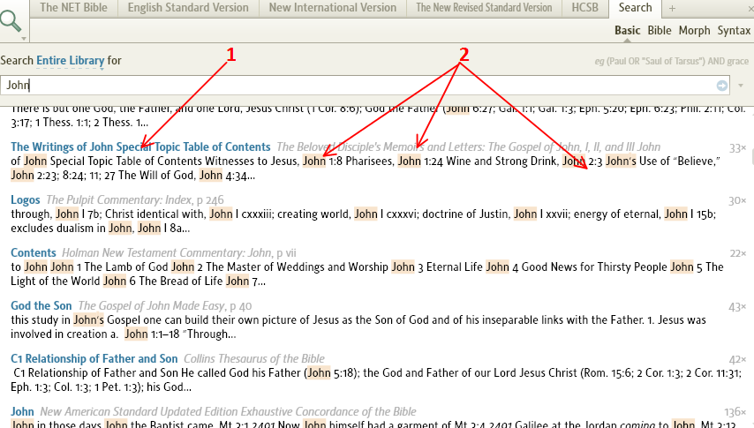

How do I search just the footnotes? (Or ignore the footnotes?)
[[@Headword:Basic Search – Footnotes ]]
This search is performed by utilizing fields within a resource. To see what fields are available: click the i icon (circle with i ) in the upper right hand corner of an open resource to display its information; the names of the fields within that resource are under search fields. Type "field:<word>" For example "footnote:Jerusalem" will locate any mention of Jerusalem in the footnotes of your book(s). Or, to ignore footnotes, use: "surface:Jerusalem". This search will only look at the surface text or the main body of a book.

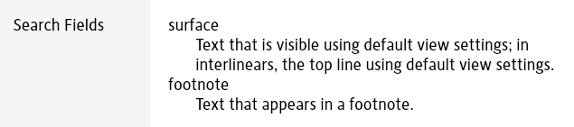

How do I search for images?
[[@Headword:Basic Search - Images ]]
• Please watch Logos4 tutorial video Search for Images

To limit your search to images, prefix your search term with "#image ", so to find images related to Jerusalem use "#image Jerusalem". Also, "#image ANDEQUALS Jerusalem" will only return images that are tagged with titles, captions or keywords as Jerusalem. #image can also be used in more complex searches like "#image NEAR Jerusalem" to find images are near a mention of Jerusalem.

How do I search for topics?
[[@Headword:Basic Search - Topics ]]
• Please watch the Logos4 tutorial video Search for Topic
• See About Topic Search for additional background

Use basic search and enter the topic in the search field. Logos will pull topics from your dictionaries and other topical resources and suggest them.

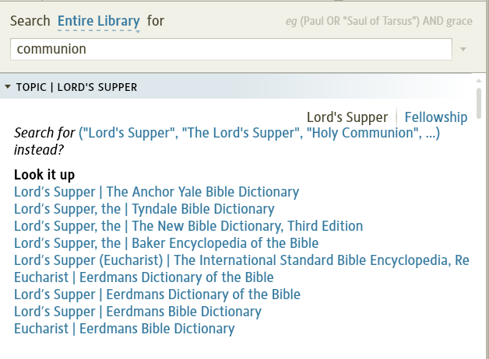
TIP: In order to limit the topics to your favorite resources, create a collection of your favorite resources and call it "Topical Resources" or something you'll remember. When you do your basic search select that collection as the Resource to search in - it will be in the drop down box when you click the blue words (usually "Entire Collection") after "Search in." That will limit the "hits" to just those resources.

Search HELP (Quick Ref)
[[@Headword:Quick Reference ]]Wiki page: Revision 62 Link

See Also
Basic Search
Detailed Search Help
Search Fields List
Syntax Search

A quick reference to the Search features of Logos4. Many operators are common to Libronix Search so you can also get documentation from L3 Help!
Note that search operators must be UPPERCASE in L4

0. Options
[[@Headword:Quick Reference - Options ]]

Select the little arrow under the Search icon.
Select Match All Word Forms to perform a search that is stemmed as in v3, else the search is exact.

1. References
[[@Headword:Quick Reference - References ]]

General format is <datatype Op reference> eg. <bible = Jn 3:16>, <LN ~26.5>
Op can be ~ (intersection), intersect (full intersection), =, subset, or superset. ~ is the default.
Note many types are handled automatically, so <~Jn 3:16> or Jn 3:16 are the same and <G5547>, <H6213> are recognized as Strong’s numbers.
Louw-Nida ranges can be specified as <LN 57.125-57.129> or <LN 57.125-129>
TWOT ranges can be specified as <TWOT 1768-1768b>
TDNT Volume/Page can be specified as <TDNT 8.1>

2. (Logical) OR, AND, ANDNOT
[[@Headword:Quick Reference – Logic [Or/And/AndNot] ]]

eg. Jesus OR Lord; Jesus AND Lord; Jesus ANDNOT Lord
Note the use of comma = OR, space = AND, dash = ANDNOT may give incorrect results, especially in Morph Search eg. use @N OR @V not @N, @V

3. (Proximity) ANDEQUALS, NOTEQUALS
[[@Headword:Quick Reference – Proximity [And/NotEquals] ]]

These require words to be in the same or different location in the text (usually an Interlinear) eg.
λόγος ANDEQUALS word => find where λόγος is translated as word
λόγος NOTEQUALS word => find where λόγος is not translated as word

4. (Proximity) BEFORE, AFTER, WITHIN, NEAR
[[@Headword:Quick Reference – Proximity [Before/After/Within/Near] ]]

eg. Jesus BEFORE Christ, Jesus NEAR Christ, Jesus WITHIN 4 Words Christ
Note You can't use proximity operators in combination with logical operators (see 6. Lists).

5. Proximity Filters
[[@Headword:Quick Reference – Proximity [Filters] ]]

The main unit for proximity is Words or word and these are the actual words you see in the text. For example Lord BEFORE 4 words Christ, Lord WITHIN 2-3 Words Christ; where 4 is no more than 4 words and 2-3 is between 2 and 3 words. Use 2-2 for exactly 2 words.

Note Characters, Chars or char, can be used in special circumstances. For example Lord BEFORE 2 Chars "Jesus Christ" will find "Lord Jesus Christ" with no punctuation between Lord and "Jesus Christ" (but a footnote marker like f might also produce the extra spacing).

Note NEAR has an inbuilt proximity filter which is 48 chars (about 8-10 words). Use WITHIN for more consistent results.

6. Lists
[[@Headword:Quick Reference - Lists ]]

Use a list to specify alternative search items in an abbreviated form eg.
(who, whoever, whom) => a list of 3 words that matches who or whoever or whom.
Use lists with proximity operators eg. (who, whoever, whom) NEAR Christ
because (who OR whoever OR whom) NEAR Christ will give incorrect results.
Note parentheses ( ) are optional in simple cases.

7. Wildcards
[[@Headword:Quick Reference - Wildcards ]]

* stands for any sequence of zero or more characters
? stands for any single character
Note Processing can be slow eg. r?se

8. Phrases
[[@Headword:Quick Reference - Phrases ]]

Use quotes to search for a phrase eg. “My God”, "people of Israel"
You can use phrases in a list eg. (“My God”, "My Lord")

9. Fields
[[@Headword:Quick Reference - Fields ]]

Specially tagged portions of text. Format is fieldname:word eg. words-of-christ:"blessed are"
See Search Fields in Resource Information for what is available.
Also use the All Text drop down to limit a Search to a field.

10. Morph Search
[[@Headword:Quick Reference – Morph Search ]]

General format is lemma:λόγος@N eg. type g:logos to get a word list & type @ to get a Morph table.
Select Bible Search and it appears as <lemma = lbs/el/λόγος> ANDEQUALS <lbs-morph+el ~ N???? >, where lbs=Logos Morph, el=Greek.
Limited to use with operators #2, #4, #7 & #9 above.
Note Use h:transliteration for Hebrew eg. h:el.
λόγος or greek:λόγος is a surface search!

11. Bible Search
[[@Headword:Quick Reference – Bible Search ]]

Can use operators and lists #2 to #9 with subset of # 1: Louw-Nida and Strong's numbers (including ranges).
Get lemma format <lemma = lbs/el/λόγος> by using Morph Search as above.
Note λόγος or greek:λόγος is a surface search!

12. Basic Search
[[@Headword:Quick Reference - Basic Search ]]

Can use operators and lists #1 to #9. Usually for non-bible searches and very fast.
Basic searches automatically include images in search results. To search specifically for an image, use #image ANDEQUALS query. (Specific maps can be searched for using the Biblical Places tool.)
Use lang:word to distinguish words if necessary, where lang can be greek, hebrew, aramaic, syriac eg. aramaic:מלך, hebrew:מלך

13. Topics
[[@Headword:Quick Reference - Topics ]]

These are listed within the TOPIC section of a Basic Search in Entire Library when articles are found within Logos compatible dictionaries eg. salvation. You might also get links from topics.logos.com.
Note use the right arrow or left arrow key in a resource tab to see the topic in other dictionaries.

Detailed Search Help
[[@Headword:Detailed Search Help ]]Wiki page: Revision 70 Link

See Also
Introduction to search
Quick reference
Search fields
List of datatypes
Morphological Search
Syntax search
Video
Logos Tutorial Video #4 – Searching

Introduction
[[@Headword:Detailed Search Help - Introduction ]]
Searching is one of the most powerful features in Logos. There are four types of search in Logos: Basic, Bible, Morph and Syntax.

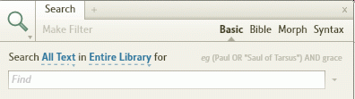
- Basic is for searching any of the Bibles and Books in your library
- Bible is for searching just Bibles. A Bible search will only search the main bible text. It won't search footnotes, nor introductory material or headings.
- Morph is for searching texts that are morphologically tagged (so you can search for just verbs, or past participles, etc.). When searching Bibles, a morph search only searches the Bible text. When searching non-Bibles, a morph search only searches what Logos calls the surface text (that's the text you can see with any interlinear display turned off). It doesn't search footnotes nor interlinear data (unless you specify the lemma: field).
- Syntax is for searching Bible syntax databases.

This wiki page documents Basic and Bible searches only, although bible syntax can also be used in morph searches.
[Please watch the video Logos Tutorial Video #4 - Searching. It is an excellent tutorial video.]

▪▪▪ Search Syntax ▪▪▪

Simple Search Syntax
[[@Headword:Detailed Search Help – Simple Syntax ]]
If you want to search for a single word, just type it in and press ENTER (e.g. love).

If you type two words, Logos will search for articles (Basic search) or bible verses (Bible search) that contain both of these words (e.g. love neighbor).

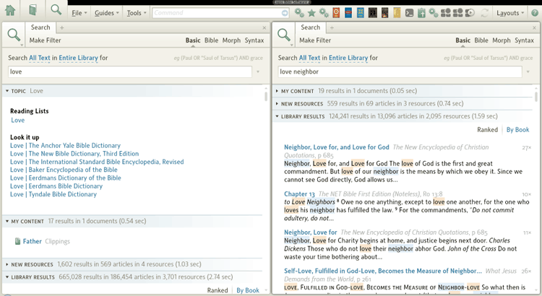

Phrases
[[@Headword:Detailed Search Help - Phrases ]]
If you want to search for a phrase, put quotation marks (") around the phrase (e.g. "love your neighbor").

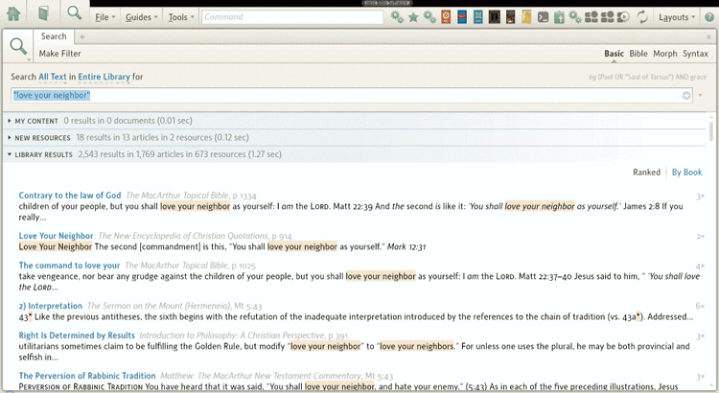

Wildcards
[[@Headword:Detailed Search Help - Wildcards ]]
Logos supports the wildcards * and ?.

- A * stands for any number of characters in a word. So s*n would find son, sin, seven, Solomon, seen, spoken, etc. 'Any number of characters' can mean zero, so love* would find love, loved, lover, lovely, love's and lovers.
- A ? stands for one character in a word. So s?n would find sin, son and sun. It cannot mean zero characters, so neighbo?r would find neighbour, but not neighbor.

A wildcard can stand for a whole word, but this makes the search very slow. Proximity Operators are a better method for whole words (so instead of "the * day" you would have the BEFORE 2-2 WORDS day).

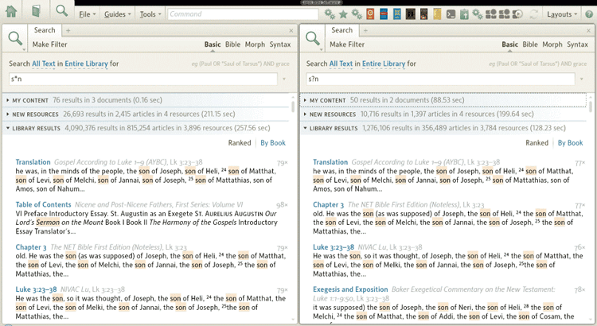

Searching in Greek and Hebrew
[[@Headword:Detailed Search Help – Greek/Hebrew ]]
If you just want to restrict your search to a particular language, you can use a language field. For example german:die, or latin:deo.

If you need to type characters in a different alphabet (e.g. Greek, Hebrew, or another language), you can do one of the following:

- Use transliteration: This enables you to use English characters to type Greek, Hebrew and Aramaic words. It is a quick and easy way to search. To use this type g: for Greek, h: for Hebrew, or a: for Aramaic and then the transliterated version of your word. For example, if you wanted to search for ἀγάπη you would type g:agape. If you wanted to search for חסד you would type h:hesed. You'll be able to choose precisely the word you want from a dropdown menu.
- Use another Windows keyboard: You can install multiple keyboards in Windows, and switch between them with a single keypress (usually LeftAlt+Shift). This allows you to type directly in Greek/Hebrew, though you'll need to learn which characters on your keyboard produce which Greek/Hebrew characters. The keyboards Logos supplied for use with Logos 3, still work with Logos 4. This method supports Coptic and Syriac as well as Greek and Hebrew.
- Use a 'soft-keyboard': A soft-keyboard is a computer program that looks like a keyboard. You choose your language, then click characters with your mouse, or type them using the on-screen keyboard as a guide. Logos has its own soft-keyboard called Shibboleth (it's free), though there are also several other soft-keyboards that could be useful for Biblical studies. Biblical Greek lists most of them.

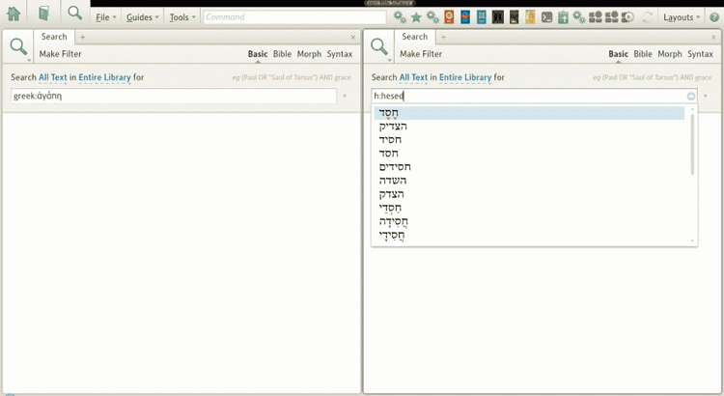
There are two things to note:

- First, when searching the Bible for Greek and Hebrew, only the surface text will be searched (not footnotes, nor the interlinear parts). If you want to force the Bible search to search the interlinear, you have to use the lemma datatype.

- Second, mixing Hebrew (which is right-to-left) with left-to-right languages, in the same sentence or search string can be a problem, as it gets a bit confusing with your cursor moving in unexpected directions! If you get this problem you may find it easier to enter all your left-to right text first, then go back and add the right-to-left text afterwards.

Using Boolean Operators
[[@Headword:Detailed Search Help - Boolean ]]
Logos supports the boolean operators AND, OR, and ANDNOT. (It doesn't support NOT however.) Operators should always be typed in capital letters.

- love AND neighbor searches for articles that contain both or these words. As noted above, AND is assumed if you don't specify an operator, so this search is the same as love neighbor.
- love OR neighbor searches for articles that contain either of these words.
- love ANDNOT neighbor searches for articles that contain 'love', but do not contain 'neighbor'. You can also use a minus sign as a shortcut: love -neighbor.

There is more information below about two additional operators, ANDEQUALS and NOTEQUALS that are mainly used for searching interlinears.

As noted above, using boolean operators means that you're trying to find (or NOT find) two search terms in the same article. 'Article' means different things in different contexts. In a Bible or Morph search, an article is a single verse. In a Basic search, an article is usually the amount of text that comes under a single heading or sub-heading that shows up in the Table of Contents bar. That means in a Bible in a Basic search, an article is a single chapter, not a single verse.

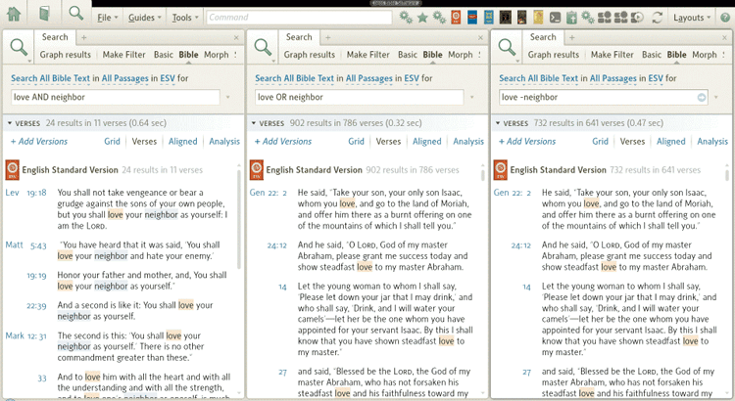

Proximity Operators
[[@Headword:Detailed Search Help – Proximity Operators ]]
Sometimes you may want more control than AND. Logos also offers proximity operators BEFORE, AFTER, WITHIN xx WORDS, and NEAR. They are mostly self-explanatory and are used like this:

- Christ BEFORE Jesus - search for articles (Basic search) or bible verses (Bible search) that contain the word 'Christ' before the word 'Jesus'.
- Jesus AFTER Christ - a different way of expressing the same search.
- Jesus BEFORE 2 WORDS Christ - search for articles (Basic search) or bible verses (Bible search) that contain the word 'Christ' one or two words before the word 'Jesus'. It will return "Jesus Christ" (one word before) or "Jesus the Christ" (two words before). It would not return "Jesus is the Christ", because that is three words before.
- Christ AFTER 2 WORDS Jesus - a different way of expressing the same search.
- Jesus BEFORE 3-5 WORDS Christ - search for articles/verses that contain the word Jesus three, four, or five words before the word Christ. It would find "Jesus was the Christ" (3 words before), and "Jesus who is called Christ" (4 words before), but not "Jesus the Christ" (2 words before). If you want a search for words an EXACT number of words before/after another one, you should do something like this: the BEFORE 2-2 WORDS day, which would find "the first day", "the last day", etc., but not "the day" or "the very next day".
- Jesus WITHIN 5 WORDS love - searches for the word Jesus within five words of the word 'love'. In this case it doesn't matter whether 'Jesus' comes after 'love', or before 'love'. All that matters is that there are no more than four words between them (so they are therefore within 5 words).

- Jesus WITHIN 20 CHARS love - searches for the word Jesus within 20 characters of the word 'love'. AFTER and BEFORE can also be used with CHARS.

- Jesus NEAR love -- NEAR means "within 48 characters" (which is about 10 words). In Basic search NEAR also searches nearby footnotes (unlike BEFORE, AFTER or WITHIN).

Proximity operators use the same article sizes as boolean operators, above.

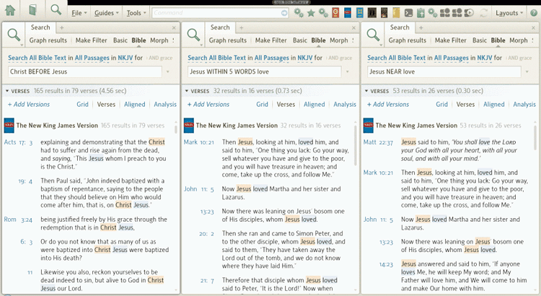
Two special proximity operators ANDEQUALS and NOTEQUALS are described below. ANDEQUALS is equivalent to WITHIN 0 WORDS, NOTEQUALS is its opposite. They are both especially useful in interlinears.

The ANDEQUALS and NOTEQUALS Operators
[[@Headword:Detailed Search Help – ANDEQUALS/NOTEQUALS ]]
Using the ANDEQUALS operator is easier to demonstrate than explain. Suppose you want to do a search for all the times the word γλῶσσα was translated as 'language'. You would perform a bible search for <Lemma = lbs/el/γλῶσσα> ANDEQUALS language. (Don't worry about the lemma syntax. That's explained below.) On the other hand, perhaps you want to find all this instances where γλῶσσα was translated as something other than 'language'. You would perform a bible search for <Lemma = lbs/el/γλῶσσα> NOTEQUALS language.

The ANDEQUALS operator is different from the AND operator because the match has to be in precisely the exact same location — the same word in the case of an interlinear — not just somewhere in the same verse.

Please note: ANDEQUALS and NOTEQUALS do not work in morphological searches if you use the @sign. If you are searching for lemmas you may not need to use ANDEQUALS, as you can use the lemma field instead (e.g. lemma:γλῶσσα@NGSF). For other searches you can use one of two workarounds:

- Use the LogosMorph reference: Instead of searching for @NGSF ANDEQUALS tongue, search for <LogosMorph = NGSF> ANDEQUALS tongue.
- Use WITHIN 0 WORDS: Instead of searching for @NGSF ANDEQUALS tongue, search for @NGSF WITHIN 0 WORDS tongue.

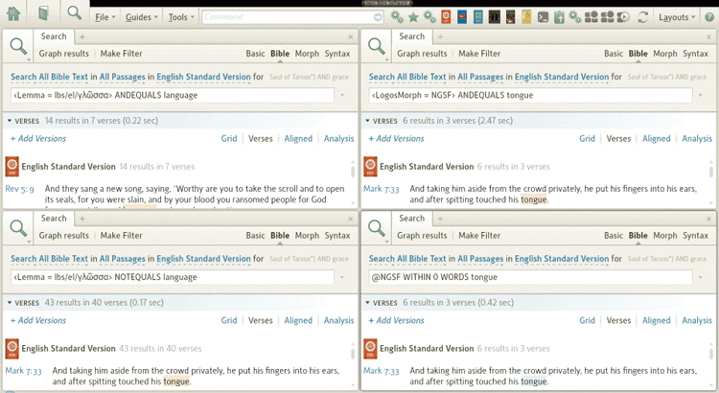

Using parentheses
[[@Headword:Detailed Search Help - Parentheses ]]
Sometimes you'll need to use parentheses to specify the order in which Logos carries out your search. Take the search love AND neighbor OR neighbour. You might think that this would search for articles where the word 'love' AND either the words 'neighbor' or 'neighbour'. But Logos (like all search engines) processes the search from left to right. So first it searches for love and neighbor then it takes that result and searches for [result] OR neighbour. You end up with all the articles that contain 'love' and neighbor, combined with every article that contains the word 'neighbour'. Just like in Math, putting parentheses around your search term forces Logos to evaluate that term first.

- In the example above, we really want to search for love AND (neighbor OR neighbour). This means neighbor OR neighbour is evaluated first, then love AND [result].
- You can nest brackets, as deep as you wish, e.g. ((love AND (neighbor OR neighbour)) OR "golden rule") OR (love AND God)

Please note: Be careful using proximity operators when you have brackets in your search. If you do, make sure you use proximity operators only in the outer terms of your search. (master OR neighbor) NEAR (love OR serve) will produce an invalid result. Because NEAR can't be used in this context, Logos wrongly assumes you want to look for the word 'near'. The correct syntax would be (master NEAR love) OR (master NEAR serve) OR (neighbor NEAR love) OR (neighbor NEAR serve). Thankfully, however, Logos does provide a shortcut in the form of lists which avoids typing this out in full (see below).

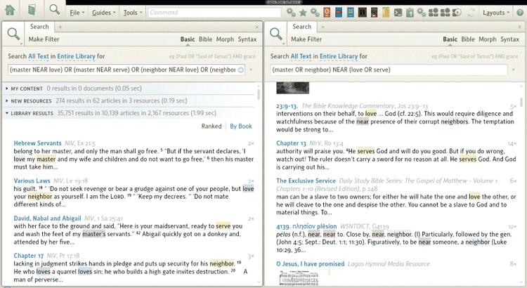

Using lists
[[@Headword:Detailed Search Help - Lists ]]
Lists are a very useful feature which provide shortcuts in a number of searches. A list is written like this: (term1, term2, term3, etc.). When Logos encounters a list, it performs the search using just term1. Then it repeats the search using just term2, then with just term3, etc. Once it has finished, it then ORs the results. Here are some examples:

- (Jesus, Christ) is equivalent to Jesus OR Christ
- (Jesus, Christ) AND love is equivalent to (Jesus AND love) OR (Christ AND love)

Lists are most useful when used with fields (see below), or when trying to ensure proximity operators are only used in the outer terms of your search. For example:

- The search described earlier (master NEAR love) OR (master NEAR serve) OR (neighbor NEAR love) OR (neighbor NEAR serve) can be simplified to (master, neighbor) NEAR (love, serve). Logos treats the two lists separately, iterating through them until every combination as been reached, like this:
  - master NEAR love
  - master NEAR serve
  - neighbor NEAR love
  - neighbor NEAR serve

Please note: Some people get confused as they equate the list with the OR command. They are not the same, even though in a very basic search they will perform in the same way. Remember, Logos iterates through lists, then ORs the results.

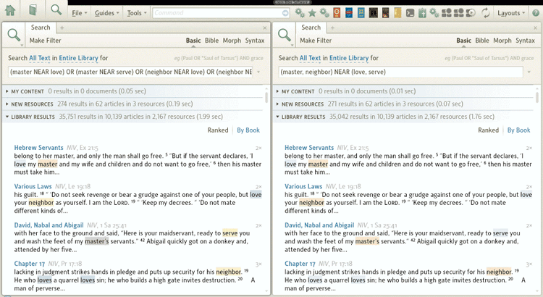
(The two searches produce exactly the same results, despite the small differences in counting. With the longer search string if a verse (e.g.) has master NEAR love, and master NEAR serve in the same verse, then it will be counted as two results. With the shorter search string it will be counted as one result.)

Searching for images
[[@Headword:Detailed Search Help - Images ]]
You can search for all the images in your library by using the special search term #image. If you want to search for all of the images with a particular caption, you should use the ANDEQUALS operator. So, to search for all the maps, use #image ANDEQUALS map. Or to search for all your vases, #image ANDEQUALS vase.

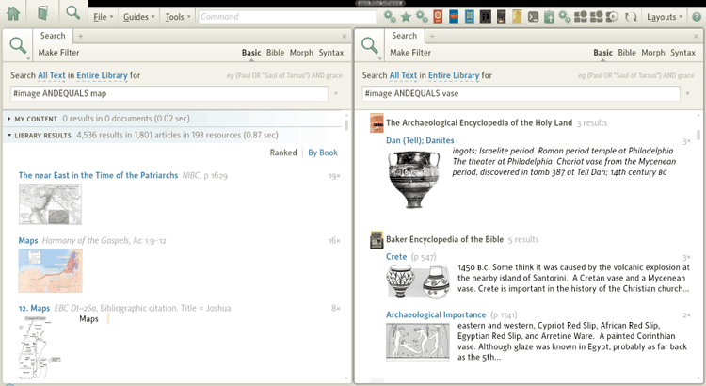

Searching for Bible Verses and other References
[[@Headword:Detailed Search Help – Bible Verses/References ]]
In basic search, Logos supports searching for many different types of references. A reference is a link from one resource to another. So a commentary, for example, would link to Bible verses, but perhaps also to Josephus or TDNT. You can search for these references, and therefore find every resource that linked to John 3:16, or Volume 5 page 42 of TDNT, etc. Note: Not all links are references. References are a special kind of link, usually to a commonly-used resource with a standard referencing system. They are normally not links to a specific resource, but could (in theory at least) open in a number of different resources depending on what resource you own, and have prioritised. A link to a Strong's number, for example, might open in one of several Greek lexicons. If a resource could open with a particular datatype, that datatype will be listed in the Indexes section of the resources information panel. (There is no official list of datatypes, but users have collected a partial list of datatypes).

The basic syntax is as follows (the example is for bible verses):

- <datatype = value> (e.g. <bible = John 3:16>)

There are literally hundreds of datatypes, and the main ones are listed below:

- Bible Verses: <bible = John 3:16> or <bible = John 3:1-20>
- Strong's Numbers: <GreekStrongs = #1345> or <HebrewStrongs = #3124>
- Louw-Nida Domains: <LouwNida = 13.21> or <LouwNida subset 13-15>
- Other resources with books with standard reference systems:
  - Apostolic Fathers: <ApostolicFathers = II Clement 11.2> or <af = II Clement 11.2>
  - Josephus: <JosephusLoeb = Against Apion 1.34–36>
  - Pseudepigrapha: <Pseudepigrapha = Martyrdom and Ascension of Isaiah 3.21–31>
  - TDNT: <TheologicalDictionaryNT ~ 5:42>

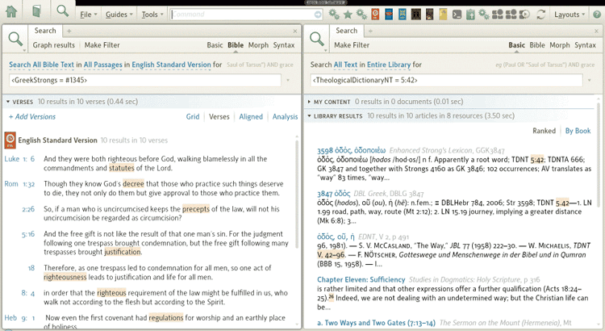
A very important datatype is Lemma. Trying to create a Lemma search from scratch can be slightly tricky as the syntax is a bit more complicated than some of the others. It looks like this: <Lemma = lbs/el/ἀγάπη>. The lbs is the morphology database (Logos Greek Morphology in this case). The el is the language (Greek). You can achieve the same result with a Morph search more easily (in a morph search the syntax is just lemma:ἀγάπη because the language and morphology database are set with a dropdown menu). You can also create a search by manually finding the word in a morphologically tagged Bible, then right-clicking on it, choosing lemma from the right-hand menu and clicking 'Search this resource'.

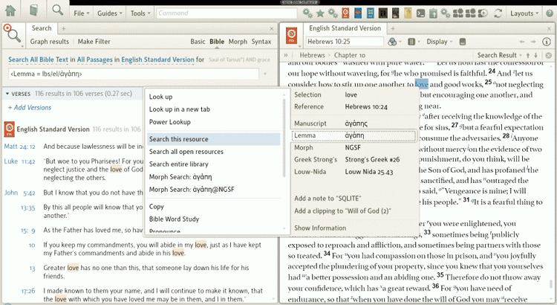
If you want to find out the syntax for any of the other datatypes, find a hyperlink to that datatype in your library. For example, if you want to find the Philo datatype, find a resource that links to Philo (it doesn't matter where in Philo it links to). Right-click on that link, make sure the datatype is selected in the righthand menu, the choose "Search this resource". A search window will pop up with the correct syntax. You can then modify the syntax to search for the exact reference you want.

With most datatypes, you can also search for ranges, as the bible example above shows. But if you want more control over the range, you can also change the operator (the equals sign). The following operators are available (listed in order, from the most exact at the top to the broadest at the bottom):

Operator | Description | Example search | John 3:16 | John 3:16-17 | John 3:17-20 | John 3:10-20 | John 3:16-4:10
= | The exact value | <bible = Jn 3:16-17> |  | Yes
subset | Any reference wholly included in the search value | <bible subset Jn 3:16-17> | Yes | Yes
superset | Any reference that includes the whole search value | <bible superset Jn 3:16-17> |  | Yes |  | Yes | Yes
~ | An intersection with the search value that doesn't cross chapter boundaries | <bible ~ Jn 3:16-17> | Yes | Yes | Yes | Yes
intersect | Any intersection with the search value | <bible intersect Jn 3:16-17> | Yes | Yes | Yes | Yes | Yes

Note that the abbreviation <Luke 2:7> is shorthand for <bible ~ Luke 2:7> not <bible = Luke 2:7>.

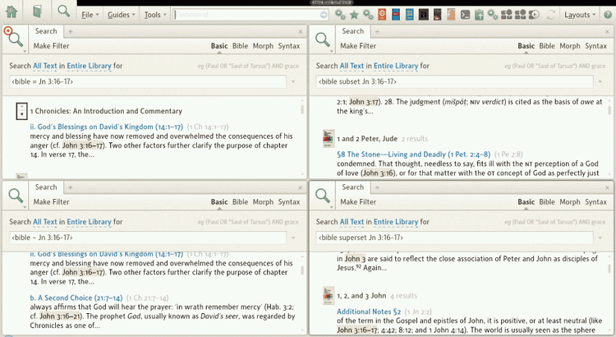
There is no official list of datatypes, but users have collected a partial list of datatypes.

Fields
[[@Headword:Detailed Search Help - Fields ]]
Most resources in Logos have several fields in them. The ESV Bible, for example, has the following fields: surface, footnote, bible, later-addition, words-of-christ, heading. Please note that fieldnames are case-sensitive. In the resource information panel, they are called search fields.

You can restrict your search to a specific field like this: fieldname:value. So if we wanted to search for every time Jesus mentioned fish, we would search for words-of-christ:fish. You can also use lists in a field search, like this words-of-christ:(give, receive)

Search fields can be accessed on the drop-down menu that normally read 'All text' or 'All Bible text'. You can find out which fields are available in any resource by bringing up the Resource Information panel, by clicking the (i) at the top-right of any open resource, or by restricting your search to just that resource and then looking at the drop-down menu. You can also view an almost complete list of search fields.

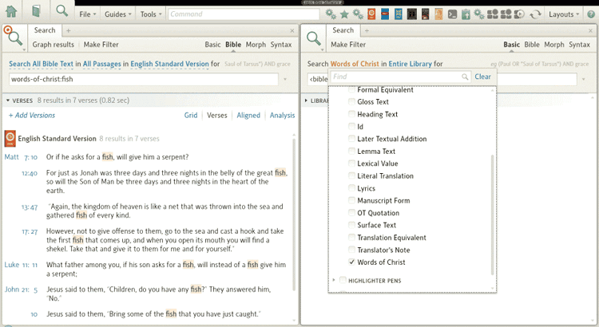

▪▪▪ Search Options ▪▪▪

Limiting your search to part of your library
[[@Headword:Detailed Search Help – Limiting [part of Library] ]]
You can limit your search to one resource, open resources, a series, or a Collection. Just select from the dropdown menu.

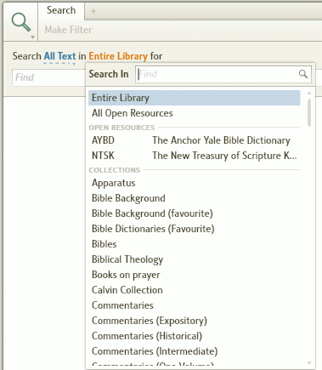

Limiting your search to part of the Bible
[[@Headword:Detailed Search Help – Limiting [part of Bible] ]]
In Bible searches you can also limit your search to part of the Bible. To do so, just select a range from the drop-down menu. Some ranges are built in (e.g. Old Testament), but you can also create your own. Just type in the reference range (e.g. Gen-Deut or Isaiah 1-39 or even John, 1 John - 3 John, Revelation), add a title if you wish (e.g. Pentateuch or Proto-Isaiah or Johannine Literature) and click Save. If you want to make your search even more precise, you can also limit it to a passage list.

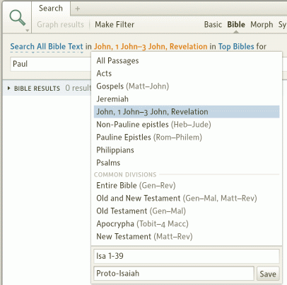

Using recent searches again
[[@Headword:Detailed Search Help – Recent searches ]]
At the end of the search box is a small drop-down arrow. If you click that arrow, you'll get a list of your most recent searches, which can save a lot of re-typing.

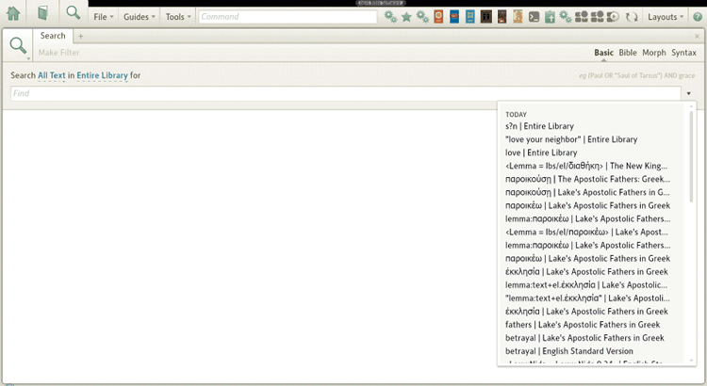

Matching Case or All Word Forms
[[@Headword:Detailed Search Help – Match [Case/Word Forms] ]]
Normally when you're searching, you won't want to match case. You probably will want a search for 'fish' to find 'Fish' and even 'FISH'. But if you're searching for 'God' or 'Spirit', case might matter. If you want to Match case it's on the main dropdown menu in a search tab. Note: It will stay selected, so make sure you turn it off when you're done!

Match All Word Forms is also useful. It means you don't need to use wildcards every time you want to search for different forms of the same word. The drop-down menu on a search tab allows you to turn Match all word forms on. Logos will then use some built in logic to try and search for all forms of the word. So searching for love, with 'match all word forms' turned on will return find love, loved, loves, lovely, loving and love's. Note that the logic isn't perfect. In this case, lover wouldn't be found. If you search needs to be precise, think about using lists, below.

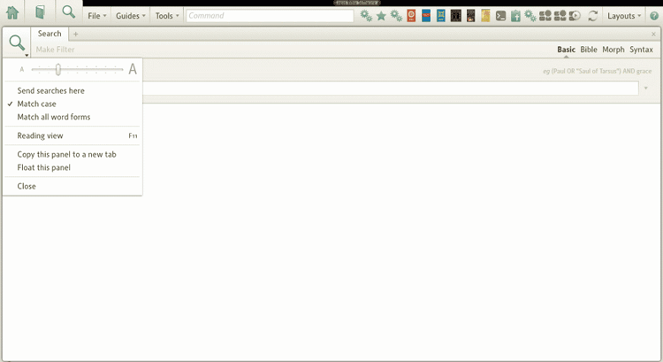

Changing the sort order
[[@Headword:Detailed Search Help – Sort Order ]]
In basic searches, you can change the sort order between Ranked, By count and By title. Ranked displays those articles which Logos believes are most relevant to the search - that is they contain the highest concentration of search hits. So short articles with lots of hits appear at the top, long articles with few hits at the bottom. By title simply shows all the articles in the order they appear, grouped by resource, and with the resources displaying in alphabetical order. By count shows the results similar to By title except that books with the most hits appear at the top.

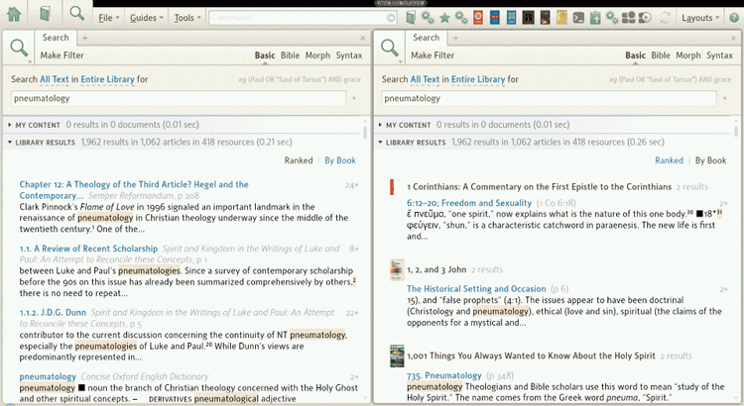

Changing the type of Bible search
[[@Headword:Detailed Search Help – Type of Bible search ]]
In bible searches you have a choice of four different types of search: Grid, Verses, Aligned and Analysis. All but grid are also available in a morph search.

- Grid is especially useful if you are searching multiple versions. It displays a list of all the hits in all the versions in a convenient grid form. The colored boxes indicate that there is a hit in that particular version (a hollow box means there is no hit), and you can hover over the colored box to read the version in that version.
- Verses shows a simple list of all the hits in an easy to read list. It's most useful when you're just search one version of the Bible and you want to be able to read the whole verse, not just a snippet.
- Aligned also shows a simple list of all the hits. But rather than show the whole verse, it just shows a snippet of the verse, centered around the keyword you searched on. It's most useful when you're only searching one version, and want to be able to very quickly scan through all the results.
- Analysis is described below.

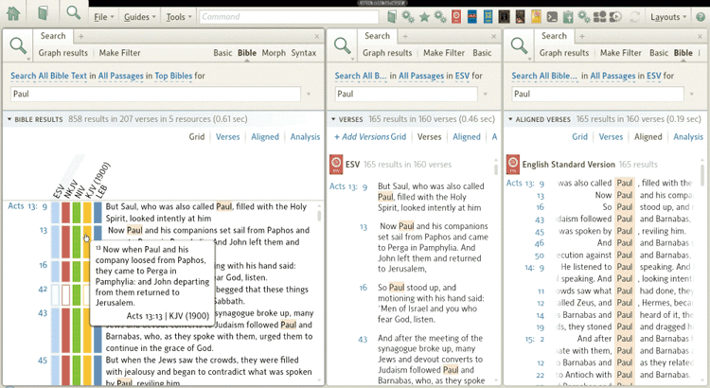

Bible search analysis
[[@Headword:Detailed Search Help - Analysis ]]
Search analysis is a very powerful feature that allows you to perform an analysis on your search results. It's probably most useful in morph searches, but you can use it on bible searches too. Your search results are presented in a tabular form. You can choose the columns by right clicking anywhere on the column headings. You can change the order of the columns by dragging them. And you can sort the results by clicking on the column headings. But the most useful feature is that you can group your search results. (In the screenshot below, the search result on the left is grouped by lemma.) To do this, simply drag the lemma column heading to the space above the headings. You'll see then that all the results are grouped by lemma, in order of the number of hits. You can collapse any of the lemmas by just click on their separator bars. You can use sub-groups as well, just by dragging up more fields. On the right I've grouped by part of speech, and then by Bible book. Other useful groups are tense, mood, and number, but you can use any of the fields to group.

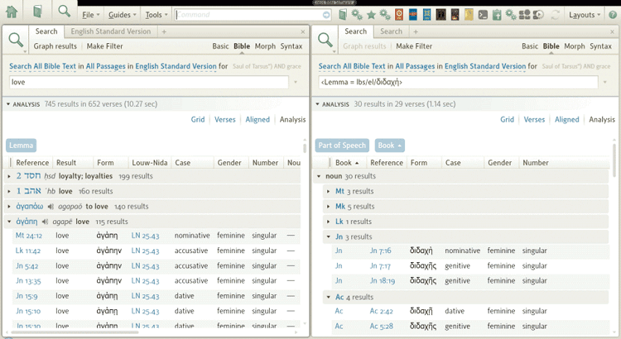

Tips on searching
[[@Headword:Detailed Search Help - Tips ]]
This post in the forum has useful tips on maximizing your search. You might also want to browse through the whole post for other tips.

Other

Graph results
[[@Headword:Detailed Search Help – Graph results ]]
When you do a Bible or Morph search the Graph results button will appear above the toolbar. If you click on it Logos4 will open the Graph Bible Search Results window. In it you will find 4 different graphs that you can select from. They show you details on the frequency and location of where your search term was found in your Bible(s). See the wiki page Graph Bible Search Results for more details.

Make filter
[[@Headword:Detailed Search Help – Make Filter ]]
When you do a Basic or Bible or Morph search the Make filter button will appear. If you click on it Logos4 will create a new Visual Filter using your search term and which books you were searching through. See the wiki page Visual Filter for more details.

Search Fields List
[[@Headword:Search Fields List ]]Wiki page: Revision 19 Link

See Also
Basic Search
Search HELP
Detailed Search Help

Search fields are the fields that can be searched by using a fieldname:searchitem syntax. For instance, heading:compassion will search for titles and headings that have the word "compassion" in them. The non-language fields below are a copy of the official Logos list of fields that comes with Logos 4. It should therefore be complete. Of course, not all fields are available on every resource, and most resources just support the surface and footnote fields. You can check which fields are supported for a particular resource by looking in the resources information panel.

'Ordinary' fields
[[@Headword:Search Fields List - Ordinary ]]

abbreviated | Morphology specifies use of an abbreviated form (used only with various numerals).
abbrevpop | The text of the pop-up indicator for an abbreviation, and the text of the abbreviation pop-up itself.
add | Text denoted by a symbol indicating insertions.
addmean | Additional phases of meaning included in the original word, phrase, or clause of the original language.
addtext | Either: familiar passages not adequately supported by the original manuscripts or words not appearing in the original language added to connect meaning for English readers.
aeolic | Morphology specifies use of the Aeolic dialect.
ambiguous | Ambiguous morphological form of a word. Ambiguous form implies no preferred form for the current word.
apocopated | Morphology specifies use of an apocopated form.
apparatus | Entries from the textual apparatus and the segmentation apparatus.
appindic | The text of an apparatus indicator, and the apparatus note itself if that note is a pop-up.
artauthor | The author of an article or review, rather than the author of a work under review.
attic | Morpholgy specifies use of the Attic dialect.
author | Authors cited or discussed.
base | Stem Form.
bhsform | The text of the Hebrew Bible as written in the Biblia Hebraica Stuttgartensia (when it differs from the text to be read).
bible | The actual text of the Bible verses, without introductions, headings, etc.
bull | Text denoted by a symbol indicating orthographic (spelling) variants.
chufat | Church Fathers.
citation | Citation.
city | A city name.
class | Libronix DLS Object Class.
clrfywrds | Justified clarifying words or comments not actually expressed in the immediate original text, as well as definitions of Hebrew and Greek names.
code-example | Examples of program code, typically occurring in documentation resources.
collection | Collection Title.
colon | Text indicating variant punctuation.
color | Liturgical color.
comment | Descriptions and comments concerning the translated manuscript or inscription.
content | The text of the original content of this resource, without headings, translators’ notes, etc.
contributor | A contributor to a song, such as the lyricist or composer.
copyright | Copyright information for an image or media element.
crasis | Morphological form when two words merge together to form a crasis or conjunction.
credit | Credit information for an image or media element.
crossref | The text of the pop-up indicator for a cross-reference, and the text of the reference itself.
date | A calendar date.
dateofpub | Date Published.
day | The title of a day, such as a Sunday or feast day, in a liturgical calendar.
description | The description of an object, usually an image or media element.
dewey | Dewey Decimal Number.
disputed-passage | Text that is disputed, especially concerning its authenticity or its inclusionin a particular corpus.
dynasty | The dynasty in which the manuscript or inscription was composed.
earlyver | Early Versions.
editions | Editions.
editor | Editor.
emend | The word or words are a textual emendation.
etymology | Descriptions of the linguistic history and development of a particular word or phrase.
event | Libronix DLS Object Event.
extdef | Extended definition of a given lemma.
fath | Church Fathers.
footnote | Text that appears in a footnote.
form | Manuscript form of an interlinear word.
formeq | A formal equivalent or gloss of a given lemma.
generalnote | The text of the pop-up indicator for a note, and the text of the note itself.
gloss | In a dictionary of lexicon, a brief explanation or definition of a word or phrase.
heading | The text of book, chapter and pericope headings.
headtitle | The text of a book, chapter and pericope headings.
id | The id of a song in a collection.
inflected | Inflected Form.
inv | In Volume.
irregular | Morphology specifies use of an irregular form.
isbn | ISBN Number.
issn | ISSN Number.
ketiv | The text of the Hebrew Bible that is written when it differs from the text to be read.
language | Language.
largetext | Allows search of headings and such.
later-addition | Text that is considered to be a later addition to earlier manuscripts.
latin | Latin Manuscript.
lect | Lectionary Manuscript.
lectionaries | Lectionaries.
lemma | Text that appears in its dictionary form.
lexeme | Lexical Form.
lexval | Translation of a lexical form of a word.
literal | Literal translation of an ancient language word or phrase.
livre | Publication Title.
livretype | Publication Type.
lmanu | Latin Manuscript.
location | The location of the manuscript or inscription.
lxx | Text of the Septuagint Greek Old Testament.
lyrics | The lyrics of a song.
mainline | The reading selected by the editors as the main line in places where variant readings exist.
method | Libronix DLS Object Method.
middle-significance | Morphology specifies use of a form with middle significance.
mini | Miniscule Manuscript.
miniscules | Miniscules.
modernized | Modernized spellings of the original text.
modlang | Modern language translation of the Greek New Testament cited in Discourse Segmentation Apparatus.
morphcode | Morphological code derived from the SEDRA 3 database.
mscule | Miniscule Manuscript.
mt | Masoretic Text of the Hebrew Old Testament.
negapp | Apparatus entries with readings that vary from the text proper.
nothing | Text that is purely informational and does not contain an apparatus indicator as such.
omit | Text denoted by symbols indicating omissions, either single words or groups of words.
original | John Knox's original text, as spelled in 18th century Scottish.
ot-quote | Text from the Old Testament Bible quoted in the New Testament.
pages | Pages.
papy | Papyrus Manuscript.
paralleltitle | Parallel Title.
param | Libronix DLS Object Parameter.
part-of-speech | Grammatical part of speech designation for a dictionary of lexicon headword.
particle-attached | Morphology specifies use of a form with a particle attached (with relative pronoun).
periodical | Periodical Title.
pernote | Text that appears in a Pericope Note.
pmt | The primary morphological tag for a given word.
possapp | Apparatus entries that support the reading found in the text proper.
primary-reading | Tischendorf's Primary Reading.
pronunciation | Text which details the exact phonetic pronunciation of a particular word or phrase.
property | Libronix DLS Object Property.
prosody | Prosodial remarks.
qere | The text of the Hebrew Bible that is to be read when it differs from the text that was written.
ran | Text denoted by symbols indicating replacements, either single words or groups of words.
rauthor | The author of a review, rather than the author of the work under review.
reading | A Scripture reading in a lectionary.
reconst | Theoretical reconstruction of the Hebrew source document for the Septuagint Greek Old Testament.
reflex | Inflected form of a given word, associated with its lemma for lookup purposes.
region | A country or tribal area or some other generic geographic region.
review | The title of the work under review.
root | The root form.
rtitle | The title of the work under review.
season | A liturgical season, such as Advent or Easter.
standards | Text that should be interpreted as a standard to be followed, e.g. a markup standard or a visual standard.
subtitle | Subtitle.
supp | The word or words are supplied for sake of clearness.
surface | Text that is visible using default view settings; in interlinears, the top line using default view settings.
tag | Tags for an image or media element.
title | The title of an object, usually an image or media element.
topic | Topics.
topiclevel | Topic level.
totalpages | Total Number of Pages.
trans | Text denoted by symbols indicating transpositions.
transeq | Suggested translation equivalent of a Greek quotation.
transitive | Morphology specifies use of a transitive form.
translation | Listings of how an ancient language word is translated in other documents.
transnote | The text of the pop-up indicator for a translator's note, and the text of the note itself.
tune | The tune of a song.
txt | The list of witnesses supporting the text of this edition. It always occurs as the last member of a group of readings or variation unit.
uncial | Uncial Manuscript.
uncials | Uncials.
used-as | Instances where a morphological form is being used for a different function than the actual form; eg., Nominative "used as" Vocative.
variant | Variant morphological form of a word.
varline | A variant reading.
varunit | A unit that is treated as a variation unit within the apparatus.
ver | Early Versions.
versions | Version.
words-of-christ | Text considered to be the Words of Christ, traditionally the "red-letter" text.
xrefs | Cross References.
year | Lectionary Year.

Language fields
[[@Headword:Search Fields List - Language ]]
aramaic
chinese
coptic
czech
dutch
english
french
german
greek
hebrew
italian
latin
portuguese
translit
spanish
syriac

▫ List of Datatypes
[[@Headword:List of DataTypes ]]Wiki page: Revision 20 Link

See Also
Author Datatypes
Bible Datatypes

This is a partial list of DataTypes that are used in Logos. Datatypes are used to create links using standard referencing systems. Unlike normal links, they don't link to a specific resource. Instead Logos will look through all your resources and choose the most prioritised appropriate resource. Therefore the table below shows a typical resource that this datatype would open. The actual resource that opens (if any) will depend on what books you have available in your library, and what your prioritisation settings are.

Over 1,000 datatypes are linked to authors, too many to list in this annotated table. But you can view a partial list of author datatypes as a simple list.

Knowing these Datatypes is most useful for searching, and for creating Personal Books. For example, to find a link to a Greek Strongs number you would search for <GreekStrongs = 5537>

- Bible datatypes
- Datatypes for pre-Christian writings
- Datatypes for early Christian writings
- Datatypes for intertestamental and post-Christian Jewish writings
- Morphology datatypes
- Date datatypes
- Page number datatypes

Bible datatypes
[[@Headword:List of DataTypes – [Bible] ]]
Description | Code | ShortCode | Typical resource this datatype would open
Bible | Bible | bible | Any Bible

There are also nearly 100 datatypes associated with specific versions of the Bible, which you can view as a simple list.

Datatypes for pre-Christian writings
[[@Headword:List of DataTypes – [pre-Christian] ]]
Description | Code | ShortCode | Typical resource this datatype would open
'nt Texts | AntTexts | ant | Religious Texts from Ugarit
Amarna Letters | AmarnaLetters | amarna | The Amarna Letters
Ancient Near Eastern Text | anet | anet | Ancient Near Eastern Texts Relating to the Old Testament (3rd Edition with Supplement)
Aqht Texts | AqhtTexts | aqht | Religious Texts from Ugarit
Aramaic Papyri of the Fifth Century | AramaicPapyriFifthCentury | APFC | Aramaic Papyri of the Fifth Century B.C.
The Context of Scripture | TheContextofScripture | cos | The Context of Scripture
Corpus des tablettes en cunéformes alphabéticas (CTA) | CTA | CTA | Religious Texts from Ugarit
CTA Ugaritic Texts | CTAUgariticsTexts | cta | Religious Texts from Ugarit
Cuneiform Alphabetic Texts (KTU) | KTU | KTU | Religious Texts from Ugarit
Dead Sea Scrolls Study Edition | dssse | dssse | Dead Sea Scrolls Study Edition
Hittite Diplomatic Texts | hdt | hdt
Hittite Laws | HittiteLaws | hl | Ancient Near Eastern Texts Relating to the Old Testament (3rd Edition with Supplement)
Hittite Myths | HittiteMyths | httmyths
Hittite Prayers | HittitePrayers | httprayers
Hyppolytus | Hippolytus | hippolytus | Old Testament Greek Pseudepigrapha with Morphology
Lawcode of Lipit-Ishtar | LawLipIsh | lli | Ancient Near Eastern Texts Relating to the Old Testament (3rd Edition with Supplement)
Krt Text | KrtText | KRT | Religious Texts from Ugarit
Laws of Eshunna | LawsofEshn | le | Ancient Near Eastern Texts Relating to the Old Testament (3rd Edition with Supplement)
Laws of Hammarubi | HammaurabiLaws | hammu | The Context of Scripture, Volume 2
Middle Assyrian Laws | MidAssyrian | mal | Ancient Near Eastern Texts Relating to the Old Testament (3rd Edition with Supplement)
Neo-Babylonian Laws | lnb | lnb | Ancient Near Eastern Texts Relating to the Old Testament (3rd Edition with Supplement)
Pseudepigrapha | Pseudepigrapha | pseud | Pseudepigrapha of the Old Testament
Qumran Sectarian Manuscripts | qsm | qsm | The Dead Sea Scrolls: Study Edition
Ras Shamra Parallels | RasShamraParallels | RSP | Ras Shamra Parallels
Sumerian Laws Exercise Tablet | sl | sl | Ancient Near Eastern Texts Relating to the Old Testament (3rd Edition with Supplement)
Ugaritic Data Bank (UDB) | UDB | TU | Religious Texts from Ugarit
Ugaritic Textbook Sections (Gordon) | UgariticTextbookSections, Gordon | utg | Ugaritic Textbook
Ugaritic Textbook Texts (Gordon) | UgariticTextbookTexts, UgariticTexts, UT | utt | Ugaritic Textbook

Datatypes for early Christian writings
[[@Headword:List of DataTypes – [early Christian] ]]
Description | Code | ShortCode | Typical resource this datatype would open
Apostolic Fathers | ApostolicFathers | af | Ante-Nicene Fathers
Apostolic Tradition | ApostolicTrad | aptr | The Apostolic Tradition
The Apostle's Creed | ApostlesCreed | aposcrd | Historic Creeds and Confessions
The Athanasian Creed | AthanasianCreed | athancrd | Historic Creeds and Confessions
Augustine's Confessions | Confessions | confess
Berlin Gnostic Papyri | BerlinGnosticPapyri | bg | The Nag Hammadi Library in English
The Diatessaron of Tatian | Diatessaron | diatess | Ante-Nicene Fathers, Volume X
Early Church Fathers | EarlyChurchFathers | ecf | Ante-Nicene Fathers
Eusebian Canons | EusebianCanons | ec | Novum Testamentum Graece (Tischendorf)
Fragments of Papias | Papias | papias | Lightfoot's Apostolic Fathers in English
Irish Biblical Apocrypha | IrishApoc | ibapoc | Irish Biblical Apocrypha
Letters of Cyprian (Migne Numbering) | CyprianLettersM | cyprianlettersm | Ante-Nicene Fathers: Volume V
Letters of Cyprian (Oxford Numbering) | CyprianLettersO | cyprianletterso | Ante-Nicene Fathers: Volume V
Nag Hammadi Codices | NagHammadiCodices | nhc | The Nag Hammadi Library in English
NT Apocrypha | NTApocrypha | ntapoc | The Apocryphal New Testament
The Q Source | Q | q | The Critical Edition of Q
The Sentences of Sextus | SentencesofSextus | sentsext | The Nag Hammadi Library in English
Sermons of Augustine (Benedictine Numbering) | AugustineSermonsBen | augustinesermb | Nicene and Post-Nicene Fathers, First Series: Volume VI
Summa Theologica | Summa | summa | Summa Theologica
 |  | tertullian
Works of Ambrose | Ambrose | ambrose | The Nicene and Post-Nicene Fathers Second Series Vol. X
Works of Anselm | Anselm | anselm | The Major Works of Anselm of Canterbury
Works of Augustine | Augustine | augustine | Nicene and Post-Nicene Fathers, First Series
Works of Basil the Great | Basil | basil | The Nicene and Post-Nicene Fathers Second Series Vol. VIII
Works of Cyprian of Carthage | Cyprian | cyprian | Ante-Nicene Fathers: Volume V
Works of Eusebius of Caesarea | Eusebius | eusebius | The Nicene and Post-Nicene Fathers Second Series Vol. I
Works of Gregory Nazianzen | GregNaz | gregnaz | The Nicene and Post-Nicene Fathers Second Series Vol. VII
Works of Gregory of Nyssa | GregNyssa | gregnyssa | The Nicene and Post-Nicene Fathers Second Series Vol. V
Works of Gregory the Great | GregGreat | greggreat | The Nicene and Post-Nicene Fathers Second Series Vol. XII
Works of Hilary of Poitiers | Hilary | hilary | The Nicene and Post-Nicene Fathers Second Series Vol. IX
Works of Irenaeus | Irenaeus | irenaeus | Ante-Nicene Fathers: Volume I
Works of Jerome | Jerome | jerome | The Nicene and Post-Nicene Fathers Second Series Vol. III
Works of John Cassian | Cassian | cassian | The Nicene and Post-Nicene Fathers Second Series Vol. XI
Works of John Chrysostom | Chrysostom | chrysostom | Nicene and Post-Nicene Fathers, First Series
Works of John Damascene | JohnDamascene | johndamascene | The Nicene and Post-Nicene Fathers Second Series Vol. IX
Works of Justin Martyr | JustinMartyr | justinmartyr | Ante-Nicene Fathers: Volume I
Works of Leo the Great | Leo | leo | The Nicene and Post-Nicene Fathers Second Series Vol. XII
Works of Origen | Origen | origen | Ante-Nicene Fathers: Volume IV

Datatypes for intertestamental and post-Christian Jewish writings
[[@Headword:List of DataTypes – [post Christian] ]]
Description | Code | ShortCode | Typical resource this datatype would open
Babylonian Talmud | BabylonianTalmud | babtalmud | Babylonian Talmud
Babylonian Talmud Folio | BabylonianTalmudFolio | babtalmudfolio | Babylonian Talmud
Jerusalem Talmud | JerusalemTalmud | jertalmud | Jerusalem Talmud
Jerusalem Talmud Folio | JerusalemTalmudFolio | jertalmudfolio | Jerusalem Talmud
Josephus (Loeb) | JosephusLoeb | josl | The Works of Flavius Josephus
Josephus (Whiston) | JosephusWhiston | josw | The Works of Flavius Josephus
Mishnah | Mishnah | mishnah | The Mishnah
Works of Philo | WorksOfPhilo | phil | The Works of Philo
Works of Philo (Yonge) | WorksOfPhiloYonge | philyng | The Works of Philo

Morphology datatypes
[[@Headword:List of DataTypes – [Morphology] ]]
Description | Code | ShortCode | Typical resource this datatype would open
Aramaic Morphology (Andersen-Forbes) | AFMorphAram
Aramaic Morphology (CAL) | CALMorph
Aramaic Morphology (SESB) |  | sesb-morph+x-arc
Aramaic Morphology (Westminster) | AramaicMorphology, AramaicMorph | AramMorph
Aramaic Morphology (WIVU) | WIVUMorphAram
Aramaic Morphology Inscriptions
Greek Morphology (Friberg) | FrMorph | frmorph
Greek Morphology (GRAMCORD™) | GreekMorphology, GreekMorph | grmorph
Greek Morphology (Logos) | lbs-morph+el | LogosMorph
Greek Morphology (Robinson) | GreekMorphologyOnline, GreekMorphOnline | MRMorph
Greek Morphology (Swanson) | SWGreekMorph, JSGreekMorph
Hebrew Morphology (Andersen-Forbes) | AFMorphHeb
Hebrew Morphology (SESB) |  | sesb-morph+he
Hebrew Morphology (Westminster) | WestMorph, HebrewMorphology, HebrewMorph
Hebrew Morphology (WIVU) | WIVUMorphHeb | wivu-morph+he
Semitic Morphology Inscriptions
Syriac Morphology (Leiden Peshitta Institute) |  | lpi-morph+syr
Syriac Morphology (Sedra) |  | s3morph

Date datatypes
[[@Headword:List of DataTypes – [Date] ]]
Description | Code | ShortCode | Typical resource this datatype would open
Date | Date | Date | On This Day
Day of Year | DayOfYear | dayofyear | Any daily devotional
YearMonthDay | YearMonthDay | ymd | Usually a lectionary

Page number datatypes
[[@Headword:List of DataTypes – [Page num] ]]
Description | Code | ShortCode | Typical resource this datatype would open
Page Number | Page | page | Opens in current resource
Volume/Number/Page | VolumeNumberPage | vnp | Opens in current resource
Volume/Page | VolumePage | vp | Opens in current resource
Volume/Page/Line | VolumePageLine | vpl | Opens in in current resource

Other datatypes
[[@Headword:List of DataTypes – [Other] ]]
Description | Code | ShortCode | Typical resource this datatype would open
The 39 Articles | 39articles | 39art | The Anglican Tradition: A handbook of sources
95 Theses (Luther) | 95theses | 95theses
Beginning Biblical Hebrew | futabbh | bbh | Beginning Biblical Hebrew
The Belgic Confession | BelgicConfession | belcon | Historic Creeds and Confessions
BHQ Apparatus | BHQApparatus | bhqcapp | Biblia Hebraica Quinta: Apparatus Criticus
BHS Apparatus Criticus | BHSApparatusCriticus | bhscapp | BHS Apparatus Criticus
Bible Knowledgebase | BibleKnowledgebase | bk | Tyndale Bible Dictionary
A Biblical Hebrew Reference Grammar | BiblicalHebrewReferenceGrammar, vanderMerwe | BHRG | A Biblical Hebrew Reference Grammar
Bibliographic Item | Biblio | biblio | Opens in current resource
Blass, Debrunner, Funk | bdf | bdf | Greek Grammar of the New Testament (Blass, Debrunner, Funk)
Book of Concord | BookOfConcord | trig | The Book of Concord
Brown-Driver-Briggs | BrownDriverBriggs | bdb | Enhanced Brown-Driver-Briggs Lexicon
The Canons of Dort | CanonsOfDort | candort | Historic Creeds and Confessions
Cascadia Syntax Graphs | CSG | csg | Cascadia Syntax Graphs of the New Testament: Glossary
Concordia Triglotta | TRIGPG | trigpg | The Book of Concord
Consolidated Gospel | ConsolidatedGospel
The Constitution of the United States of America | USConstitution | USConst
Dictionary of Biblical Languages (Aramaic) | DBLAramaic | dbl+x-arc | Dictionary of Biblical Languages (Aramaic)
Dictionary of Biblical Languages (Greek) | DBLGreek | dbl+g | Dictionary of Biblical Languages (Greek)
Dictionary of Biblical Languages (Hebrew) | DBLHebrew | dbl+h | Dictionary of Biblical Languages (Hebrew)
Documents of Vatican II | VaticanII | vaticanii | Vatican II Documents
The Federalist Papers | FederalistPapers | fedpap
Gesenius' Grammar | gesgram | gkc | Gesenius' Hebrew Grammar
Gesenius' Leixon | GeseniusLexicon | geslex | Gesenius' Hebrew-Chaldee Lexicon to the Old Testament
A Grammar of Biblical Hebrew (Joüon, Muraoka) | GrammarofBiblicalHebrew, Jouon, Joüon, JouonMuraoka | JM | A Grammar of Biblical Hebrew
Grammar of the Greek New Testament | RobertsonGrammar, ATRGrammar | robertsongram | A Grammar of the Greek New Testament in Light of Historical Research (Robertson)
Grammar of New Testament Greek, II (MHT II) | MHT II | mht2 | A Grammar of New Testament Greek, Volume 2
Grammar of New Testament Greek, III (MHT III) | MHT III | mht3 | A Grammar of New Testament Greek, Volume 3
Grammar of New Testament Greek, IV (MHT IV) | MHT IV | mht4 | A Grammar of New Testament Greek, Volume 4
Greek GK Number | GreekGK | GGK, gk+g | Mounce's Expository Dictionary of Greek and Hebrew Words
Greek Strong's Number | GreekStrongs, StrongsGreek | ggbtb | Enhanced Strong's Lexicon
Hebrew GK Number | HebrewGK | HGK, gk+h | Mounce's Expository Dictionary of Greek and Hebrew Words
Hebrew Strong's Number | HebrewStrongs, StrongsHebrew | strongs+h | Enhanced Strong's Lexicon
Hebrew Syntax | DavidsonSyntax | hebsyn | Hebrew Syntax (Third Edition)
The Heidelberg Catechism | HeidelbergCatechism | heidcat | Historic Creeds and Confessions
Idioms of the Greek New Testament | IdiomGreekNT | ignt | Idioms of the Greek New Testament (Porter)
Institutes of the Christian Religion | InstitutesOfTheChristianReligion | cicr | Calvin's Institutes of the Christian Religion
Introduction to Akkadian | IntroAkk | iakk | Introduction to Akkadian
An Introduction to Hebrew Syntax | wltkhebsyn, ibhs | woc | An Introduction to Hebrew Syntax
Introduction to the Study of New Testament Greek Word List | instgwl | Introduction to the Study of New Testament Greek
Introduction to the Study of NT Greek Word List | ISNTGWL | isntgwl | An Introduction to the Study of New Testament Greek, Part One: Morphology, Volume 2
IVP Pocket Dictionary Topic | IVPPocket | ivppocket | Pocket Dictionary of Biblical Studies
Kirchliche Dogmatic (KD) | KD | kd | Church Dogmatics (Barth)
Learning the Basics of New Testament Greek | BasicGreek, LearningGreek | learninggreek | Learning the Basics of New Testament Greek
 |  | lemma
Lexham Discourse Greek New Testament | ldgnt | ldgnt | Lexham Discourse Greek New Testament
Lexham High Definition New Testament Annotation Structure | hdnt | hdnt | Lexham High Definition New Testament Annotation Structure
Lexham SGNT Clause Structure |  | sgnt-clause
Lexham SGNT Syntatic Force | SGNTSyntacticForce | sgnt-syn | The Lexham Syntactic Greek New Testament Glossary
Louw-Nida Semantic Domains | LouwNida, louw | ln | Greek-English Lexicon of the New Testament Based on Semantic Domains
Morphology Field | morph-field | morph-field | Any morphology glossary
Nestle-Aland 27th Edition Textual Apparatus | NA27ApparatusCriticus | na27capp | Nestle-Aland: NTG Apparatus Criticus
 |  | number
Nunn Syntax Section | nunnsyn | nunnsyn | A Short Syntax of New Testament Greek
OpenText.org Syntactic Structures | otext | otext | The OpenText.org Syntactically Analyzed Greek New Testament Glossary
Quran | Quran | Quran | The Quran
Regula Orientalis | RegulaOrientalis
Rule of Macarius | RuleOfMacarius
Rule of St. Benedict | RuleOfStBenedict
Rule of the Four Fathers | RuleOfTheFourFathers
Rule of the Master | RuleOfTheMaster
Second Rule of the Fathers | SecondRuleOfTheFathers
Shakespeare | Shakespeare
Synonyms of the New Testament (Trench) | Trench | trenchsyn | Synonyms of the New Testament
Syntax of the Moods and Tenses of New Testament Greek (Burton) | Burton | smtntg | Syntax of the Moods and Tenses in New Testament Greek
Tense/Voice/Mood | TenseVoiceMood | tvm | Tense, Voice, Mood
Theological Wordbook of the Old Testament | TheologicalWordbookOT | twot | Theological Wordbook of the Old Testament
Third Rule of the Fathers | ThirdRuleOfTheFathers
The Westminster Confession of Faith | WestminsterConfession | wcnf | The Westminster Confession of Faith
The Westminster Larger Catechism | WestminsterLargerCatechism | wlgc | The Westminster Larger Catechism
The Westminster Shorter Catechism | WestminsterShorterCatechism | wshc | The Westminster Shorter Catechism
Theological Dictionary of the New Testament | TheologicalDictionaryNT | tdnt | Theological Dictionary of the New Testament
Word Number | wn | wn | Dictionary of Biblical Languages
Wuest's Word Studies in the Greek New Testament | WuestNT | wuest | Wuest's Word Studies in the Greek New Testament
Zerwick Biblical Greek | Zerwick | zbg | Biblical Greek, Illustrated by Examples
Zerwick Biblical Greek (3rd Edition) | Zerwick3 | zbg3e | Biblical Greek, Illustrated by Examples

▫ Author Datatypes
[[@Headword:Author Datatypes ]] Wiki page: Revision 2 Link

This page provides a partial list of author Datatypes. In order to use it effectively you will need to know the works attributed to these authors. You can then search for these references like this: <au+hippolytus ~ De antichristo 1-99>

au+abydenusau
au+acacius
au+acesander
au+achaeus
au+achilles-tatius
au+acilius
au+acropolites
au+acta-alexandrinorum
au+acta-barnabae
au+acta-et-martyrium-apollonii
au+acta-eupli
au+acta-joannis
au+acta-justini-et-septem-sodalium
au+acta-pauli
au+acta-petri
au+acta-phileae
au+acta-philippi
au+acta-scillitanorum-martyrum
au+acta-thomae
au+acta-xanthippae-et-polyxenae
au+acusilaus
au+adamantius
au+adespota-papyracea
au+adrianus
au+ae+tius
au+aegimius
au+aelianus
au+aelius-dius
au+aeneas
au+aeschines
au+aeschines-socraticus
au+aeschrion
au+aeschylus
au+aesopus
au+aethiopis
au+aethlius
au+agaclytus
au+agamestor
au+agatharchides
au+agathemerus
au+agathias
au+agathocles
au+agathodaemon
au+agathon
au+agathyllus
au+agesilaus
au+agias-dercylus
au+aglai+s
au+aglosthenes
au+agroetas
au+albinus
au+alcaeus
au+alcibiades
au+alcidamas
au+alcimenes
au+alcimus
au+alciphron
au+alcmaeon
au+alcmaeonis
au+alcman
au+alexander
au+alexandri-magni-epistulae
au+alexarchus
au+alexinus
au+alexis
au+amasis-epistulae
au+amelesagoras
au+amelii-epistula
au+amipsias
au+ammonius
au+amometus
au+amphiarai-exilium
au+amphicrates
au+amphilochius
au+amphis
au+amyntas
au+anacharsidis-epistulae
au+anacreon
au+anacreontea
au+anagnostes
au+ananius
au+anaxagoras
au+anaxandridas
au+anaxandrides
au+anaxarchus
au+anaxicrates
au+anaxilas
au+anaximander
au+anaximenes
au+anaximenis-milesii-epistulae
au+anaxion
au+anaxippus
au+andocides
au+andreas
au+andriscus
au+androetas
au+andromachus
au+andron
au+andronicus-rhodius
au+androtion
au+anna-comnena
au+anonyma-de-musica-scripta-bellermanniana
au+anonymi-aulodia
au+anonymi-commentarius-in-platonis-theaetetum
au+anonymi-curetum-hymnus
au+anonymi-de-astrologia-dialogus
au+anonymi-de-barbarismo-et-soloecismo
au+anonymi-de-terrae-motibus
au+anonymi-exegesis-in-hesiodi-theogoniam
au+anonymi-geographiae-expositio-compendiaria
au+anonymi-geographia-in-sphaera-intelligenda
au+anonymi-grammatici
au+anonymi-historici
au+anonymi-hymnus-in-dactylos-idaeos
au+anonymi-in-aphthonium
au+anonymi-in-aristotelis-artem-rhetoricam
au+anonymi-in-aristotelis-categorias
au+anonymi-in-aristotelis-librum-alterum-analyticorum-posteriorum-commentarium
au+anonymi-in-aristotelis-librum-de-interpretatione
au+anonymi-in-aristotelis-librum-primum-analyticorum-posteriorum-commentarium
au+anonymi-in-aristotelis-sophisticos-elenchos
au+anonymi-in-hermogenem
au+anonymi-in-oppiani-opera
au+anonymi-paradoxographi
au+anonymus
au+anonymus-ad-avircium-marcellum-contra-cataphrygas
au+anonymus-alexandri
au+anonymus-de-metrorum-ratione
au+anonymus-de-philosophia-platonica
au+anonymus-de-plantis-aegyptiis
au+anonymus-de-scientia-politica
au+anonymus-de-viribus-herbarum
au+anonymus-dialogus-cum-judaeis
au+anonymus-diodori
au+anonymus-epicureus
au+anonymus-iamblichi
au+anonymus-lexicographus
au+anonymus-londinensis
au+anonymus-photii
au+anonymus-presbyter
au+anonymus-seguerianus
au+antagoras
au+antenor
au+anthemius
au+anthologiae-graecae-appendix
au+anthologia-graeca
au+antidotus
au+antigenes
au+antigoni-epistula
au+antigonus
au+antileon
au+antimachus
au+antiochi-regis-epistulae
au+antiochus
au+antipater
au+antiphanes
au+antiphon
au+antisthenes
au+antonini-pii-imperatoris-epistula
au+antoninus-liberalis
au+antonius
au+antonius-diogenes
au+aphareus
au+aphthonius
au+apion
au+apocalypsis-baruch
au+apocalypsis-eliae
au+apocalypsis-esdrae
au+apocalypsis-joannis
au+apocalypsis-sedrach
au+apocalypsis-sophoniae
au+apocalypsis-syriaca-baruchi
au+apocryphon-ezechiel
au+apollas
au+apollinaris
au+apollinarius
au+apollodorus
au+apollonides
au+apollonius
au+apollonius-dyscolus
au+apollophanes
au+apomasar
au+apophthegmata
au+apostolius
au+appendix-proverbiorum
au+appianus
au+apsines
au+araethus
au+araros
au+aratus
au+arcadius
au+arcesilai-epistula
au+arcesilaus
au+archebulus
au+archedemus
au+archedicus
au+archelaus
au+archemachus
au+archestratus
au+archias
au+archigenes
au+archilochus
au+archimedes
au+archimelus
au+archinus
au+archippus
au+archytas
au+aresas
au+aretades
au+aretaeus
au+arethas
au+argyropulus
au+arimnestus
au+ariphron
au+aristaenetus
au+aristaeus
au+aristagoras
au+aristarchus
au+aristeae-epistula
au+aristeas
au+aristias
au+aristides
au+aristides-quintilianus
au+aristippus
au+aristobulus
au+aristocles
au+aristocrates
au+aristocreon
au+aristocritus
au+aristodemus
au+aristombrotus
au+aristomenes
au+ariston
au+aristonicus
au+aristonous
au+aristonymus
au+aristophanes
au+aristophon
au+aristoteles
au+aristoxenus
au+arius-didymus
au+armenidas
au+arrianus
au+arsenius
au+artaxerxis-epistulae
au+artemidorus
au+artemon
au+asclepiades
au+asclepiodotus
au+asclepius
au+asinius-quadratus
au+asius
au+asopodorus
au+aspasius
au+assumptio-mosis
au+astrampsychus
au+astydamas
au+athamas
au+athanasius
au+athanis
au+athenaeus
au+athenagoras
au+athenio
au+athenodorus
au+atridarum-reditus
au+attalus
au+atticus
au+augeas
au+autesion
au+autocharis
au+autocrates
au+autolycus
au+axionicus
au+babrius
au+bacchylides
au+balagrus
au+balbilla
au+barlaam
au+barnabae-epistula
au+basilides
au+basilis
au+basilius
au+bato
au+batrachomyomachia
au+berosus
au+bias
au+bion
au+biottus
au+biotus
au+blaesus
au+boeo
au+boethus
au+boeus
au+boi+das
au+boiscus
au+bolus
au+brotinus
au+bruti-epistulae
au+bryson
au+bucolicum
au+butas
au+butherus
au+caecalus
au+calani-epistula
au+callias
au+callicrates
au+callicratidas
au+callimachus
au+callinicus
au+callinus
au+calliphon
au+callippus
au+callisthenes
au+callistratus
au+callixenus
au+camaterus
au+cameniates
au+cananus
au+canon-librorum
au+cantharus
au+cantus-lugubris
au+capito
au+carcinus
au+carmen-astrologicum
au+carmen-naupactium
au+carmina-convivialia
au+carmina-popularia
au+carneiscus
au+carystius
au+cassius
au+cassius-dio
au+castorion
au+catenae
au+cebes
au+cedrenus
au+cephalion
au+cephisodorus
au+cercidas
au+cercops
au+certamen-homeri-et-hesiodi
au+chaeremon
au+chaerion
au+chalcocondyles
au+chamaeleon
au+charax
au+chares
au+chariclides
au+charinus
au+chariton
au+charon
au+charondas
au+chersias
au+chilonis-epistula
au+chionides
au+chionis-epistulae
au+choerilus
au+choeroboscus
au+choliambica-adespota
au+choricius
au+christodorus
au+chronicon-paschale
au+chronographiae-anonymae
au+chrysermus
au+chrysippus
au+chrysocephalus
au+cincius-alimentus
au+cineas
au+cinesias
au+cinnamus
au+claudius-iolaus
au+cleaenetus
au+cleanthes
au+clearchus
au+clemens-alexandrinus
au+clemens-romanus
au+cleobuli-epistula
au+cleobulina
au+cleobulus
au+cleomachus
au+cleomedes
au+cleomenes
au+cleon
au+cleonides
au+cleopatra
au+cleophon
au+cleostratus
au+clidemus
au+clinias
au+clitarchus
au+clitonymus
au+clitophon
au+clytus
au+codinus
au+colluthus
au+comarius
au+comica-adespota
au+commentaria-in-dionysii-thracis-artem-grammaticam
au+conon
au+constantinus-vii-porphyrogenitus
au+constitutiones-apostolorum
au+conventus-avium
au+corinna
au+cornutus
au+corpus-hermeticum
au+cosmas-indicopleustes
au+crantor
au+craterus
au+crates
au+cratetis-epistulae
au+crateuas
au+cratinus
au+cratippus
au+cratylus
au+creophylus
au+crinis
au+critias
au+crito
au+critobulus
au+critolaus
au+crobylus
au+ctesias
au+ctesiphon
au+cydias
au+cypria
au+cyranides
au+daimachus
au+damascius
au+damastes
au+damianus
au+damigeron
au+damippus
au+damon
au+damoxenus
au+danai+s
au+daphitas
au+david
au+de-arboribus-avibusque-fabulae
au+deiochus
au+demades
au+demaratus
au+demareta
au+demetrii-phalerei-epistula
au+demetrius
au+demochares
au+democles
au+democritus
au+demodocus
au+demon
au+demonax
au+demonicus
au+demosthenes
au+dercyllus
au+dexicrates
au+dexippus
au+diagoras
au+dialexeis--
au+dicaearchus
au+dicaeogenes
au+dictys
au+didymarchus
au+didymus
au+dieuches
au+dieuchidas
au+dinarchus
au+dinias
au+dinolochus
au+dinon
au+dio-chrysostomus
au+diocles
au+diodorus
au+diodorus-siculus
au+diogenes
au+diogenes-laertius
au+diogenianus
au+diogenis-sinopensis-epistulae
au+dionis-epistulae
au+dionysius
au+dionysius-areopagita
au+dionysius-chalcus
au+dionysius-halicarnassensis
au+dionysius-i
au+dionysius-iambus
au+dionysius-ii
au+dionysius-metaqe-menos
au+dionysius-scymnaeus
au+dionysius-scytobrachion
au+dionysius-thrax
au+diophantus
au+diophilus
au+dioscorides
au+dioscorides-pedanius
au+dioscorus
au+dioscurides
au+diotimus
au+diotogenes
au+dioxippus
au+diphilus
au+discipulorum-cantiuncula
au+dius
au+diyllus
au+doctrina-patrum
au+dorieus
au+dorotheus
au+dosiadas
au+dositheus
au+doxapatres
au+dromo
au+ducas
au+duris
au+eccelus
au+echecrates
au+echembrotus
au+echephylidas
au+ecphantides
au+ecphantus
au+elegiaca-adespota
au+elias
au+empedocles
au+encomium-ducis-thebaidos
au+eparchides
au+ephippus
au+ephorus
au+ephraem
au+ephraem-syrus
au+epica-adespota
au+epica-incerta
au+epicharmus
au+epicrates
au+epictetus
au+epicurus
au+epigenes
au+epigoni
au+epilycus
au+epimenides
au+epimerismi
au+epinicus
au+epiphanius
au+epistula-ad-diognetum
au+epistula-a-martyribus-lugdunensibus
au+epistula-ecclesiarum-apud-lugdunum-et-viennam
au+epitaphium-abercii
au+epitaphium-pectorii
au+erasistratus
au+eratosthenes
au+erenius-philo
au+ergias
au+erinna
au+eriphus
au+erotianus
au+erotica-adespota
au+erycius
au+etymologia-alphabeti
au+etymologicum-genuinum
au+etymologicum-gudianum
au+etymologicum-magnum
au+etymologicum-parvum
au+etymologicum-symeonis
au+euagon
au+euangelus
au+euanthes
au+euaretus
au+euboeus
au+eubulides
au+eubulus
au+euclides
au+eudemus
au+eudocia-augusta
au+eudoxus
au+eudromus
au+euenus
au+eumachus
au+eumedes
au+eumelus
au+eunapius
au+eunicus
au+euphanes
au+euphantus
au+euphorion
au+euphro
au+euphronius
au+eupolis
au+euripides
au+euripides-ii
au+euripidis-epistulae
au+euryphamus
au+eurytus
au+eusebius
au+eustathius
au+eustochius
au+eustratius
au+eutecnius
au+euthycles
au+euthydemus
au+eutocius
au+eutropius
au+eutychianus
au+evagrius
au+evangelium-aegyptium
au+evangelium-bartholomaei
au+evangelium-ebionitum
au+evangelium-evae
au+evangelium-mariae
au+evangelium-petri
au+evangelium-philippi
au+evangelium-secundum-hebraeos
au+evangelium-thomae
au+fabius-pictor
au+favorinus
au+florilegium-cyrillianum
au+fragmenta-adespota
au+fragmenta-alchemica
au+fragmenta-anonyma
au+fragmentum-lexici-graeci
au+fragmentum-stoicum
au+fragmentum-synodicae-epistulae-concilii-caesariensis
au+fragmentum-teliambicum
au+fronto
au+gaius
au+galenus
au+geminus
au+gennadius-i
au+geographica-adespota
au+geoponica
au+georgius
au+georgius-monachus-continuatus
au+georgius-peccator
au+georgius-pisides
au+georgius-syncellus
au+glaucus
au+glossae-in-herodotum
au+glycas
au+gnomologium-vaticanum
au+gorgias
au+gorgon
au+gregorius
au+gregorius-nazianzenus
au+gregorius-nyssenus
au+gryllus
au+harmodius
au+harpocration
au+harpocrationis-epistula
au+hecataeus
au+hedyle
au+hedylus
au+hegemon
au+hegesander
au+hegesianax
au+hegesinus
au+hegesippus
au+heliodorus
au+hellanicus
au+hellenica
au+heniochus
au+hephaestion
au+heraclides
au+heraclides-lembus
au+heraclides-ponticus
au+heracliti-ephesii-epistulae
au+heracliti-epistulae
au+heraclitus
au+hereas
au+herillus
au+hermaeus
au+hermarchus
au+hermas
au+hermes
au+hermesianax
au+hermias
au+hermippus
au+hermocles
au+hermodorus
au+hermogenes
au+hermolochus
au+hermonax
au+herodas
au+herodianus
au+herodicus
au+herodorus
au+herodotus
au+heron
au+hesiodus
au+hestiaeus
au+hesychius
au+hicetas
au+hierocles
au+hieronymus
au+hierophilus
au+himerius
au+hipparchus
au+hippasus
au+hippias
au+hippiatrica
au+hippocrates
au+hippodamus
au+hippolytus
au+hippon
au+hipponax
au+hippostratus
au+hippothoon
au+hippys
au+historia-alexandri-magni
au+historia-monachorum-in-aegypto
au+homerica
au+homerus
au+horapollo
au+hymni-anonymi
au+hymni-homerici
au+hyperides
au+hypermenes
au+hyperochus
au+hypsicles
au+iambica-adespota
au+iamblichus
au+ibycus
au+iccus
au+idaeus
au+idomeneus
au+ignatius
au+ilias-parva
au+iliu-persis
au+ion
au+iophon
au+isaeus
au+isidorus
au+isigonus
au+isocrates
au+ister
au+isyllus
au+joannes
au+joannes-actuarius
au+joannes-antiochenus
au+joannes-chortasmenus
au+joannes-damascenus
au+joannes-epiphaniensis
au+joannes-malalas
au+joannes-philoponus
au+joannes-scylitzes
au+joannes-vi-cantacuzenus
au+joel
au+josephus
au+josephus-et-aseneth
au+juba-ii
au+julianus
au+julius
au+julius-africanus
au+jusjurandum-medicum
au+justinianus
au+justinus-martyr
au+lachares
au+laetus
au+lamprocles
au+lamynthius
au+laon
au+lasus
au+leo
au+leo-magentinus
au+leontius
au+lepidus
au+lesbonax
au+leschides
au+leucippus
au+leuco
au+lexica-in-opera-gregorii-nazianzeni
au+lexica-segueriana
au+lexica-synonymica
au+lexica-syntactica
au+lexicon-$ai(mwdei=n
au+lexicon-artis-grammaticae
au+lexicon-de-atticis-nominibus
au+lexicon-patmense
au+lexicon-rhetoricum-cantabrigiense
au+lexicon-sabbaiticum
au+lexicon-vindobonense
au+liber-eldad-et-modad
au+liber-enoch
au+liber-jannes-et-jambres
au+liber-jubilaeorum
au+licymnius
au+limenius
au+lobo
au+longinus
au+longus
au+lucianus
au+lucullus
au+lyceas
au+lycon
au+lycophron
au+lycophronides
au+lycurgus
au+lycus
au+lydus
au+lynceus
au+lyrica-adespota
au+lysanias
au+lysias
au+lysimachus
au+lysippus
au+lysis
au+mace
au+machon
au+maeandrius
au+magica
au+magnes
au+magnus
au+maiistas
au+mamercus
au+manasses
au+manetho
au+mantissa-proverbiorum
au+marcellinus
au+marcellinus-i
au+marcellus
au+marcianus
au+marci-aurelii-epistula
au+marcus
au+marinus
au+martyrium-agapae,-irenae,-chionae-et-sodalium
au+martyrium-carpi,-papyli-et-agathonicae
au+martyrium-cononis
au+martyrium-dasii
au+martyrium-et-ascensio-isaiae
au+martyrium-ignatii
au+martyrium-marini
au+martyrium-pionii
au+martyrium-polycarpi
au+martyrium-potamiaenae-et-basilidis
au+martyrium-ptolemaei-et-lucii
au+matron
au+matthiae-traditiones
au+mauricius
au+maximus
au+maximus-confessor
au+megasthenes
au+megillus
au+melampus
au+melanippides
au+melanthius
au+meletius
au+meletus
au+melissa
au+melisseus
au+melissus
au+melito
au+memnon
au+menander
au+menandri-et-philistionis-sententiae
au+menecles
au+menecrates
au+menelaus
au+menesthenes
au+menestor
au+menetor
au+menippus
au+menodotus
au+menophilus
au+menyllus
au+meropis
au+mesomedes
au+metagenes
au+metopus
au+metrodorus
au+metrophanes
au+michael
au+michael-attaliates
au+milon
au+mimnermus
au+minyas
au+mithridatis-epistula
au+mnaseas
au+mnesimachus
au+moderatus
au+moeris
au+moero
au+molpis
au+monimus
au+monodia
au+montanus
au+morsimus
au+moschion
au+moschus
au+musaeus
au+musonius-rufus
au+myia
au+myron
au+myronianus
au+myrsilus
au+myrtilus
au+naumachius
au+nausicrates
au+nausiphanes
au+nautarum-cantiunculae
au+neanthes
au+nemesius
au+neophron
au+neoptolemus
au+nessas
au+nicaenetus
au+nicander
au+nicanor
au+nicephorus-bryennius
au+nicephorus-gregoras
au+nicephorus-i
au+nicephorus-ii-phocas
au+niceratus
au+niciae-epistula
au+nicias
au+nico
au+nicochares
au+nicocles
au+nicocrates
au+nicolaus
au+nicolaus-i
au+nicomachus
au+nicophon
au+nicostratus
au+ninus
au+nonnosus
au+nonnus
au+nostoi
au+novum-testamentum
au+numenius
au+nymphis
au+nymphodorus
au+ocellus
au+oechaliae-halosis
au+oecumenius
au+oedipodea
au+oeniades
au+oenomaus
au+oenopides
au+olympiodorus
au+onasander
au+onatas
au+ophelio
au+oppianus
au+oracula-chaldaica
au+oracula-sibyllina
au+oracula-tiburtina
au+oratio-josephi
au+oratio-manassis
au+oribasius
au+orion
au+orphica
au+orus
au+pachymeres
au+paeanes
au+paeon
au+palaephatus
au+palladius
au+pamphila
au+pamphilus
au+pamprepius
au+panarces
au+pancrates
au+panteleius
au+panyassis
au+papias
au+paradoxographus-florentinus
au+paradoxographus-palatinus
au+paradoxographus-vaticanus
au+paraleipomena-jeremiou
au+paramonus
au+paraphrases-in-dionysium-periegetam
au+parmenides
au+parmeno
au+parmiscus
au+parodica-anonyma
au+paron
au+parrhasius
au+parthax
au+parthenius
au+passio-perpetuae-et-felicitatis
au+patria-constantinopoleos
au+patrocles
au+paulus
au+pausaniae-i-et-xerxis-epistulae
au+pausanias
au+pediasimus
au+peirazomene
au+pempelus
au+periander
au+perictione
au+periplus-hannonis
au+periplus-maris-erythraei
au+periplus-maris-magni
au+periplus-ponti-euxini
au+persaeus
au+persinus
au+petron
au+petrus
au+phaedimus
au+phaenias
au+phaestus
au+phalaridis-epistulae
au+phanocles
au+phanodemus
au+phanodicus
au+pherecrates
au+pherecydes
au+pherecydis-epistula
au+pherenicus
au+phileas
au+philemon
au+philes
au+philetaerus
au+philetas
au+philiades
au+philicus
au+philinus
au+philippides
au+philippus
au+philippus-ii
au+philiscus
au+philistus
au+phillis
au+philo
au+philochorus
au+philocles
au+philodamus
au+philogelos
au+philo-judaeus
au+philolaus
au+philonides
au+philostephanus
au+philostorgius
au+philostratus
au+philoxenus
au+philumenus
au+philyllius
au+phintys
au+phlegon
au+phocylides
au+phoebammon
au+phoenicides
au+phoenix
au+phormis
au+phoronis
au+photius
au+phrynichus
au+phrynichus-ii
au+phylarchus
au+physiologus
au+pigres
au+pindarus
au+pisander
au+pisistrati-epistula
au+pittaci-epistula
au+pittacus
au+plato
au+platonius
au+plotinus
au+plutarchus
au+polemaeus
au+polemon
au+poliochus
au+pollux
au+polyaenus
au+polybius
au+polycarpus
au+polycharmus
au+polyclitus
au+polycrates
au+polycritus
au+polyidus
au+polyphrasmon
au+polystratus
au+polyzelus
au+pompeius-macer
au+porphyrius
au+posidippus
au+posidonius
au+possis
au+potamon
au+praecepta-salubria
au+praelusio-mimi
au+pratinas
au+praxagoras
au+praxilla
au+praxiphanes
au+praxiteles
au+priscianus
au+priscus
au+prodicus
au+prodromus
au+prolegomena-de-comoedia
au+promathidas
au+promathion
au+pronomus
au+prorus
au+protagoras
au+protagorides
au+protevangelium-jacobi
au+proxenus
au+psellus
au+pseudo-auctores-hellenistae
au+ptolemaei-ii-philadelphi-et-eleazari-epistulae
au+ptolemaeus
au+ptolemaeus-iii-euergetes-i
au+ptolemaeus-iv-philopator
au+ptolemaeus-viii-euergetes-ii
au+ptolemais
au+pyrander
au+pyrgion
au+pyrrhus
au+pythaenetus
au+pythagoras
au+pythagoristae
au+pytheas
au+pythermus
au+pythocles
au+python
au+quintus
au+rhetorica-anonyma
au+rhianus
au+rhinthon
au+romanus-melodus
au+rufus
au+rutilius-rufus
au+sallustius
au+sannyrion
au+sappho
au+sapphus
au+satyrus
au+scamon
au+scholia-in-aelium-aristidem
au+scholia-in-aeschinem
au+scholia-in-aeschylum
au+scholia-in-apollonium-rhodium
au+scholia-in-aratum
au+scholia-in-aristophanem
au+scholia-in-aristotelem
au+scholia-in-callimachum
au+scholia-in-clementem-alexandrinum
au+scholia-in-demosthenem
au+scholia-in-dionysium-byzantium
au+scholia-in-dionysium-periegetam
au+scholia-in-diophantum
au+scholia-in-euclidem
au+scholia-in-euripidem
au+scholia-in-hesiodum
au+scholia-in-iamblichum-philosophum
au+scholia-in-isocratem
au+scholia-in-lucianum
au+scholia-in-lycophronem
au+scholia-in-maximum-confessorem
au+scholia-in-nicandrum
au+scholia-in-oppianum
au+scholia-in-pausaniam
au+scholia-in-pindarum
au+scholia-in-platonem
au+scholia-in-sophoclem
au+scholia-in-theocritum
au+scholia-in-theonem-rhetorem
au+scholia-in-thucydidem
au+scholia-in-xenophontem
au+sciras
au+sclerias
au+scolia-alphabetica
au+scriptor-incertus-de-leone-armenio
au+scylax
au+scylitzes-continuatus
au+scythinus
au+semonides
au+semus
au+seniores-alexandrini
au+seniores-apud-irenaeum
au+sententiae-pythagoreorum
au+sententiae-sexti
au+septem-sapientes
au+septuaginta
au+serapion
au+serenus
au+severianus
au+severus
au+sextus-empiricus
au+silenus
au+simias
au+simon
au+simonides
au+simplicius
au+simus
au+simylus
au+sminthes
au+socrates
au+socraticorum-epistulae
au+socratis-epistulae
au+sodamus
au+sogenes
au+solon
au+solonis-epistulae
au+sopater
au+sophaenetus
au+sophilus
au+sophocles
au+sophonias
au+sophron
au+sophronius
au+soranus
au+sosibius
au+sosicrates
au+sosigenes
au+sosipater
au+sosiphanes
au+sositheus
au+sosthenes
au+sostratus
au+sotadea
au+sotades
au+sotion
au+sozomenus
au+speusippus
au+sphaerus
au+sphrantzes
au+spintharus
au+staphylus
au+stephanus
au+stesichorus
au+stesichorus-ii
au+stesiclides
au+stesimbrotus
au+sthenelus
au+sthenidas
au+stobaeus
au+strabo
au+straton
au+stratonicus
au+strattis
au+suda
au+susarion
au+symeon
au+symeon-logothetes
au+symeon-metaphrastes
au+synesius
au+syriani,-sopatri-et-marcellini-scholia-ad-hermogenis-status
au+syrianus
au+tatianus
au+telauges
au+teleclides
au+telegonia
au+telephus
au+telesilla
au+telestes
au+terpander
au+testamenta-xii-patriarcharum
au+testamentum-abrahae
au+testamentum-jobi
au+testamentum-salomonis
au+testamentum-xl-martyrum
au+teucer
au+thales
au+thallus
au+theagenes
au+theages
au+theano
au+thearidas
au+thebai+s
au+themison
au+themistius
au+themistoclis-epistulae
au+theocles
au+theocritus
au+theodectas
au+theodoretus
au+theodoridas
au+theodorides
au+theodorus
au+theodorus-studites
au+theodosius
au+theodotus
au+theognetus
au+theognis
au+theognostus
au+theolytus
au+theon
au+theophanes
au+theophanes-confessor
au+theophanes-continuatus
au+theophilus
au+theophrastus
au+theophylactus-simocatta
au+theopompus
au+theotimus
au+theseus
au+thespis
au+thessalus
au+theudo[tus
au+thomas-magister
au+thrasyalces
au+thrasybuli-epistula
au+thrasyllus
au+thrasymachus
au+thucydides
au+thugenides
au+tiberius
au+timachidas
au+timaeus
au+timaeus-praxidas
au+timagenes
au+timagetus
au+timagoras
au+timesitheus
au+timocles
au+timocreon
au+timolaus
au+timon
au+timonax
au+timonides
au+timostratus
au+timotheus
au+timoxenus
au+titanomachia
au+tragica-adespota
au+troilus
au+trophonius
au+tryphon-i
au+tryphon-ii
au+tynnichus
au+tyrannion
au+tyrtaeus
au+tzetzes
au+ulpianus
au+uranius
au+valentinus
au+verba-in-scripturis-de-christo
au+vettius-valens
au+vita-adam-et-evae
au+vitae-aeschinis
au+vitae-aesopi
au+vitae-arati-et-varia-de-arato
au+vitae-aristotelis
au+vitae-dionysii-periegetae
au+vitae-hesiodi-particula
au+vitae-homeri
au+vitae-oppiani
au+vitae-pindari-et-varia-de-pindaro
au+vitae-prophetarum
au+vita-et-sententiae-secundi
au+vita-sophoclis
au+xanthus
au+xenagoras
au+xenarchus
au+xeniades
au+xenion
au+xeno
au+xenocles
au+xenocrates
au+xenomedes
au+xenophanes
au+xenophilus
au+xenophon
au+xenophontis-epistulae
au+xuthus
au+zaleucus
au+zeno
au+zenobius
au+zenodotus
au+zenonis-epistula
au+zenothemis
au+zonaras
au+zopyrus
au+zosimus

▫ Bible Datatypes
[[@Headword:Bible Datatypes ]] Wiki page: Revision 52 Link

This page provides a full list of Bible Datatypes, as they stand in Logos 4.3 SR-3. Knowing the datatypes can be useful when producing bibles as Personal Books. A complete list of which verses are supported by which datatypes can be found on the Bible Verse Maps page.
Internal Name | Datatype name | Index Name | Where used (Bible/Resource)
bible | Bible | Bible | Arabic Bible, Cotton Patch, 1890 Darby, Elzevir (1624), Giovanni Diodati, God's Word, ISV, The Message, NCV, NET, Newberry Interlinear, NIrV, NIV (Anglicised), Peshitta, Sahidic NT, Scrivener's TR (1894), Stephen's TR (1550), Swanson WH, TENT Greek Manuscripts, Tischendorf (plus variant), TNIV, WuestNT, Young'a Literal
bible+afr1933 | BibleAFR1933 | Bible (AFR1933) | Die Bybel: Ou Vertaling 1933/53
bible+afr1983 | BibleAFR1983 | Bible (AFR1983) | Afrikaanse Nuwe Vertaling 1983
bible+akesons | BibleAKESONS | Bible (AKESONS) | Bibeln översatt av Helge Åkeson
bible+alfnt | BibleALFNT | Bible (ALFNT) | Greek Testament: An Exegetical and Critical Commentary (Alford)
bible+apok82 | BibleAPOK82 | Bible (APOK82) | Tillägg Till GT-82: De apokryfa eller deuterokanoniska skrifterna
bible+ara | BibleARA | Bible (ARA) | Almeida Revista e Atualizada
bible+arc | BibleARC | Bible (ARC) | Almeida Revista e Corrigida
bible+at | BibleAT | Bible (AT) | Alpha Text of Esther as published in the Göttingen Septuagint
bible+at2 | BibleAT2 | Bible (AT2) | Alpha Text of Esther that begins with Chapter 1 instead of Chapter A
bible+b2000 | Superceded |  | See bible+bl2000
bible+b21 | BibleB21 | Bible (B21) | Bible, preklad 21. stoleti (Czech Bible 21st Century Edition)
bible+bfc | BibleBFC | Bible (BFC) | La Bible en Français Courant (Nouvelle édition révisée 1997)
bible+bhs | BibleBHS | Bible (BHS) | AFAT, BHQ, BHS Morph, BHS/SESB2.0, BHS/WIVU, BHS/WHM 4.2, BHS/WTS 4.0, BHS/WTS 3.5, Five Books of Moses, Fox, LHI, Targums (CAL), Tov's LXX/MT Parallel Variants
bible+bhs2 | BibleBHS2 | Bible (JPS) | Tanakh, The Holy Scriptures (Jewish Publication Society 1985, 1997)
bible+bibel82 | BibleBIBEL82 | Bible (BIBEL82) | Bibel-82, 1917, Svenska Folkbibeln, BOKEN, Giertz, KR-1933/38, Raamattu (1933, 1938)
bible+bl2000 | BibleBL2000 | Bible (B2000) | Bibel 2000
bible+bnp | BibleBNP | Bible (BNP) | La Biblia de Nuestro Pueblo (2006)
bible+brenton | BibleBRENTON | Bible (LXX-B) | The Septuagint Version of the OT (Brenton)
bible+buber | BibleBUBER | Bible (Buber) | Die Schrift des Alten Testaments (Buber/Rosenzweig)
bible+byz | BibleBYZ | Bible (BYZTXT) | Byzantine Textform 2005
bible+cap | BibleCAP | Bible (CAP) | The Apocrypha and Pseudepigrapha of the Old Testament in English (Charles)
bible+cjb | BibleCJB | Bible (CJB) | See bible+ut for Complete Jewish Bible
bible+danbib | BibleDANBIB | Bible (DANBIB) | Den Hellige Skrifts Kanoniske Bøger
bible+danclv | BibleDANCLV | Bible (DANCLV) | Bibelen. Den hellige Skrifts kanoniske Bøger
bible+dr | BibleDR | Bible (DR) | Douay-Rheims Bible
bible+dss | BibleDSS | Bible (DSS) | Biblical Dead Sea Scrolls (DSS) Database/Hebrew
bible+dss2002 | BibleDSS2002 | Bible (DSS2002) | The Dead Sea Scrolls Bible
bible+einheit | BibleEINHEIT | Bible (Einheit) | Die Bibel Einheitsübersetzung der Heiligen Schrift
bible+elber | BibleELBER | Bible (Elber) | Die Bibel Elberfelder Übersetzung (revidierte Fassung)
bible+esv | BibleESV | Bible (ESV) | ESV, Lexham HDNT (ESV)
bible+expnt | BibleEXPNT | Bible (EXPNT) | The Expanded Bible:New Testament (2009)
bible+gnb | BibleGNB | Bible (GNB) | Good News Translation
bible+gnbnr | BibleGNBNR | Bible (GNB-NR) | Gute Nachricht Bibel in neuer Rechtschreibung
bible+gnt | BibleGNT | Bible (GNT) | The Good News Translation with Apocrypha
bible+gp | BibleGP | Bible (GP) | Old Testament Greek Pseudepigrapha with Morphology
bible+hb | BibleHB | Bible (HB) | The Hebrew Bible with support for the book of Sirach (Ben Sira)
bible+hcsb | BibleHCSB | Bible (HCSB) | Holman Christian Standard Bible (2003)
bible+isv | BibleISV | Bible (ISV) | International Standard Version
bible+jfa | BibleJFA | Bible (JFA) | João Ferreira de Almeida Edição Atualizada
bible+jps1917 | BibleJPS1917 | Bible (JPS1917) | Tanakh, The Holy Scriptures (Jewish Publication Society, 1917)
bible+kjv | BibleKJV | Bible (KJV) | ASV, Cambridge Paragraph Bible (AV 1873), CWSB, KJV (1769, 1900), KJV Apoc
bible+leb | BibleLEB | Bible (LEB) | The Lexham English Bible
bible+lsg | BibleLSG | Bible (LSG) | La Sainte Bible (Louis Segond)
bible+lu1545 | BibleLU1545 | Bible (LUT1545) | Luther Bibel (1545)
bible+lu1912 | BibleLU1912 | Bible (LUT1912) | Luther Bibel (1912)
bible+lutbib1984 | BibleLUTBIB1984 | Bible (LUT1984) | Die Bibel nach der Übersetzung Martin Luthers (1984)
bible+lxx | BibleLXX | Bible (LXX-R) | Biblical Dead Sea Scrolls (DSS) Database/Greek, Lexham LXX, Septuagint Alternate Texts (Rahlfs), Septuagint with Logos Morphology (Rahlfs)
bible+lxx2 | BibleLXX2 | Bible (LXX-S) | The Old Testament in Greek (Swete)
bible+lxx2a | BibleLXX2A | Bible (LXX-S2) | The Old Testament in Greek - Alternate Texts (Swete)
bible+lxxg | BibleLXXG | Bible (LXX-G) | Septuaginta (Göttingen)
bible+lxxmtpar | BibleLXXMTPAR | Bible (LXXMTPAR) | The Parallel Aligned Hebrew-Aramaic and Greek Texts (Tov)
bible+menge | BibleMENGE | Bible (MENGE) | Die Heilige Schrift übersetzt von Hermann Menge
bible+na27 | BibleNA27 | Bible (NA27) | Det Nye Testamentet 2005 (Bokmål), Det Nye Testamentet 2005 (Nynorsk), GNT 4th, NA26, NA27, NA27 Int, NA27 w/Apparatus, NA27 w/GRAMCORD, NA27 w/GRAMCORD Int, Lexham Clausal Outlines, Lexham Discourse GNT, LGNTI, Lexham SGNT, OpenTxt.org GNT, UBS4, UBS4 Int
bible+nab | BibleNAB | Bible (NAB) | New American Bible
bible+nasb95 | BibleNASB95 | Bible (NASB95) | New American Standard Bible: 1995 Update
bible+nbg | BibleNBG | Bible (NBG) | Bijbel (Nederlands Bijbelgenootschap-Vertaling 1951)
bible+nbmst | BibleNBMST | Bible (NO78-85) | Bibelen NO 78/85 (Bokmål), Bibelen NO 78/85 (Nynorsk)
bible+nbs | BibleNBS | Bible (NBS) | La Nouvelle Bible Segond, édition d'étude
bible+nbv | BibleNBV | Bible (NBV) | De Nieuwe Bijbelvertaling
bible+ncv | BibleNCV | Bible (NCV) | New Century Version (2005)
bible+niv | BibleNIV | Bible (NIV) | New International Version (1984, 2011)
bible+njb | BibleNJB | Bible (NJB) | New Jerusalem Bible
bible+nkjv | BibleNKJV | Bible (NKJV) | New King James Version
bible+nlt | BibleNLT | Bible (NLT) | New Living Traslation
bible+nlv | BibleNLV | Bible (NLV) | Nuwe Lewende Vertaling
bible+nrsv | BibleNRSV | Bible (NRSV) | The New Revised Standard Version with Apocrypha
bible+nrsvce | BibleNRSVCE | Bible (NRSVCE) | The New Revised Standard Version Catholic Edition
bible+ntlh | BibleNTLH | Bible (NTLH) | Nova Tradução na Linguagem de Hoje
bible+nvul | BibleNVUL | Bible (N-VUL) | Nova Vulgata
bible+osg | BibleOSG | Bible (OSG) | Old Syrian Gospels, Codex Curetonianus and Codex Sinaiticus
bible+otp | BibleOTP | Bible (OTP) | Old Testament Pseudepigrapha (Charlesworth)
bible+pesh | BiblePESH | Bible (PESH) | Peshitta (ancient Syriac)
bible+pesh2 | BiblePESH2 | Bible (PESH2) | Leiden Peshitta Electronic Text Project
bible+pijin | BiblePIJIN | Bible (PIJIN) | HOLI BAEBOL, wetem Diutrokanon (Pijin Bible)
bible+raa1933 | BibleRAA1933 | Bible (RAA1933) | Raamattu (Finnish Bible 1933/38)
bible+rcuv | BibleRCUV | Bible (RCUV) | Revised Chinese Union Version – Old and New Testament
bible+rmnt | BibleRMNT | Bible (RMNT) | Russian Modern New Testament
bible+rst | BibleRST | Bible (RST) | Russian Synodal Translation 1956
bible+rst2 | BibleRST2 | Bible (RST1995) | Russian Synodal Translation 1995
bible+rsv | BibleRSV | Bible (RSV) | Revised Standard Version
bible+rsvce | BibleRSVCE | Bible (RSVCE) | Revised Standard Version, Catholic Edition
bible+rv1909 | BibleRV1909 | Bible (RV1909) | Reina-Valera (1909)
bible+rva | BibleRVA | Bible (RVA) | Reina-Valera Actualizad (1989)
bible+rvr60 | BibleRVR60 | Bible (RVR60) | Reina-Valera Revisada (1960), Reina-Valera 1995
bible+rvr95 | BibleRVR95 | Bible (RVR95) | La Biblia del Siglo de Oro (1995)
bible+sblgnt | BibleSBLGNT | Bible (SBLGNT) | The Greek New Testament: SBL Edition, LGNTI:SBL
bible+scriv | BibleSCRIV | Bible (SCRIV) | The New Testament in Greek (Scrivener 1881)
bible+svv | BibleSVV | Bible (SVV) | Statenvertaling
bible+tb | BibleTB | Bible (TB) | Traducao Brasileira
bible+tgv | BibleTGV | Bible (TGV) | Today’s Greek Version
bible+thb1973 | BibleTHB1973 | Bible (THB1973) | Thai Holy Bible (1973)
bible+tisch | BibleTISCH | Bible (TISCH) | Novum Testamentum Graece
bible+tobible | BibleTOBIBLE | Bible (TOB) | Traduction Oecuménique de la Bible
bible+tongan | BibleTONGAN | Bible (TONGAN) | KO E TOHITAPU KATOA (The Holy Bible in Tongan)
bible+tsv | BibleTSV | Bible (TSV) | Thai Standard Version
bible+ubs4 | BibleUBS4 | Bible (UBS4) | Analytical Greek New Testament, GNT 4th Revised Edition, UBS4 w/Swanson
bible+ut | BibleUT | Bible (UT) | Biblia Sacra: Ultriusque Testamenti, Český Studijní Překlad (ČSP), Complete Jewish Bible (CJB), Czech Study Translation, Groot Nieuws Bijbel, Zürcher Bible
bible+vpee | BibleVPEE | Bible (VPEE) | Dios Habla Hoy: Edición interconfesional de estudio
bible+vul | BibleVUL | Bible (VUL-W) | Biblia Sacra Vulgata (inc. Varia Lectio Psalms), Vulgate SESB
bible+vul2 | BibleVUL2 | Bible (VUL-C) | Clementine Vulgate
bible+wh | BibleWH | Bible (WH) | Westcott & Hort Greek New Testament 1881, Logos WH
bible+wv95 | BibleWV95 | Bible (WV95) | Willibrordvertaling 1995

Morphological Search
[[@Headword:Morphological Search ]] Wiki page: Revision 13 Link

Videos
Logos video: Morphological Search in Reverse Interlinear
See Also
Morphology Codes
Quick Reference
Detailed Search Help
Search Fields List
BDAG Search
Syntax Search
Morph charts in this post

What is a morphological search for?
[[@Headword:Morphological Search – What is it ]]
You can use Morph Search to search in a Greek, Hebrew, Aramaic, or Syriac morphologically-tagged resource by the grammatical features of a word. For example, you could find all places where the verb γινώσκω (to know) appears in the passive voice.

How do I do a morphological search?
[[@Headword:Morphological Search – How to do it ]]
The numbers in the instructions below refer to this diagram:

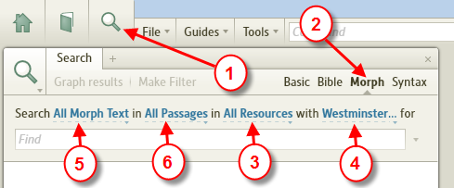

1. Open a Search panel by clicking on the magnifying glass icon in the upper left of the Logos window.
2. Select Morph as the search type from choices on the right side, if it isn't already selected.
3. Click where it says "All Resources," and choose a morphologically-tagged resource (Bible or otherwise), or a collection that includes some, or leave it set to All Resources. In addition to original language resources, you can also do Morph searches in Reverse Interlinears. The list of morph resources will differ depending on what you've got in your library, but it will generally look like this. (You'll need to scroll to the bottom of the listbox, past Collections and Series to see this list.)

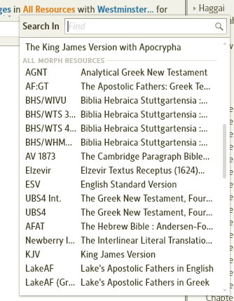

4. Choose a specific morphology to use. Different resources in Logos use different methods of morphological tagging (see why) and you can only search one system of tagging at a time. If you're only searching in one resource, the dropdown list will only show the morphologies supported in that resource. Your choice among them is self-evident (e.g., Greek, Hebrew, or Aramaic). But if you want to search many resources, the dropdown list can be a bit overwhelming. If you're not sure which morphology you need, temporarily select the one resource you most to want to search, and choose its morphology. You can then switch back to searching your entire library, and Logos will search all resources that support the morphology you have chosen. These are most of the available morphologies at present:

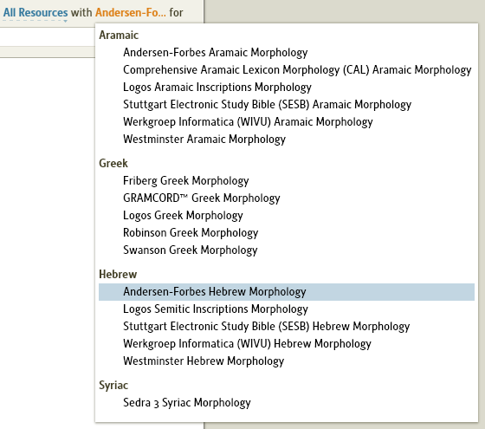
The most commonly used ones are these:

- Andersen-Forbes Hebrew/Aramaic for RI's, AFAT & Lexham resources (Logos' preferred morph)
- Logos Greek for RI's and Lexham Greek resources, including Septuagint (Logos' preferred morph)
- WIVU for BHS/WIVU resource
- Westminster for other BHS resources
- others depend on one's Library

5. If you wish, choose what search fields you want to limit the search to by clicking on "All Morph Text" to drop down the list and turning on the appropriate checkbox(es). This list will also vary according to what resource you've selected. Here are a couple of examples of what it might look like:

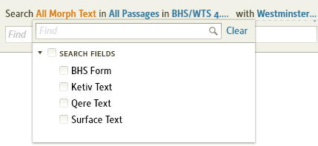

Note: You can only use search fields with original language versions, not Reverse Interlinears.

6. Also optionally select what reference range you want to limit the search to. Click where it says "All Passages" (or whatever had been selected there before) to drop down the list. Then select one of the Common Divisions or a named range you've created before, or a Passage List, or type a specific range in the "New reference range" box (6a). You don't need to give it a name, but if you think you might use this range again later, type a name for it in the "Range title" box (6b) and click Save (6c). Again, your list will look different than this, but it's organized this way.

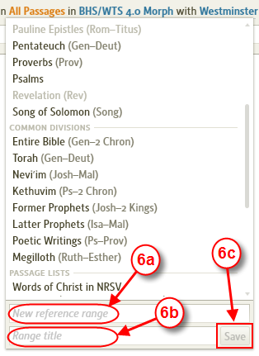

If the "New reference range" box shows a red outline around it and the Save button is grey, you've typed an invalid reference range. Once you correct it, the red outline will go away and Save will be enabled.

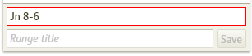

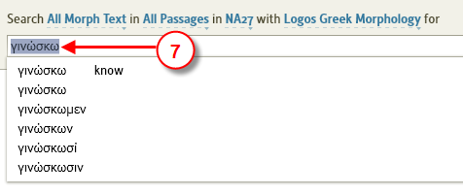

7. [This step is optional] Type or copy and paste a search term, and choose the exact form of the word from the suggested matches displayed in the dropdown as you type. The ones with a gloss are lemmas. Logos will add the appropriate prefix (lemma:, greek:, hebrew:, etc.) to the form of the word you choose. You can of course type the prefix in yourself if you know you've got a lemma, for example, instead of selecting from the menu. See How to enter text in Greek and Hebrew

The next set of numbers refer to this diagram:

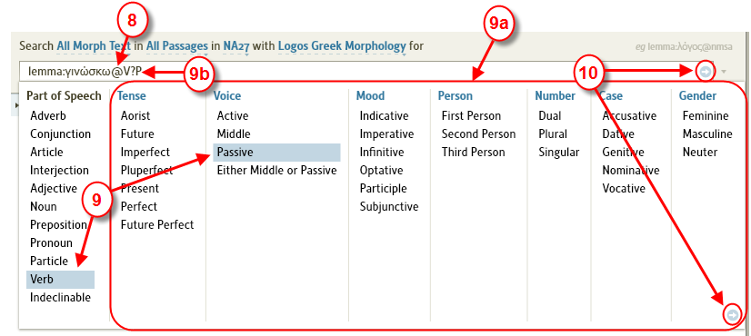
8. Type an @ sign after the word (or just type the @ sign if you're not using a specific word), and a menu will drop down showing parts of speech.
9. Choose a part of speech from the menu, and the menu will expand out to the right, showing you all the other options that apply to that part of speech (9a). Select all the grammatical inflections you want to search for. You can select multiple entries in each column (no need to hold the Ctrl key down). Column selections will be AND’d and multiple row selections will be OR’d when the search is executed. As you make your selections, you will see Logos build up the Morphology codes needed for this search (9b). You don't need to learn these codes, as they will all be generated for you automatically by your menu selections. But if you're curious or want to learn a few of the common ones so you can be super fast at entering some of these codes from the keyboard, you can look them up. See Morphology Codes.
10. When you've got the search set up the way you want it, click either the blue arrow at the right of the Find box or at the lower right of the menu. Or if you can press Escape to dismiss the menu if you want to make more changes in the search criteria before starting the search.

The next set of numbers refer to this diagram:
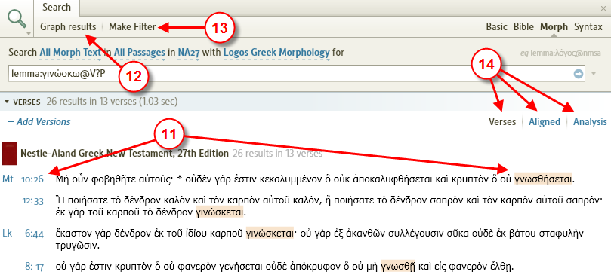
11. Once you get the search results, you can either click on a verse reference (to go to the start of the verse) or the highlighted word in that verse (to go to that search result).
12. If the resource you searched was a Bible, you can click on Graph results to see a graph of how these results are distributed throughout the Bible. (This option won't be available for other books.)
13. If you find this search useful and want to mark all the search hits with some special highlighting, you can click on Make Filter to create a Visual Filter based on it.
14. As with other types of searches you can view the results in Verses view (the default) or Aligned or Analysis view.

If your Morph search was in a Bible, you can compare the results in different versions.
[[@Headword:Morphological Search – In a Bible ]]
15. Click Add Versions:
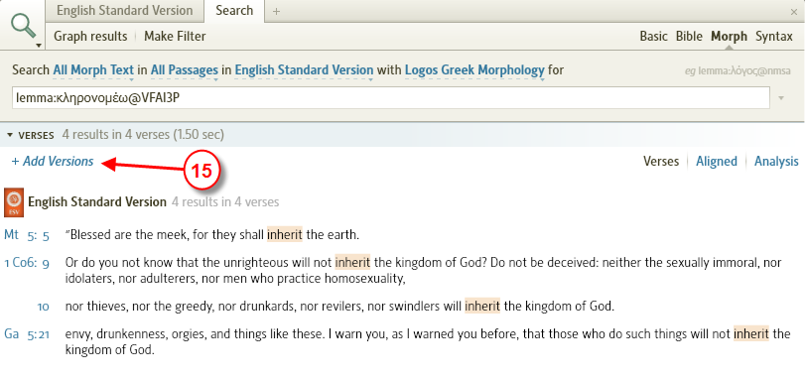

A box will open up saying Resources, where you can type in the abbreviations of any versions you want to compare with, separated by commas.

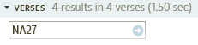
Press <Enter> or click the blue arrow. You will now see the results displayed in columns.

Launching a Morph search from within a resource
[[@Headword:Morphological Search – Launching from resource ]]
You can also do a morph search from within a resource, either an original language resource or a Reverse Interlinear:

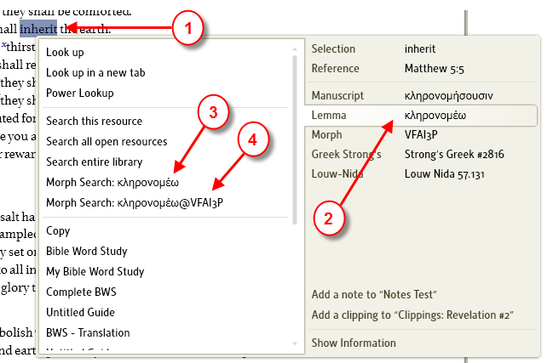
1. Right-click on a word
2. Make sure the Lemma tab is selected in the pop-up menu
3. Choose the first Morph Search option (just the lemma) to open a Morph Search panel and start a search with no morphological qualifiers. (You can type a @ after the word once you get to the Morph Search panel and add the morphology. See above.)
4. Choose the second Morph Search option (lemma with morphology) to open a Morph Search panel and search for this lemma with the same morphology as the word that you right clicked on.

Note: Ctrl+P (Print/Export) will work in Morph Search (coming in 4.1).
[[@Headword:Morphological Search – Print/Export ]]

▫ Morphology Codes
[[@Headword:Morphology Codes ]] Wiki page: Revision 8 Link

These are the codes you see entered in the Find box when you type @ and select from the dropdown menu in a Morph Search. They also can be used to decode the morphology line in Interlinears. You need to know which morphology you are dealing with.

Here is a downloadable nicely formatted PDF version of all this info (thanks to Seth Hewitt for the formatting).

Logos Greek Morphology
GRAMCORD Greek Morphology
Friberg Greek Morphology
Robinson Greek Morphology
Swanson Greek Morphology
Andersen-Forbes Hebrew Morphology
Westminster Hebrew Morphology
Werkgroep Informatica (WIVU) Hebrew Morphology
General

Greek Morphological Codes used in Search

Logos Greek Morphology
[[@Headword:Morphology Codes – Logos Greek ]]

Part of Speech

• B - Adverb
• C - Conjunction
• D - Article
• I - Interjection
• J - Adjective
• N - Noun
• P - Preposition
• R - Pronoun
• T - Particle
• V - Verb
• X - Indeclinable

Adverb/Particle Type

• C - Conditional
• E - Emphatic
• I - Interrogative
• K - Correlative
• N - Negative
• P - Place
• S - Superlative
• X – Indefinite

Conjunction Subtype

• AC - Adverbial Conditional
• AD - Adverbial Declarative
• AL - Adverbial Local
• AM - Adverbial Comparative
• AN - Adverbial Concessive
• AP - Adverbial Purpose
• AR - Adverbial Result
• AT - Adverbial Temporal
• AZ - Adverbial Causal
• LA - Logical Ascensive
• LC - Logical Contrastive
• LD - Logical Disjunctive
• LI - Logical Inferential
• LK - Logical Correlative
• LM - Logical Emphatic
• LN - Logical Connective
• LT - Logical Transitional
• LX - Logical Explanatory
• SC - Substantival Content
• SE - Substantival Epexegetical

Case (for Articles, Adjectives, Nouns, Pronouns, and Verbs)

• A - Accusative
• D - Dative
• G - Genitive
• N - Nominative
• V - Vocative

Number (for Articles, Adjectives, Nouns, Pronouns, and Verbs)

• D - Dual
• P - Plural
• S - Singular

Gender (for Articles, Adjectives, Nouns, Pronouns, and Verbs)

• F - Feminine
• M - Masculine
• N - Neuter

Degree (for Adjectives and Nouns)

• C - Comparative
• O - Other
• P - Positive
• S - Superlative

Pronoun Type

• C - Reciprocal
• D - Demonstrative
• F - Reflexive
• I - Interrogative
• K - Correlative
• N - Negative
• P - Personal
• R - Relative
• S - Possessive
• X - Indefinite

Person (for Pronouns and Verbs)

• 1 - First Person
• 2 - Second Person
• 3 - Third Person

Pronoun Subtype

• A - Intenstive Attributive
• P - Intensive Predicative

Verb Tense

• A - Aorist
• F - Future
• I - Imperfect
• L - Pluperfect
• P - Present
• R - Perfect
• T - Future Perfect

Voice (for Verbs)

• A - Active
• M - Middle
• P - Passive
• U - Either Middle or Passive

Mood (for Verbs)

• I - Indicative
• M - Imperative
• N - Infinitive
• O - Optative
• P - Participle
• S - Subjunctive

GRAMCORD Greek Morphology
[[@Headword:Morphology Codes – Gramcord Greek ]]

Part of Speech

• A - Article
• B - Adverb
• C - Conjunction
• F - Foreign Word
• I - Interjection
• J - Adjective
• M - Improper Preposition
• N - Noun
• O - Pronoun
• P - Preposition
• S - Punctuation
• T - Particle
• V - Verb

Gender (for Articles, Adjectives, Nouns, Pronouns, and Verbs)

• F - Feminine
• M - Masculine
• N - Neuter

Number (for Articles, Adjectives, Nouns, Pronouns, and Verbs)

• D - Dual Number
• P - Plural
• S - Singular

Case (for Articles, Adjectives, Improper Prepositions, Nouns, Pronouns, and Verbs)

• A - Accusative
• D - Dative
• G - Genitive
• N - Nominative
• V - Vocative

Degree (for Adverbs and Adjectives)

• C - Comparative
• S - Superlative
• X - No Degree or a Positive Degree

Conjunction Subtype

• CB - Coordinating Continuative
• CC - Coordinating Correlative
• CD - Coordinating Disjunctive
• CG - Coordinating Interrogative
• CJ - Coordinating Copulative
• CQ - Coordinating Inferential
• CV - Coordinating Adversative
• CX - Coordinating Explanatory
• PD - Pronoun Demonstrative
• PP - Pronoun Personal
• SC - Subordinating Causal
• SE - Subordinating Conditional
• SF - Subordinating Final (Purpose)
• SG - Coordinating Interrogative
• SL - Subordinating Locational
• SN - Subordinating Nominal
• SP - Subordinating Comparative
• SR - Subordinating Result
• SS - Subordinating Concessive
• ST - Subordinating Temporal

Foreign Word Type

• A - Aramaic
• H - Hebrew

Pronoun Subtype

• AD - Adjectival Demonstrative
• AF - Adjectival Indefinite
• AG - Adjectival Interrogative
• AI - Adjectival Intensive
• CR - Correlative
• DE - Adjectival Demonstrative
• IF - Adjectival Indefinite
• IG - Adjectival Interrogative
• IR - Indefinite Relative
• P1 - Personal First Person
• P2 - Personal Second Person
• P3 - Personal Third Person
• PI - Adjectival Intensive
• RC - Reciprocal
• RR - Relative
• S1 - Possessive First Person
• S2 - Possessive Second Person
• X1 - Reflexive First Person
• X2 - Reflexive Second Person
• X3 - Reflexive Third Person

Punctuation Type

• J - Major Stop
• N - Minor Stop

Particle Class

• A - Alternating
• F - Indefinite
• G - Interrogative
• M - Emphatic
• N - Negative
• P - Comparative
• S - Subjective
• U - Modal [Uncertainty]

Person (for Verbs)

• 1 - First Person
• 2 - Second Person
• 3 - Third Person

Verb Tense

• A - Aorist
• F - Future
• I - Imperfect
• L - Pluperfect
• P - Present
• R - Perfect

Voice

• A - Active
• M - Middle
• P - Passive

Mood (for Verbs)

• I - Indicative
• M - Imperative
• N - Infinitive
• O - Optative
• P - Participle
• S - Subjunctive

Participle Number (for Verbs)

• D - Dual Number
• P - Plural
• S - Singular

Friberg Greek Morphology
[[@Headword:Morphology Codes - Friberg Greek ]]

Part of Speech

• A - Adjective
• C - Conjunction
• D - Determiner
• N - Noun
• P - Preposition
• Q - Particle
• V - Verb

Adjective Category

• B - Adverb
• P - Pronomial

Adjective Type

• C - Cardinal
• D - Demonstrative
• I - Indefinite
• M - Comparative
• O - Ordinal
• R - Relative
• S - Superlative
• T - Interrogative

Case (for Adjectives, Determiners, Nouns, Prepositions, and Verbs)

• A - Accusative
• D - Dative
• G - Genitive
• N - Nominative
• V - Vocative

Gender (for Adjectives, Determiners, Nouns, and Verbs)

• F - Feminine
• M - Masculine
• N - Neuter

Person (for Adjectives, Nouns, and Verbs)

• 1 - 1st Person
• 2 - 2nd Person
• 3 - 3rd Person

Number (for Adjectives, Determiners, Nouns, and Verbs)

• P - Plural
• S - Singular

Conjunction Category

• C - Coordinating
• H - Superordinating (Hyperordinating)
• S - Subordinating

Noun Subcat

• P - Pronoun

Particle Category

• N - Negative
• S - Sentence
• T - Interrogative
• V - Verbal

Mood (for Verbs)

• I - Indicative
• M - Imperative
• N - Infinitive
• O - Optative
• P - Participle
• R - Participle (Imperative Sense)
• S - Subjunctive

Tense (for Verbs)

• A - Aorist
• F - Future
• I - Imperfect
• L - Pluperfect
• P - Present
• R - Perfect

Voice (for verbs)

• A - Active
• D - Middle Deponent
• E - Either Middle or Passive
• M - Middle
• N - Middle or Passive Deponent
• O - Passive Deponent
• P - Passive

Robinson Greek Morphology
[[@Headword:Morphology Codes - Robinson Greek ]]

Part of Speech

• A - Adjective
• B - Adverb
• C - Conjunction
• I - Interjection
• L - Particle
• N - Noun
• P - Preposition
• Q - Conjunction or Conditional Particle
• R - Pronoun
• T - Definite Article
• V - Verb
• Z - Indeclinable

Case (for Adjectives, Nouns, Pronouns, Definite Articles, and Verbs)

• A - Accusative
• D - Dative
• G - Genitive
• N - Nominative
• V - Vocative

Number (for Adjectives, Nouns, Pronouns, Definite Articles, and Verbs)

• P - Plural
• S - Singular

Gender (for Adjectives, Nouns, Pronouns, Definite Articles, and Verbs)

• F - Feminine
• M - Masculine
• N - Neuter

Adj Type (for Adjectives, Adverbs, and Particles)

• C - Comparative
• I - Interrogative
• N - Negative
• S - Superlative

Conj Type (for Conjunction or Conditional Particle)

• C - Contracted Form, or Two Words Merged by Crasis

Pronoun Type

• C - Reciprocal
• D - Demonstrative
• F - Reflexive
• I - Interrogative
• K - Correlative
• P - Personal
• Q - Correlative or Interrogative
• R - Relative
• S - Possessive
• X - Indefinite

Person (for Pronouns and Verbs)

• 1 - First Person
• 2 - Second Person
• 3 - Third Person

Tense (for Verbs)

• A - Aorist
• A2 - Second Aorist
• F - Future
• F2 - Second Future
• I - Imperfect
• L - Pluperfect
• L2 - Second Pluperfect
• P - Present
• R - Perfect
• R2 - Second Perfect
• V - Adverbial Imperative
• X - No Voice Stated

Tense Type (for verbs); after Aorist, Future, Pluperfect, or Perfect

• 2 - Second

Voice (for verbs)

• A - Active
• D - Middle Deponent
• E - Either Middle or Passive
• M - Middle
• N - Middle or Passive Deponent
• O - Passive Deponent
• P - Passive
• Q - Impersonal Active
• X - No Voice Stated

Mood (for verbs)

• I - Indicative
• M - Imperative
• N - Infinitive
• O - Optative
• P - Participle
• R - Imperative-Sense Participle
• S - Subjunctive

Indeclinable Type

• A - Aramaic
• H - Hebrew
• L - Indeclinable Letter (Noun)
• N - Indeclinable Numeral (Adjective)
• O - Indeclinable Noun of Other Type
• P - Indeclinable Proper Noun

Swanson Greek Morphology
[[@Headword:Morphology Codes – Swanson Greek ]]

Part of Speech

• C - Conjunction
• D - Adverb
• E - Preposition
• F - Foreign Word
• I - Interjection
• J - Adjective
• M - Number/Word
• N - Noun
• O - Contraction
• P - Pronoun
• R - Definite Article
• S - Substantive
• T - Particle Verb
• VF - Finite Verb
• VI - Infinitive Verb
• VP - Participle

Conjunction Type

• D - Disjunctive
• T - Temporal

Adverb Type

• C - Comparative
• I - Indefinite
• P - Of Place
• R - Relative
• S - Superlative

Case (for Prepositions, Adjectives, Number/Words, Nouns, Pronouns, Definite Articles, Substantives, and Verb Participles)

• A - Accusative
• D - Dative
• G - Genitive
• N - Nominative
• V - Vocative

Foreign Word Type

• C - Conjunction
• I - Interjection
• N - Noun
• V - Verb

Number (for Adjectives, Number/Words, Nouns, Pronouns, Definite Articles, Substantives, Verb Finites, and Verb Participles)

• P - Plural
• S - Singular

Gender (for Adjectives, Number/Words, Nouns, Pronouns, Definite Articles, Substantives, and Verb Participles)

• F - Feminine
• M - Masculine
• N - Neuter

Comparator (for Adjectives)

• C - Comparative
• E - Elative
• S - Superlative

Pronoun Type

• D - Demonstrative
• G - Interrogative
• I - Indefinite
• L - Reciprocal
• P - Personal
• R - Relative
• X - Reflexive

Particle Type

• C - Conditional
• E - Enclitic

Tense (for Verb Finite, Verb Infinitive, and Verb Participle)

• 2 - Second Aorist
• A - Aorist
• F - Future
• I - Imperfect
• L - Pluperfect
• P - Present
• R - Perfect

Mood (for Verb Finite)

• I - Indicative
• O - Optative
• S - Subjunctive
• V - Imperative

Voice (for Verb Finite, Verb Infinitive, and Verb Participle)

• A - Active
• D - Deponent
• N - Middle
• P - Passive

Impersonal (for Verb Finite)

• I - Impersonal

Andersen-Forbes Hebrew Morphology
[[@Headword:Morphology Codes – AF Hebrew ]]

Parts of Speech

• A - Adverbial
• C - Conjunction
• N - Noun
• P - Preposition
• R - Pronoun
• V - Verb
• X - Miscellany

Adverbial Family

• a - "Together" (יחדו)
• b - "Afterwards" (אחר)
• c - "Above" (מעל)
• d - "Eagerly" (אספרנא)
• e - "Suddenly" (פתאם)
• E - Emphatic
• f - "Farther" (הלאה)
• g - "Then" (אז or אדין)
• h - "Here" (הנה)
• i - "Inadvertently" (הצדא)
• I - Interrogative
• j - "Thither" (שמה)
• k - "Back" (אחור)
• K - [Question] (אם)
• l - "Positively" (אפתם)
• m - "Thus" (כה or כן)
• M - Modal
• n - "Now" (עתה)
• N - Negative
• o - "Then" (אפוא)
• O - Restrictive (אך)
• p - "Certainly" (לא)
• q - "Quickly" (חיש)
• Q - Quasiverbal
• r - "Already" (כבר)
• R - Restrictive (רק)
• s - "Still" (עוד)
• t - "There" (שם)
• T - "Now" (טרם)
• u - "Upwards" (מעלה)
• v - "Very" (מאד)
• w - "Underneath" (מטה or תחת)
• x - "Apart" (לבד)
• y - "Yet" (עדן)
• Y - "Not Yet" (טרם)
• z - "Again" (עוד)

Adverbial Subclass

• a - "Yes or No?" (ה)
• b - "Who?" (מי)
• B - "Behold!" (הנה)
• c - "What?" (מה)
• d - "How?" (איך)
• D - "Do Not" (אל)
• e - "When?" (מתי)
• E - "Exists" (יש)
• f - "Where?" (אנה)
• g - "Whence?" (מאין)
• G - Negation (בלי)
• h - "Why?" (מדוע)
• i - "Where?" (איה)
• n - "Not Exists" (|אי)
• N - "Not" (לא)
• S - "Still" (עוד)
• T - Temporal

Conjunction Subclass

• a - "Also" (אף)
• A - Adverbial
• b - "But Indeed" (אולם)
• c - Sequential (ו)
• C - Coordinating (ו)
• G - "Also" (גם)
• I - "If" (אם)
• K - כי
• O - "Or" (או)
• R - Nominalizer
• T - Temporal
• X - Other

Conjunction Sub Subclass

• A - Concessive ("although")
• B - "because"
• E - Adversative ("but")
• I - "if"
• S - Asseverative ("surely")
• T - "that"
• W - "whe"

Noun Subclass

• C - Common
• P - Proper

Noun Family

• A - "All"
• c - Common
• C - City
• D - Divine
• E - Ethnic
• G - Other Geographic
• H - Human
• J - Adjective
• L - Land
• M - Mountain
• N - Numeral
• O - Ordinal
• R - River

Number (for Nouns, Pronouns, and Verbs)

• C - Collective
• d - Distributive
• D - Dual
• P - Plural
• S - Singular

Gender (for Nouns, Pronouns, and Verbs)

• C - Common
• F - Feminine
• M - Masculine

State (for Nouns, Pronouns, and Verbs)

• c - Discontinuous Construct
• C - Construct
• D - Determined
• N - Normal
• P - Pausal
• S - Suffixed

Definiteness (for Nouns, Pronouns, and Verbs)

• h - Definite Without ה
• H - Definite With ה
• I - Indefinite

Derivational Suffix (for Nouns)

• A - Adverb Derived
• H - Locative ה

Preposition Subclass

• a - "Above" (Aram.עלא)
• A - Object Marker
• b - "Between" (בין)
• B - "In" (ב)
• d - "Of" (Aram.די)
• D - "Until" (עד)
• e - "Except" (בלת)
• E - "Except" (לבד)
• f - "For" (למען)
• F - "After" (אחר)
• h - "Without" (בלעד)
• H - "Through" (בעד)
• K - "Like" (כ)
• l - "At" (Aram. לות)
• L - "To" (ל)
• M - "From" (מן)
• N - "Near" (אצל)
• O - "On Account of" (בגלל)
• q - "Before" (Aram. קדם)
• Q - "Before" (Aram.קבל)
• S - "For sake of" (בעבר)
• t - "Under" (תחת)
• T - "Inside" (תוך)
• u - "Upon" (על)
• U - "Unto" (אל)
• w - "With" (עם)
• W - "With" (את)
• X - Other
• Y - "Because" (יען)
• Z - "Except" (זולת)

Pronoun Subclass

• B - Suffixed
• D - Demonstrative
• F - Personal

Person (for Pronouns and Verbs)

• 1 - First Person
• 2 - Second Person
• 3 - Third Person

Verb Stem

• A - Afal
• h - Hifil
• H - Hofal
• I - Itpael
• n - Nifal
• p - Piel
• P - Pual
• q - Qal
• Q - Qal Passive
• S - Safal
• t - Hitpael
• T - Tafal

Voice (for Verbs)

• A - Active
• M - Middle
• P - Passive
• T - Reflexive

Verb Family

• a - Infinitive Absolute
• c - Cohortative Sequential
• C - Cohortative
• f - Suffixed (Perfect) Sequential
• i - Insistent Imperative
• I - Imperative
• J - Jussive
• m - Prefixed (Imperfect) Sequential
• M - Prefixed (Imperfect)
• n - Noun-Verb/noun Participle
• p - Noun-Verb Participle
• P - Preterite
• s - Suffixed (Perfect)
• t - Pure Noun Participle
• T - Infinitive Construct
• v - Pure Verb Participle

Miscellany Subclass

• D - Definite Article
• E - Exclamation
• K - Qetiv Welo Qere
• L - Lapsus Calami
• N - Nominalizer
• Q - Qere Welo Qetiv

Westminster Hebrew Morphology
[[@Headword:Morphology Codes – Westminster Hebrew ]]

Part of Speech

• a - Adjective
• E - Ending
• I - Imperfect Ending
• n - Noun
• p - Pronoun
• P - Particle
• S - Suffix
• v - Verb
• V - Perfect Ending
• x - Paragraph Marker or Nun

Person (for Pronouns and Verbs)

• 1 - First Person
• 2 - Second Person
• 3 - Third Person
• i - Interrogative

Gender (for Adjectives, Nouns, Pronouns, and Verbs)

• b - Feminine and Masculine
• c - Common
• f - Feminine
• m - Masculine

Number (for Adjectives, Nouns, Pronouns, and Verbs)

• d - Dual Number
• p - Plural
• s - Singular

State (for Adjectives, Nouns, and Verbs)

• a - Absolute
• c - Construct
• d - Determined

Pronominal Suffix Person (for Adjectives, Nouns, Pronouns, Particles, and Verbs; follows +S and is combined in brackets, e.g. +S[12])

• +S1 - First Person
• +S2 - Second Person
• +S3 - Third Person
• +Si - Interrogative

Pronominal Suffix Gender (for Adjectives, Nouns, Pronouns, Particles, and Verbs; follows pronominal suffix person, e.g. +S1b)

• b - Feminine and Masculine
• c - Common
• f - Feminine
• m - Masculine

Pronominal Suffix Number (for Adjectives, Nouns, Pronouns, Particles, and Verbs; follows pronominal suffix person and gender, e.g. +S1fp)

• d - Dual Number
• p - Plural
• s - Singular

Ending Type (for Adjectives, Nouns, Pronouns, Particles, and Verbs; follows +S???E)

• a - Apocopated
• d - Directional Heh
• h - Paragogic Heh
• n - Paragogic Nun

Imperfect Type (for Imperfect Endings follows +; for Verbs follows I)

• C - Cohortative
• J - Jussive

Imperfect Form (for Imperfect Endings follows +; for Verbs follows I; follows imperfect type, e.g., +Cf or IJm)

• f - In Form Only
• m - In Meaning Only
• t - In Form and Meaning

Noun Type

• c - Common
• g - Gentilic Noun
• p - Proper Name

Particle Class

• a - Article
• b - Inseparable Preposition With Article
• c - Conjunction
• d - Adverb
• g - Interrogative
• i - Interjection
• n - Negative
• o - Direct Object
• p - Preposition
• r - Relative

Verb Stem

• a - Palel
• b - Pealal
• c - Pilel
• d - Pilpel
• e - Polel
• f - Polal
• g - Polpal
• h - Hiphil
• H - Hophal
• i - Pulal
• k - Poel
• l - Poal
• m - Tiftl
• n - Niphal
• p - Piel
• P - Pual
• q - Qal
• Q - Truly Qal Passive
• s - Hishtafel
• t - Hithpael
• u - Hotpaal
• v - Hitpolel
• w - Hitpalpel
• x - Nitpael

Verb Aspect

• a - Infinitive Absolute
• c - Infinitive Construct
• i - Imperfect
• p - Perfect
• P - Participle
• s - Passive Participle
• v - Imperative
• w - Imperfect Waw Consecutive

Consecutive Type (for Perfect Ending follows +; for Verbs follows V)

• v - Consecutive

Werkgroep Informatica (WIVU) Hebrew Morphology
[[@Headword:Morphology Codes – Werkgroep Hebrew ]]

Part of Speech

• A - Article
• C - Conjunction
• D - Adverb
• G - Negation
• I - Interrogative
• J - Adjective
• N - Noun
• P - Preposition
• R - Pronoun
• V - Verb
• X - Interjection

Conjunction Type

• R - Relative

Gender (for Adjectives, Nouns, Pronouns, and Verbs)

• F - Feminine
• M - Masculine

Number (for Adjectives, Nouns, Pronouns, and Verbs)

• D - Dual
• P - Plural
• S - Singular

State (for Adjectives, Nouns, Pronouns, and Verbs)

• A - Absolute
• C - Construct
• D - Determined

Noun Type

• C - Common
• P - Proper

Preposition Type

• O - Object Marker

Pronoun Type

• D - Demonstrative
• I - Interrogative
• P - Personal
• S - Suffixed

Person (for Pronouns and Verbs)

• 1 - First Person
• 2 - Second Person
• 3 - Third Person

Verb Stem
• a - Qal
• b - Pi"el
• c - Hif'il
• d - Nif'al
• e - Pu"al
• f - Hafel
• g - Hitpa"el
• h - Hitpe"el
• i - Hof'al
• k - Hishtaf'al
• l - Hotpa"al
• m - Nitpa"el
• n - Etpa"al
• o - Tif'al
• p - Afel
• q - Shaf'el
• r - Pe'al
• s - Pa"el
• t - Pe'il
• u - Hitpa"al
• v - Etpe'el

Verb Tense

• F - Infinitive
• I - Imperfect
• M - Imperative
• P - Perfect
• R - Participle
• S - Passive Parti
• w - Weyiqtol
• W - Wayyiqtol

Verb Mood

• C - Cohortative
• J - Jussive

General
[[@Headword:Morphology Codes - General ]]

• ^ - Not (for multi-selectable options)
• ? - Any

Greek Morphological Codes used in Search
[[@Headword:Morphology Codes – Greek Morph in Search ]]
This is copied from Mark Barnes reply to a post and placed here so we have them documented in the wiki.

The reason for the codes is that different resources in Logos have different morphologies. They're not documented, but there's only five of them to my knowledge:

• lbs: Logos Greek Morphology
• lls: Gramcord Greek Morphology
• fe: Friberg Greek Morphology
• mr: Robinson Greek Morphology
• js: Swanson Greek Morphology

Example of using these codes in a search
[[@Headword:Morphology Codes - Example ]]

Copy and paste the line below and paste it into a Basic Search
<lemma = lbs/el/δικαιόω>, <lemma = lls/el/δικαιόω>, <lemma = fe/el/δικαιόω>, <lemma = mr/el/δικαιόω>, <lemma = js/el/δικαιόω>

Remember that if you want to specify morphology for each lemma, then the different morphologies have different codes.

A Strategy for Syntax Search
[[@Headword:A Strategy for Syntax Search ]] Wiki page: Revision 26 Link

See Also
Basic Search
Search HELP
Search Fields List
BDAG Search
Setting up a Syntax Search

Logos Videos
Syntax Searching For Everyone: Pt1
Syntax Searching For Everyone: Pt2
Syntax Searching For Everyone: Pt3

This is not a tutorial on any of the Syntax methods but merely advice as how to go about constructing a syntax query. For simplicity this description will tend to use the terms of the two simplest, and complete, methods namely Cascadia and Opentext. The Cascadia Syntax Graphs of the New Testament is available in Scholar's Silver packages and above.

Have a very good idea of the problem you are trying to solve
[[@Headword: A Strategy for Syntax Search – Have a very good idea of the problem ]]
A problem involving relationships between words and their syntactical/semantic use is ideal for this type of query. A problem that involves simple relationships between words, or usage of words, is best addressed by a Morphological text query.

Construct a text query that will be your Control
[[@Headword:A Strategy for Syntax Search – Construct Query ]]
It should capture all possible results but will also capture false positives because relationships are expressed by Proximity (distance). Be sure you have some valid results before you start the syntax query.

Examine the Clause Analysis
[[@Headword:A Strategy for Syntax Search – Examine the Clause Analysis ]]
Examine the structure of at least 3 results in the Clause Analysis of the syntax method and concentrate on the relationship of clause functions within a single parent clause and implement that structure on the Syntax diagram in L4 eg.

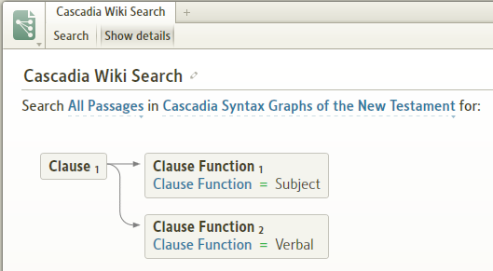
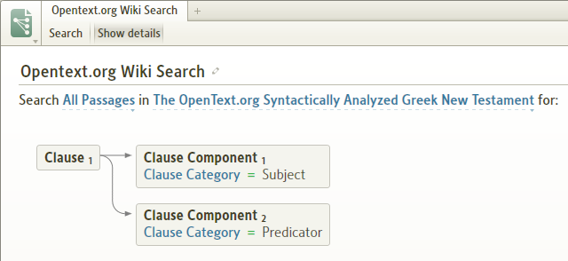

If these can occur in any order then use an Unordered Group

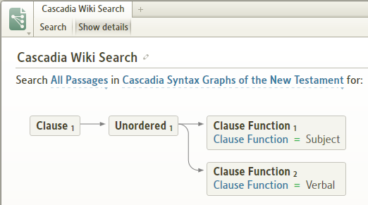
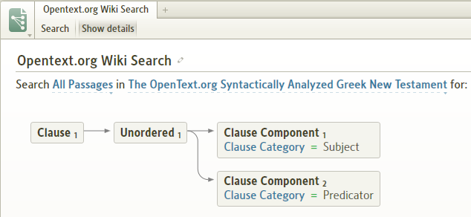

Word level detail (& skipping levels of the clause analysis diagram)
[[@Headword:A Strategy for Syntax Search – Word level details ]]
A verbal function is usually the simplest to complete as it usually involves only one word. The Subject may be more complex, but it is usually one word. So let’s skip the intermediate levels:

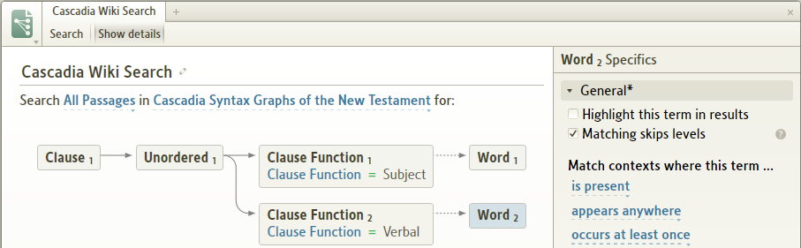
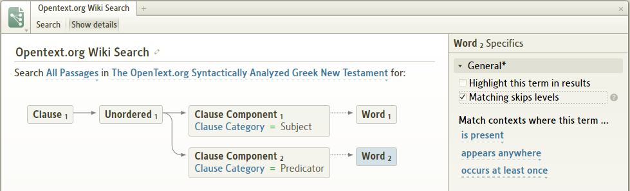

Complete any necessary morphological details to identify Word1 and Word2 and run the query. Ensure the results include the passages that provided the prototype query above!

If the subject has to be qualified, typically by the definite article then find the structure that provides it (eg. determiner, specifier) and try to avoid a word-level definition.

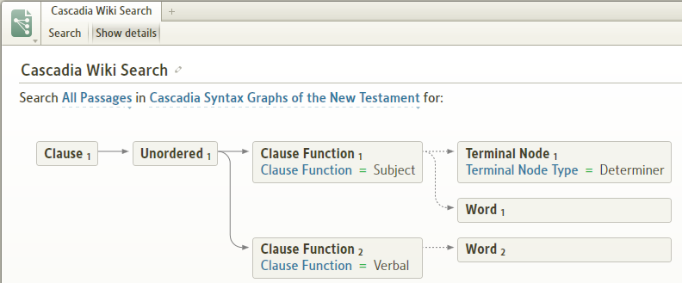
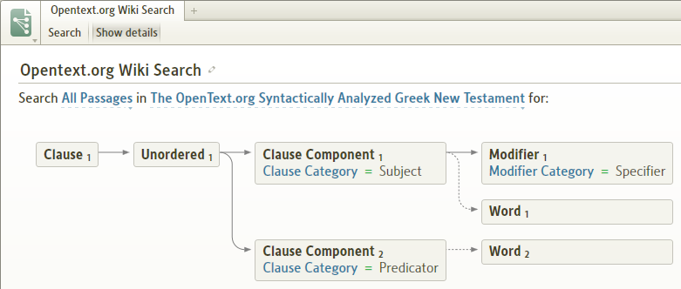

If the qualifier is not to be present then alter the attributes ie. is not present. If it doesn’t matter then use may or may not appear.

Unordered Group
[[@Headword:A Strategy for Syntax Search – Unordered Group ]]
Note that the above structure with [Unordered Group] is flexible as any other function can appear between the Subject and Verbal ones. In the absence of Unordered Group you would have to insert Anything between the two functions eg.

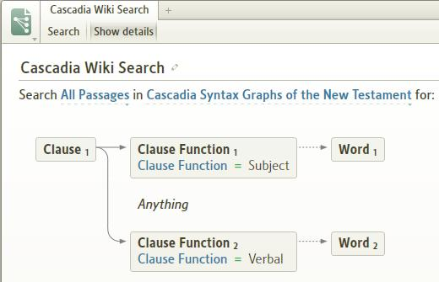
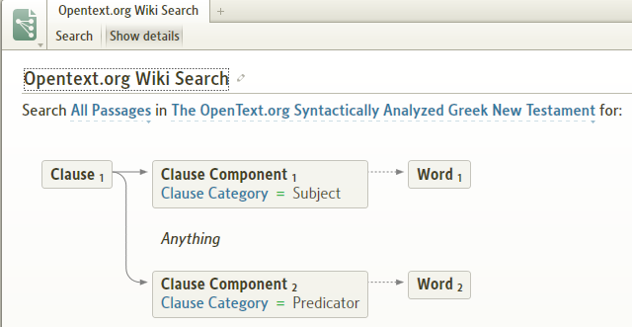

Also remember that in an Unordered Group, the specified components can appear in any order. By removing an Unordered Group, the search will only return results in which the components appear in the order in which they are set in the search.

Run the query
[[@Headword:A Strategy for Syntax Search – Run the Query ]]
Now you should be getting valid results from your query, comparing them to the control set and begin fine tuning your query to eliminate spurious hits.

Is it complete enough?
[[@Headword:A Strategy for Syntax Search – Is it complete enough? ]]
Eventually you have to decide that the query is as good as it can be, because there is no guarantee any query will be 100% complete. At that point you have to manually determine what results are missing.

Some Forum threads with help on creating specific Syntax searches:
[[@Headword:A Strategy for Syntax Search – Forum threads ]]
• http://community.logos.com/forums/t/12328.aspx
• http://community.logos.com/forums/t/13018.aspx
• http://community.logos.com/forums/t/11510.aspx
• http://community.logos.com/forums/t/12890.aspx
• http://community.logos.com/forums/p/15697/119540.aspx#119540

▫ BDAG Search
[[@Headword:BDAG Search ]] Wiki page: Revision 8 Link

In LDLS 3 the BDAG search utility was a powerful tool to search the various fields (surface, footnote, lemma, extdef, formeq, transeq) of that Lexicon. This particular tool is not available in Logos 4.

However, the search function can be duplicated by a Basic Search restricted to BDAG. For example: "About the Electronic Edition" in BDAG illustrated the power of searching fields to locate when "Jerusalem" was used as a formal equivalent. Simply click on "All Text" and a drop down menu was appear with the various search fields available for BDAG. This can also be used for all resources that have multiple search fields (most resources have surface and footnote).

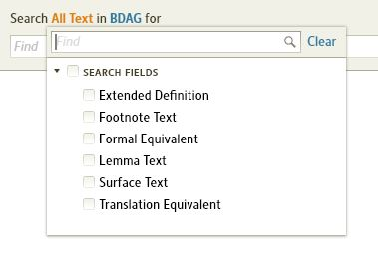

The fields which can be search in BDAG are:

• surface: will search surface text;
• footnote: will search footnotes only;
• lemma: will search for the lexical form of the word;
• extdef: will search the extended definition, italicized in BDAG;
• formeq: will search the bold glosses; and
• transeq: will search the suggested translation of Greek quotations within the text. Search queries can be strung together with AND or OR operators.

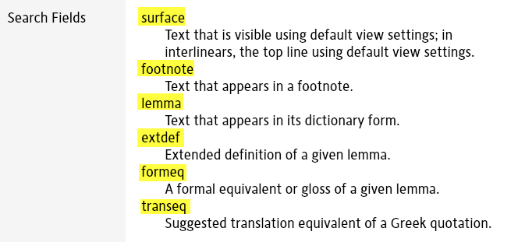

Setting up a Syntax Search
[[@Headword:Setup Syntax Search ]] Wiki page: Revision 17 Link

Logos Videos
Syntax 1: Andersen-Forbes
Syntax 2: Andersen-Forbes
Syntax Searching For Everyone: Pt1
Syntax Searching For Everyone: Pt2
Syntax Searching For Everyone: Pt3
Logos4 Videos

See Also
A Strategy for Syntax Search

Example 1
[[@Headword:Setup Syntax Search – Example1 ]]
• This example will step you through setting up a Syntax Search including setting up a Query.
• The example is from Dave Hooton's forum post. (see Syntax)
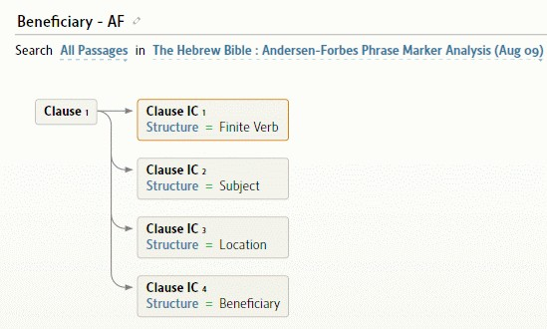

• By following these steps you can setup other Syntax Searches.
1. On Logos4 top menu, right click on Search and select Open in floating window

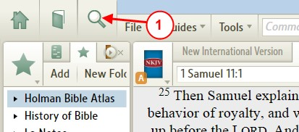

2. When the Search window opens, select Syntax
3. Click on Query (under Syntax). When the drop down menu appears, select New Syntax Search…
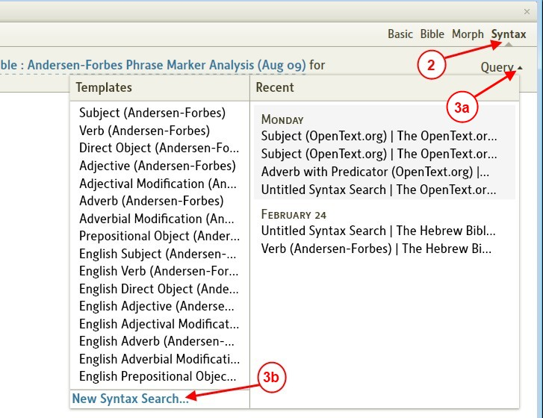

4. Click on the in item
5. When the drop down menu appears, select the Andersen-Forbes Phrase Marker Analysis
6. Set the Search to All Passages
7. Click on the Title and add a name.
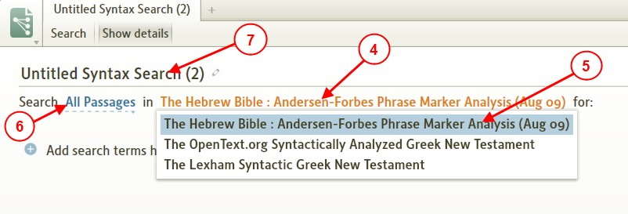

8. Click on the + next to Add search terms
9. When the drop down menu appears select Clause
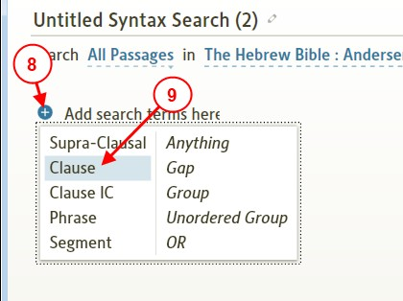

10. Hold your mouse over the Clause icon and when an + appears as shown, click on it.
11. You will see a drop down menu appear, select Clause IC
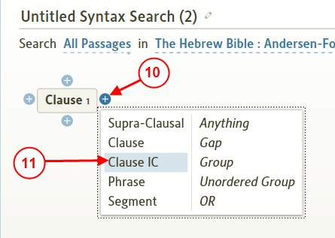

12. Expand Constituent (found on the right side)
13. Check Finite Verb (in Clause IC1, you will see Structure = Finite Verb)
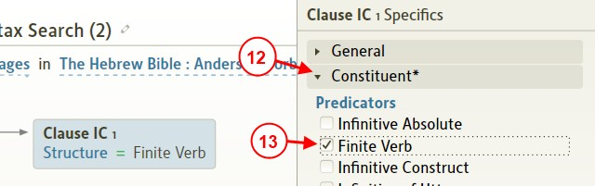

14. Hold your mouse over Clause IC1 and then click on the + under Clause IC1
15. In drop down menu, click on Clause IC
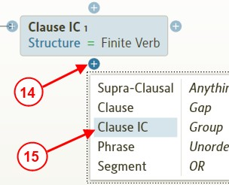

16. Under Constituents check Subject
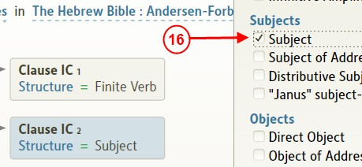

17. Repeat steps 14 & 15 to create Clause IC3 (under Clause IC2)
18. Scroll down under Constituents and check Location
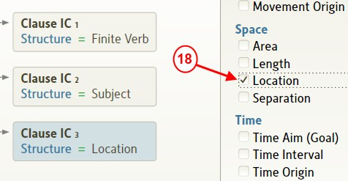

19. Repeat steps 14 & 15 to create Clause IC4 under Clause IC3
20. Under Constituents check Beneficiary
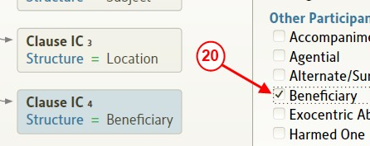

21. Now we have finished building the Query, so click on Search to perform the search
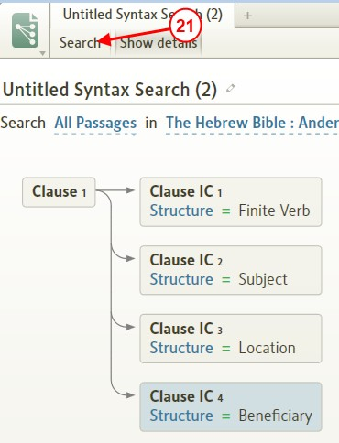

• Now we see the search results in the Hebrew Bible.
1. We can also view the results in a side by side view in English. Click on Add Versions and select NKJV (for example).
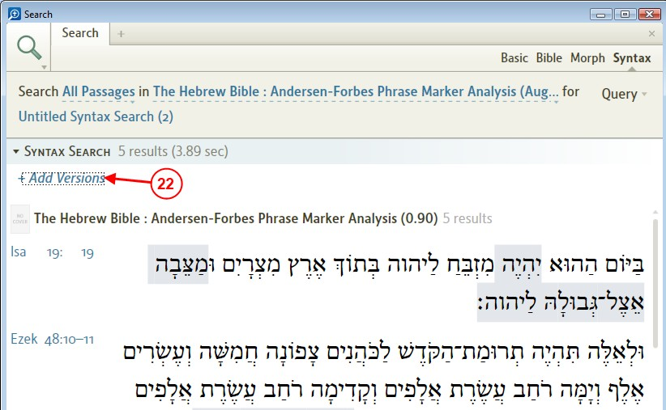

• Now we see the final results
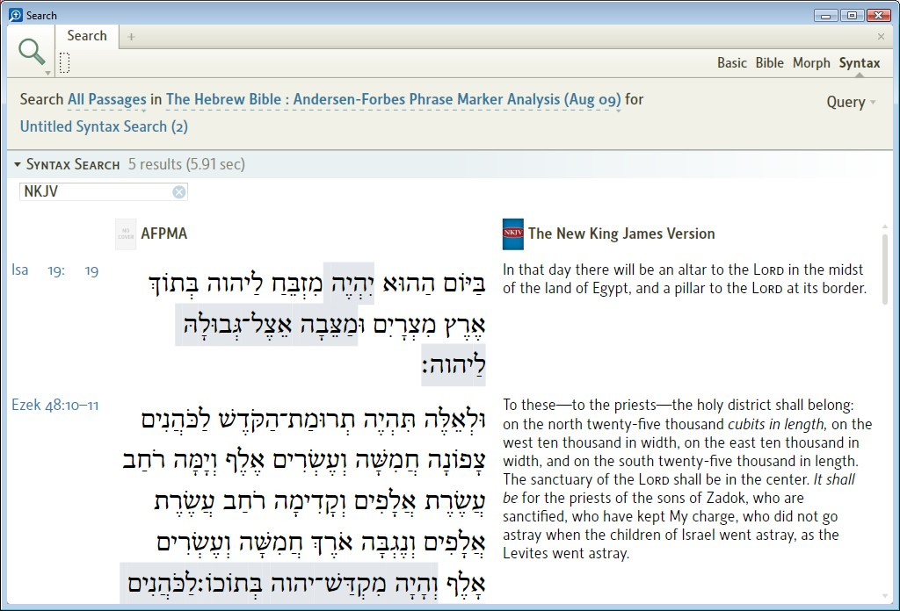

Related Books
[[@Headword:Setup Syntax Search – Example 1 [Related books] ]]
• You can also look at these books in your Library for more information
▪ A SYSTEMATIC GLOSSARY TO THE ANDERSEN-FORBES ANALYSIS OF THE HEBREW BIBLE (this details the syntax on how to use the parts of speech)
▪ Hebrew Bible: Andersen Forbes Phrase Marker Analysis (0.90) (this is the Hebrew Bible with all markings, you can use this to lookup specific Bible verses and see how a phrase is marked)

Example 2
[[@Headword:Setup Syntax Search – Example 2 ]]
• Example of setting up an OpenText.org using Kevin's example from the forum (see Subject and Finite Verb)
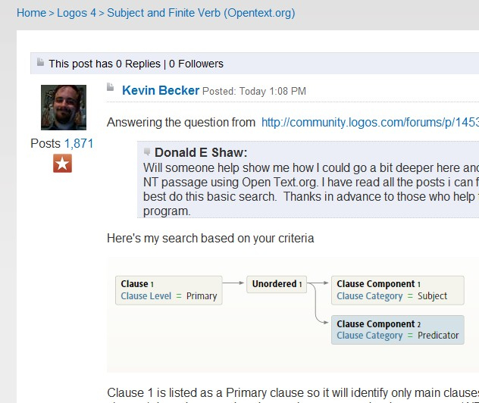

▪ Example:
1. Click on File in the top menu of Logos4.
2. Click on Syntax Search in the drop down menu.
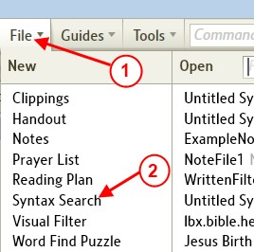

3. Click on the In item
4. In the drop down menu, select The OpenText.org Syntactically Analyzed Greek New Testament.
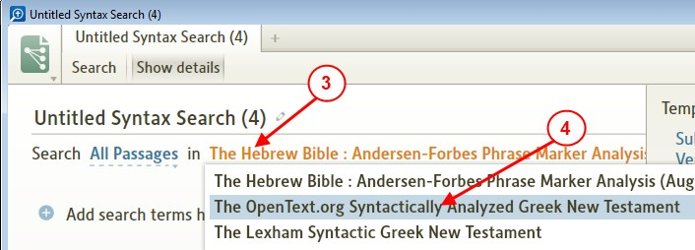

5. Click on the Search item.
6. In the drop down menu, select New Testament (Matt--Rev).
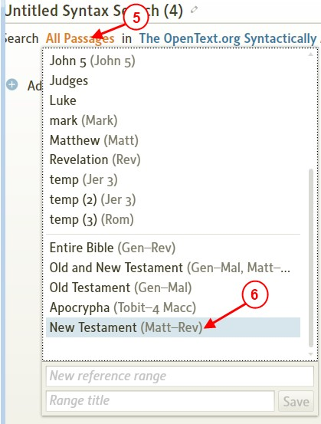

7. Click in the Title box and type in Subject and Finite Verb (OpenText.org).
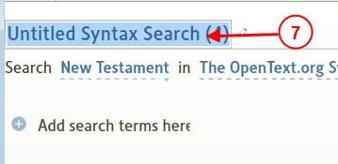

• Now lets add the search criteria
1. Click on the + next to Add search term here
2. In the drop down menu, select Clause
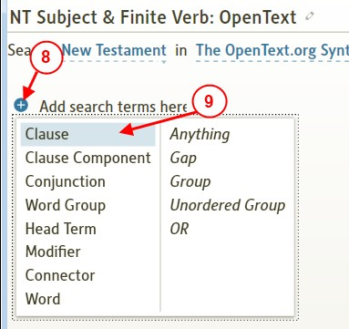

3. On the right section, click on Level to uncompress it.
4. Check Primary.
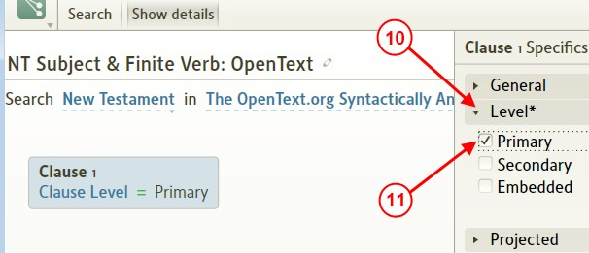

5. Hold your mouse over Clause1, when the + appear around it, click on the right +.
6. In the drop down menu, click on Unordered Group.
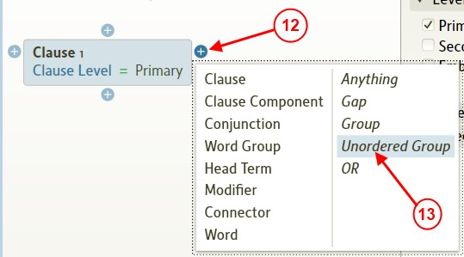

7. Hold your mouse over Unordered1 until the + appear around it, click on the right +.
8. In the drop down menu, click on Clause Component.
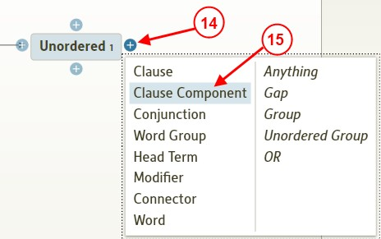

9. On the right section click on the Clause Category to uncompress it.
10. Click to check Subject.
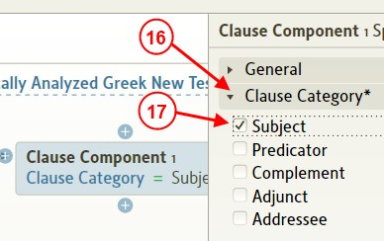

11. Hold your mouse over Clause Category1, click on the + under it.
12. In the drop down menu, click on Clause Component.
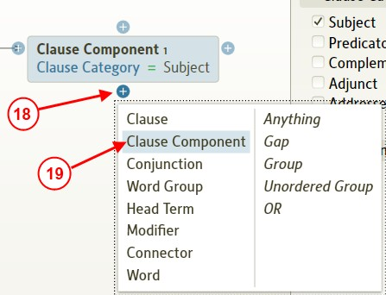

13. On the right side, click to check Predicator.
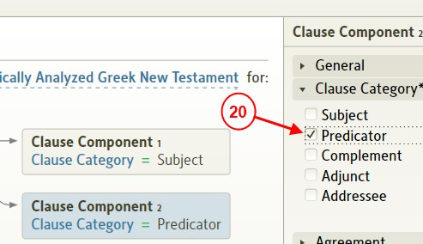

• Now that we have the Search criteria finished...
1. In the upper left area of the Search window, click on the Search button.
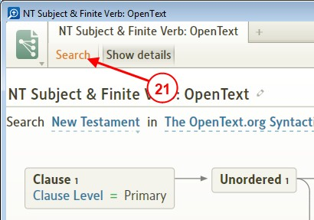

• Now the results for the search appear in a new search window.
1. You can open an English Bible version to view side-by-side next to the Greek results.

Click on Add Versions
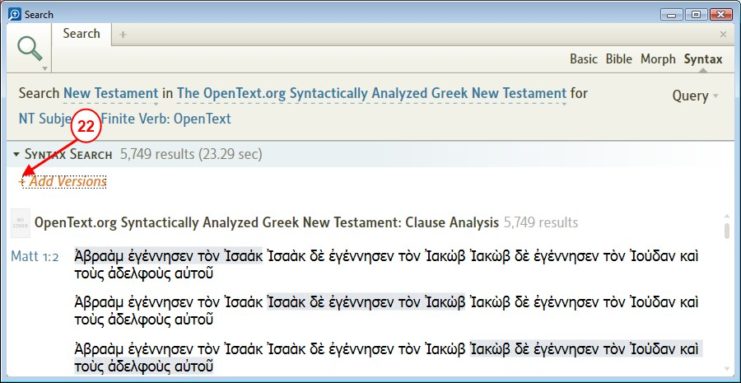

2. In the drop down menu, select your Bible version.
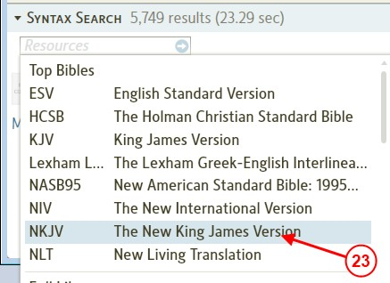

• Now you have your completed results showing
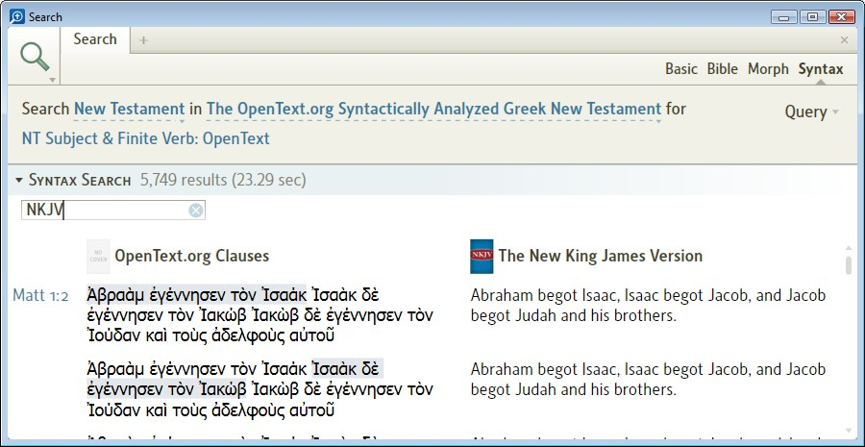

Related Books (OpenText.org)
[[@Headword:Setup Syntax Search – Example 2 [Related books] ]]
• You can also look at these books in your Library for more information
▪ OpenText.org SYNTACTICALLY ANNOTATED GREEK NEW TESTAMENT: Bible
▪ OpenText.org SYNTACTICALLY ANNOTATED GREEK NEW TESTAMENT: Glossary of Terminology
▪ OpenText.org SYNTACTICALLY ANNOTATED GREEK NEW TESTAMENT: Clause Analysis

About Topic Search
[[@Headword:About Topic Search ]] Wiki page: Revision 5 Link

This page addresses how to search for topical material in Logos 4, and how this has changed from Libronix. Since this subject has come up quite a bit on the forums, it also serves as a reference guide to the full conversation.

Then: Topic Browser in Libronix
[[@Headword:About Topic Search – in Libronix ]]
Many users have asked why the Libronix Topic Browser is no longer available. Here are some of the reasons:

- the keywords used to describe topics were not chosen consistently: one resource might use "communion", and another "Lord's supper". So you couldn't be sure the keyword you were searching would match the topic annotation of your resources.
- Only some resources had topic annotation, and even then it wasn't always applied comprehensively throughout a given resource.

Now: Topics in Logos 4
[[@Headword:About Topic Search – in Logos4 ]]
Logos 4 uses a new approach to try and make topical search more powerful, thorough, and consistent. The foundation is the Logos Controlled Vocabulary (LCV), which organizes a defined set of concepts, the keywords that can be used to describe them, and links to the dictionaries, encyclopedias, and other subject-oriented resources that organize content this way (many resources don't).

Where Do Topics Appear in Logos 4?
[[@Headword:About Topic Search – Where do Topics appear in L4 ]]
1. When you do a Basic Search of your Entire Library and the search term matches a concept in the LCV, you'll see a section above the search results called Topic. This section contains

- for ambiguous terms, links to choose an alternate sense ("bear" can mean an animal, a constellation, or the action of bearing a child)
- an expanded query you can use to search more broadly for this concept
- links to dictionary articles that address this concept
- user-contributed Reading List content and other links from topics.logos.com

2. In a Passage Guide, the Topics section lists concepts for dictionary articles that discuss this passage. The concepts are ranked by the strength of association between the passage and the concept. Note that Biblical People, Places and Things listed in previous Passage Guide sections aren't repeated here.
3. Reports on Biblical People, Places and Things include the LCV links for dictionary content on associated concepts.

What Resources Are Integrated into the LCV?
[[@Headword:About Topic Search – Resources in LCV ]]
• Anchor Yale Bible Dictionary
• The Archaeological Encyclopedia of the Holy Land
• Baker Encyclopedia of the Bible
• Easton's Bible Dictionary
• Eerdmans Dictionary of the Bible
• Eerdmans Bible Dictionary
• Harper's Bible Dictionary
• International Standard Bible Encyclopedia
• Nelson's New Illustrated Bible Dictionary
• New Bible Dictionary
• New Nave's Topical Bible
• Tyndale Bible Dictionary
• The New Unger's Bible Dictionary
• The Wycliffe Bible Encyclopedia

Current Limitations of Logos 4 Topic Search
[[@Headword:About Topic Search – Current Limitations ]]
- Not all subject-oriented resources are integrated in the LCV.

Other Issues That Get Conflated with Topic Searching
[[@Headword:About Topic Search – Other Issues ]]
- Searching for words in text headings offers some of the same benefit as topical search
- If you're overwhelmed by all the search results, try using collections to manage how many resources you search, or organize the results by book to skim through more effectively
- Power Lookup, launched from the right-click menu on an English word, shows dictionary definitions for that word.
- From a subject-oriented resource like a dictionary, the New Tab button opens a list of parallel resources, and the right section lists resources with articles whose headings match the current heading. Power Lookup on the headword of a dictionary article functions approximately the same way.

Forum References:
[[@Headword:About Topic Search – Forum references ]]
- Bob Pritchett on problems with Libronix topic searching
- Differences in topic searching between Logos 4 and Libronix (Sean Boisen, Senior Information Architect)
- Additional comments on topic searching (Sean Boisen, Senior Information Architect)
- Logos' Preferred Dictionaries for use in topic searching-2 (Sean Boisen, Senior Information Architect)
- Heading-specific searching (Sean Boisen, Senior Information Architect)

Topical Search Suggestions
[[@Headword:Topical Search Sugg. ]] Wiki page: Revision 19 Link

See Also
About Topic Search
Using in Floating Tool

Topic found in Passage Guide
[[@Headword:Topical Search Sugg. – in Passage Guide ]]
Logos4 provides a Topic tool in the Passage Guide. Also you may not be familiar with the ability to enter a topic word in the Reference box rather than a scripture reference. This can help you locate Bible scripture references to your topic.

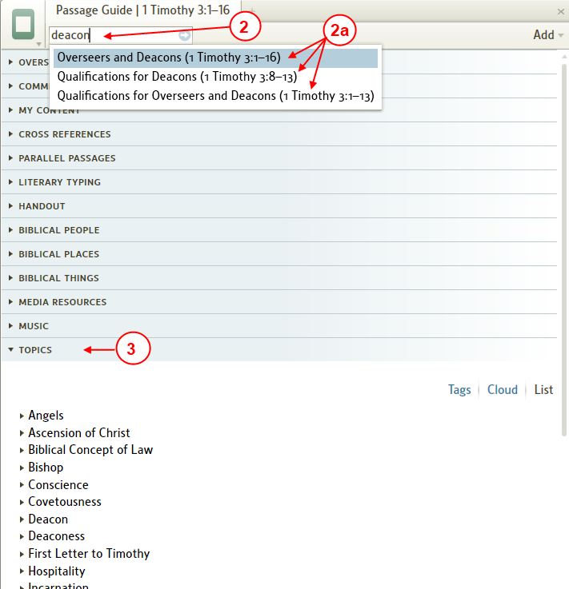

1. Open your Passage Guide by clicking on Guides in the top menu. Then in the drop down menu click on Passage Guide.
2. In the reference box type a word for your topic
a. Logos4 will show you various pericopes which are associated with your topic word. Click on one that you think is closely related to your topic.
3. Locate the Topic bar and click on it to expand. Logos4 shows you various topics which it thinks relates to your scripture reference.
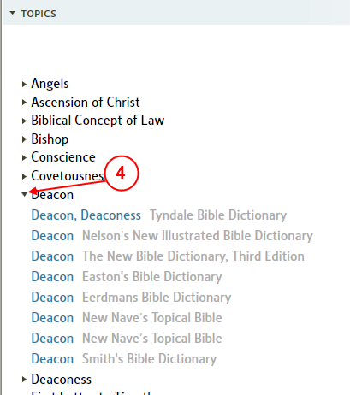

4. Now locate a specific topic in which you are interested in and click on the arrow on the left to expand that topic to view links to resources which Logos4 has tagged for that topic.

Topic found in Basic Search
[[@Headword:Topical Search Sugg. – in Basic Search ]]
Logos4 provides a Topic tool in Search when you use Basic search method and have Entire Library selected for which resources to be searched.

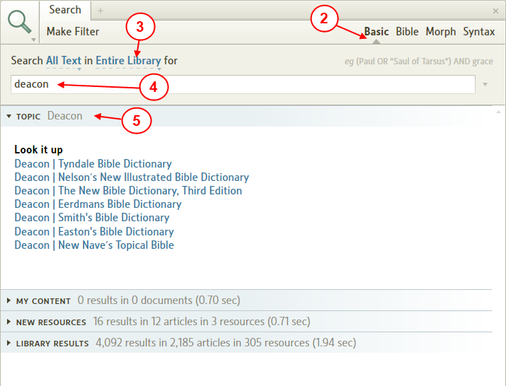

1. Open the Search tool. In the top menu click on the magnifying glass icon to open the Search tool.
2. Set the search method by clicking on Basic.
3. Set resources to be search to Entire Library.
4. In the Find box type in your topic word and press Enter.
5. After Logos4 finishes the search, notice the Topic bar. Click on the bar to expand it.
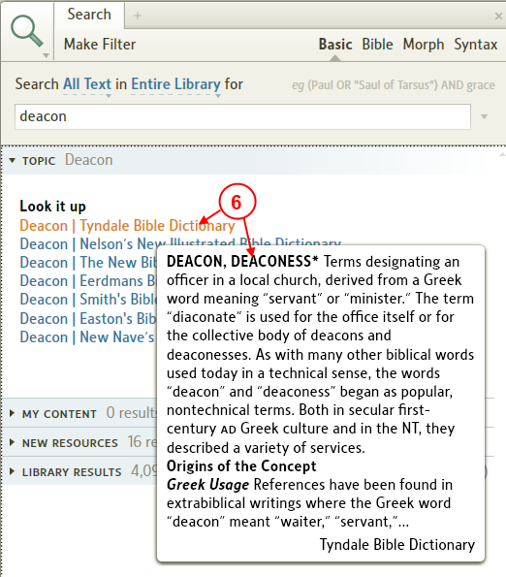

6. In the expanded view hover your mouse over the different links. Logos4 shows you a preview of what you will find for those links. Once you find a useful link, click on it and Logos4 will open that resource to that location.

Topic from Large Text Search
[[@Headword:Topical Search Sugg. – using Large Text Search ]]
The Large Text Search will work in any resource that has been tagged with the largetext Search Field ie. Large Text on the drop down in Basic Search. This tagging is based on font size and is automatically provided by the Indexer on all resources with "large" text, which is usually found in headings. The size basis is not perfect but it is a stop-gap until more extensive LCV resources (see below) are made available. The advantages are that you can search for a phrase eg. "eternal life", not just single words, and restrict the search to any topical collection.

Searching using a Collection
[[@Headword:Topical Search Sugg. – Searching using Collection ]]
You might want to create a collection for resources which you consider having useful topic information. Then you can use the Search tool to search for your topic only in your collection.

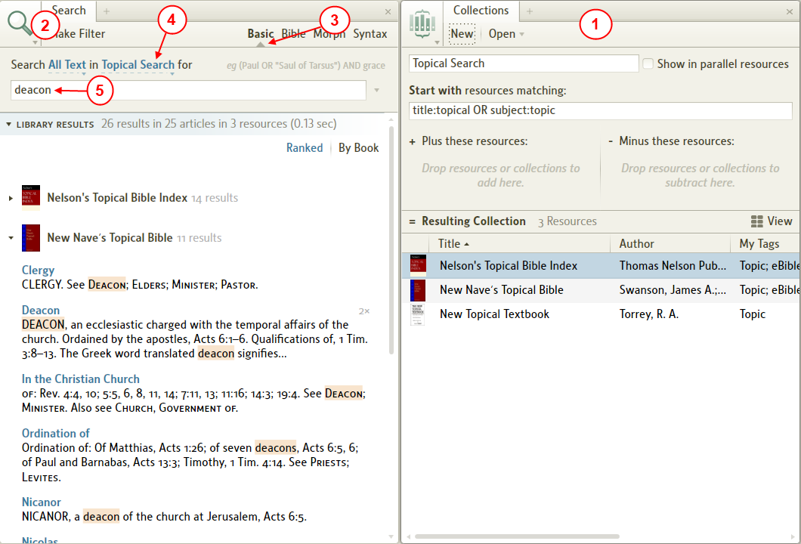

1. Create a collection of books in your library which are useful for finding topics.
2. Open the Search tool.
3. Set the Search method to Basic.
4. Set the resources to be searched to your collection for topical searches.
5. Enter your topic word in the Find box and press Enter.
6. Review each book in the search window to locate articles on your topic.

Topics and Logos Controlled Vocabulary
[[@Headword:Topical Search Sugg. – Topics & LCV ]]
Both the Topics section in Basic search and the Topics section in the Passage Guide depend on the Logos Controlled Vocabulary (LCV) to function. Basically the LCV is a manual association of synonyms. For example, Eucharist, Lord's Supper, and Communion can all refer to the same concept; the LCV associates these terms and allows searches with different terminology to bring up relevant results. Topical resources (i.e. Bible Dictionaries) must be specially tagged to work in these Topic Sections. Logos is working on expanding resources with this special tagging focusing first on the most widely owned topical works. See About Topic Search for more detailed information about the LCV, a list of tagged resources, and links to forum posts discussing it. Not all of the searching strategies discussed by this page are not limited to the LCV-tagged resources.

General methods to help on topics
[[@Headword:Topical Search Sugg. – General methods ]]
You will find these methods useful when researching a topic.

Use Lookup in the Command box
[[@Headword:Topical Search Sugg. – Lookup in Command box ]]
To quickly find a definition on your topic you can use Lookup in the command box. Logos4 will open your prioritized dictionary to your topic's definition. From there you might want to also Use the Parallel Resources.

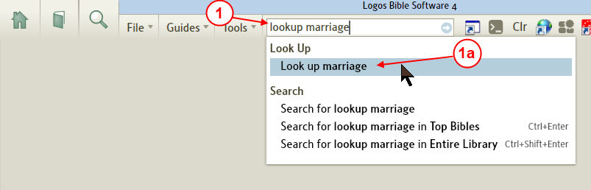

1. In the Command box type: Lookup followed by your topic word.
a. Logos4 will show you the full command as you type in the Command box. Click on it.
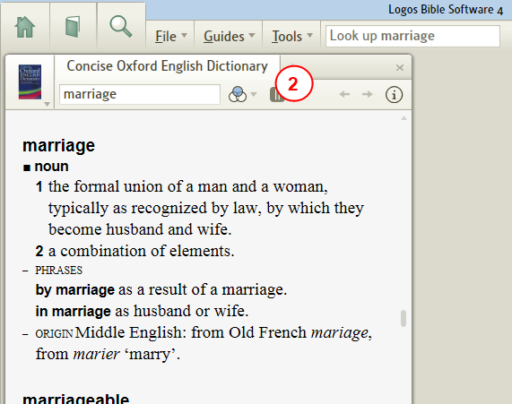

2. Logos4 opens your dictionary to that word.

Use the Parallel Resources
[[@Headword:Topical Search Sugg. – Use Parallel Resources ]]
You can use Parallel Resources from a resource that you have open to a topic. Logos4 will look through your parallel resource for that topic or a close subject and display them in the Parallel drop down menu. It helps to have collections tagged to display in parallel resources.

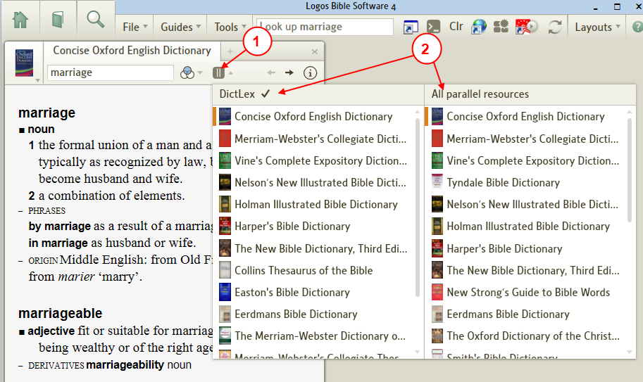

1. Click on the Parallel Resource's icon in your resource's toolbar.
2. Logos4 searches through your parallel resources (and collections in which your resource occurs) and shows them in the drop down Parallel Resource list.
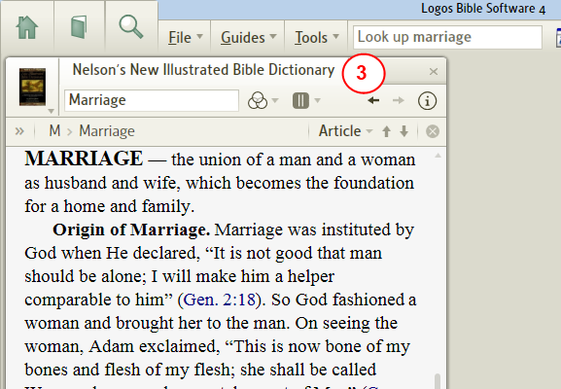

3. Once that you have clicked on a Parallel Resource Logos4 opens it in your tab.

Use the Plus tab to see other resources
[[@Headword:Topical Search Sugg. – Use Plus tab ]]
When you click on the Plus sign in a panel to open a new resource, Logos4 will use the topic that you have open in the current tab when selecting resources to show you in the new Plus tab. This can aid you in locating other resources which cover your topic.

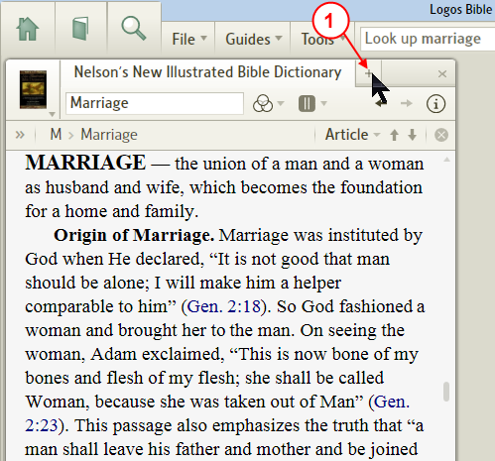

1. In the panel where you have a tab with a resource open to your topic, click on the + (plus sign).
[That resource needs to be the active resource showing when you click on the plus.]
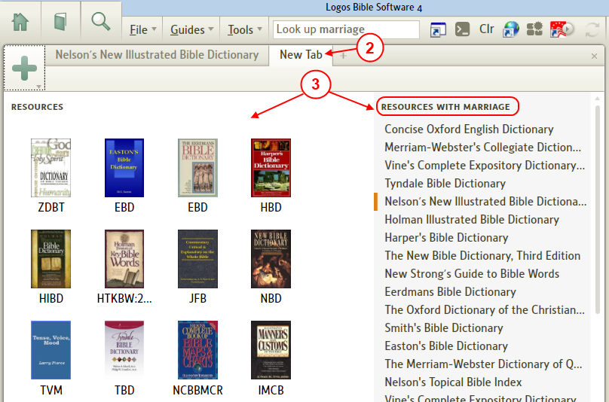

2. Logos4 will open a New Tab. In it Logos4 shows other resources that you own which are related to your topic.
3. The icons on the left just show you resources similar to the current resource. That's not what you want. But the list on the right shows the list of all resources that have the currently selected topic.

Using Bible Word Study for topic info
[[@Headword:Topical Search Sugg. – Use BWS ]]
In Bible Word Study you can use the Definition section to aid you in searching for a topic word. You even may want to create a custom BWS guide just for this (see wiki page Use BWS to look in multiple Dict/Lexicons).

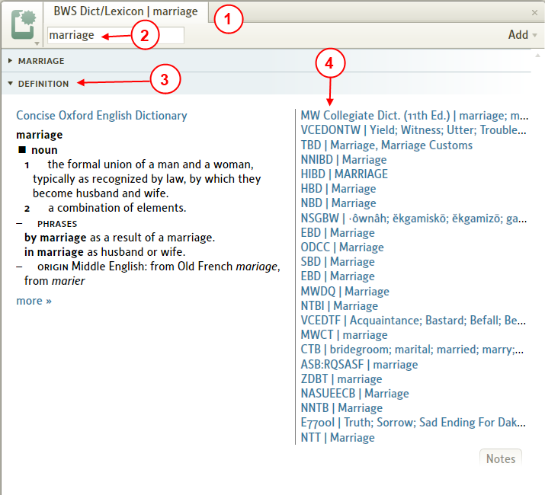

1. Open Bible Word Study or your Custom BWS guide.
(In the top menu click on Guides and in the drop down menu click on Bible Word Study or select your custom BWS guide)
2. In the Word box type in your topic word and press Enter.
3. Next click on the Definition bar to expand it.
4. On the right side you will see links to resources which cover this word. Hover your mouse over a link and Logos4 will show a pop-up preview for that resource. Click on a link to have Logos4 open that resource to that location.

Finding Highlighted Text
[[@Headword:Finding Highlighted Text ]] Wiki page: Revision 13 Link

See also
Navigating a Resource
Click on search results didn’t take me there

Text that you highlighted with Highlighter Pens
[[@Headword:Finding Highlighted Text – with Highlighter Pens ]]
- You can turn ON the Visual Filter for highlighting and then setting the Navigator Choice to Highlighting.
(Visual Filter icon)
This will allow you to use the navigation arrows on the Locator bar to move between highlighted text in your resource.
- If you are not familiar with Highlighting, see the wiki page Highlighting

- Example:

1. Open your resource where you know that you have Highlighting used.
2. Click on the Visual Filter icon on the resource's toolbar.
3. In the drop down menu, click on Highlighter Pens to check it.
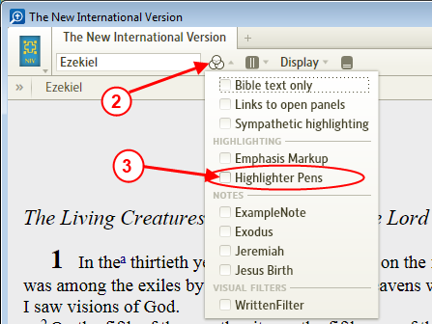

4. In the Locator bar, click on the Navigator Choice field.
(If you don't see the Locator bar, on your keyboard press Ctrl Shift L)

5. In the drop down list of the Navigator Choice, click on Highlight.
(this option in the list will not appear unless the Visual Filter for Highlighter Pens is checked, see step 2 & 3)
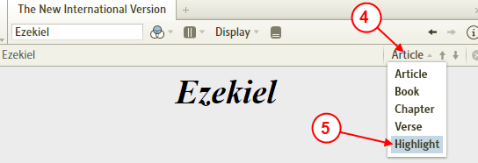

6. Now you can use the vertical arrows on the Locator bar to navigate to highlighted text in your resource.
(simply click on the down/up arrow to go to the next highlighted text)
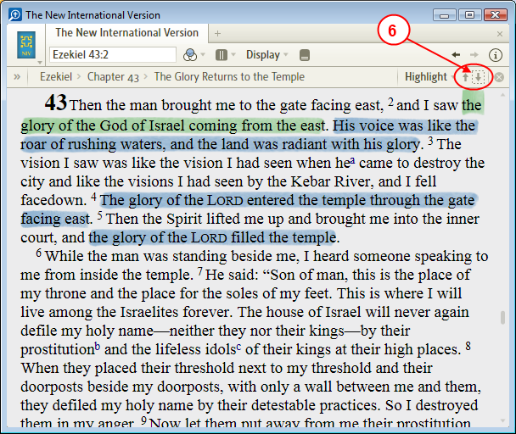

Text that you have highlighted with Visual Filters
[[@Headword:Finding Highlighted Text – with Visual Filters ]]
- If you are not familiar with Visual Filters see Visual Filters wiki page.
- You can find and navigate between Visual Filter highlighting in your resource.
  - Visual Filters are saved as a file, so if you click on File they will be located on the right side of the drop down menu.

- Example:
  - This example has a Visual filter which finds the word written and applies orange outlined text to it in the book of Luke.
  - The visual filter is named WrittenFilter.
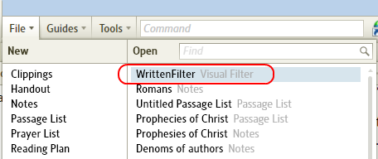

- So you could create a simple Visual Filter to help you walk through this example. (see Visual Filters )

1. Open your resource where you know that you have Visual Filters applied.
2. Click on the Visual Filter icon (shown below) on the resource's toolbar.
3. In the drop down menu under the heading Visual Filter, click to check the visual filter that you want to use.
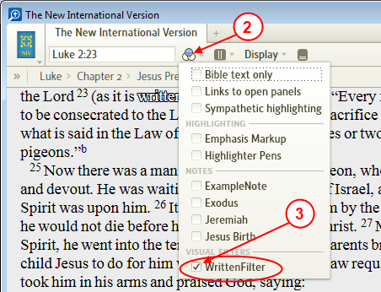

4. In the Locator bar, click on the Navigator Choice field.
(If you don't see the Locator bar, on your keyboard press Ctrl Shift L)

5. In the drop down list of the Navigator Choice, click on Filter Highlight.
(this option in the list will not appear unless the a Visual Filter is checked, see step 2 & 3)
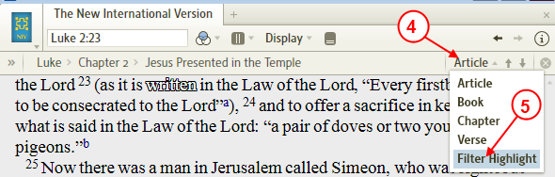

6. Now you can use the vertical arrows on the Locator bar to navigate to Visual Filtered text in your resource.
(simply click on the down/up arrow to go to the next Visual Filtered text)
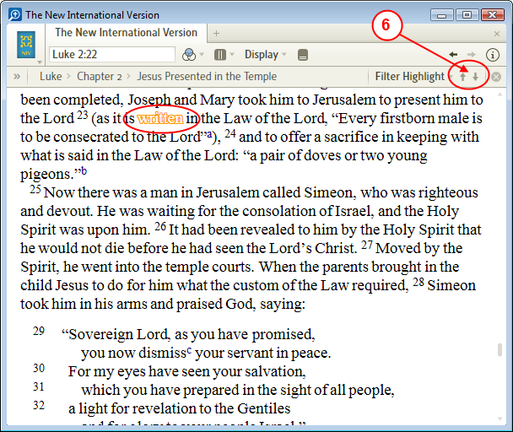

Finding all specific Highlighted text in a Resource
[[@Headword:Finding Highlighted Text – Finding in a Resource ]]
- You can use the Search tool to locate Highlighted text.

Searching for a word with a specific highlighted pen
[[@Headword:Finding Highlighted Text – Searching a word w/highlight ]]
1. Click on Search in the top menu.
2. Click on All Bible text field.
3. In the drop down menu, click on the arrow next to Highlighter Pens.
4. Click to check the color that you want to search for.
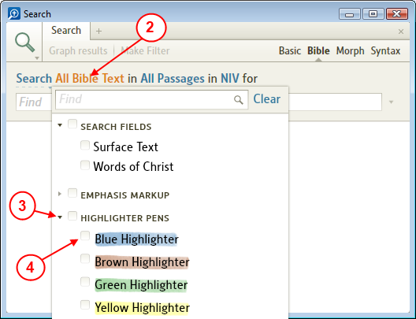

5. In the Find box enter your word that you want to search for.
(in this example we have highlighted phrases with Lord with a blue highlighter pen)
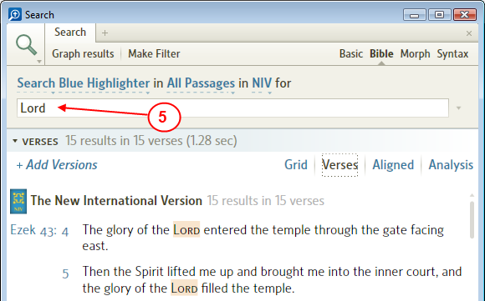

6. Open your Bible resource in which you've highlighted text.
7. Click on the Navigation Choice in the Locator bar.
8. In the drop down menu, click on Search Result.
9. Now use the Navigator arrows on the Locator bar to move to locations of the search word.
10. Notice as you click the navigator arrows that your highlighted word is shown in your Bible resource.
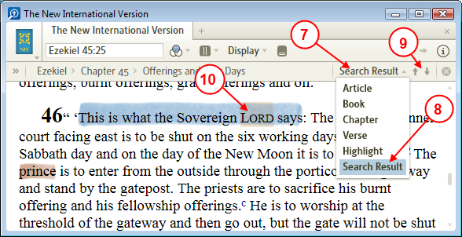

- Note: in this example, highlighter pens was turned on in Visual Filters
As you will notice that text is highlighted and the search results have a 2nd highlight.

Searching for all highlighted text in a resource
[[@Headword:Finding Highlighted Text – Searching all highlighting ]]
- To find all highlighting in resources you can use Search as shown below.

a) Open a Search window.
b) Change the search text to Highlighter Pens.
c) Set your range and resources.
d) In the Find box, enter the wildcard character * and click on the arrow to start the search. (this will take a long time)

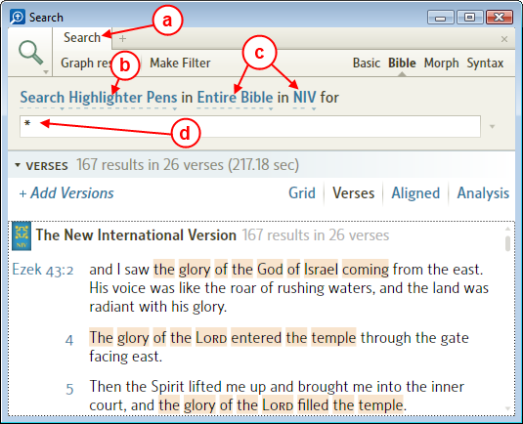
e) Now you can click on the verse(s) in the Search window to take you to your highlighting.
(don't forget to turn on the visual filter in your Bible to show Highlighter Pens)

Finding a Heading in your Bible using Search
[[@Headword:Finding Heading in Bible via Search ]] Wiki page: Revision 22 Link

See also
Search HELP
Fields in Detailed Search Help
Search Fields List

What do you mean by finding a Heading?
[[@Headword:Finding Heading in Bible via Search – What is finding a Heading? ]]
- Can't remember the book or passage reference to what you are looking for?
- You can use Search to search for that word. But you might have to sort through many scripture hits.
- But you think you remember a word that might be in one of the Headings... (e.g. see image below)

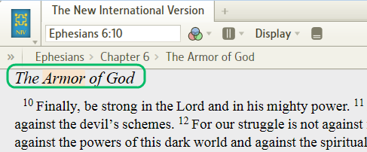

- Did you know that you can search just through the headings/pericopes in most Bibles?
- Well this is possible. And often returns fewer hits and can help you find your passage faster.
- Keep reading...

How to Search Headings
[[@Headword:Finding Heading in Bible via Search – Search for Headings ]]
- Say that we want to find the scripture headings for Jesus tells the hour and day are unknown in the NIV Bible.
- Open the Search window
(By clicking on Search in the top menu)
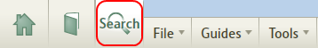
Then ....

1. Click on Basic for the search type.
2. Select the Bible from the resource list (you need to click on the in parameter and choose NIV Bible in the drop down list).
3. Click on the search area parameter (this may show as All Text)...
4. In the drop down menu click on the arrow to the left of Search Fields to expand it.
5. Now click on Heading Text to check it.
(if you don't see this field, see Why don't I see Headings in the Search Field?)

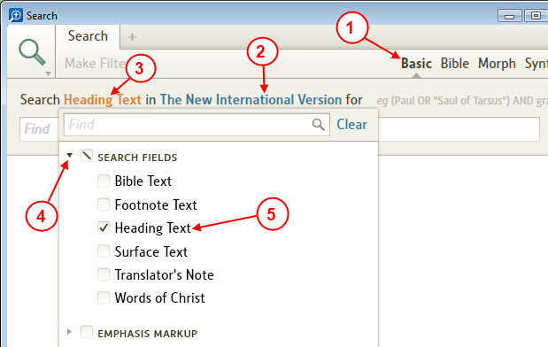

6. Now say we remember the word hour might be in the heading.
So enter the word hour in the Find box and press Enter.
7. When Logos4 finishes the search, we see that there are two headings found in the NIV Bible.
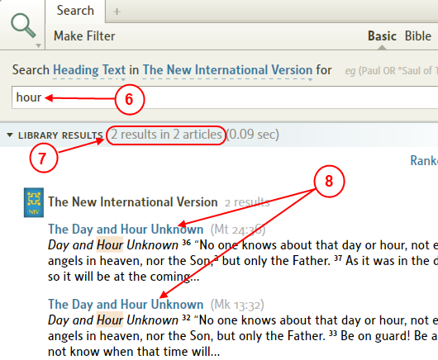

8. Now you can click on one of the headings and Logos4 will open that Bible to that heading.
(if Logos4 didn't take you exactly to the heading see Clicking on search results didn't take me there)
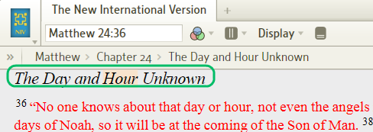

- Obviously you can choose a different Bible version. Give it a try!
- Do you have a collection of Bibles? If so, try changing the resource from a Bible to your collection of Bibles.

If you are not finding your word
[[@Headword:Finding Heading in Bible via Search – not finding your word? ]]
- Make sure that you have Match all word forms enabled in the Search window

a) Click on the Search window's icon.
b) Click to check Match all word forms.
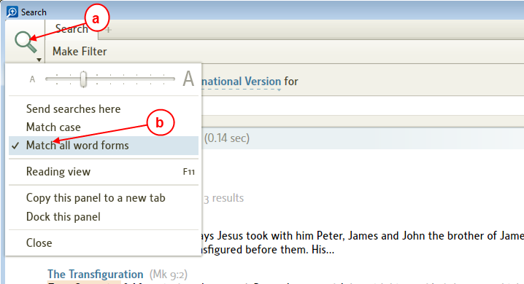
c) Then run your search again.

Clicking on search results didn't take me there
[[@Headword:Finding Heading in Bible via Search – clicking or word in Search ]]
- I have noticed sometimes that clicking on a search result didn't take me to the Heading exactly.
- Don't forget that you can use the Locator bar to navigate to search results.
(if you don't see the Locator Bar, click in your Bible and then press Ctrl Shift L to toggle the viewing of the Locator Bar)

a) Click on the navigation type.
b) In the drop down list click on Search Results.
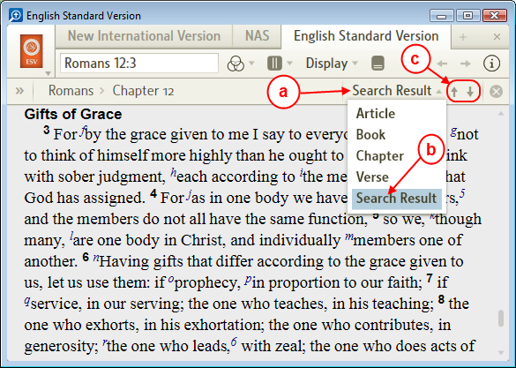
c) Now you can use the Navigation arrows (vertical arrows) to move between search results.

Why don't I see Headings in the Search Field?
[[@Headword:Finding Heading in Bible via Search – I didn’t see Headings in Search ]]
- Make sure that you are using the Basic search method!
The Bible search method has a bug (as of 4.0c) which occasionally shows fields which are not supported in this search method.
So make sure that you are using the Basic search method.

• Not all Bible resources have Heading as a valid search field.
• You can view your Bible Info to see if Heading is available in a specific Bible.

1. Open your Bible resource
2. Click on the Info icon on the resource's toolbar.
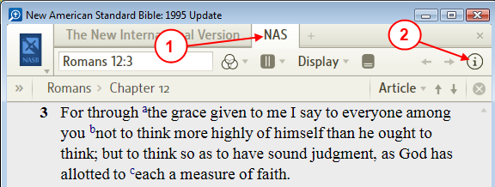

3. Now scroll down so that Search Fields is visible in the window.
4. Look for Heading in the list.
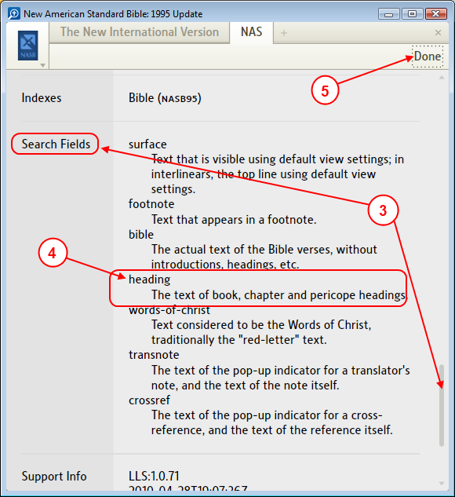

  - If you find Heading in the list, then Heading Text should show up in Search Fields (when using Basic method).
  - If you don't find Heading in the list, then you will not find Heading Text in the Search Fields.

5. Press the Done button on the toolbar to hide the Info.

- The King James Version (1900) doesn't support Heading
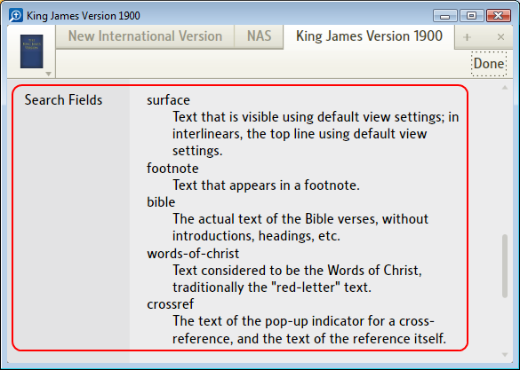

  - Note: this resource has been renamed so I can tell the difference between the different KJV Bibles.

Englishman's Concordance
[[@Headword:Englishman’s Concordance ]] Wiki page: Revision 2 Link

See Also
Morphological Search
Quick Reference
Detailed Search Help
Search Fields List

Libronix (Logos 3) had a feature to generate an Englishman's Concordance which would display all the particular ways a particular Greek or Hebrew word was translated. Logos 4 can achieve the same effect by using the Aligned Search view in either a Bible or Morph Search.

While using Strong's numbers will be slightly simpler for those without knowledge of Biblical language, taking the time to learn how to identify and use lemmas will allow for more powerful search applications in Logos 4.

Using Strong's Numbers
[[@Headword:Englishman’s Concordance – Using Strong’s numbers ]]
1. Identify the number of the word from which you want to generate an Englishman's concordance.
2. Open a Bible search, specify the version you want to search (it must be tagged with Strong's numbers).
3. Search for the Number. The syntax is <G####> for Greek and <H####> for Hebrew.
4. Select the Aligned view.
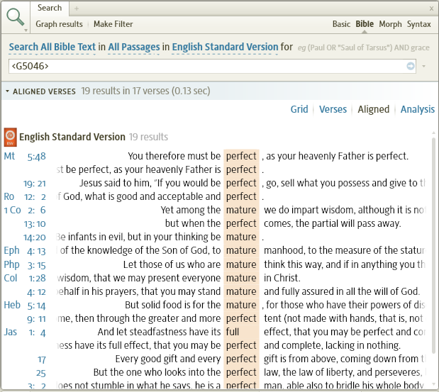

Using Lemmas
[[@Headword:Englishman’s Concordance – Using Lemmas ]]
1. Identify the lemma from which you want to generate an Englishman's concordance. You can find the lemma most easily in the right click menu of a reverse-interlinear Bible.
2. Open a Morph Search, specify the version you want to search.
3. If a Hebrew word select Andersen-Forbes Hebrew Morphology, if Greek select Logos Greek Morphology.

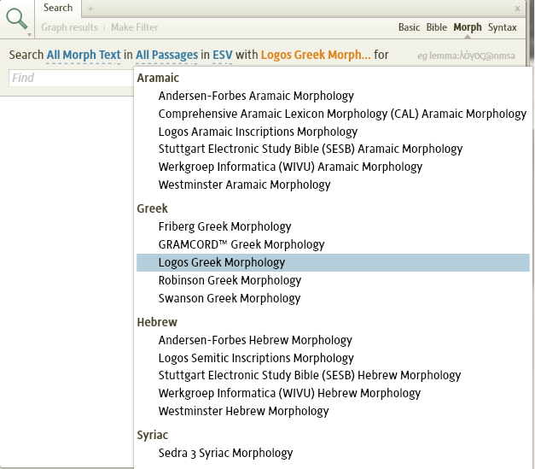
4. Search for the lemma. For help on this see: Morphological Search.
5. Select the Aligned view.

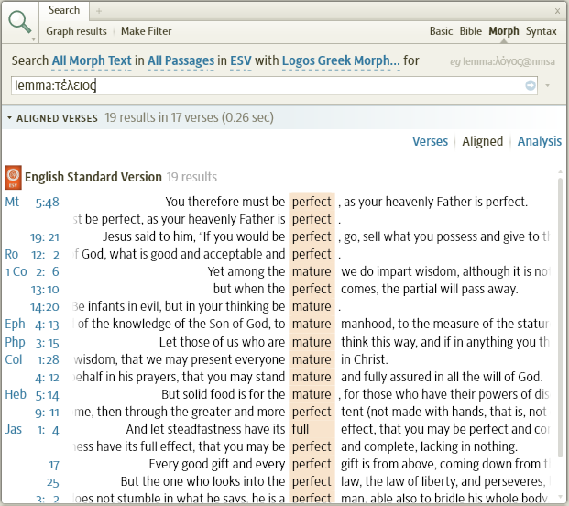

Using Passage Guide to find MyContent files
[[@Headword:Using PG to find MyContent ]] Wiki page: Revision 10 Link

See also
Using Search to find MyContent files
Explorer

Objective
[[@Headword:Using PG to find MyContent - Objective ]]
- Sometimes it is difficult to locate Notes/Clipping/etc that you created which have to do with a scripture reference.
- These documents are referred to by Logos 4 as My Content in some of the Logos 4 tools.
- Others on the Forum found a unique way of using a custom Passage Guide to aid in finding these.
- This wiki page documents how to create such a custom Passage Guide and use it.

Building the custom Passage Guide
[[@Headword:Using PG to find MyContent – Building custom PG ]]
- The following steps will guide you in building this custom Passage Guide.
- I suggest starting with a blank layout.
  - In the command box type Clear all and press enter.

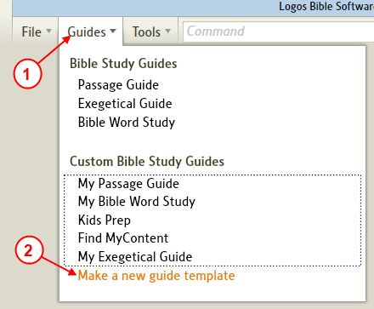

1. In the top menu, click on Guides.
2. In the drop down menu click on Make a new guide template.

• (Logos will open a new tab as shown below)
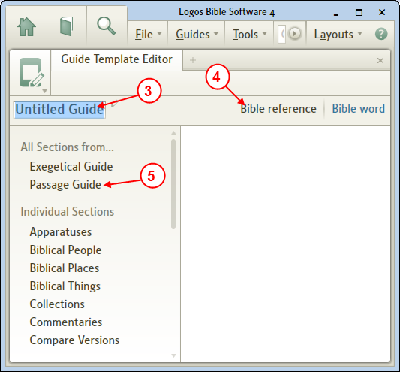
3. Click in the Title area and rename your Passage Guide to FindMyContent.
4. Make sure that Bible Reference is selected.
5. Click on Passage Guide.

• (Logos will populate the right side as shown below)
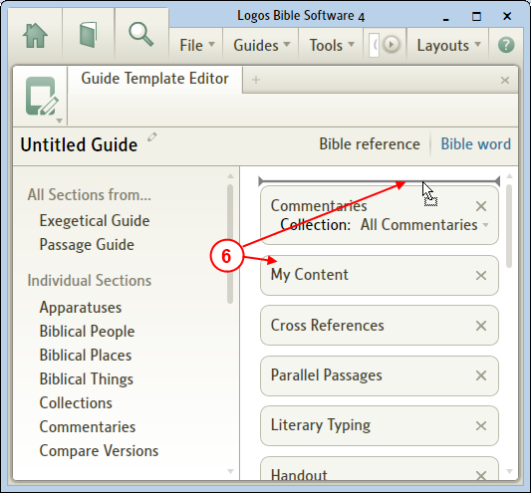

6. Drag the My Content item to the top of the list.

• (it should look as shown below)
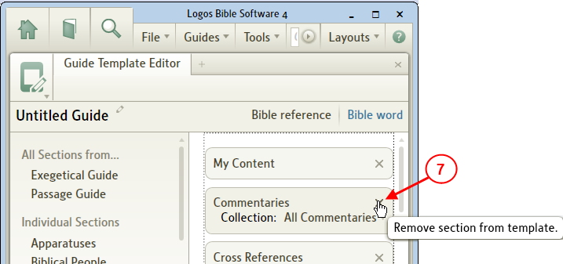

7. Now for all items below My Content click on the x on the right of each item to remove them.

• (it should look as shown below)
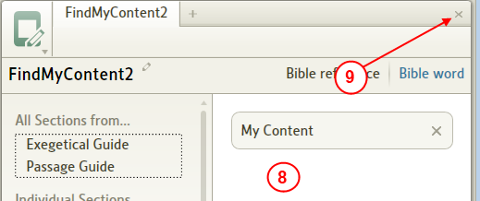

8. There should be no items below My Content. (if there are then repeat step 7)
9. Now click to close the Passage Guide editor.
We are finished building our custom Passage Guide for locating MyContent files.

Using the custom Passage Guide
[[@Headword:Using PG to find MyContent – Using the custom PG ]]
- This section illustrates how to use the custom guide built above.

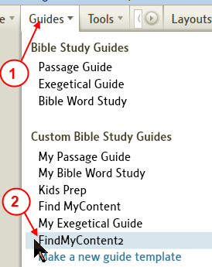

1. In the top menu, click on Guides.
2. In the drop down menu, click on the guide that you built in the previous section, FindMyContent to open the guide.
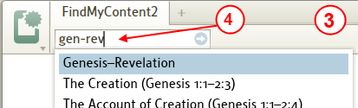

3. Logos 4 opens the guide in a new tab.
4. In the passage box type the scripture range in which you want to find files (MyContent) and then press Enter.
If you type Gen-Rev, Logos 4 will search for your content for the whole Bible.
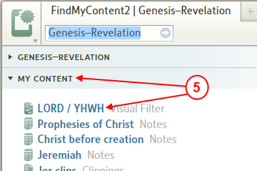

5. Under the heading My Content you will see all your files which intersect the passage range that you typed in the passage box.
If the heading My Content is collapsed, click on the heading and it will expand.
6. To open one of your newly found files, click on it and Logos 4 will open it in another tab.

Using Search to find MyContent files
[[@Headword:Using Search to find MyContent ]] Wiki page: Revision 1 Link

See also:
Using Passage Guide to find MyContent files

Objective
[[@Headword:Using Search to find MyContent - Objective ]]
Logos4 provides a way for locating documents that you have created. This wiki will describe how to do this using the Search tool. In the Search tool you may have noticed a blue heading bar named My Content. The My Content bar is where Logos4 lists your documents in which it found hits for your search term. Your documents may be of any type that are found under the File menu (e.g. Clippings, Notes, Visual Filters, etc).

After a while you may find that you have numerous documents which appear under the right side of the File drop down menu. And at times you may wish to locate document(s) in which you referred to a scripture reference or a word. Then this use of Search is a great way to locate those documents. This wiki shows you 2 ways to search for those documents: by word or by scripture reference. Just follow the examples below.

Finding MyContent using a word
[[@Headword:Using Search to find MyContent – Finding MyContent by word ]]
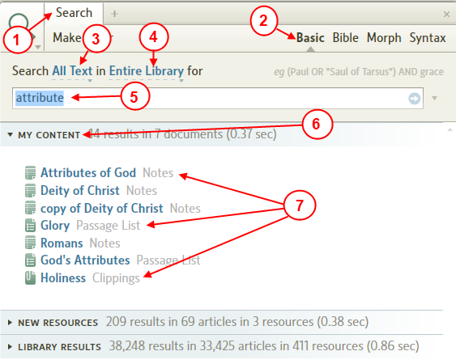

1. Open the Search tool.
2. Set the search type to Basic.
3. Set the search text type to All Text.
4. Set the search IN location to Entire Library.
5. In the Find box type your word which might appear in your document(s) either in the title or within the document. Then press the Enter key or click on the blue arrow on the right side of the Find box to start your search.
6. Notice the My Content bar. Click on it to expand it.
7. If Logos4 found hits for your search term in any of your documents, they will be shown under My Content. Notice the different document types that the search term (attribute) was found in the example above.

Finding MyContent using a Bible verse
[[@Headword:Using Search to find MyContent – Finding MyContent by Bible verse ]]
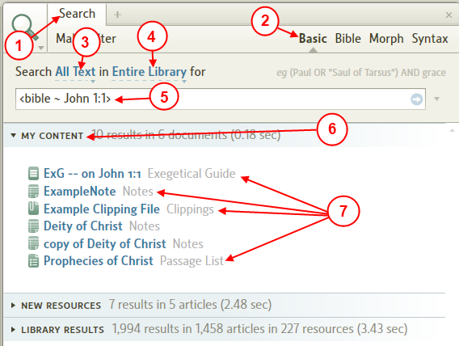

1. Open the Search tool.
2. Set the search type to Basic.
3. Set the search text type to All Text.
4. Set the search IN location to Entire Library.
5. In the Find box type your scripture reference which might appear in your document(s) either in the title or within the document. See Search HELP for instruction on using a scripture reference in the Find box if you are unfamiliar with this method.
Then press the Enter key or click on the blue arrow on the right side of the Find box to start your search.
6. Notice the My Content bar. Click on it to expand it.
7. If Logos4 found hits for your scripture reference in any of your documents, they will be shown under My Content. Notice the different document types that the search term (John 1:1) was found in the example above.

Searching Specific books Example
[[@Headword:Searching Specific books Example ]] Wiki page: Revision 4 Link

See also:
Collections
Example Collections
Detailed Search Help

Objective
[[@Headword:Searching Specific books Example - Objective ]]
Show you how to search selected books in your Library. This can be very helpful in reducing the number of hits for your search term. To pick which books that you want to search you will need to create a Collection. Then you will need to select Basic search and select your collection.

Step-by-step Example
[[@Headword:Searching Specific books Example – Step by Step Example ]]
• First you will need to build a Collection

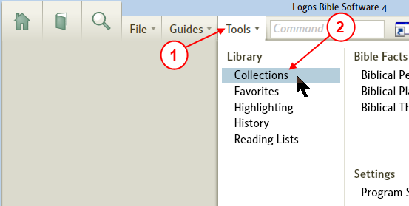

1. In the top menu click on Tools
2. In the drop down menu click on Collections. Logos4 will open the Collection tool in a new panel.

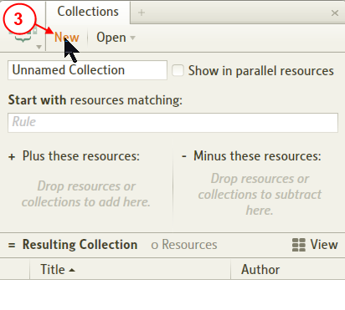
3. In the Collection toolbar click on New to create a new collection.

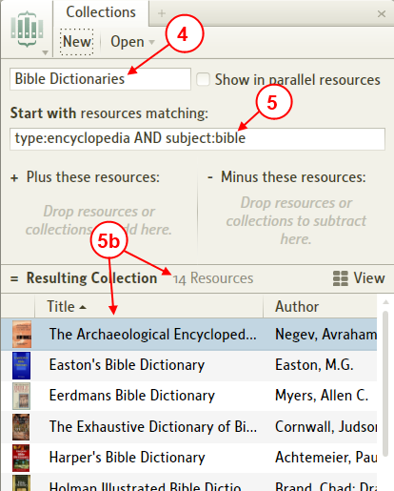

4. Now name your Collection. Click in the name box, then type in the new name for your collection.
5. Now in the Rule box enter your rule to have Logos4 select your desired resources:
a. You can use rules from the Example Collections wiki page which other users have added.
To learn more about collection rules see Collection Rules.
b. Once that you have your rule set, Logos4 shows you how many books in your collection and shows you the titles.

• Now lets use our new collection in a Search
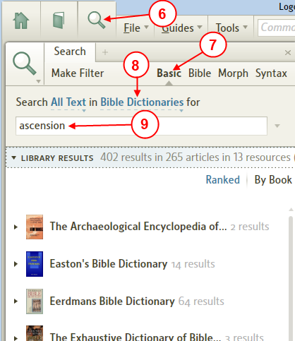

6. In the top menu, click on Search (the magnifying glass icon) to open the Search tool.
7. Click on Basic to select the Basic search method. This works for collections which contain books other than Bibles.
8. Click on the in link and Logos4 will show you a drop down list. Find your collection in the list and click on it.
9. Now in the Find box enter your search term and then press Enter on your keyboard.
Now you can view the results which Logos4 found in your books which were in your collection.
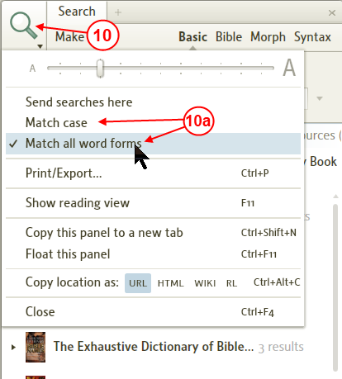

10. Don't forget to set search criteria. Click on the icon to have Logos4 show you the Search menu.
a. If Match all word forms is checked then Logos4 will look for variations to your search term. If it is not checked, then Logos4 will use a strict search for your search term.

Likewise if you have Match case checked, Logos4 will look for exact case of your search term. Or if it is unchecked then Logos4 ignores the case of your search term.

Finding How a word is translated in different versions
[[@Headword:Finding How a word is translate in different versions ]] Wiki page: Revision 6 Link

Objective
[[@Headword:Finding How a word is translate in different versions - Objective ]]
The method shown here will show you how to search and see how a word is translated differently in your English Bibles. The search method being used here is Morphology and not all Logos 4 base package may support this (see Comparison chart). Also the example below uses a Collection for all English Bibles. You could also use Tagging to tag English Bibles with a specific tag and use it instead of a collection. Please be aware that the Bible which appear in your Morph Search will need to be Reverse Interlinear Bibles.

You can thank Jerry M, he showed us this in this post.

Step-by-step Example
[[@Headword:Finding How a word is translate in different versions – Step by Step Example ]]
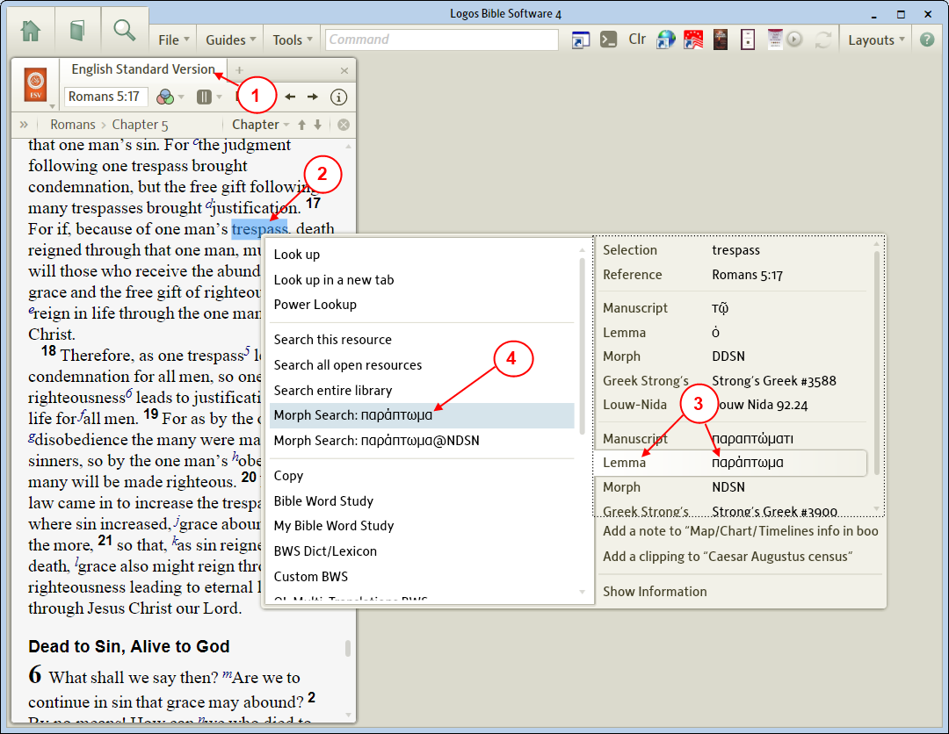
1. Open a Bible (one which has Reverse Interlinear ability. e.g. ESV, NKJV, NASB)
2. Locate a word in which you want to see in different translations and right click on it.
3. The Right Click menu will appear. On the right side of the menu locate your Lemma (make sure not to use an lemma article) and click on it.
4. Now on the left side of the menu click on Morph Search:xxxxx (where xxxx shows your lemma).

  - Now Logos 4 opens the search window, we will need to make some adjustment as shown below
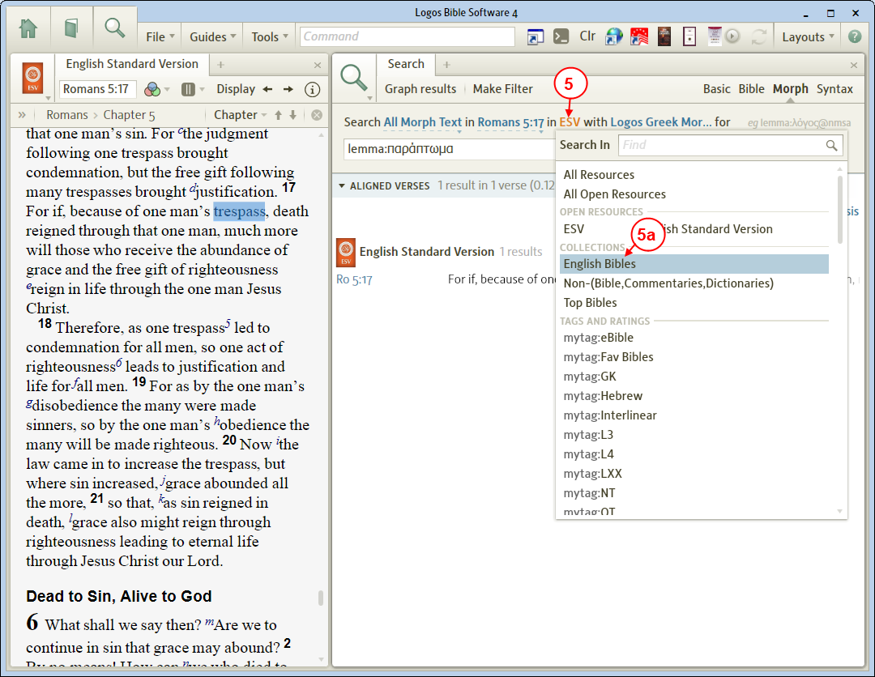

5. Click on the Resources field. Logos 4 will show you a drop down list.
a. Locate your collection English Bibles (if you haven't built it please see below), or if you have tagged your English Bibles you can select your tagged Bibles.
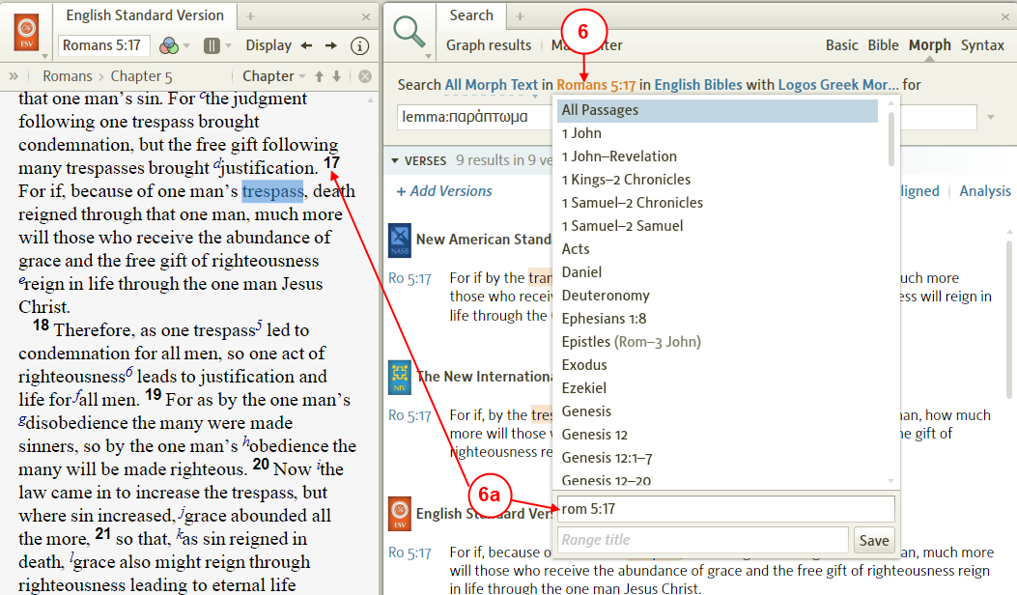

6. Now let’s limit the Bible range to where our word was selected from.
Click on the Range field. In the drop down menu click in the New Reference Range box. Now type in the scripture reference for the word you started your search with. This limits your search to showing Only the same scripture reference for your word in your English Bibles.
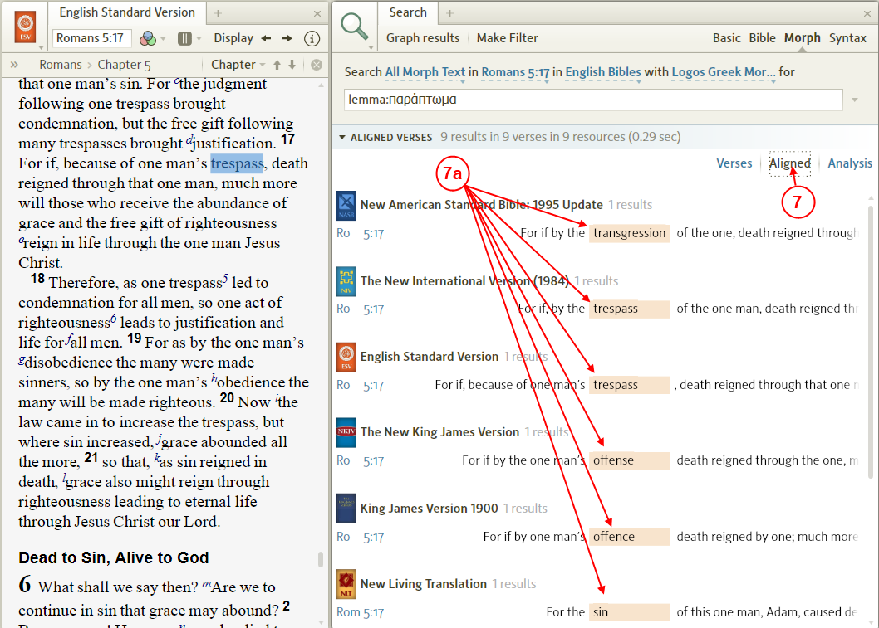

3. Now click on the display method Aligned to have your result word lined up for you.
a. Notice how your word is found in your different English Bibles.

Creating an English Bibles collection
[[@Headword:Finding How a word is translate in different versions [Creating an English Bible collection] ]]
The example below will show you how to build a specific Collection: English Bibles.

1. In the top menu click on Tools
2. In the drop down menu click on Collections. Logos4 will open the Collection tool in a new panel.

3. In the Collection toolbar click on New to create a new collection.

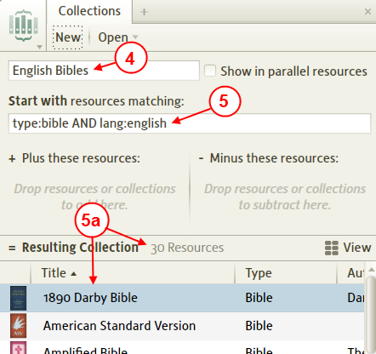

4. Now in the name box type: English Bibles
5. Now in the Rule box type: type:bible AND lang:english
a. Now Logos4 shows you how many books in your collection and shows you the titles.

Graph Bible Search Results
[[@Headword:Graph Bible Search Results ]] Wiki page: Revision 15 Link

See also:
Bible Word Study
Detailed Search Help

What is the Graph Bible Search Results tool?
[[@Headword:Graph Bible Search Results – What is it ]]
The Graph Bible Search Results tool is a window which can be accessed from Bible Word Study translation ring sections and from Search tool when using Bible or Morph methods. Within that window you can select from 4 methods to show your graph results: Results Map, Bar Chart, Column Chart and Pie Chart. These graphs can show you where your search word/phrase was found in the different books of the Bible, as well as give you specific number of times that it was found.

When selecting the Graph from the Bible Word Study (BWS) translation section, the graph tool will only show you the results for the specific Bible that you had selected in the BWS section. But when selecting Graph from the Search tool using Bible or Morph and selecting multiple Bibles in your search then the Graph tool allows you to select from multiple Bibles in the tool bar of the Graph window.

The Graphs can provide you a wealth of details about the frequency and locations of your search word(s) in books of the Bible. When starting the graph from the Search tool you can also compare how many times your word(s) were found in different translations. If you search for original language words you can also see how many times they are found in different books (e.g. greek word in New Testament and LXX). When using the Bar & Column graphs you will find a section of the toolbar enabled which allows you to select a statistical method to apply to your search results.

When the Graph window opens you will see a ribbon of graph icons at the bottom of the window. To select a graph method simply click on one of the graph icons at the bottom. Please be aware that if you have several books or if your word(s) is very plentiful that it may take several seconds for Logos4 to populate the graph, be patient.

Graph methods in the Graph window
(when multiple Bibles are mentioned below, it refers to when starting the graph from Search)

Method | Details
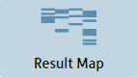 | Shows you at a glance all the hits for each book of the Bible for the selected Bibles
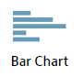 | Allows you to select from various statistic methods from the toolbar and displays them in horizontal bar chart. You can also select which Bible(s) to include.
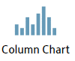 | Allows you to select from various statistic methods from the toolbar and displays them in a vertical bar chart. You can also select which Bible(s) to include.
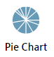 | Shows you the number of hits per book of the Bible. This shows only one Bible at a time, but you can choose which Bible that you want to use.

Toolbar items

The toolbar items in the Graph window are enabled/disabled depending on which graph you are viewing. Details on toolbar items is covered below for each of the graph types.

Opening the Graph Bible Search Results window
[[@Headword:Graph Bible Search Results - Opening ]]
You can open the Graph from two different Logos4 tools: Bible Word Study translation sections or the Search tool. How to do this from each tool is shown below:

Opening from the Bible Word Study (BWS) tool
[[@Headword:Graph Bible Search Results – Opening [from Bible Word Study] ]]
You can open the Graph tool from inside the Translation sections of the BWS tool.

BWS mode | Locations in this mode to open the graph from
English word | Hebrew words section see item #3
 | Greek words section see item #3
Original language word | Translation section see item #2
 | (Greek words only) Septuagint Translation section see item #2

In one of the above sections of the BWS tool you will see a small bar graph in the upper right corner of the section (as shown below). Simply click on the small bar graph and Logos4 will open your Graph.

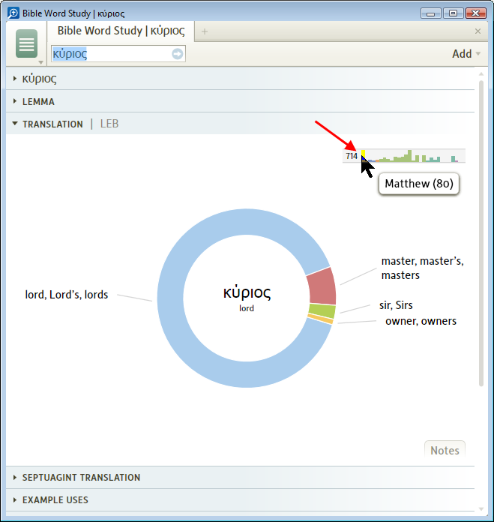

Notice that when you open a Graph from the BWS that only the book that you had selected in BWS is used in the graph.

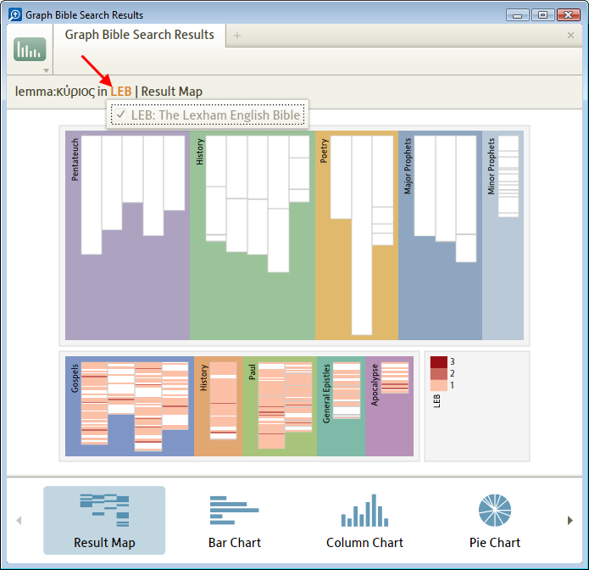

Opening from the Search tool
[[@Headword:Graph Bible Search Results – Opening [from the Search tool] ]]
When you use the Bible or Morph search methods in the Search tool you will see the Graph results button appear as shown below. Simply click on it and Logos4 will open a Graph window for your word(s). Logos4 will use the books that you selected in your search and make them available in the graph window. So try searching for an English word in a Bible and select Top Bibles (this is one of my Collections, you could choose All Bibles if you don't have this collection) in your search, then select the graph button and you should notice multiple Bibles shown in various graphs. To better control which Bibles that are included I suggest using Collections or Tagged books.

In Search window click Graph results

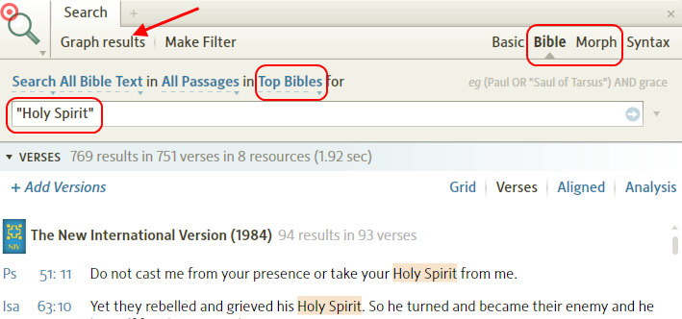

Logos4 opens your graph window, notice the books are those you had in the search window.

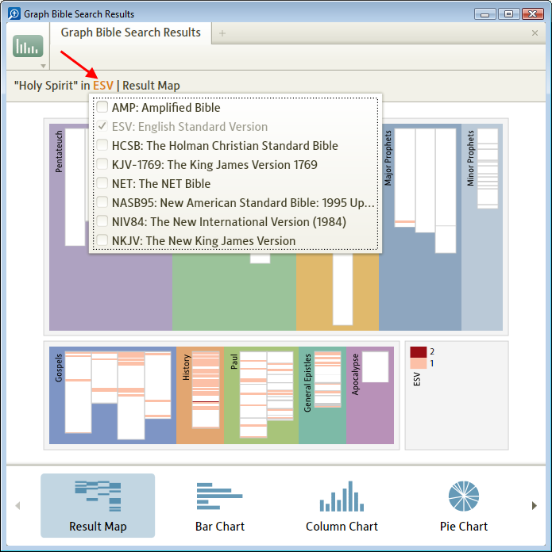

The Results Map graph
[[@Headword:Graph Bible Search Results – Results Map graph ]]
The Results Map graph shows you at a glance where all of your hits are for your search word(s) in each of the Bible books. Its window has 3 main block in it: Old Testament, New Testament, and legend. You should also notice that when you move the cursor in a the graph (not over a hit marker) that you see a hand cursor. This graph is user interactive and allows you to zoom/pan to desired location on the graph. The zooming/panning work much like a few other tools in Logos4. If you roll the mouse wheel over the graph it allows you to zoom in/out over the area where your mouse is located. If you left click and drag you can pan (reposition) the graph within the window. This graph also has an interesting feature, it shows you verses in which your word(s) occurs more than once with different gradients of color.

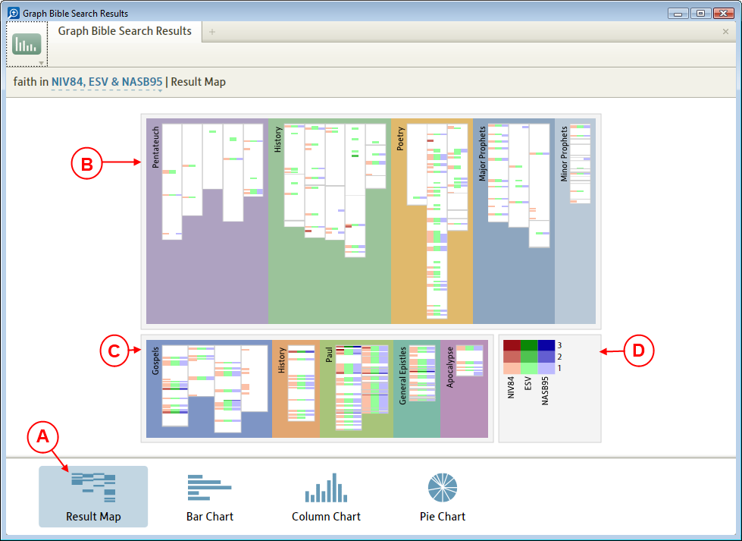
A. Click on this icon to select the Results Map chart.
B. This block shows the Old Testament books sectioned out in a literary alignment.
C. This block shows the New Testament books sectioned out in a literary alignment.
D. This is the legend for the hits found in each of the books in the other two blocks.

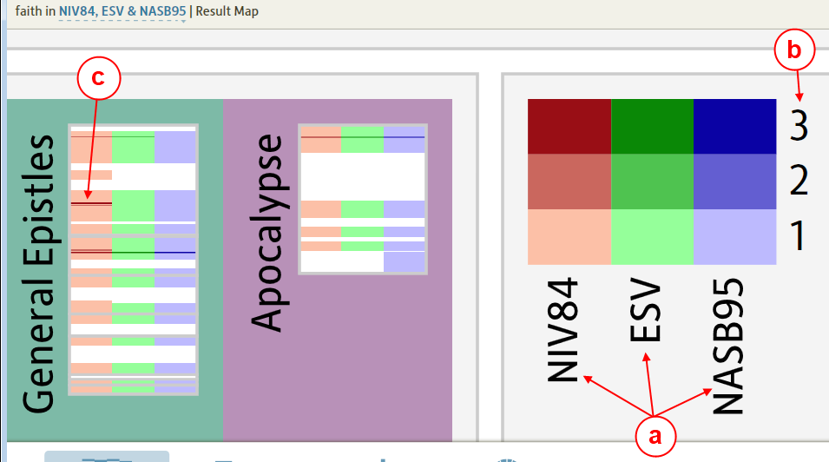
a. Bible translation are identified by different colors.
b. The density of hits for your search word(s) is shown by darker shades. The darker the shade the more times your word was found in that verse. The number indicates the number of times your word(s) was found in a specific verse for this shade.
c. You will see these hash marks identifying your hits in the sections of the Old & New Testament blocks in the graph.

E. When you hold your mouse over the hash marks in the graph Logos4 will show you the verse in which your word(s) hit are found. It also shows you the scripture reference for the verse associated with that hash mark.

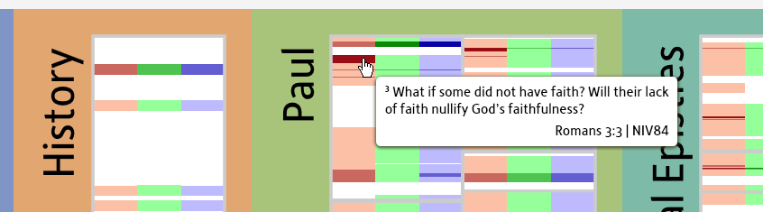
a. You will quickly see that it is difficult to place your mouse over individual hash marks in the graph. So you will need to zoom in on the graph to more easily position your mouse over the hash mark. You do this by rolling your mouse wheel over an area of the graph.
b. You will also want to be able to reposition the screen after you have zoomed into an area. So press the left mouse button on an area of the graph that you want to move and keep the button down, then with the button down move the mouse. The graph image will relocate as you move your mouse with the left button down.

F. If you have opened the Graph window from Search and searched more than one Bible, then you can click on the Bible in the toolbar and in the drop down menu you can click to check/uncheck which Bibles that you want shown in the Results Map graph.

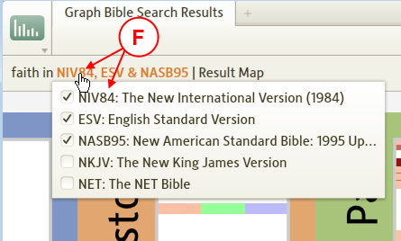

The Bar and Column graphs
[[@Headword:Graph Bible Search Results – Bar & Column graphs ]]
The Bar and Column charts are very similar with the difference being one shows horizontal bars (Bar) and the other shows vertical bars (Column). When you view the Bar chart (horizontal bars) make sure to remember to use the Vertical slider to view graph bars which may not be visible in the window. When you view the Column chart (vertical bars) make sure to remember to use the Horizontal slider to view graph bars which may not be visible in the window. Also be aware these graphs may take longer for Logos4 to compute and then display them.

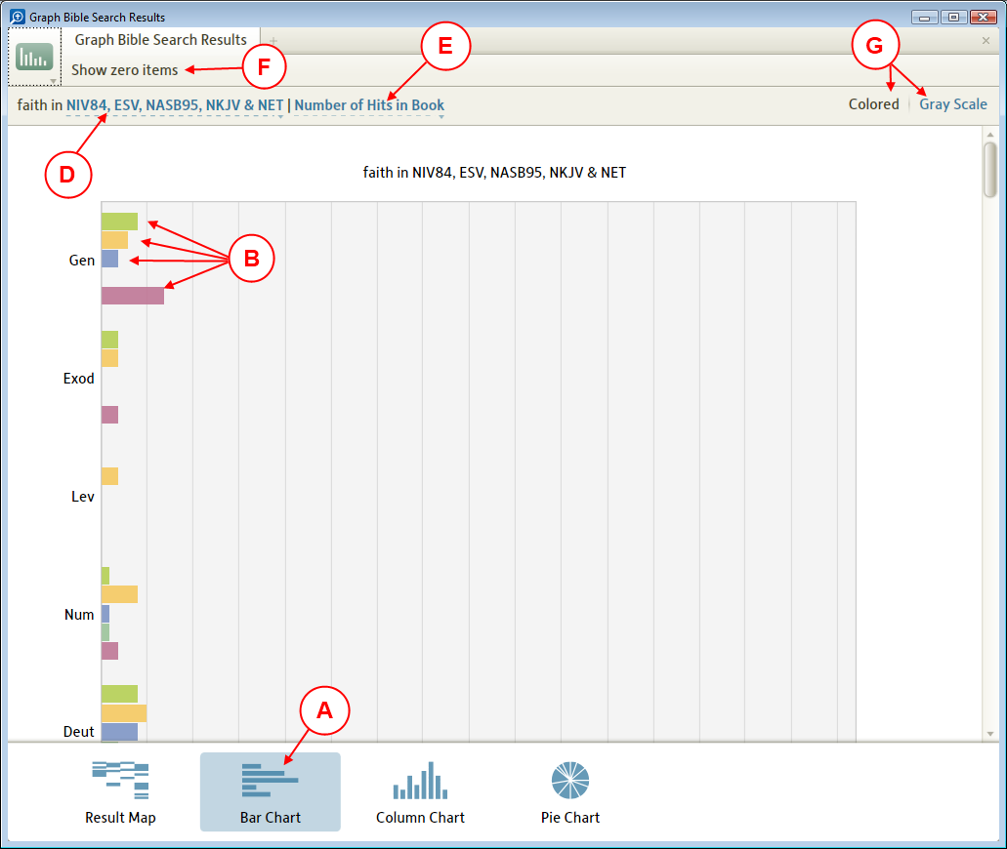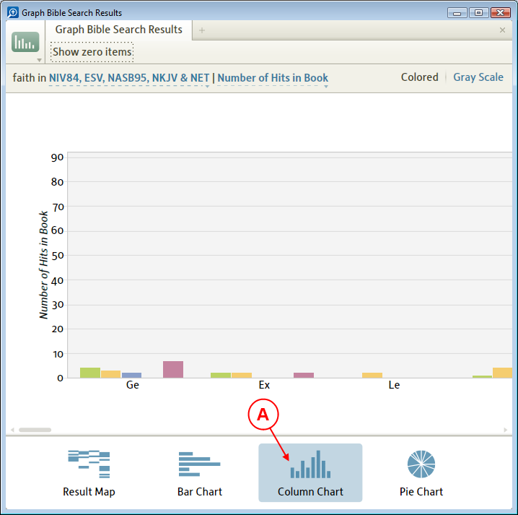
A. Click on one of these icons to select the Bar or Column charts.
B. You will see the bars visible for each Bible book shown in the graph.
C. The legend for your graph often will not be visible when the graph is first shown, so you will need to use the Vertical/Horizontal slider to slide down or to the right to find it.

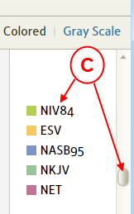

D. If you opened the Graph window from the Search tool and had selected multiple Bibles, then you can click on the Bible in the toolbar and click to check/uncheck which Bibles that you want graphed in the chart.

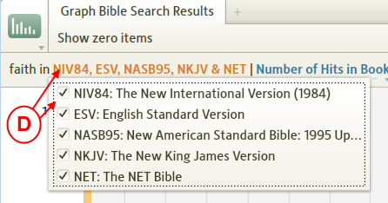

E. You can click on the graph's method in the toolbar and change which kind of statistics that are shown in your graph.

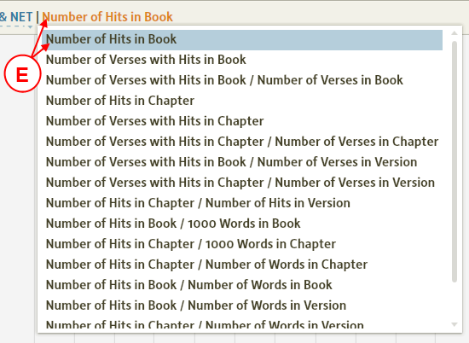

F. You can click on Show zero items to have Bible books not added to the graph when there are no hits in them. This button toggles, so if you click it a second time it does not show empty books.

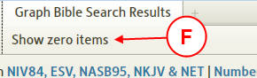

G. You can choose to show your graph in Color or in Gray Scale by clicking the one you desire.

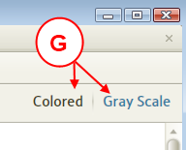

H. If you are using the Bar chart, then you will need to use the vertical slider to position your graph to the bottom to view the X scale display.

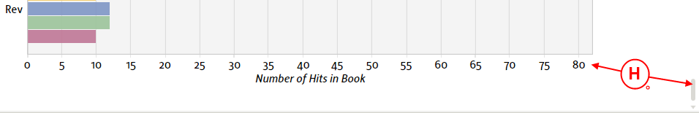

I. When you hover your mouse over a bar in your graph, Logos4 will show the value associated with that bar.

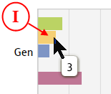

The Pie Chart graph
[[@Headword:Graph Bible Search Results – Pie chart ]]
The Pie Chart graph shows you all the hits for your word(s) as they are found in a single Bible.

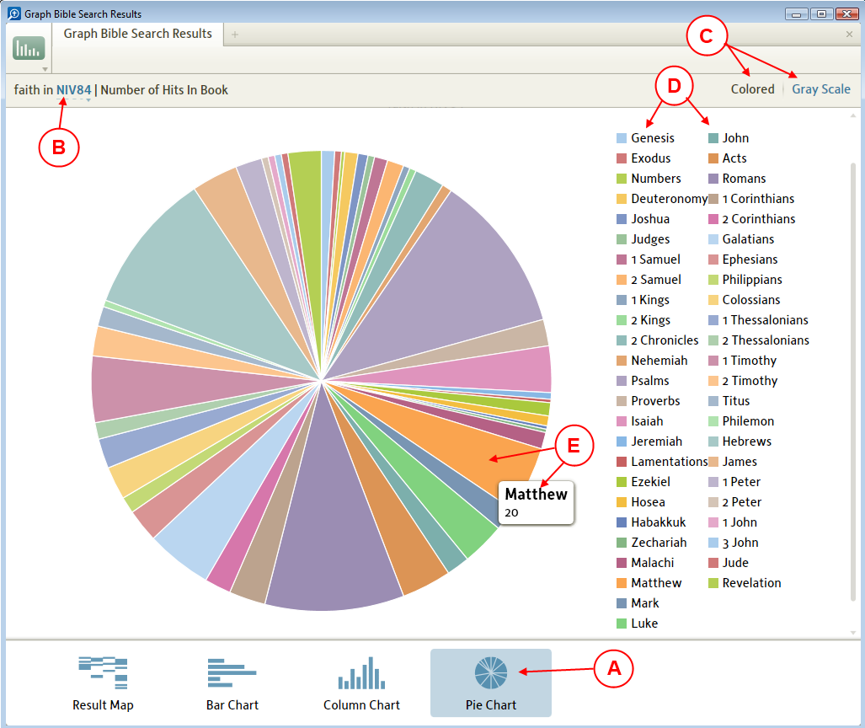
A. Click on this icon to show the Pie Chart.
B. If you have opened the graph window from the Search tool and have searched multiple Bibles, then you can click on the Bible in the toolbar to select which Bible that you want to be used in the pie chart.

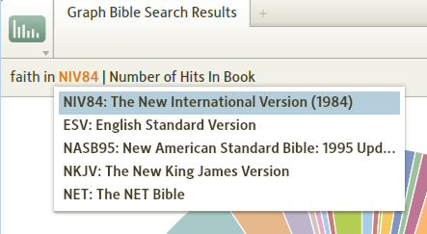
C. You can choose to use Color or Gray scaling for the Pie Chart.
D. This is a legend to identify the color for each Bible book in the Pie Chart.
E. If you hover your mouse over a slice in the Pie Chart you will see a pop-up box identifying the Bible book and the number of hits for your search word that were found in that book.

Printing/Exporting the Graphs
[[@Headword:Graph Bible Search Results – Print/Export ]]
You can print/export your graph by clicking the window's icon in the upper left corner of the window (see image below). In the drop down menu click on Print/Export or from your keyboard press the key combination Ctrl P (Mac users press Cmd P).

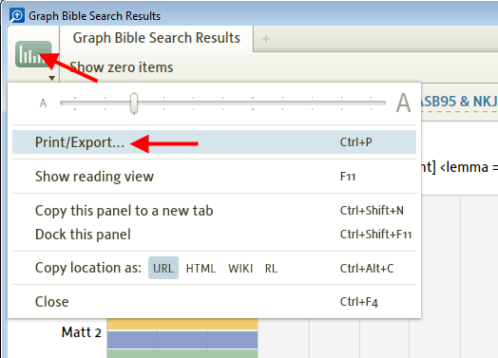

Then Logos4 will open the familiar Print/Export window. As with other special tool windows the options in the Print/Export window will be unique for this tool. See details below:

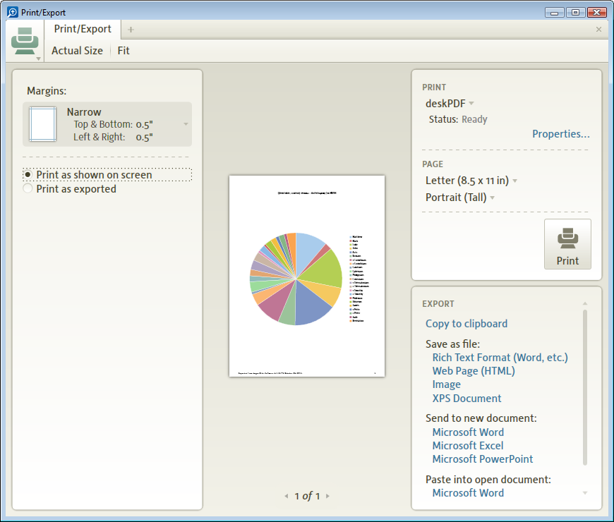
Print as shown on the Screen
This option will print your graph like you have it shown in the Graph window. But this will vary from graph type to graph type. For instance if you are using Bar or Column then Logos4 will spread your graph across multiple printed pages.

Print as exported
This option basically prints your graph as a picture. This works fine for graphs which can show on a single page (Results Map or Pie Chart). But when you use the other graphs and there are numerous pages, then you will see a very small single image on the Print/Export window.

Using Excel to print your graph
[[@Headword:Graph Bible Search Results – Using Excel to print ]]
When printing some of the graphs you may discover that the information that is printed or exported to Word is too small as shown below

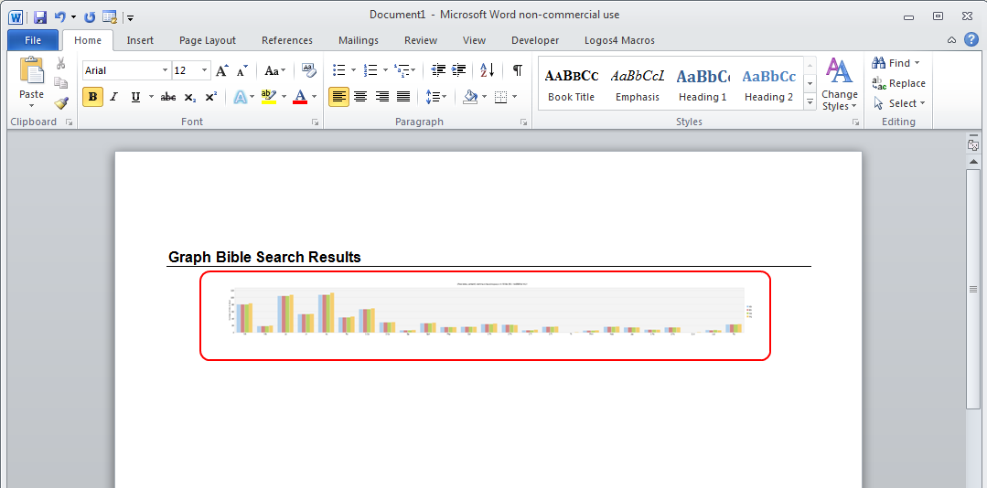

Or you may at times want to print only a portion of a graph (e.g. certain books of the Bible from a Bar or Column graph). You can use the Export options in the Print/Export window to send the graph results to an Excel spreadsheet. Logos4 will populate the spreadsheet with values. Then you could use the graphing functions of Excel to create your custom graph.

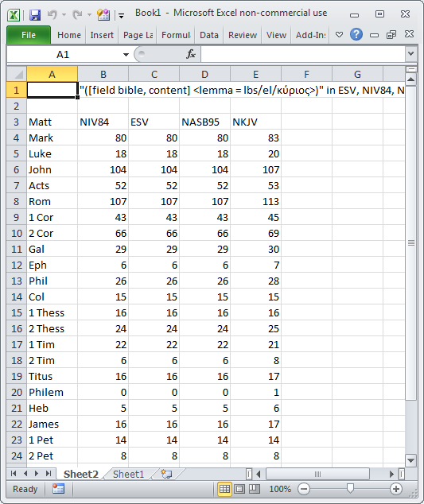

Export image using Right Click
[[@Headword:Graph Bible Search Results – Exportint the Image ]]
You can quickly send your graph's image to the clipboard, file, Power Point, or printer by right-clicking on your graph.

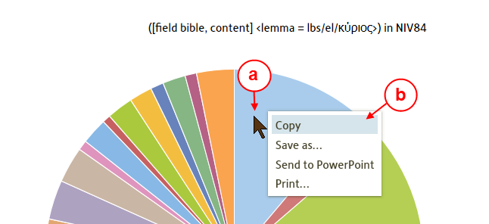
a. Hover your mouse over the graph and right-click.
b. Then you will see a pop-up menu. Simply click on where you want your graph image sent.

Tools
[[@Headword:Tools ]]
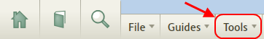

Tools [methods]
[[@Headword:Tools [Methods] ]]Wiki page: Revision 16 Link

What are the differences in user information tools ?
[[@Headword:Tools [Methods – What are the differences in user info tools?] ]]
John Fidel spent some time reviewing Mark Barnes video series on sermon preparation, and consequently put together a chart outlining what various tools are available to gather, save and retrieve information in Logos 4. The chart below outlines what each of these tools can and cannot do. Hopefully this chart will assist you in your selection and method for gathering information in Logos 4. This chart is consistent with the way Mark demonstrates these tools and will help you capitalize on each of their strengths.

Here are the 5 tools available, not counting the Handouts, that can be used to gather, organize and retrieve information in Logos Bible Software 4:

1. Highlighting
2. Bookmarks
3. Clipping
4. Notes
5. Favorites

The chart below compares and contrasts the differences of version 4.0:

 | Highlighting | Bookmarks | Clipping | Notes | Favorites
Highlight | Yes | No | No | Yes | No
Retrievable | No | Yes | Yes | Yes | Yes
Searchable | Yes (4.2 SR1) | No | Yes | Yes | No
Focus | Resource | Tool | Tool | Both | Tool
Multi Resource | No | No | No | Yes | No
Bibliographic Info | No | No | Yes | No | No

Definition of terms:

1. Highlight-Can the tool highlight the resource?
2. Retrievable-Can you retrieve information using this tool?
3. Searchable-Do searches retrieve information from this tool?
4. Focus-From where does this tool allow you to retrieve your information?
5. Multi Resource-Can this tool mark information in multiple resources such as various translations of the Bible?
6. Is bibliographic information easily available?

From here a simple decision tree could be created asking the following questions:

1. Do you want the information highlighted in the resource? If so, do you want to be able to search, retrieve of access this information? If yes, then notes, if no then highlighting.
2. If you do not want to highlight the resource, then do you want to be able to search the information? If yes, then clipping or notes. Do you want to access the information from the tool or the resource? If resource, then notes, if tool then either. Do you want to have access to bibliographic information? If yes, then clipping.

Making a decision on which tool to use

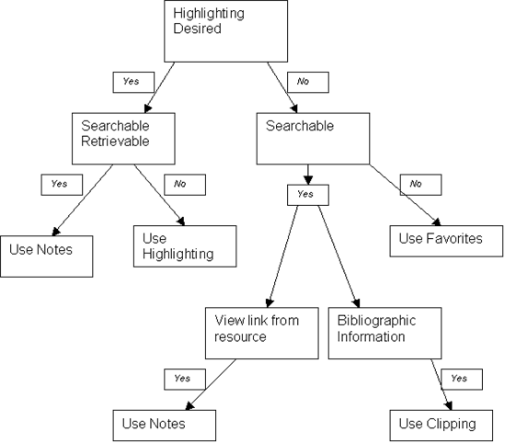

In Summary:

• Highlighting is for marking up biblical texts and accenting other resources that will draw attention the next time you are reading that text.
• Bookmarks are for temporarily marking your place in a resource to come back to easily at a later date. This is not the best way to accumulate information on a subject or pericope.
• Clippings are for retrieving subject specific information that provide a link back to the resource and bibliographic information. There will be no indication in the resources that there are clippings saved. I think clippings are better for gathering specific information directly from a resource as I usually do not want the text highlighted and do not need a reference from the text to the saved data.
• Notes are very flexible and can be used for everything from highlighting to linking to information in resources. However, they are not always the best tool to use for such tasks depending on what is desired. As such I think notes are best used for organizing thoughts and taking short notes on the biblical text that you may want to be able to retrieve the next time you are reading that text. Any time you want to go from a resource to an idea or thought you had, notes is what you want to use.
• Favorites are best used for organization of information as shown in Mark’s excellent video series on sermon preparation. It is where you can gather and organize your notes and clippings on a pericope or topic.

I do not have the sermon outline tool available from Logos. With that said, I still believe that the final product should be done in word processing software. It can be printed, retrieved and in most cases is in a format that can be transferred easily to other programs if required. Of course none of this is set in stone, and some of you may have other preferences. As long as you get deeper into God's Word it really does not matter.

I hope this analysis, along with Mark's videos provide you some good ideas for gathering, organizing and retrieving information collected in your study of God's Word.

▪ Library ▪
[[@Headword:Library section ]]
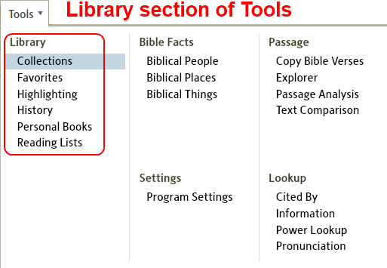

Collections
[[@Headword:Collections ]]Wiki page: Revision 47 Link

See also
Example Collections
Canonical Commentary Collections
Building a Custom Guide Example
Merging Collections posts here & here

Description
[[@Headword:Collections - Description ]]

If you are new to Logos, you may be wondering what the purpose of collections is. The primary purpose for collections is to limit your search to a given set of resources. Suppose you have a library of 2000 resources and you want to find a theological discussion of ecclesiology. Rather than searching all 2000 resources and getting a bunch of hits you are not interested in you could limit your search to only your systematic theologies.

If you are moving up to L4 from L3 it is good to keep in mind that there has been a major shift in the thinking behind collections in L4.

In L3 collections were static, meaning you selected a book and added it to the collection. You repeated this for every book. When you purchased a book you would have to go to collections and add it to the collections you wanted it in.

In L4 collections are dynamic, meaning you tell Logos what type of books you want to add to your collection by establishing rules. L4 also gives you the ability to add “exception” books. When you purchase a book it is then automatically added to the collections where it meets the criteria you have established. This may sound threatening but its not as difficult as it may sound. If you still have concerns over the rationale for dynamic collections, I encourage you to read my defense of them at the bottom of this wiki.

For more on this, see A Rationale for Dynamic Collections.

There are two user-created videos on defining collections, Creating Advanced Dynamic Collections and Creating Nested Dynamic Collections.

On Logos website: webpage Collection, Logos Tutorial Video Dynamic, Rule-based Collections.

In L4 version 4.0b and up, you can export a Bibliography of your collection Bibliography.

Creating
[[@Headword:Collections - Creating ]]

1. In Logos 4 go to Tools>Collections

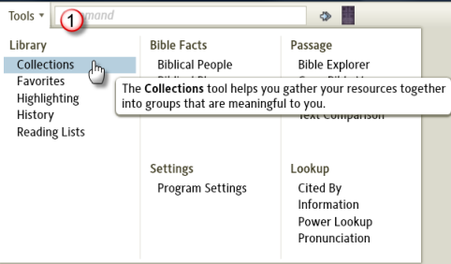

2. Click "New" in the collection pane. (Getting into this habit will prevent you from accidentally changing a collection you already made.)

3. Replace the first text box (It will have "unnamed collection" in it) with the name you want to give your collection. For instance, if you want a collection containing all your journals, you could name it "Journals".

4. Establish a rule that defines the resource you wish to have in your collection. You could cut and paste from the examples below, or for the sake of learning you could type "type:journal" in this box. This tells your collection to include all resources that have been defined by Logos as journals.

5. At this point your collection is done, but possibly not fine tuned. the number beside the "=Resulting collection" is the number of resources in this collection. There may be one journal you do not want in your collection. Or perhaps there is a resource you want included, but that has not been defined by Logos as a journal. This is where the "+ Plus these resources:" and "- minus these resources:" sections come in handy. These features will be covered under the "editing" heading.

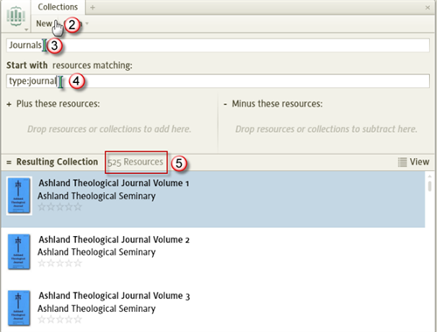

Opening
[[@Headword:Collections - Opening ]]

1. In Logos, go to Tools>collections.

2. Click "Open"

3. Select the collection you wish to open. Either (a) scroll through the list or (b) begin typing the name of the collection and the list will be narrowed accordingly.

4. Your collection will open.

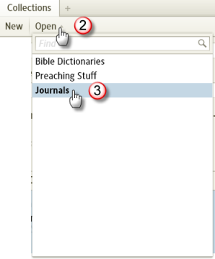

Editing
[[@Headword:Collections - Editing ]]

Under this section we will cover adding individual resources to the exception areas and adding a collection to the exception area of a collection (called nested collections).

Removing an individual resource from the collection
[[@Headword:Collections – Editing [Removing individual resource] ]]
1. If you notice a resource in a collection that you do not want in the collection, open the collection (see instructions above under "Opening")

2. Find the resource in your collection's resource list, which is under "= Resulting Collection" (note: Most people find it easier to open the library next to the collection window and drag resources from the library instead of this list. To do so right click on "Library" and select "Open in Tab" or drag "Library" to the location you want it.)

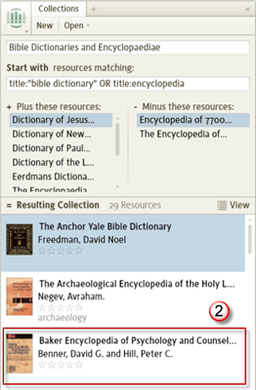

3. Drag the resource to the section labeled "- Minus these resources:"

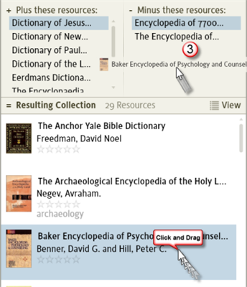

4. At this point your resource has been excluded.

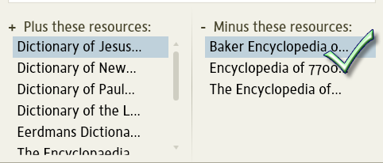

Adding an individual resource from the collection
[[@Headword:Collections – Editing [Adding] ]]

1. If you notice a resource that should be in your collection but is missing, open the collection (see instructions above under "Opening").

2. Open the library next to the collection window and drag resources from the library instead of this list. To do so right click on "Library" and select "Open in Tab" or drag "Library" to the location you want it.

3. Locate the resource you want to add in the Library.

4. Drag the resource from the Library to the section labeled "+ Plus these resources:"

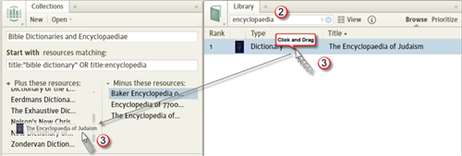

5. Drop the resource and it is now included.

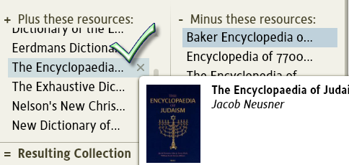

Adding a collection of books to an exception area (Nesting Collections)
[[@Headword:Collections – Editing [Exceptions] ]]

If you have a collection of all your journals there may be one journal series you do not wish to have in your collection. You could add each year of the journal individually, but when you update your journal collection the new year's issue of this journal would be added to your collection. The better option is to create a collection containing all the issues of that journal and exclude that collection from your "Journal" collection. Then when the new issue is added to your library, it is added to the collection for that journal, and excluded from your "journal" collection automatically. In the following instructions we will seek to exclude the fictional journal "Making It Up Journal" from a collection of journals.

1. Create a collection of the journal series you wish to exclude. Use the instructions above under "creating". Title the collection "Making It Up Journal", and use the rule (without brackets and WITH quotes) [title:"Making It Up Journal"]. This collection will include every issue of Making It Up Journal.

2. Open the collection "Journal" using the instructions above labeled "Opening" or create it if you have not already done so.

3. Click "Open" and navigate to the collection you wish to exclude. Do not press enter!

4. Drag the name of the collection you wish to exclude to the area titled "- Minus these resources:"

5. At this point the journal series "Making It Up Journal" is excluded from your "Journals" collection.

Deleting
[[@Headword:Collections - Deleting ]]

1. Open the collection Pane by selecting Tools>Collections.

2. Click Open, right click on the name of the collection and select Delete

3. After this your collection has been deleted.

Creating Rules
[[@Headword:Collections - Rules]]

Creating rules is fun! OK, I'm just trying to encourage you :-) There are two courses to go through here. You can learn the tips listed below so you can generate your own rules, or you can cut and paste the examples into the rules section of your own collection. this actually makes sharing collections extremely easy. No downloading, no getting it into the correct folder, just a simple cut and paste. Most likely though you will want to generate your own collections for your own needs. Hopefully the following will help you.

Filterable fields
[[@Headword:Collections – Filter Fields ]]

you'll notice things like title: and type: and you might be looking for the other fields you can use to filter your collection. The various fields can be found by opening your library, setting it to table view (click on "view" to alternate views) and right clicking on the columns' headers. Most of these fields can be used to filter your collection. Some are not exact matches. For instance to filter by My Tags you must use mytags:. Below is a list of the fields and their corresponding search format.

Image - Not usable Type - type: Title - title: Author - author: My Tags - mytag: Rating - rating: Abbreviated Title - abbrev: Alternate Title - alttitle: Tags - tag: Electronic Publication Date - epubdate: Languages - lang: Publication Date - pubdate: Publisher - publisher: Series - series: Subjects - subject:

field label notes:
[[@Headword:Collections – field label ]]

• Do not leave a space after the colon; e.g., it's lang:greek not lang: greek (if you do leave a space it ignores the field name and will find all resources that mention the text you put after the space)

• Use quotation marks for phrases (e.g., title:"bible doctrine" finds only references with those two words together in the title, but title:bible doctrine would find books with bible in the title and doctrine anywhere in any of the searchable fields)

• The difference between "Tags" and "My Tags" is that "My Tags" are the tags you set up on your machine. These are the tags you apply to a resource in the Library. "Tags" are a future enhancement where a resource tagged the same by 5 or more users (exact number TBD) would be "pushed" to other users into this field. It is somewhat of a community tagging feature.

• Publication Date can be very beneficial if you want to limit your collection to more recent resources, or resources of a given generation. For instance if you want to limit your Journals collection to issues between 1990 and 2000 you would include (pubdate:>=1990 AND pubdate:<2000) in your string.

• exact matches when filtering are not required. The field only has to contain the string, not equal the string. For instance if you filter by subject:theolog it will return resources that contain theology, theologies, and theologians.

• ANDNOT can be used to refine resource exclusion. To exclude resource(s) with Second (or 2 or II) in Title but not have First (or 1 or “I”) in Title nor have 1 in Subject, use: ANDNOT (Title:(Second,2,II) ANDNOT (Title:(First,1,”I”),Subject:1))

Examples
[[@Headword:Collections -Examples ]]

Wiki has Example Collections and Canonical Commentary Collections

Refer to Tagging for adding MyTags to your Library resources (dynamic rule can include other fields)

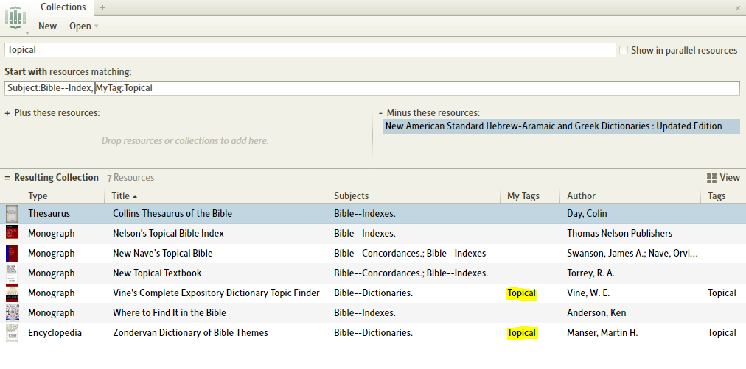
Alternate (does not need manual exclusion) Start With Rule: Subject:Bible--Index, MyTag:Topical ANDNOT Title:"New American Standard"

▫ Example Collections
[[@Headword: Example Collections ]] Wiki page: Revision 37 Link

To learn more about collections, see main Collections page. The Canonical Commentary Collections page has commentary collections that sort in canonical order.

Below example collection list are links to other examples.

If you have a collection that is better built please add it to the appropriate section as a new entry. This will allow others to see new ways of doing things and pick the collections that best suit them.

(The Library Size and Collection Size values are included as examples to show how many books are placed in the collection based on a specific user's library size. Those values are not used to define the collection. See this post for illustration.)

Apparatus
• Library Size: 3,549
• Collection Size: 11
• Rule: type:apparatus
• Manually Included Items: none
• Manually Excluded Items: none

Bibles
• Library Size: 4,032
• Collection Size: 229
• Rule: type:bible
• Manually Included Items: none
• Manually Excluded Items: none

Bible Background
• Library Size: 3,549
• Collection Size: 28
• Rule: (title:(manner,custom,background,archaeolog, archeolog) OR subject:(manner,custom,"New Testament--Background","Jews", "Judaism") OR (subject:(excavation,archaeolog,archeolog, antiquities) AND type:dictionary)) ANDNOT subject:(canon,doctrine,"Jews--Conversion", "Hebrew Language")
• Manually Included Items: none
• Manually Excluded Items: none

Bible Background
• Library Size: 4,050
• Collection Size: 132
• Rule: Title:("Bible Atlas",Background,Context,Every,Images,Jewish,Judaism,Milieu,Manners,Map,Social,Talmud,Travel) OR subject:(Jews,Judaism) OR author:Jastrow
• Manually Included Items: {Bible Dictionaries}
• Manually Excluded Items: none

Bible Dictionaries
• Library Size: 2251
• Collection Size: 28
• Rule: ((type:encyclopedia AND subject:Bible) OR title:pocket)
• Manually Included Items: none
• Manually Excluded Items: none

Bible Dictionaries
• Library Size: 1,776
• Collection Size: 40
• Rule: type:Encyclopedia AND subject:(Bible,Christian,History,Religion,Theology)
• Manually Included Items: none
• Manually Excluded Items: none

Bible Dictionaries
• Library Size: 3,549
• Collection Size: 24
• Rule: type:encyclopedia AND (title:bibl OR (subject:bible AND subject:dictionaries) OR subject:"220.3")
• Manually Included Items: none
• Manually Excluded Items: none

Biblical Theology
• Library Size: 3,780
• Collection Size: 11
• Rule: (title:(Biblical, "Old Testament", "New Testament") AND title:theology) OR (subject:(“bible. o.t.—theology”, “bible. n.t.—theology”, “bible.—o.t.—theology”, “bible.—n.t.—theology”))
• Manually Included Items: none
• Manually Excluded Items: Theological Wordbook of the Old Testament

Biography
• Library Size: 4,032
• Collection Size: 13
• Rule: type:(monograph, dictionary) AND subject:biography ANDNOT (subject:("Jesus Christ", Bible, Apostles))
• Manually Included Items: none
• Manually Excluded Items: none

Books on Prayer
• Library Size: 4,032
• Collection Size: 26
• Rule: title:pray, subject:pray
• Manually Included Items: none
• Manually Excluded Items: none

Calvin and Calvinism
• Library Size: 4,032
• Collection Size: 80
• Rule: author:"calvin, john", title:calvin, subject:calvin
• Manually Included Items: none
• Manually Excluded Items: Dogmatic Theology, The Reformed Doctrine of Predestination, The Theology of James Daane

Commentaries, Academic
• Library Size: 4,032
• Collection Size: 312
• Rule: type:bible-commentary AND(series:("New International Commentary on the Old and New Testament", "New International Greek Testament Commentary", "Eerdmans Critical", "Anchor Yale Bible", Hermeneia, JPS, Pillar, "socio-rhetorical", "word biblical", "Baker Exegetical", "Continental Commentary") OR (series:"international critical" AND pubdate:>1970))
• Manually Included Items: none
• Manually Excluded Items: none

Commentaries, Historical
• Library Size: 4,032
• Collection Size: 175
• Rule: type:bible-commentary AND (series:("Commentary on the New Testament from the Talmud", "ancient christian commentary", "Classic Commentaries on the Greek New Testament", "Early Church Fathers") OR (series:"international critical" AND pubdate:<=1970) OR author:("hodge, charles", "Luther, Martin", "darby, John Nelson", "Spurgeon, Charles") OR pubdate:<1939)
• Manually Included Items: Several 'one-off' commentaries
• Manually Excluded Items: none

Commentaries, Intermediate

• Library Size: 4,032
• Collection Size: 470
• Rule: type:bible-commentary AND (series:("zondervan illustrated bible backgrounds", "expositor's bible commentary", "niv application commentary", "Ariel's", "baker new testament", "bible speaks today", "black's new testament", "book of Isaiah (Young)", "Calvin's Commentary", Ellicott, "Charles Hodge", "Hebrews (Owen)", "Holman New Testament", "International Theological", "IVP New Testament", Lange, Lenski, "New American", Barnhouse, "United Bible Societies' Handbooks", "Tyndale Commentaries", "New International Biblical Commentary", "Cornerstone") OR mytag:intermediate OR author:"Calvin, John")
• Manually Included Items: none
• Manually Excluded Items: none

Commentaries, Expository
• Library Size: 4,032
• Collection Size: 378
• Rule: type:bible-commentary AND (series:("opening up", exposit, believer, "daily study", horae, "MacArthur New Testament", preach, pulpit, Wiersbe, "college press NIV") OR author:"Pink, Arthur" OR title:exposition*)
• Manually Included Items: none
• Manually Excluded Items: none

Commentaries, One Volume
• Library Size: 4,032
• Collection Size: 17
• Rule: type:commentary AND subject:”Bible—Commentaries” ANDNOT subject:”Bible—Commentaries—Collected works”
• Manually Included Items: Commentary on the New Testament Use of the Old Testament
• Manually Excluded Items: none

Commentaries One Volume: New Testament
• Library Size: 4,050 Note: 6 Study Bibles are Type:"Bible Notes" while 3 Study Bibles are Type:Commentary
• Collection Size: 30
• Rule: Type:("Bible Notes",Commentary) AND ((Title:Bible AND Title:(Background,Believer,Companion,Concise,Exposition,KJV,Knowledge,NET,Open,Study,Whole,Wycliffe)) OR Title:("First Series, Volume VI","Life and Epistles of St. Paul",Nelson,Olshausen,Outline)) ANDNOT Title:("Believers Church",Old)
• Manually Included Items: Commentary on the New Testament Use of the Old Testament
• Manually Excluded Items: none

Commentaries One Volume: Old Testament
• Library Size: 4,050 Note: 6 Study Bibles are Type:"Bible Notes" while 3 Study Bibles are Type:Commentary
• Collection Size: 28
• Rule: Type:("Bible Notes",Commentary) AND (Author:Keil OR (Title:Bible AND Title:(Background,Believer,Companion,Concise,History,KJV,Knowledge,NET,Open,Study,Whole,Wycliffe)) OR Title:(Nelson,Outline,Philo)) ANDNOT Title:("Believers Church","New Testament")
• Manually Included Items: none
• Manually Excluded Items: none

Commentaries, Unclassified
• Library Size: 4,032
• Collection Size: 227
• Rule: type:bible-commentary
• Manually Included Items: none
• Manually Excluded Items: {Academic Commentaries}, {Intermediate Commentaries}, {Expository Commentaries}, {One Volume Commentaries}

Commentaries on 1 Corinthians
• Library Size: 4,032
• Collection Size: 40
• Rule: (subject:("1 Corinthians", "Corinthians, 1st", "Corinthians. 1st"), title:corinth) type:bible-commentary ANDNOT (title:("2 Corinthians", second, "II Corinthians") ANDNOT (title:(first, 1, "i"), subject:(1st, "1 Corinthians")))
• Manually Included Items: none
• Manually Excluded Items: none

Commentaries on 1 Peter
• Library Size: 4,032
• Collection Size: 28
• Rule: type:commentary AND (title:peter OR subject:peter) ANDNOT ((subject:"2nd" OR title:"2 Peter") ANDNOT (subject:"1st" OR title:"1 Peter"))
• Manually Included Items: none
• Manually Excluded Items: none

Commentaries 02 Exodus
• Library Size: 4,050 Note: Logos 4 Bible book # for Exodus is 2, Canonical Commentary Collections page has complete set
• Collection Size: 39
• Rule: Type:Commentary AND (Subject:Exodus,Title:(Exodus,"Horae Homileticae Vol.1",Pentateuch))
• Manually Included Items: {Commentary One Volume: Old Testament}
• Manually Excluded Items: none

Commentaries on Genesis
• Library Size: 4,032
• Collection Size: 53
• Rule: type:commentary AND (subject:genesis, title:genesis)
• Manually Included Items: none
• Manually Excluded Items: none

Commentaries on Hebrews
• Library Size: 4,032
• Collection Size: 40
• Rule: type:"bible commentary" AND (title:hebrews OR subject:hebrews)
• Manually Included Items: none
• Manually Excluded Items: none

Commentaries 64 John
• Library Size: 4,050 Note: Logos 4 Bible book # for Gospel of John is 64, Canonical Commentary Collections page has complete set
• Collection Size: 52
• Rule: Type:Commentary AND (Subject:John,Title:(John,”First Series, Volume VII”,”First Series, Volume XIV”) ANDNOT Title:(Apocalypse,Epistles,Letter,"1 John","2 John","3 John",Jude,Revelation))
• Manually Included Items: {Commentary One Volume: New Testament}
• Manually Excluded Items: none

Commentaries on John's Gospel
• Library Size: 4,032
• Collection Size: 47
• Rule: type:commentary AND (title:john,subject:john) ANDNOT (subject:”1 John” OR subject:”2 John” OR subject:”3 John” OR subject:”John, 1st” OR subject:”John, 2nd” OR subject:”John, 3rd” OR subject:revelation OR subject:”epistles of john”)
• Manually Included Items: none
• Manually Excluded Items: none

Commentaries on John's Letters
• Library Size: 4,032
• Collection Size: 30
• Rule: type:commentary AND (title:john OR subject:john) ANDNOT (subject:revelation)
• Manually Included Items: none
• Manually Excluded Items: {Commentaries on John's Gospel}

Commentaries on Luke
• Library Size: 4,032
• Collection Size: 40
• Rule: type:commentary and (title:luke, subject:luke)
• Manually Included Items: none
• Manually Excluded Items: none

Commentaries on Philippians
• Library Size: 4,032
• Collection Size: 35
• Rule: type:commentary (subject:philippians, title:philippians)
• Manually Included Items: none
• Manually Excluded Items: none

Commentaries on Psalms
• Library Size: 4,032
• Collection Size: 35
• Rule: type:commentary (title:psalm,subject:psalm)
• Manually Included Items: none
• Manually Excluded Items: none

Commentaries on the Old Testament
• Library Size: 628
• Collection Size: 44
• Rule: (title:old OR title:(genes, exod, levit, numb, deut, josh, judg, ruth, samue, kings, chronic, ezra, nehem, esther, job, psalms, proverb, "song of", eccles, isaiah, jerem, lament, ezekiel, daniel, hosea, joel, amos, obadiah, jonah, micah, nahum, habakk, zephan, haggai, zecha, malachi)) AND title:commen
• Manually Included Items: none
• Manually Excluded Items: none

Commentaries on the New Testament
• Library Size: 1623
• Collection Size: 210
• Rule: (title:new OR title:(Matthew, Mark, Luke, John, Acts, Romans, Corinthians, Galatians, Ephesians, Philippians, Colossians, Thessalonians, Timothy, Titus, Philemon, Hebrews, James, Peter, Jude, Revelation)) AND title:commentary
• Manually Included Items: none
• Manually Excluded Items: none

Commentary OR Notes
• Library Size: 1,776
• Collection Size: 470
• Rule: type:(Commentary,Notes)
• Manually Included Items: none
• Manually Excluded Items: none

Creeds & Confessions
• Library Size: 4,138
• Collection Size: 18
• Rule: title:(creed,confession,Nicaea,catechism) OR subject:creed
• Manually Included Items: none
• Manually Excluded Items: A Confession of My Faith (Bunyan), The Confessions of St. Augustine, The Nature of Confession: Evangelicals & Postliberals in Conversation

Criticism,interpretation
• Library Size: 6,144
• Collection Size: 443
• Rule: Subject:(Criticism,interpretation,semantic)
• Manually Included Items: none
• Manually Excluded Items: none

Dead Sea Scroll Studies
• Library Size: 1812
• Collection Size: 18
• Rule: Dead Sea Scrolls ANDNOT dictionary ANDNOT greek
• Manually Included Items: none
• Manually Excluded Items: none

Dead Sea Scrolls
• Library Size: 1,776
• Collection Size: 261
• Rule: subject:"Dead Sea"
• Manually Included Items: none
• Manually Excluded Items: none

Devotionals
• Library Size: 2,546
• Collection Size: 16
• Rule: (title:devotion OR subject:devotional OR type:devotion) ANDNOT type:commentary
• Manually Included Items: none
• Manually Excluded Items: none

Encyclopedias
• Library Size: 1,776
• Collection Size: 47
• Rule: type:Encyclopedia
• Manually Included Items: none
• Manually Excluded Items: none

English Bibles
• Library Size: 4,032
• Collection Size: 32
• Rule: type:bible AND lang:english ANDNOT (title:(commentary,epistle))
• Manually Included Items: none
• Manually Excluded Items: none

English Dictionaries
• Library Size: 2,546
• Collection Size: 4
• Rule: title:dictionary subject:”english language dictionaries” -latin
• Manually Included Items: none
• Manually Excluded Items: none

English Library without Perseus
• Library Size: 4,096
• Collection Size: 1,889 Excludes 825 Perseus by including one collection and excluding another collection
• Rule:
• Manually Included Items: {Language:English}
• Manually Excluded Items: {Perseus}

English Library without Perseus
• Library Size: 4,096
• Collection Size: 1,889 Excludes 825 Perseus via rule equivalent to including a collection while excluding another
• Rule: Language:English -Publisher:Perseus
• Manually Included Items: none
• Manually Excluded Items: none

Everything but Bibles
• Library Size: 1,250
• Collection Size: 1,014
• Rule: rating:<=5 ANDNOT type:bible
• Manually Included Items: none
• Manually Excluded Items: none

Fathers: Early Church
• Library Size: 4,096
• Collection Size: 59 Excludes 3 Perseus compared to Rule: title:(Early,Fathers)
• Rule: (Title:Early AND Title:Christ,Church) OR Title:Fathers
• Manually Included Items: none
• Manually Excluded Items: none

Grammars
• Library Size: 1,776
• Collection Size: 40
• Rule: subject:(Grammar,Language,Reference) AND type:("Bible Notes",Grammar,Encyclopedia,Monograph)
• Manually Included Items: none
• Manually Excluded Items: none

Greek Bibles
• Library Size: 1,776
• Collection Size: 42
• Rule: type:Bible AND Language:Greek ANDNOT subject:Manuscript
• Manually Included Items: none
• Manually Excluded Items: none

Greek Language
• Library Size: 1,776
• Collection Size: 124
• Rule: Language:Greek
• Manually Included Items: none
• Manually Excluded Items: none

Greek Manuscripts
• Library Size: 1,776
• Collection Size: 69
• Rule: type:Bible AND Language:Greek AND subject:Manuscript
• Manually Included Items: none
• Manually Excluded Items: none

Greek Papyri - Duke Data Bank
• Library Size: 4,096
• Collection Size: 250 Perseus
• Rule: Series:"Duke Data Bank" Language:Greek
• Manually Included Items: none
• Manually Excluded Items: none

Greek Texts: Search Set
• Library Size: 4,096
• Collection Size: 360 includes 355 Perseus Greek Classics [[based on Mike Aubrey's Greek Text Search collection >> http://community.logos.com/forums/p/39030/291577.aspx#291577]]
• Rule: Language:Greek AND (Author:(Aeschylus,Andocides,Aratus,Aristophanes,Aristotle,Bacchylides,Callimachus,Colluthus,Demades,Demosthenes,Dinarchus,Diodorus,Dionysius,Euclid,Heiser,Herodotus,Hesiod,Hippocrates,Homer,Hyperides,Lycophron,Lycurgus,Lysias,Pindar,Plato,Polybius,Sophocles,Strabo,Theocritus,Theophrastus,Xenophon) OR Title:("Apostolic Fathers: Greek", "Discourse Greek", "Interlinear Septuagint"))
• Manually Included Items: {Greek Texts: 1st-2nd Century CE}
• Manually Excluded Items: none

Greek Texts: 1st-2nd Century CE
• Library Size: 4,096
• Collection Size: 256 includes 255 Perseus Greek Classics plus Philo (Greek) [[based on Mike Aubrey's Greek Texts 1-2nd c. CE collection >> http://community.logos.com/forums/p/39030/291577.aspx#291577]]
• Rule: Language:Greek Author:(Apollodorus,Appian,Aretaeus,Aristides,Arrian,Epictetus,Galen,Lucian,Pausanias,Philo,Plutarch)
• Manually Included Items: none
• Manually Excluded Items: none

Greek Texts: 3rd-5th Century CE
• Library Size: 4,096
• Collection Size: 25 Perseus Greek Classics [[based on Mike Aubrey's Greek Texts 3-5th c. CE collection >> http://community.logos.com/forums/p/39030/291577.aspx#291577]]
• Rule: Language:Greek Author:(Athenaeus,Diogenes,Nonnus,Oppian,Pseudo-Plutarch,Smyrnaeus,Tryphiodorus)
• Manually Included Items: none
• Manually Excluded Items: none

History
• Library Size: 1,776
• Collection Size: 40
• Rule: subject:History
• Manually Included Items: none
• Manually Excluded Items: none

History - Classics
• Library Size: 4,096
• Collection Size: 1,115 Perseus
• Rule:
• Manually Included Items: {History - English Classics},{History - Greek Classics},{History - Latin Classics}
• Manually Excluded Items: none

History - English
• Library Size: 4,096
• Collection Size: 899 includes 452 Perseus English Classics plus Beowolf Perseus Medieval
• Rule: subject:History Language:English
• Manually Included Items: none
• Manually Excluded Items: none

History - English Classics
• Library Size: 4,096
• Collection Size: 453 includes 452 Perseus Classics plus Beowolf Perseus Medieval
• Rule: Subject:(Classics--English,Medieval)
• Manually Included Items: none
• Manually Excluded Items: none

History - English Classics - Commentary
• Library Size: 4,096
• Collection Size: 45 Perseus
• Rule: Subject:Classics--English Type:Commentary
• Manually Included Items: none
• Manually Excluded Items: none

History - English without Perseus
• Library Size: 4,096
• Collection Size: 85 Excludes 821 Perseus
• Rule: subject:History
• Manually Included Items: {History - English}
• Manually Excluded Items: {History - English Classics},{History - Europe until 1800},{History - US Civil War}

History - Europe until 1800
• Library Size: 4.096
• Collection Size: 22 Perseus
• Rule: Subject:"Europe--History--to 1800"
• Manually Included Items: none
• Manually Excluded Items: none

History - Greek Classics
• Library Size: 4,096
• Collection Size: 404 Perseus
• Rule: Subject:(Classics--Greek)
• Manually Included Items: none
• Manually Excluded Items: none

History - Jewish
• Library Size: 6,144
• Collection Size: 128
• Rule: (Subject:(Ancient,Antiqu,Histor) AND Subject:(Biblical,"Early Church",Israel,Jew,Judaism,Palestine)) OR Title:"Jewish Context"
• Manually Included Items: none
• Manually Excluded Items: none

History - Latin Classics
• Library Size: 4,096
• Collection Size: 258 Perseus
• Rule: Subject:(Classics--Latin)
• Manually Included Items: none
• Manually Excluded Items: none

History - US Civil War
• Library Size: 4,096
• Collection Size: 346 Perseus
• Rule: Subject:"United States--History--Civil War,1861-1865" OR Series:"Richmond Daily Dispatch"
• Manually Included Items: none
• Manually Excluded Items: none

Illustrations
• Library Size: 6,144
• Collection Size: 60
• Rule: Subject:illustration,Title:illustrat
• Manually Included Items: none
• Manually Excluded Items: none

IVP Reference Collection
• Library Size: 6,144
• Collection Size: 17
• Rule: IVP Title:(Dictionary,"Bible Background",Hard)
• Manually Included Items: none
• Manually Excluded Items: none

Jewish Background
• Library Size: 2,546
• Collection Size: 34
• Rule: (title:jewish, title:judaism, title:jews, title:israel, type:(judaism, jews, jewish, israel)) -title:archaeology -type:commentary -type:bible -type:timeline -mytag:hebref -subject:("bible o.t. theology","bible criticism interpretation","bible study and teaching")
• Manually Included Items: Israel's Hope Encouraged
• Manually Excluded Items: none

Journals
• Library Size: 4,032
• Collection Size: 728
• Rule: type:journal OR title:Semeia OR title:"Evangelical Review of Theology"
• Manually Included Items: none
• Manually Excluded Items: none

Koran
• Library Size: 4,096
• Collection Size: 2 Perseus
• Rule: Subject:Koran
• Manually Included Items: none
• Manually Excluded Items: none

Language:English
• Library Size: 4,096
• Collection Size: 2,714 includes 825 Perseus
• Rule: Language:English
• Manually Included Items: none
• Manually Excluded Items: none

Language:Latin
• Library Size: 4,096
• Collection Size: 269 includes 264 Perseus
• Rule: Language:Latin
• Manually Included Items: none
• Manually Excluded Items: none

Language:Non-English
• Library Size: 2,910
• Collection Size: 851
• Rule: type:* ANDNOT lang:english ANDNOT type:timeline
• Manually Included Items: none
• Manually Excluded Items: none

Lexicons, Aramaic
• Library Size: 4,032
• Collection Size: 4
• Rule: type:lexicon AND (subject:aramaic OR title:aramaic)
• Manually Included Items: none
• Manually Excluded Items: The Hebrew and Aramaic Lexicon of the Old Testament, Enhanced Strong's Lexicon

Lexicons, Greek
• Library Size: 4,032
• Collection Size: 22
• Rule: type:lexicon AND (subject:greek OR title:greek) ANDNOT title:(glossary, vocab)
• Manually Included Items: none
• Manually Excluded Items: none

Lexicons, Hebrew
• Library Size: 4,032
• Collection Size: 16
• Rule: type:lexicon AND (subject:hebrew OR title:hebrew) ANDNOT title:glossary
• Manually Included Items: none
• Manually Excluded Items: The Hebrew and Aramaic Lexicon of the Old Testament: Volume 5, Aramaic

Luther's Works
• Library Size: 4,032
• Collection Size: 55
• Rule: title:"Luther's Works"
• Manually Included Items: none
• Manually Excluded Items: none

Monographs
• Library Size: 4,032
• Collection Size: 1,347
• Rule: type:monograph ANDNOT title:(journal, encylopedia, "evangelical review of theology")
• Manually Included Items: none
• Manually Excluded Items: none

Pauline Studies
• Library Size: 4,032
• Collection Size: 31
• Rule: (subject:(paul,romans,corinthians,galatians,ephesians,philippians,colossians,thessalonians,timothy,titus,"pastoral epistles",philemon) OR title:(paul,romans,corinthian,galatia,ephesian,philippian,colossian,thessalonian,timothy,titus,"pastoral epistles",philemon)) AND type:monograph ANDNOT subject:"bible study"
• Manually Included Items: none
• Manually Excluded Items: your choice

Perseus
• Library Size: 4,096
• Collection Size: 1,743 Perseus has 825 English, 654 Greek, & 264 Latin
• Rule: Publisher:Perseus
• Manually Included Items: none
• Manually Excluded Items: none

Personal Books
• Library Size: 4,084
• Collection Size: 4
• Rule: Edition:User
• Manually Included Items: none
• Manually Excluded Items: none

Philosophy
• Library Size: 6,144
• Collection Size: 28
• Rule: Subject:Philosophy OR Title:Philosophy
• Manually Included Items: none
• Manually Excluded Items: none

Preaching Resources
• Library Size: 2,546
• Collection Size: 41
• Rule: (title:preach, title:sermon, title:homiletical) -type:commentary -author:pentecost -mytag:biog -author:bunyan -title:devotions
• Manually Included Items: none
• Manually Excluded Items: none

Second Temple Judaism
• Library Size: 4,032
• Collection Size: 107
• Rule: (title:("second temple", jps, qumran, targum, "dead sea", "rabbinical", "ascension of isaiah") OR subject:("Judaism--Influence",targum, "second temple", qumran, "dead sea", "rabbinical", "Palestine--History--To 70 A.D.", "Jews--History--586 B.C.-70 A.D.", mishnah, "Philo", josephus, "Judaism--Encyclopedias", "ascension of isaiah", "Jews--History--168 B.C.-135 A.D.", "Judaism--History--Talmudic period") OR author:(Josephus, Philo) OR (subject:(apocrypha, pseudepigrapha) AND subject:("O.T.", "Old Testament")) OR mytag:"Second Temple") ANDNOT author:"Comprehensive Aramaic Lexicon"
• Manually Included Items: none (tagged missing resources with "Second Temple" instead)
• Manually Excluded Items: none

Sermon Collections
• Library Size: 2,546
• Collection Size: 84
• Rule: (title:sermon OR subject:sermons) -subject:homiletic -subject:preaching -title:"how to" -subject:illustrations -title:exposition
• Manually Included Items: none
• Manually Excluded Items: none

Sermon Illustrations
• Library Size: 4,032
• Collection Size: 17
• Rule: (title:(illustration, quotation) OR subject:(illustration,quotation)) ANDNOT (subject:(bible) OR title:Philo)
• Manually Included Items: none
• Manually Excluded Items: none

Spurgeon
• Library Size: 1,776
• Collection Size: 85
• Rule: author:Spurgeon OR title:Spurgeon
• Manually Included Items: none
• Manually Excluded Items: none

Study Bibles
• Library Size: 2251
• Collection Size: 5
• Rule: title:"study Bible"
• Manually Included Items: The NET Bible (/While not a Study Bible it is a well noted Bible so I added it. Your inclusion is, of course, your choice./)
• Manually Excluded Items: none

Systematic Theologies
• Library Size: 4,032
• Collection Size: 85
• Rule: (title:”systematic theology” OR title:dogmatic OR (subject:theology AND subject:doctrinal)) AND type:monograph ANDNOT (title:sermon)
• Manually Included Items: none
• Manually Excluded Items: your choice

Systematic Theologies
• Library Size: 2,546
• Collection Size: 26
• Rule: type:monograph AND (title:"systematic theology" OR title:"dogmatic theology" OR subject:"theology, doctrinal") ANDNOT (title:magazine OR subject:"Sermons--Outlines" OR subject:theologians)
• Manually Included Items: none
• Manually Excluded Items: none

Texts: 1st-2nd Century CE
• Library Size: 4,096
• Collection Size: 467 includes 464 Perseus Classics plus Josephus and Philo (Greek) based on Mike Aubrey's Greek Texts 1-2nd c. CE collection]
• Rule: Author:(Apollodorus,Appian,Aretaeus,Aristides,Arrian,Epictetus,Galen,Josephus,Lucian,Pausanias,Philo,Plutarch)
• Manually Included Items: none
• Manually Excluded Items: none

Texts: 3rd-5th Century CE
• Library Size: 4,096
• Collection Size: 30 includes 29 Perseus Classics plus Philocalia of Origen based on Mike Aubrey's Greek Texts 3-5th c. CE collection
• Rule: Author:(Athenaeus,Diogenes,Nonnus,Oppian,Origen,Pseudo-Plutarch,Smyrnaeus,Tryphiodorus)
• Manually Included Items: none
• Manually Excluded Items: none

Theologies
• Library Size: 2251
• Collection Size: 81
• Rule: title:(doctrine, theology), dogmatics ANDNOT type:journal
• Manually Included Items: The Fundamentals; God, Revelation, and Authority; Pocket Dictionary of Theological Terms; What We Believe
• Manually Excluded Items: your choice

Topical
• Library Size: 6,144
• Collection Size: 78
• Rule: (Subject:(Bible--Index,illustration,Quotation), Title:(Barbed,Topical),MyTag:Topical) ANDNOT Title:"Greek Dictionaries"
• Manually Included Items: {IVP Reference Collection}
• Manually Excluded Items: none

Refer to Tagging for adding MyTags to your Library resources. Without illustrations and quotations, can use Rule: Subject:Bible--Index,MyTag:Topical ANDNOT Title:"Greek Dictionaries"

Topicals
• Library Size: 2251
• Collection Size: 5
• Rule: title:topical
• Manually Included Items: Where to find it in the Bible
• Manually Excluded Items: none

Untagged Resources in your Library
• Library Size: n/a
• Collection Size: n/a
• Rule: rating:>=0 ANDNOT mytag:*
• Manually Included Items: none
• Manually Excluded Items: none
• Note: your collection will have all books in your library in which you have not tagged them. This is useful when you have tagged a significant number of books in your library and you want to search those books in which you have not tagged.

Vyrso
• Library Size: 4,450
• Collection Size: 35
• Rule: edition:eBook
• Manually Included Items: none
• Manually Excluded Items: none

Other Examples

• A step-by-step example of adding one of the above Example collections to your collections. (see this post)
• A step-by-step example of building a new collection and adding it to your Passage Guide. (see this post)
• A step-by-step example of manually adding a resource to your collection. (see this post)

Favorites
[[@Headword:Favorites ]]Wiki page: Revision 54 Link

What are Favorites?
[[@Headword:Favorites – What are they ]]
Favorites in Logos 4 are like favorites that you add in Internet Explorer or other browser programs. It allows you to store locations to resources. As in favorites in your browser you can create Folders and organize your favorites. This is a very powerful feature in Logos 4. You can save Bible study resources, clippings, layout and such for a particular Bible study in a named folder.

• Please watch Mark Barnes excellent video on favorites Logos Tutorial Video #6 - Favorites.

• Please watch Mark Barnes excellent video on Logos Tutorial Video #11 - Managing your content

How do I view Favorites?
[[@Headword:Favorites - Viewing ]]
1. Click on Tools in the top menubar.

2. Click on Favorites in the drop down menu.

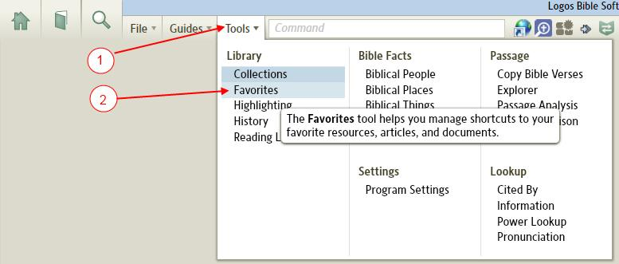

How do I add favorites to the Favorites window?

Adding Internet links to Favorites
[[@Headword:Favorites – Add internet links ]]
1. Open the Favorites tool (if it is not open) on your work area. (see How do I view Favorites?)

2. Open your browser to the link that you want to add.

3. Drag the icon (next to the address) to the Favorites window in Logos 4 and drop it there.

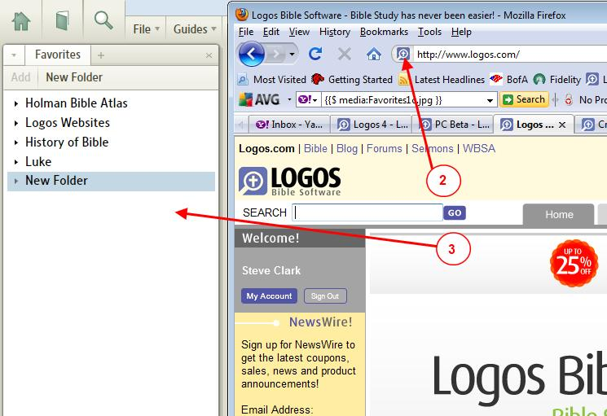

4. You can right click on the new favorite (in Logos 4) and select Rename to rename the favorite.

• Note, user found problem when you have set Logos4 to open with Run as Administrator (see [[http://community.logos.com/forums/p/11512/90190.aspx#90190]] ).

Adding Bible links or Resource links
[[@Headword:Favorites – Adding Bible links ]]
You can add favorites of a Bible & its location. Or of a resource (map, commentary, dictionary, etc) to your favorites.

1. Open a Bible resource that you want to add

2. Navigate to the book/verse that you want to link to

3. Drag the tab for that book (or resource)

4. Drop it on the Favorites window.

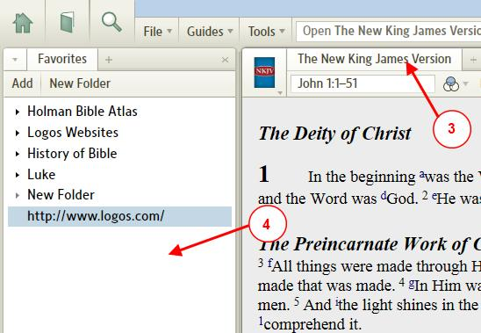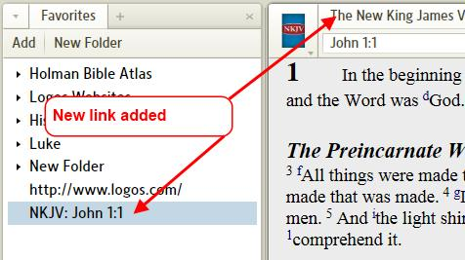

5. You can right click on the new favorite (in Logos 4) and select Rename to rename the favorite.

Adding a link to a Note
[[@Headword:Favorites – Adding link to Note ]]
You can add a link to any of your Notes to your favorites.

1. Open the Favorites tool (if it is not open) on your work area.

2. Click on File in the menu

3. Once the File list appears, click on the Note file that you want to add a link to

4. Drag the Note file and drop it on the Favorites window (this will not remove your notes, but merely creates a link to it)

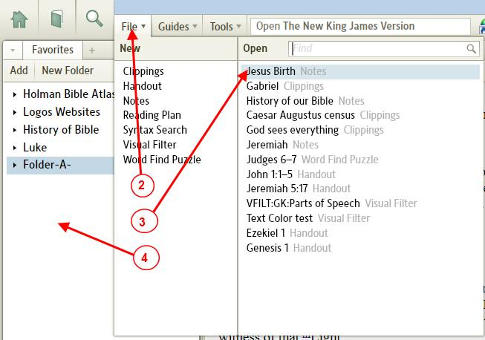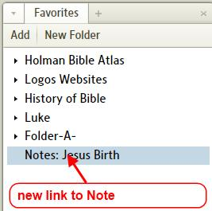

Adding a link to a Clipping
[[@Headword:Favorites – Adding link to Clipping ]]
You can add a link to any of your Clippings to your favorites.

1. Open the Favorites tool (if it is not open) on your work area.

2. Click on File in the menu

3. Once the File list appears, click on the Clipping file that you want to add a link to

4. Drag the Clipping file and drop it on the Favorites window (this will not remove your clipping, but merely creates a link to it)

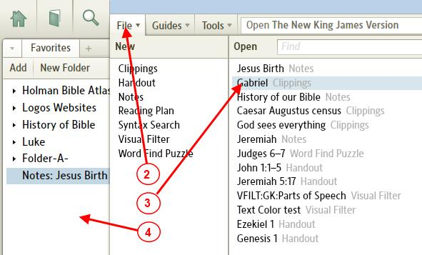

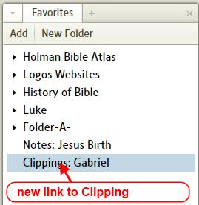

Adding a link to a Layout
[[@Headword:Favorites – Adding link to Layout ]]
You can add a link to any of your named Layouts to your favorites.

1. Open the Favorites tool (if it is not open) on your work area.

2. Click on Layouts in the tool bar

3. Once the Layout list appears, click on the named Layout (on the left side of the Layout list) that you want to add a link to

4. Drag the Layout name and drop it on the Favorites window (this will not remove your named Layout, but merely creates a link to it)

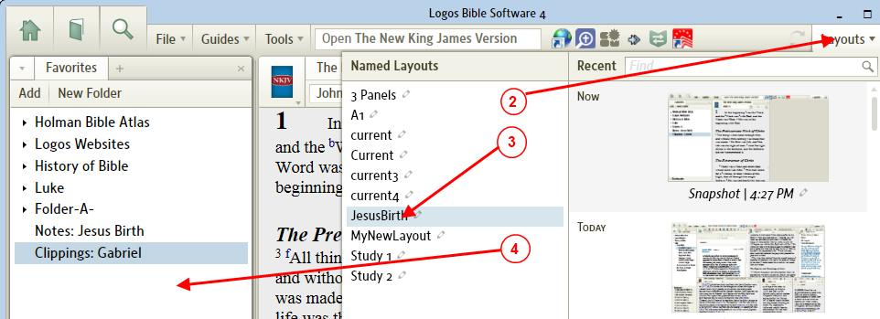

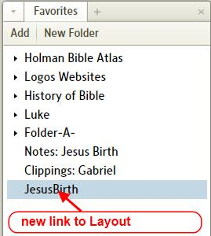

Adding a link to Biblical People
[[@Headword:Favorites – Adding link to Biblical People ]]
• See Biblical People

Adding a link to a Word document
[[@Headword:Favorites – Adding link to Word doc ]]
• You can add a link to a Microsoft Word document to Favorites. When you click on a favorite which is a Word doc, it will open Word to that document.

• Similarly you can add Excel & PowerPoint document links to your Favorites.

1. Open the Favorites tool (if it is not open) on your work area.

2. Open Windows Explorer and navigate to where your Word document resides.

3. Drag the Word file and drop it over an open area in your Favorites window.

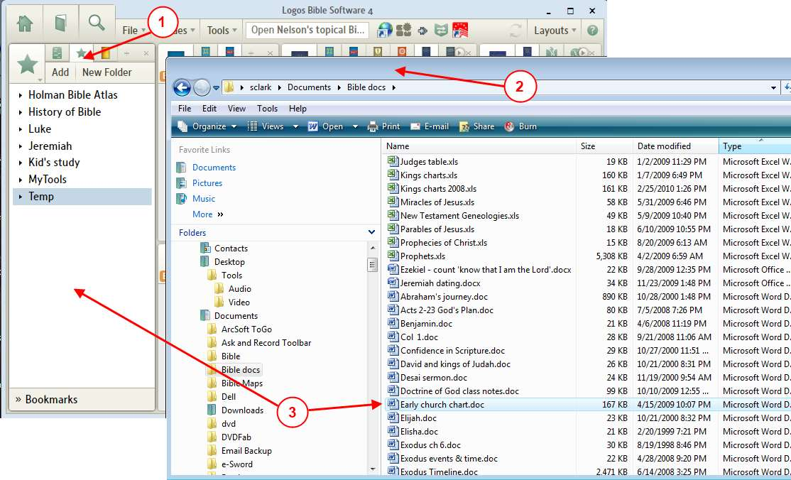
4. You can now right click on the new favorite and select Rename to rename it.
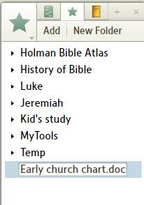

Adding a link to a windows program to your Favorites
[[@Headword:Favorites – Adding link to Window program ]]
• You can add links to various Windows program (e.g. Logos3, a webpage on your hard-drive, etc).

1. Resize your Logos4 program so that you can see your desktop.

2. Drag an icon for your program shortcut to the Logos4 Favorites window and drop it in an open space there.

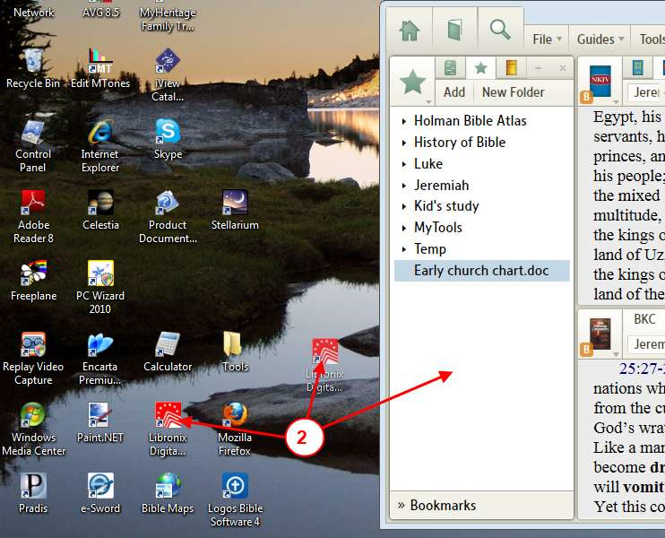
3. Right click on the new favorite in your Favorites window and click on Rename, then rename it.
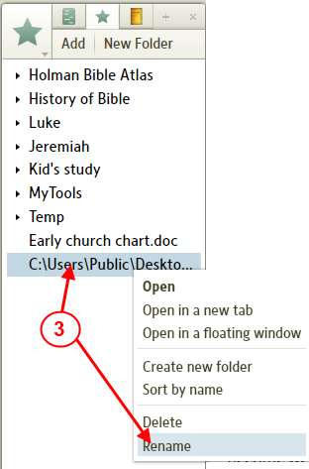
• This works with windows shortcuts (e.g. the icons you see on your desktop). But I am not sure this would work for the actual executable program as found in windows explorer. (you could create a shortcut to your executable program and then drag that shortcut to Logos4 Favorites window.

Using the keyboard to add a resource to your Favorites
[[@Headword:Favorites - Keyboard ]]
• When you have a resource active, you can press Ctrl D and Logos4 will add that resource to your Favorites.
(at the bottom of your favorites, you then can drag it from the bottom to where you want it)

• This comes in real handy when you have a resource open in a floating window and want to add it to your Favorites.

Adding a link from your Library
[[@Headword:Favorites Adding link from Library ]]
• You can add a link to a resource directly from your library. This is useful when you want to open a Bible and have Logos 4 position it to the current scripture that you have open in other Bibles or Commentaries. Notice after you create the link that there is not scripture reference after the Bible name.

1. Open the Favorites tool (if it is not open) on your work area.

2. Open your Library and locate the resource that you want to add to your favorites.

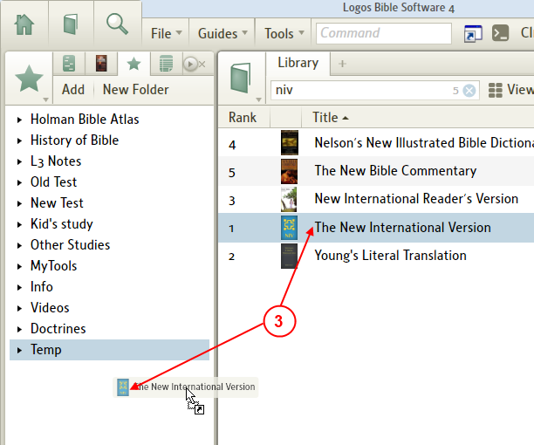
3. Grab the resource in your library and drag it into the favorites window and drop it.

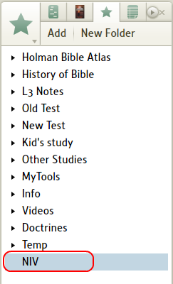
• Notice that there is not a scripture reference after the Bible name. If you have another Bible open to a scripture reference and you click on this favorite link, it will open that Bible to the same scripture reference in the Bible that you already had open. You can save links to commentaries in the same way.

Using the *Add* button in the Favorites window
[[@Headword:Favorites – Add button ]]
• You can use the Add button in the favorites window to add a link to the active window in your layout.

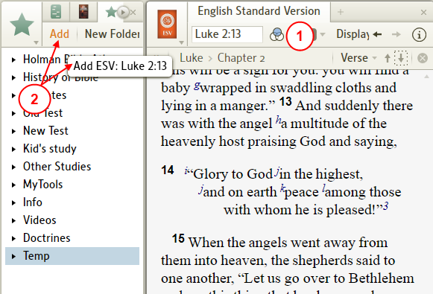
1. When you have a resource active and positioned to where you want it...

2. You can move your mouse to the favorites window and hover over the Add button. It will briefly show you the link in a pop-up box. If you click on Add it will add a link to that resource in your favorites.

Creating flexible tools from the shortcut bar
[[@Headword:Favorites – Flexible tools ]]
You may have noticed that when you create a Shortcut on the shortcut bar that your tool opens to where you are currently viewing in a Bible. If you create a favorite from the shortcut, then your favorite will take on the properties of the shortcut for that specific tool. This adds flexibility for the favorites in that when you save a favorite directly from an open tool it remembers specifically where the tool was opened to. And when using a favorite built from a shortcut it is now flexible to use your current Bible location in the tool. Please see this post for details Creating flexible tools from the shortcut bar.

How do I delete a link in Favorites?
[[@Headword:Favorites - Deleting ]]

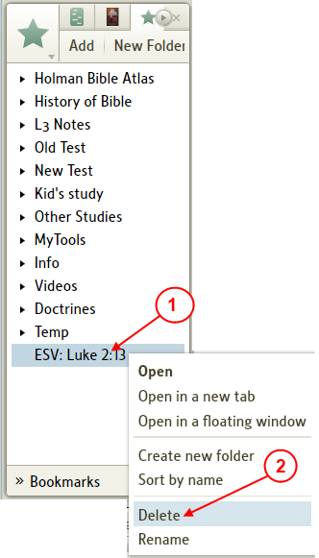
1. Right click on the link in the favorites window that you wish to delete.

2. In the pop-up menu, click on Delete.

How do I create Folders?
[[@Headword:Favorites – Creating Folders ]]
1. Click on the New Folder button in the top of Favorites window.

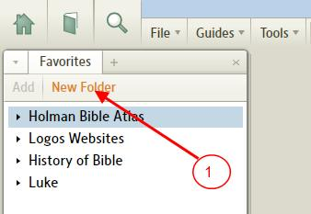

2. Enter a name for your Folder when it appears.

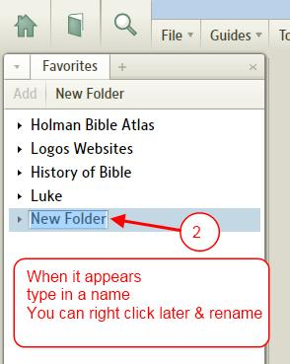

How do you nest a Folder within a Folder?
[[@Headword:Favorites – Nesting Folders ]]
Nesting a Folder within a Folder means to place a Folder inside another Folder. This is very useful in organizing your favorites.

1. Open the Favorites tool (if it is not open) on your work area.

2. Drag the Folder that you want to place inside another folder.

3. Drop it on top of the Folder that you want it inside of.

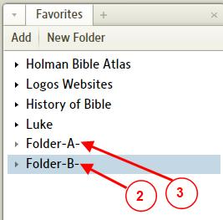

.
4. Now Folder B is inside Folder A. When you collapse Folder A, Folder B is hidden and visa versa.

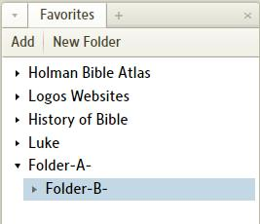

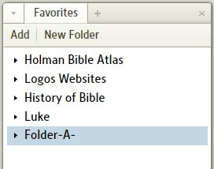

Or you can

1. Right click under a folder that you want to create a new Folder inside of.

2. Click on Create new folder.

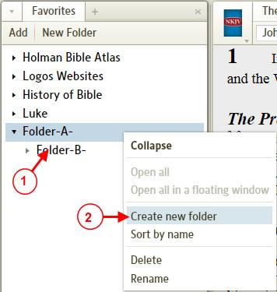

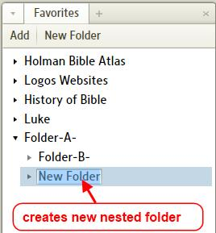

You can drag a new favorite directly into a folder
[[@Headword:Favorites – Drag N Drop ]]
• You do not have to drop a favorite into a blank area of Favorites.

• You can drag your favorites directly into folders.
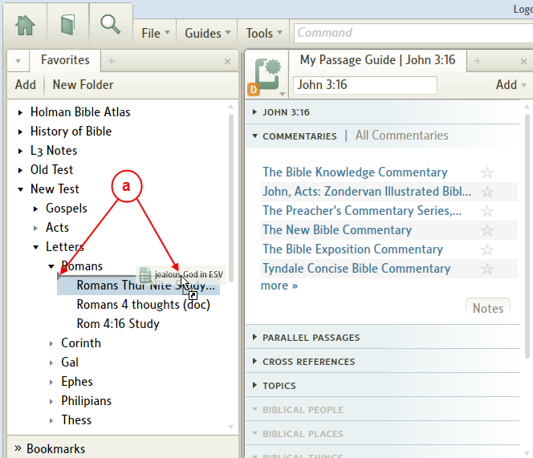

• But before adding the link to nested folders you will need to expand the folder in the Favorites window before dragging your new link there.

The power of Favorites

Organize Notes/Clippings
[[@Headword:Favorites – Power of Favorites ]]
I discovered the power of using the Favorites in videos that Mark Barnes made (they are found here Preparing a Sermon), please view them!

Also Mark has made a new short video Logos Tutorial Video #11 - Managing your content which is also helpful!

I created a sample project as shown in the image below. Just follow the item numbers below which are associated with the image.
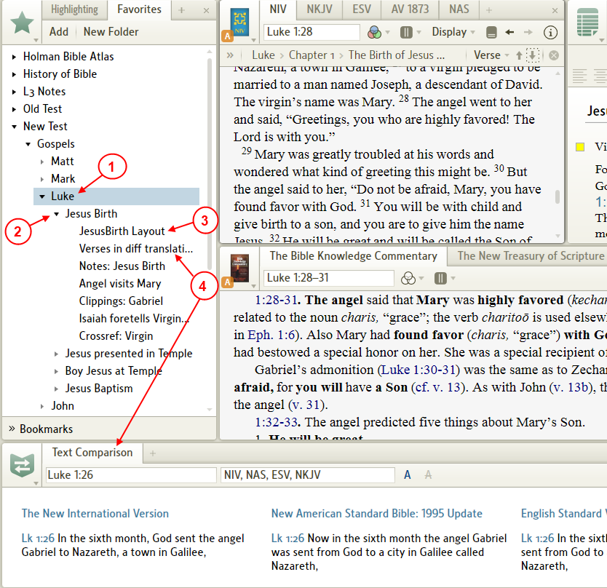
(click on image to view larger view)

1. By organizing using folders you can quickly be able to locate multiple projects. Here i have made a folder named Luke for all my projects which may fall under the category of Luke.

2. This is my project that i named Jesus Birth (taken from Mark's example). Notice that it is a folder under the main folder Luke. So i can collapse it or expand it as needed. For pastors, you could easily name the folder Sermon on Jesus return given 1/24/2010.

3. This is a link to one of my named Layouts. You can create special Layouts and associate them to a specific project (via a link). This can come in pretty handy. You can place your resources in the panes as you like. In this Layout, it will remember where each book was located and the exact place the book was at when we saved the Layout. (this is not my general Layout that i use for my normal study, so this is a really good use of named Layouts)

4. This is a link to the Text Comparison tool. I set the range of verses that i wanted to display in the tool before making a link in my favorites. So if i ever move or hide the tool and want to return back to the verse range/Bibles that i orginally setup, i can just click on this link and it will restore the verse_range/Bibles that were there when i made the link. Thus you can change the Bibles or verse range and then later return. Again you can have different links which were set to different verse_ranges/Bibles, thus by just clicking a link could take you to different comparisons.
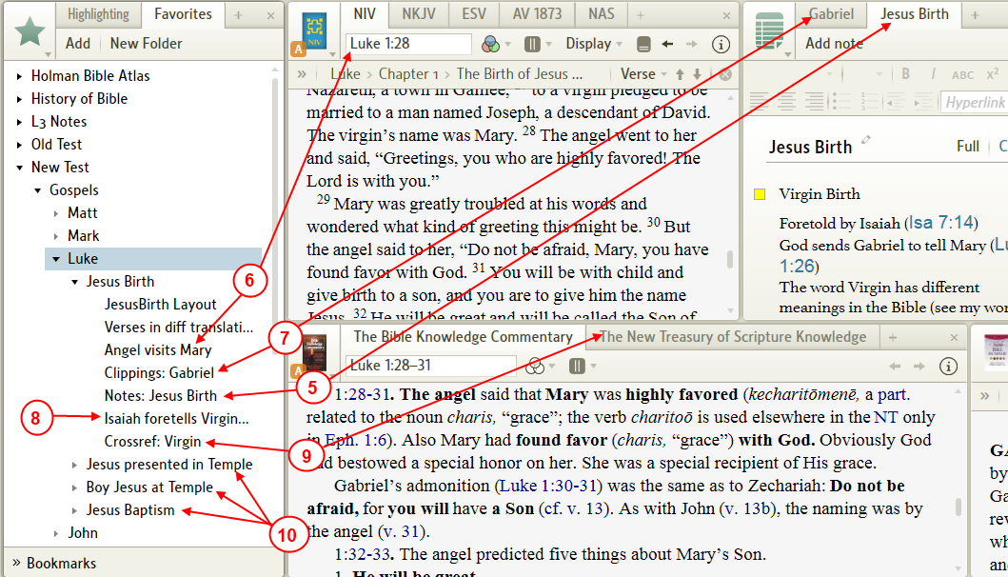
(click on image to view larger view)

5. This is a link to a Notes file. You can create as many links to different notes files as you wish. This is one way in which you can logically tie different note files to a project. In some cases you may even want to create links to the same note file in different projects.

6. This is a link to a Bible reference. It allows me to link a specific Bible & verse. So i can quickly navigate either my preferred Bible to this exact book/verse or set another pane up with Send Hyperlinks here. Again you can create as many links to as many verses as you need.

7. This is a link to a Clippings file. As Mark showed us, we can have named clippings files for specific topics (ones we have put time into for detailed info). Again you can link as many clippings file as you want to your project. Mark's use for general researched info to be placed in a named clipping and then be used in any/many place in my studies was really sharp.

8. This is a link to the NKJV Bible verse (similar to item 6, but in a different version). Again to show that you can have numerous links to different verses in different Bibles (even in Greek/Hebrew versions).

9. This is a link to the New Treasury of Scripture Knowledge. By setting the NTSK up to a specific verse and creating a link, i can quickly have references to this verse at hand. I can see using multiple links in a project for various cross-ref to different verses. Having a links (with a descriptive name) can get me to places that i may need to investigate further.

10. This is just showing you that you can organize multiple projects under a general project name.

• There are many other things that you can link into your project: Bible Word Studies, Passage Guides to specific verses, and the list goes on.

• Doug has some good ideas in this post [[http://community.logos.com/forums/p/10356/81726.aspx#81726]]

Tip: using Favorites to add Floating Tool windows
[[@Headword:Favorites – Floating Windows ]]
You can use Favorites to open multiple resources/tools into a floating window. Please see this wiki page: Floating Tool Windows.

Tip: Creating your own Custom Go Box
[[@Headword:Favorites – Custom Go Box ]]
You can use Favorites to Create a custom Go Box.

Bookmarks
[[@Headword:Bookmarks ]]Wiki page: Revision 17 Link

What are Bookmarks?
[[@Headword:Bookmarks – What are Bookmarks ]]

• Bookmarks are as they suggest, they mark where you were reading in one of your books.

• Logos 4 provides up to 9 bookmarks.

• These are not the same as Visual Bookmarks. (see Visual Bookmarks)

• Bookmarks tool appears under the Favorites tool panel.

• When using the keyboard to open/save a bookmark, don't use the keypad, use the numbers at the top of the keyboard.

(see also Keyboard shortcuts (PC), Keyboard shortcuts (Mac))

• Please watch Mark Barnes video on Favorites, he discusses Bookmarks there Logos Tutorial Video #6 - Favorites.

How do I view the Bookmarks tool?
[[@Headword: Bookmarks - Viewing]]

1. Click on Tools in the top menu.

2. In the drop down menu, click on Favorites.

3. The Favorites tool panel will appear on the left side of your Logos work area.

4. At the bottom of the Favorites panel you will see Bookmarks.
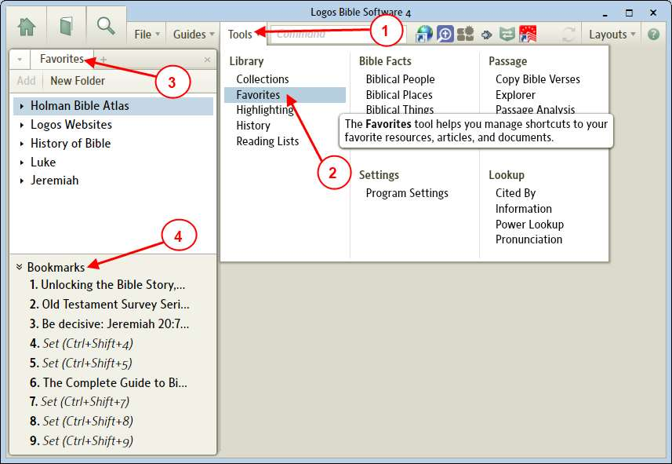

How do I set a bookmark?
[[@Headword:Bookmarks - Setting ]]

• You will need to open the book in which you want to bookmark.

• Next you will need to place your reading position so that it appears at the top of your panel. (e.g. ESV Bible was opened with Luke 2:1 at the top of the pane)

• You can then use the keyboard to set a bookmark by pressing key combination Ctrl+Shift+1 on PC or Cmd+Opt+Shift+1 on Mac (replacing 1 with which bookmark that you want, from 1 to 9).

▪ In example below, ESV Luke 2:1 was created by pressing Ctrl+Shift+4 on PC or Cmd+Opt+Shift+4 on Mac => 4th bookmark.
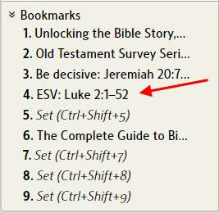

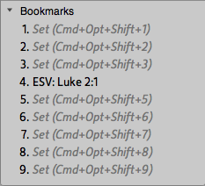

• Or you can drag and drop a bookmark using the numbered steps below. Dragging is holding down the left mouse button while moving the mouse (don't release the mouse button while moving the mouse) and dropping occurs when you release the mouse button.

1. Open the Favorites tool so that you can see Bookmarks on your work area. (see How do I view the Bookmarks tool? ).

2. Open the book that you want to bookmark (e.g. ESV Bible).

3. Position the place in the book that you want to bookmark (e.g. move the verse to the top of the window of your visible book).

4. Drag the Tab for your book to the bookmark that you want to have it saved as (e.g. the image shows saving the ESV in the 4th bookmark).

5. Now your bookmarked book appears in the bookmarks tool (e.g. please notice ESV:Luke 2 appears in the 4th bookmark. See image above for the name showing up.).
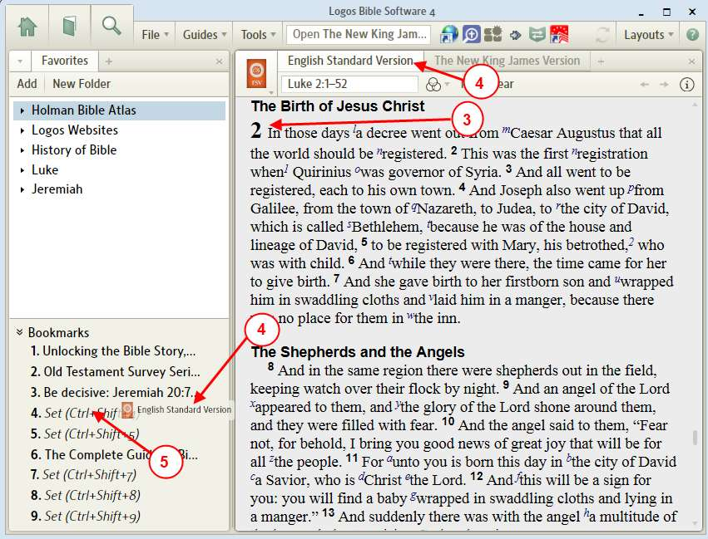

How do I open a book using a Bookmark?
[[@Headword:Bookmarks - Opening ]]
• Click on a bookmark to open it into your work area. (if bookmarks tool is not visible, see How do I view the Bookmarks tool?) If the book is not already visible in a Tab in your work area, then Logos will open that book in a Tab associated with that type of book.

• Or you can right click on the bookmark and a pop-up menu will appear which allows you to Open in a new tab or Open in a floating window.
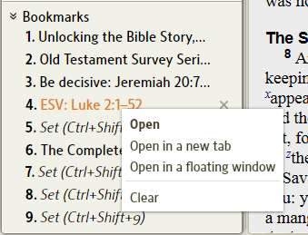

• Or holding the Ctrl key down and click on a bookmark will open the book in a new Tab on your work area.

• Or you can use the keyboard to open a bookmark by using key combination Ctrl+4 on PC or Cmd+4 on Mac (replace 4 with appropriate bookmark number).

How do I update or replace a Bookmark?
[[@Headword:Bookmarks – Updating/Replace ]]
• To update a bookmark

▪ Make sure that your new position is placed at the top of your book's window. Then overwrite your previous bookmark (see How do I set a bookmark? ).

• To replace a bookmark, just bookmark your new bookmark over the old bookmark. (see How do I set a bookmark? )..

How do I clear/erase a bookmark?
[[@Headword:Bookmarks – Clear/Erase ]]
• There are 2 ways to clear a bookmark

1. Hold the mouse over the bookmark that you want to clear. Then click on the x next to the bookmark.
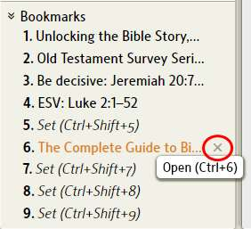

2. Or right click on the bookmark that you want to clear and in the pop-up menu click on Clear.
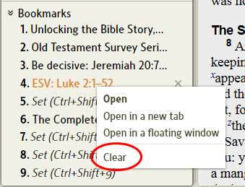

Tip from Morris Proctor
[[@Headword:Bookmarks – MP Tips ]]
• See this blog, Morris tells how you should reserve Bookmark #1. He has a short video worth watching!

Highlighting
[[@Headword:Highlighting ]]Wiki page: Revision 30 Link

Video
Mark Barnes
Logos Tutorial Video #9 – Highlighting

See Also
Tools
Extended Tips for Highlighting
Navigating by Highlights
Finding Highlighted Text
Creating and Using Highlights video

Opening the Highlight Tool
[[@Headword:Highlighting - Opening ]]
The Highlighting tool can be opened using Tools | Highlighting. If it is opened by a simple click it will open in a fixed pane (cannot be re-sized) on the left side of the screen.

If you want to give the Highlighting pane custom dimensions you can drag it from the Tools Menu or by its tab to any location on your screen, just like any other resource.

Applying Highlighting
[[@Headword:Highlighting - Applying ]]
The tool looks like this (you can expand or collapse sections by clicking on their titles).

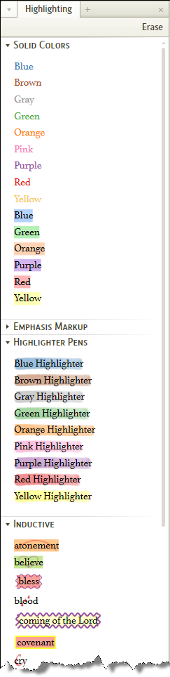
To highlight some text, select the text you want to highlight, and click on a highlighting style. Pressing Ctrl+K will apply that same selected highlighting style which is now the current one (you can only have one current highlighting style at a time).

You can keep the highlighting tool open in a panel (usually it comes up by default as a narrow panel on the left) if you're going to be using various different highlight colors. Or if you're just going to use one color, you can close the panel, select text and press Ctrl+K to apply the current highlighting style to the selection. Also you can assign keyboard shortcut keys to simplify the process (see the next section).

Erasing Highlighting
[[@Headword:Highlighting - Erasing ]]
To erase highlighting, select the highlighted text and click Erase (on the upper right of the Highlighting panel).

Or from the keyboard: select the highlighted text and on your keyboard press the key combination Ctrl Shift K (Mac users: Shift Cmd K).

New with version 4.2a: select the highlighted text, then right click on it; with Selection set on the right you will find Remove Highlighting on the left, click on it.

Shortcut keys
[[@Headword:Highlighting – Shortcut Keys ]]
Introduced in 4.0c

Assigning

1. Right click on a highlighter style

2. On the pop-up menu click on the arrow to the right of Shortcut key

3. In the new pop-up menu click on the letter that you want to assign to this highlighter shortcut.

4. Hit Esc or click somewhere else to dismiss the pop-up menu.

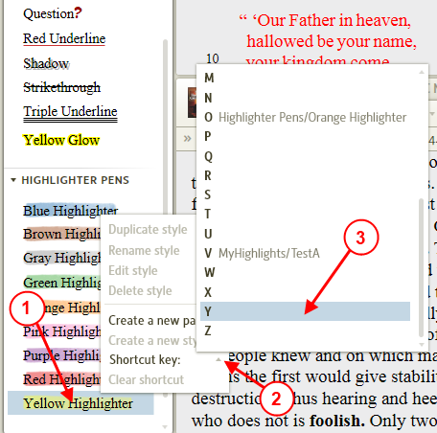

Using

Select the text you want highlighted and press the appropriate shortcut key. (No Shift, Ctrl, Alt combination is needed)

Clearing a Shortcut key

1. Right click on the highlight style

2. In the pop-up menu click on Clear shortcut.
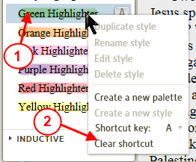

Creating Custom Palettes
[[@Headword:Highlighting – Custom Palettes ]]
Watch John Norman's helpful Creating and Using Highlights.

In the Highlighting panel right click and select "Create a new Palette"

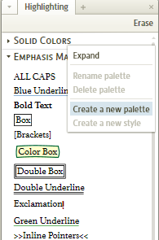

Give the new palette a name.

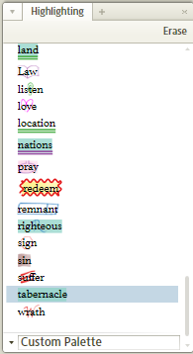

Right click on your new palette and select "Create a new style"

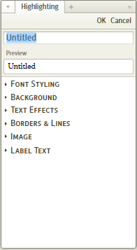

Give the new style a name and then proceed to modify the Font, Background, Text Effects, Borders & Lines, Image, and Label Text. The preview area will show you what your style will look like. See below for detailed descriptions of what each of these options do.

As you add new styles to your custom palette the program will order them alphabetically. If you want to have the styles listed in an alternate order place a number before the style name (i.e. 1Genesis) before you save the style. If you add a number after you create the style you will have to relaunch the highlighting pane for the change in order to take effect. You might need to play around to see how numbers letters and spaces interact.

Font Styling

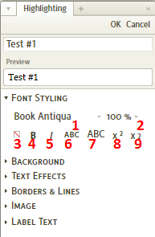
The font is changed when the markup is applied:

1. Select font from drop-down to change the font of text

2. Changes the size of the text

3. Changes the color of the text

4. Makes the text bold

5. Makes the text italicized

6. Makes the text all small caps

7. Makes the text all caps

8. Superscripts the text

9. Subscripts the text

Background

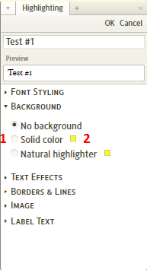
1. Choose None, Solid Background, or Highlights

2. Use colored square to choose the background color.

Text Effects

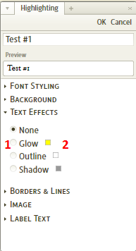

1. Choose Glow, Outline, or Shadow

2. Use the colored square to choose the color of the effect.

Borders & Lines

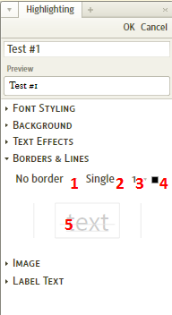
1. Selects the type of line to be used (i.e. solid, dashed)

2. Selects the number of lines to be used

3. Selects the thickness of the line

4. Changes the color of the lines

5. Click on the light gray lines to choose where in relationship to the text the line/border is used.

Image

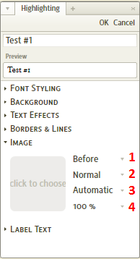
Click on the gray square to bring up the file navigator. Choose the desired image (a number are available by default).

1. Chooses the Horizontal alignment of the image

2. Chooses the Vertical alignment of the image

3. Chooses the color of the image

4. Chooses the size of the image

Label Text

This option allows the insertion of a text label before or after an applied highlight. The font selection is identical to the Font Styling section above with the exception of the "Bubble" option which encases the text in a bubble (not surprisingly).

Old Test. icons

Small icons which you can add to your highlighting are in this File. They were posted in this forum post

Examples
[[@Headword:Highlighting - Examples ]]
See this wiki page for highlighting examples. Highlighting – Examples

▫ Highlighting - Examples
[[@Headword:Highlighting Examples ]] Wiki page: Revision 7 Link

See also:
Highlighting
Visual Filter Menu

Creating a new Palette and adding 2 styles to it
[[@Headword:Highlighting Examples – Creating a new Palette ]]
This example will show you how to create a new Palette. Then it will show you how to add 2 new styles within that new palette.

Creating the new Palette
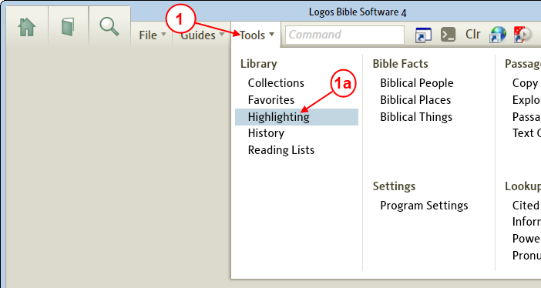

1. First we need to open the Highlighting tool window. In the top menu bar click on Tools.
a. In the drop down menu, click on Highlighting.
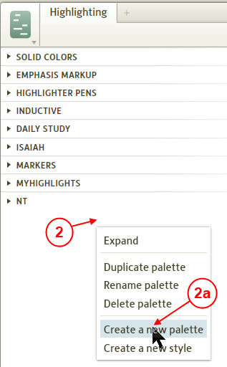

2. Now in an open area in the Highlighting tool right click to have Logos4 open a pop-up menu.
a. In the pop-up menu click on Create a new palette.

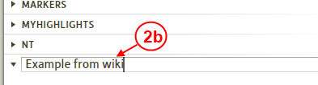

b. In the new palette (which should be selected and blue) type the new name for the new palette: Example from wiki, then press Enter on your keyboard.

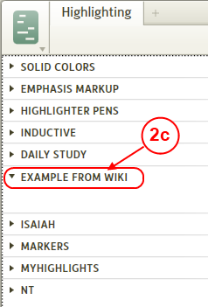

c. Now we see our new palette in the Highlighting tool.

Now let's add a new style to our new palette
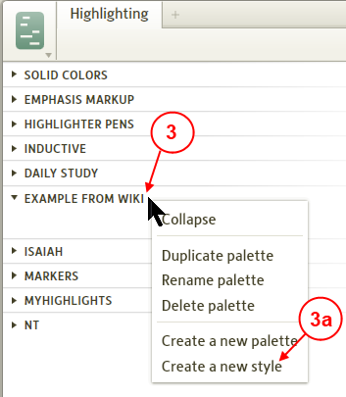

3. Next to the new palette, right click to have Logos4 show us the pop-up menu
a. In the pop-up menu click on Create a new style.

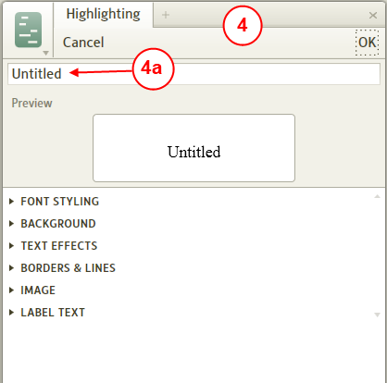

4. Now we see the Style editor in the Highlighting window.
a. Click on the title box and enter the title for our new style: Green Underline.

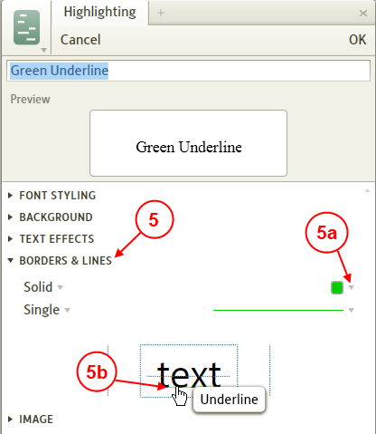

5. Click on Borders and lines. Since we want to make a green underline style.
a. Click on the arrow next to the color box, in the pop-up color selector (not shown) click on Green for the color.
b. Now we need to identify where the line will be placed for this style. Hold the mouse over the bottom of the TEXT until you see the pop-up information cue for Underline, then click once with your mouse.

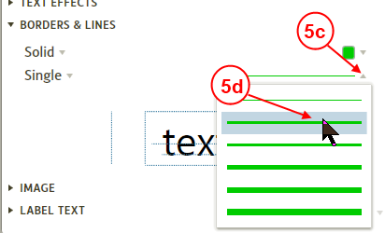

c. Let's also make our underline more bold. Click on the arrow next to the line width.
d. In the pop-up width selector click on a thicker width as shown.
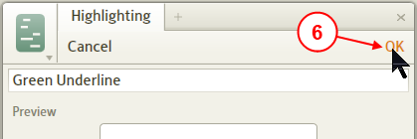

6. Now we are done creating our new Style, so click on OK at the top of the Style editor.
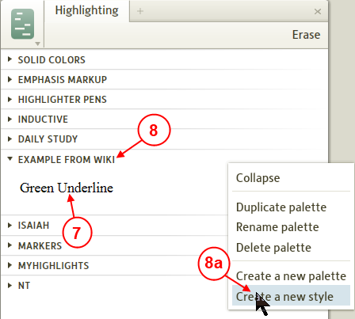

7. Now we see our new style which we created.

Now let's create another Style in our palette

8. Right click next to our palette name to have Logos4 show the pop-up menu.
a. In the pop-up menu click on Create a new style.

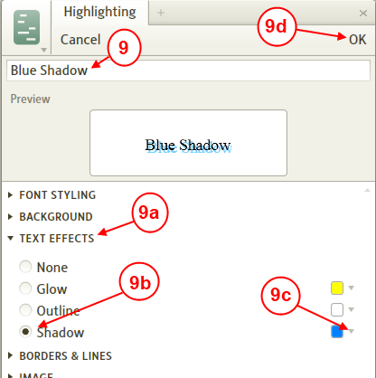

9. Click on the title box and type: Blue Shadow and press the Enter key.
a. Click next to Text Effects to use these effects for our style.
b. Click on Shadow to have our style use shadow.
c. Click on the arrow next to the color box, in the pop-up color selector (not shown) click on blue.
d. Now we are done, click on OK to close the style editor.
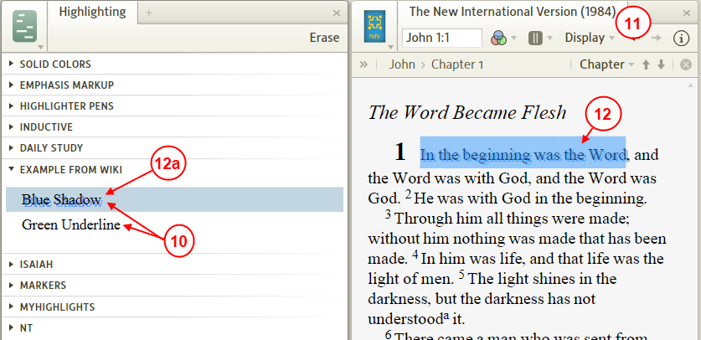

10. Now we see both of our new styles in our new palette.
11. Open a Bible next to your Highlighting tool.
12. Use your mouse to click and drag to select some text in your Bible.
a. Now click on Blue Shadow in the Highlighting tool. This will cause Logos4 to apply the Blue Shadow highlighting to our selected text in our Bible.
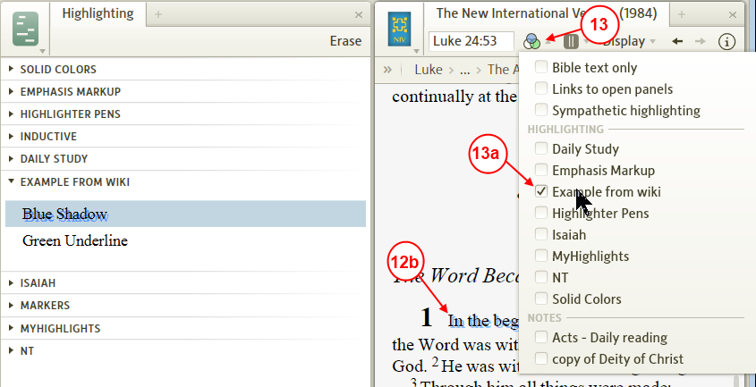

b. Now in the Bible, click somewhere off the selected text. Notice that the text you had selected is now highlighted with your new Blue Shadow.

13. You can use the visual filter menu to Show or Hide your highlighting. So click on the visual filter icon to have Logos4 show the visual filter menu.

a. Find your highlighting palette name. If you click on it, Logos4 will check or uncheck it. When it is checked your highlighting for this palette will be shown in your book. Likewise when it is unchecked highlighting for that palette will not be shown. Something useful to learn from this is that if you want to control what is highlighted in a book, you can do this by having custom highlighting palettes with unique names. That way you can turn certain highlighting Off while still allowing other highlighting to show.

14. Now experiment with your new highlighting styles in your book. Also experiment with using the visual filter menu to turn On/Off your highlighting in your book.

Adding keyboard shortcuts for highlight styles
[[@Headword:Highlighting Examples – Adding keyboard shortcuts to highlight styles ]]
This example will show you how to add highlighting styles to keyboard shortcuts. Having keyboard shortcuts for highlighting styles can make it much easier to add highlighting to your books. If you have several shortcuts that you remember it will prevent you from having to open the Highlighting tool and save you space on your layout. In this example we will add keyboard shortcuts to various Underlining styles.

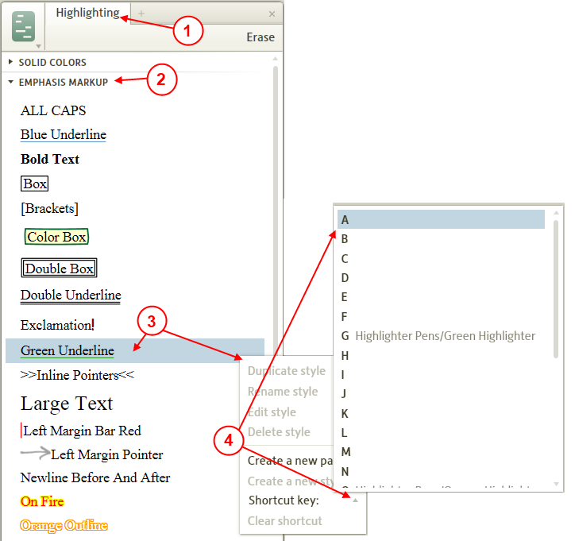

1. Open the Highlighting tool. (Click on Tools in the top menubar, then click on Highlighting)
2. In the Highlighting tool, click on Emphasis Markup to expand it.
3. Right click on Green Underline. Logos 4 will show you a pop-up menu.
4. In the pop-up menu to the right of Shortcut key click on the triangle. Logos 4 will show you another pop-up menu. Click on A to have Logos 4 assign the keyboard letter A to the Green Underline style.
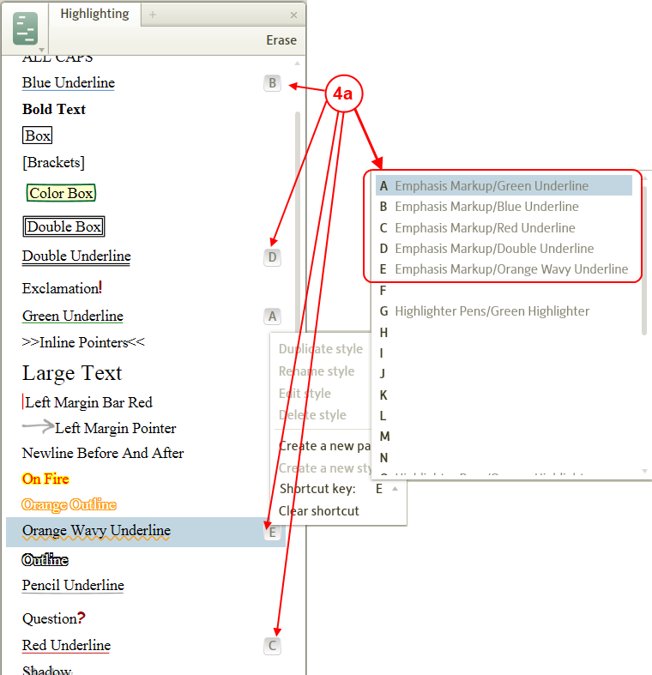
a. You may want to add other Underline styles. In this example we have added 4 other shortcuts to Underline styles (to do this just repeat steps 3 & 4 using the letters below and the styles below)

• B = Blue underline
• C = Red underline
• D = double underline
• E = wavy underline
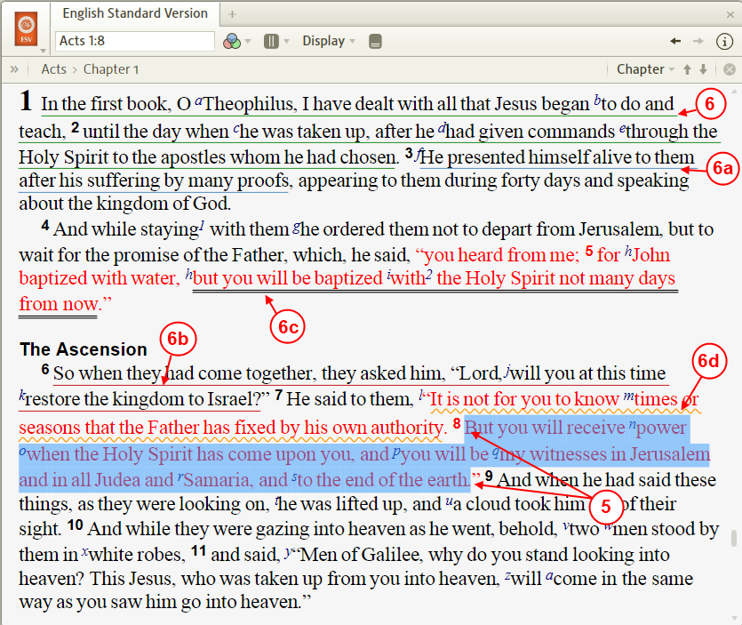
5. Now open a book (e.g. ESV Bible). Use your mouse to select text that you want to highlight (click at the beginning of text and keep the button down and drag over the text you want selected, then release the mouse button)
a. Now on your keyboard press the letter A to apply Green Underlining to your selected text.

6. In the above image you will see where using step 5 was applied to text to apply Green Underlining.
a. Here we applied Blue underlining using the B key.
b. Here we applied Red underlining using the C key.
c. Here we applied Double underlining using the D key.
d. Here we applied Wavy underlining using the E key.

Now you see how to add keyboard shortcuts to Highlighting styles. You can create shortcuts for any of your highlighting styles. You may want to group different kind of style to specific groups of letters (e.g. Underlines to A-E, Highlighter Pens to G-K, and so forth).

History
[[@Headword:History ]]Wiki page: Revision 2 Link

History is a tool that you get to from the Tools menu. It works very similar to the history that you find in an internet browser. See Morris Proctor's blog on this item Logos 4: Global History in Logos 4

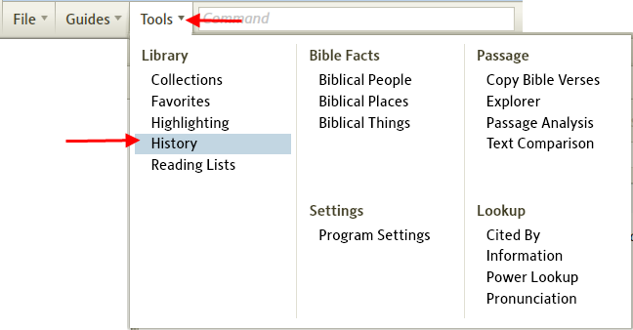

Personal Books
[[@Headword:Personal Books ]]Wiki page: Revision 151 Link

See also
List of Datatypes
Search Fields List
Bible Datatypes
Author Datatypes
Finding a datatype name and reference
Bible Book Abbreviations
Logos Bible Book Names
Logos Personal Books Tool
User Contributed Personal Books

(Personal Book Builder in Logos 3)

Personal books are user created resources with almost all the features of a Logos resource. They are built from Microsoft Word documents (.docx files) using the Personal Books tool in Logos 4 and are fully incorporated into your Library.

Note that Personal books built in Logos 3 are incompatible with Logos 4.

Quick Clip Videos

Official Logos 4 Trainer, Morris Proctor, has excellent free Personal Book Quick Clip Videos.

Terminology
[[@Headword:Personal Books - Terminology ]]
To create PBs, you need to understand the types of tags that you can add to a document:

• Milestones are not seen in the finished resource. They're hidden markers that indicate the location in a resource. For example, in a Bible, a milestone is needed at every verse. In a Dictionary, a milestone is needed at the beginning of every article. In many resources, milestones are also added at the beginning of each page.
• Datatype links are visible in the finished resource. As they name suggests, they add links to other resources or Bible passages. Datatype links don't link to a specific resource, but to a datatype (such as Bible or Josephus). Logos will then open the link in the most highly prioritised resource that supports that datatype.
• Resource links are also visible in the finished resource. As the name suggests, resource links link to specific resources, and optionally to a specific location in that resource.
• Fields are also called Search Fields. A Bible resource can have fields like footnote, bible, heading, words-of-christ; where bible refers to the manuscript text and words-of-christ refers to the words (within bible) spoken by Jesus.

Syntax
[[@Headword:Personal Books - Syntax ]]

Milestones
[[@Headword:Personal Books - Milestones ]]

The syntax for milestones is {{~ [[@datatype:reference]] }}. For example:

• {{~ [[@Headword:Rome]] }} It uses the language from the Word document, else specify @Headword+<language>
• {{~ [[@Bible:jn 3:16]] }}
• {{~ [[@GreekStrongs:G3056]] }}
• {{~ [[@DayOfYear:January 17]] }} This would tend to be used in calendar devotionals that could be used in any year
• {{~ [[@YearMonthDay:Jan 17, 2012]] }} This would tend to be used in lectionaries that would be used in a specific year
• {{~ [[@Page:513]] }} or {{~ [[@VolumePage: 1,513]] }}

If you're unsure how to find out the name of the datatype and reference, there are step-by-step instructions available.

Datatype links
[[@Headword:Personal Books – Datatype links ]]
The syntax for datatype links is very similar to milestones, but without the @ sign, and with an optional label {{~ [[label >> datatype:reference]] }}. For example:

• {{~ [[Rome, City of >> Headword:Rome]] }} this will link to the current resource if the milestone is present
• {{~ [[Bible:Jn 3:16]] }} most Bible links are created automatically, which means you don't need to tag them
• {{~ [[GreekStrongs:G3056]] }}
• {{~ [[DayOfYear:January 17]] }}
• {{~ [[YearMonthDay:Jan 17, 2012]] }}
• {{~ [[Page:513]] }} Page numbers always link to the current resource

If you're unsure how to find out the name of the datatype and reference, there are step-by-step instructions available.

Resource links
[[@Headword:Personal Books – Resource links ]]
Open the resource to the desired place, select WIKI as the Copy Location method in the panel menu, then copy with Ctrl+Alt+C and paste the link with Ctrl+V. It uses the syntax {{~ [[label >> link]] }} so you can change the label as needed.

Note:
• Page offsets are not yet supported e.g. {{~ logosres:hlmnbblhbk;ref=Page.p_591;off=759 }} will go to the start of the page.
• To open a lectionary to today's reading specify ref=YearMonthDay.today e.g. {{~ logosres:BCPDOLECT;ref=YearMonthDay.today }}

Fields
[[@Headword:Personal Books - Fields ]]
The syntax for Fields is {{~ {{field-on:<fieldname>}} }} ... {{~ {{field-off:<fieldname>}} }} OR use a Word style field:<fieldname>. For example:

• {{~ {{field-on:Bible}} }} "For God so loved the world, {{~ {{field-off:Bible}} }}
• {{~ {{bible-on}} }} "For God so loved the world, {{~ {{bible-on}} }}
• If above text has a Style called field:RedLetter then it will be compiled as words-of-christ or WOC.

For a list of fieldnames see Search Fields List.

Building Personal Books
[[@Headword:Personal Books - Building ]]

Create the book
[[@Headword:Personal Books - Create ]]
Your book is built from one or more Word .docx files. Add text or paste text from your original and add milestones, fields, links and other syntax elements as necessary. You can generate footnotes and use Word Heading styles for your articles/chapters as this will automatically generate a TOC. Text and syntax elements should use the Normal style and can be intermingled. Keep formatting consistent between the files of your book.

Note that milestones can be on the same line as the Heading because they are not visible in the resource, including TOC. Also remember that milestones are the only way to index the content of the article.

See Examples for other suggestions.

Build the book
[[@Headword:Personal Books – Build the book ]]
1. Go to Tools > Personal Books
2. Click Add book
3. Enter Title
4. Enter Author (optional)
5. Enter Copyright message and Description (optional)
6. Choose the book Type (default: Monograph).
7. Choose a Language (it is hoped that more will be added in the future)
8. Click Add field for a menu of optional fields (Abbreviated Title is displayed)
9. Optionally add a cover image: Click Change... under the blank book cover and choose an image file from your hard disk. You can find usable image files for most published books by searching for their title on Google Images
10. Click Add file... and select the .docx file from your hard disk. You can add multiple .docx files to make up a book and use "drag&drop" to reorder them (right-click a file to remove it).
11. Click Build book

After the book is built (aka "compiled") it should automatically open in a tab and begin Indexing.

Rebuilding a Book
[[@Headword:Personal Books – Rebuilding a Book ]]
Make changes to your docx files, Add or remove any BODY FILES and then click Build book.
It will recompile, recreate the resource file and then Index it.

Problems you may encounter
[[@Headword:Personal Books - Problems ]]
• If you get the message "Build Failed - Could not remove existing resource" it will advise you to close all open panels, but a restart works best.
• When the build succeeds you may get some Warnings/Errors and click View Log File, only to be confused by the messages. You can ignore them provided the document is converted properly.
• Your milestones and links may appear to be correct but if they aren't recognised by Logos you can often fix them in Microsoft Word by following these steps:
1. Save your Word document as an RTF file and close it.
2. Re-open the RTF file and Save as a Word .docx file.
• Logos can crash without generating a log file. If this happens to you please send the document to logos4feedback@logos.com so they can test the document.

If the document doesn't get converted properly report the issue as a Bug on Logos 4 Windows or Logos 4 Mac as appropriate.

Hints and Tips
[[@Headword:Personal Books – Hints and Tips ]]

Add a Search
[[@Headword:Personal Books – Add a Search ]]
First perform your search in the Search tool, then click on the Search menu and click on URL to copy the query to the clipboard. Then paste it into your document e.g. {{~ logos4:Search;kind=Basic;q=Word1_OR_Word2;match=stem }}

Consistent Formatting
[[@Headword:Personal Books – Consistent Formating ]]
Consistent formatting is essential to getting your links compiled correctly e.g. it is almost impossible to notice different styles having the same font+size. Here is the best way to achieve this in MS Word:-
1. place your cursor somewhere in the document that has the desired formatting (style + font).
2. press CTRL+SHIFT+C to copy the formatting
3. select the text/link.
4. right click> Styles> Clear formating (or select Clear All in the Styles box)
5. press CTRL+SHIFT+V to paste the formatting.

Convert PDF to Word format
[[@Headword:Personal Books – Convert PDF ]]
There are many free converters, mostly online. Afterward you may have to use your word processor to convert to docx.

Hidden hyperlinks
[[@Headword:Personal Books – Hidden hyperlinks ]]
A datatype reference, particularly bible ones, can display duplicated entries in a hover popup. The reference may look OK in the docx file and the resource but there is a hidden hyperlink. You can fix with Word's Remove Hyperlink or select a number of references and use Ctrl+Shift+F9.

Ignore a reference
[[@Headword:Personal Books – Ignore ref ]]
If you want a reference to be ignored by the compiler try the syntax {{~ {{~ reference }} }} (note the space before and after the reference).

Labels
[[@Headword:Personal Books - Labels ]]
Use the syntax {{~ [[label >> link]] }}.

Lemmas
[[@Headword:Personal Books - Lemmas ]]
The 'Lemma' tab in the (right-click) context menu is not currently supported. But you can change the language setting in Word to Greek or Hebrew (after selecting the text) to get your prioritized lexicons in the lower portion of the context menu.

Pictures and Images
[[@Headword:Personal Books – Pictures and Images ]]
You can paste images from Logos 4 or .bmp (bitmap) format directly into your document. Others must be inserted from the hard drive and with Text Wrapping (on right click menu) set to In Line.
Note: Neither method works with Word 2003, so you have to save to docx from Word 2007 or Skydrive.

Search Fields
[[@Headword:Personal Books – Search Fields ]]
Fields appear in the Search panel drop-down. Note that Red Letter text is "Words of Christ" and that you can only search for (tagged) Bible text in a Bible.

Search Results
[[@Headword:Personal Books – Search Results ]]
Results appear in the Search panel under My Books but the section may need to be opened. Results from the Collections section of Passage Guide are also separated and PB's will appear after any Logos books!

Searchable TOC Entries
[[@Headword:Personal Books – Searchable TOC ]]
If you want your TOC entries (Article heading, Chapters, Bible Book names, Pericope headings) to be searchable as a Heading field enclose them with {{~ {{field-on:Heading}} }} / {{~ {{field-off:Heading}} }} tags on separate lines.

Searching Bibles
[[@Headword:Personal Books – Searching Bibles ]]
You can use Bible Search for Bibles tagged with the bible search field, but Morph Search is not currently supported (see Lemmas).

Space is ignored (Workaround)
[[@Headword:Personal Books – Space ignored ]]
If space between words and codes (syntax) is ignored then expand the character spacing (Ctrl+D in Word 2007) by 1 or 2 pt.

Word hyperlinks
[[@Headword:Personal Books – Word hyperlinks ]]
If Word hyperlinks do not compile then try the syntax {{~ [[label >> link]] }}. However, if the link reference is then detected as a hyperlink (blue and underlined in Word) right-click on the link and choose Remove Hyperlink.

Resource type requirements
[[@Headword:Personal Books – Resource Type requirements ]]
• Ancient Manuscript:
• Apparatus:
▪ Like Bible Apparatus, but has non-Bible milestones.
• Bible:
▪ create milestones for each verse
▪ use Fields to separate Bible text from verse numbers and headings, etc. Punctuation may safely be included; maybe footnote marks as well. Use Text Compare to see what is showing up in your PB book. For more see Bohuslav's examples
▪ Bibles are not fully working in Guides and Tools.
• Bible Apparatus:
▪ Has Bible milestones (like Bible Commentary); the primary content for each verse is critical apparatus notes.
• Bible Commentary:
▪ Mark text which comments on a verse with a milestone like {{~ [[@Bible:jn 1:1]] }}
▪ Commentaries usually comment on every verse
• Bible Concordance:
▪ Has headword milestones (like Dictionary); the primary content for each word is a list of verses in which that word appears. This type exists for backwards compatibility with print books; the Search feature can be used to replace this type of book in a digital library.
• Bible Cross-Reference Index:
▪ Has Bible milestones (like Bible Commentary); the primary content for each verse is references to other verses.
• Bible Harmony:
• Bible Notes:
▪ see Bible Commentary. However, Bible Notes may not comment on every verse and have concise comments or study notes.
▪ If your comment covers different passages then put milestones on successive lines.
• Calendar Devotional:
▪ requires tag in the format of {{~ [[@DayOfYear:MMMM d]] }} e.g. {{~ [[@DayOfYear:January 17]] }}.
• Commentary:
▪ Like Bible Commentary, but has non-Bible milestones (e.g., Apostolic Fathers, Josephus, Shakespeare).
• Cross-Reference Index:
▪ Like Bible Cross-Reference Index, but has non-Bible milestones.
• Dictionary:
▪ requires tag in the format of {{~ [[@Headword:Your_Item]] }} e.g. Sin{{~ [[@Headword:Sin]] }}.
▪ For the differences between "Dictionary", "Encyclopedia", and "Lexicon", see this thread.
• Encyclopedia:
▪ Same as Dictionary.
• Grammar:
• Journal:
• Lectionary:
▪ requires tag in the format of {{~ [[@YearMonthDay:MMMM d, yyyy]] }} e.g. {{~ [[@YearMonthDay:Jan 17, 2012]] }}.
• Lexicon:
▪ Same as Dictionary.
• Magazine:
• Manual:
• Monograph:
▪ no special requirements
• Thesaurus:

Examples
[[@Headword:Personal Books - Examples ]]

Wiki pages
[[@Headword:Personal Books – Wiki pages ]]
• How to add a Table of Contents to your Personal Book
• How to add a Footnote to your Personal Book

From the Forum
[[@Headword:Personal Books – From Forum ]]
• Making a commentary, see this post.
• Making a commentary series see this post
• Making a Bible, see this post
• Tag generator, see this post
• Macro page number generator, see this post
• Various PB tagging examples, see this post
• Macros for Word 2010 & 2007 and for Word 2003
• Example of setting up a Devotional PB, see this post
• Adding a Heading without it appearing in the TOC of your PB, see this post
• Logos has no plans for lemma and morph tagging syntax in PB's, see this post

▫ Adding TOC in PBs
[[@Headword:Adding TOC in PBs ]] Wiki page: Revision 4 Link

See also:
Personal Books

This wiki page will show you how to add Styles in Microsoft Word to your source document to add a Table of Contents (TOC) to your Personal Book (PB).

Word's Styles
[[@Headword:Adding TOC in PBs – Word’s Styles ]]
You should already have the following styles in Word's style list.

• Heading 1
• Heading 2
• Heading 3
• and so forth

Styles in Word 2003
[[@Headword:Adding TOC in PBs – Word’s Styles [2003] ]]
You can view Styles in Word 2003 by clicking in the menu on Format and in the drop down click on Styles and Formatting.

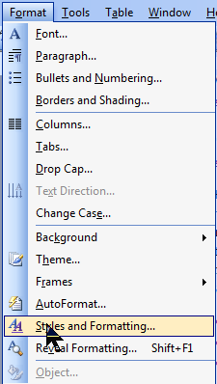

Then you will see the Styles pane appear in Word

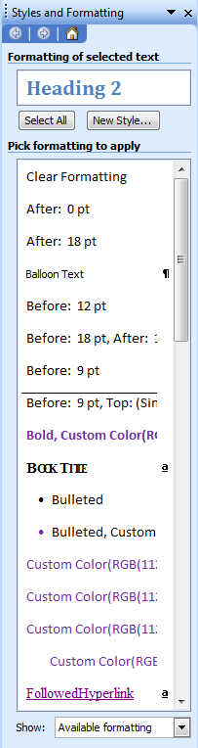

Styles in Word 2010
[[@Headword:Adding TOC in PBs – Word’s Styles [2010] ]]
You can view a pane of styles in Word 2010 if you select the Home tab and then click on the corner of the Styles panel

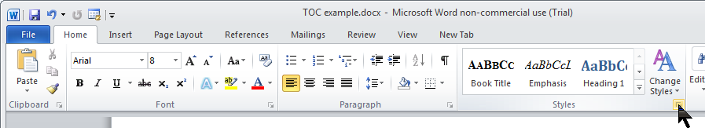

Then you will see the Styles pane appear in Word
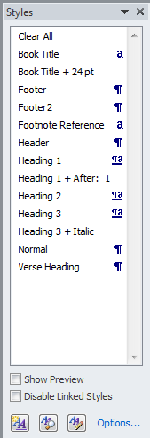

Adding the Styles in your Word doc
[[@Headword:Adding TOC in PBs – Adding the Styles ]]
In your Logos 4 books you should have noticed in some Table of Contents that some entries are indented under other entries. These indented entries are basically articles which are under the non-indented TOC entries.

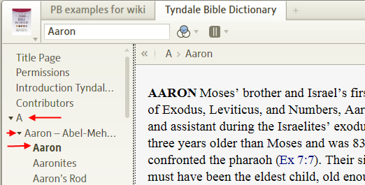

In your PB Word doc
[[@Headword:Adding TOC in PBs – Adding the Styles [In your PB Word doc] ]]
So you will need to select lines in your document that you want to show in the PB's Table of Contents and then click on a Heading style to tag it. After you tag the lines in your Word document and then build your PB, your TOC entries will appear in your PB. Below is a screen shot showing Word sitting on top of Logos 4's PB.

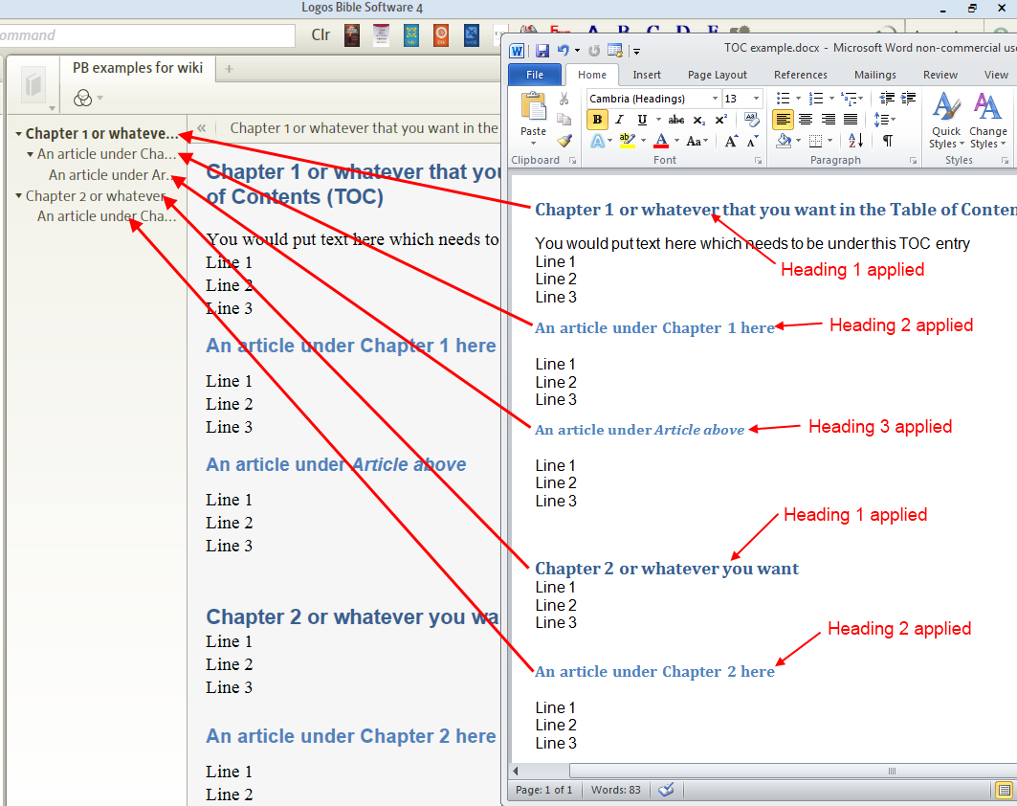

Notice how lines marked with style Heading 1 are not indented in your PB's TOC.
And those which are marked with styles of Heading 2 & Heading 3 are indented under Heading 1.

▫ Adding Footnotes to your PB
[[@Headword:Adding Footnotes to PB ]] Wiki page: Revision 3 Link

See also:
Personal Books

This wiki page will show you how to footnotes to your Personal Book (PB).

Adding a footnote in your Word document
[[@Headword:Adding Footnotes to PB [to Word doc] ]]
To get footnotes in your Personal Book (PB) you add footnotes in Word as you normally would and after building your PB they will show up when you hover your mouse over a footnote.
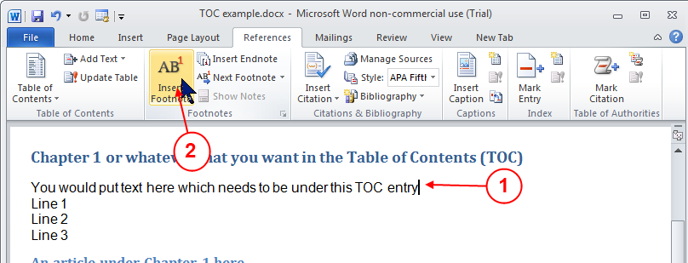

1. Place your cursor where you want your footnote
2. Select the Reference tab and then click on Insert Footnote.
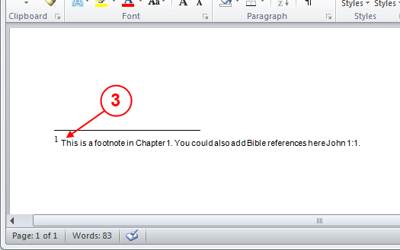

3. When Word sets your footnote marker at the bottom of the page, enter the text that you want in the footnote. This text will appear in your PB when you hover your mouse over the footnote number.

Note: You can skip step #2 by using the keyboard shortcut Ctrl Alt F in Word.

Checking your Footnote in your PB
[[@Headword:Adding Footnotes to PB [checking it in PB] ]]
After you have built your PB and are viewing it, then follow the steps below to check each of your footnotes.
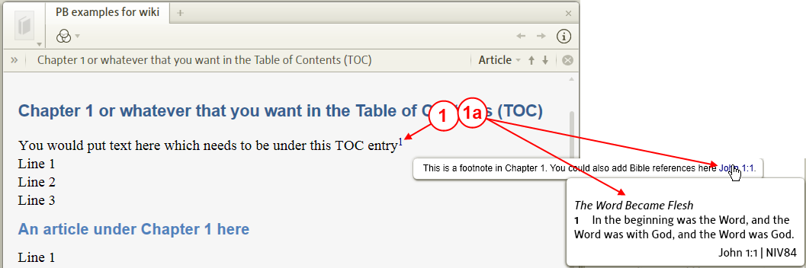

1. Hover your mouse over your Footnote in your PB and you should see your footnote appear as a pop-up box.

a. If you click on the Footnote in your PB, Logos 4 will show the footnote in a pop-up box which will remain visible after you move your mouse away from the footnote. This is useful when you want to ensure that other references in which you added to your footnote will appear when you hover your mouse over those references.

▫ Finding the right datatype name and reference
[[@Headword:Finding right DataType name & ref ]] Wiki page: Revision 6 Link

See also
Personal Books
List of Datatypes
Bible Datatypes
Author Datatypes
Logos Personal Books Tool

If you are creating a Personal Book, you will probably need to specify milestones and datatype links. This page is designed to help you find the names of the datatypes you need for this task.

You can create milestones and datatype links for any of the datatypes that exist in Logos, although you can't create new datatypes. To be able to insert a milestone or datatype link, you need to know both the datatype name and the exact reference. For this you need to own a resource that supports that datatype, or own another resource that points to that datatype.

If you own a resource that supports that datatype
[[@Headword:Finding right DataType name & ref – in resources that you own ]]
For example, imagine you wanted to create a datatype link to Josephus' Wars where he mentions Bethel.

First, you obviously need to locate the right place in Wars. If you already know the name of the datatype, then finding the name of the reference is easy because it is displayed in the reference box at the top of the resource (in this case it's Wars of the Jews 4.551 or Wars IV, ix 9). Most books (including Josephus) support multiple datatypes, and clicking on the reference box will allow you to switch between the different datatypes. Make sure you choose the correct reference for the datatype you are using. If you're not sure which references matches your datatype, you'll need to follow the instructions below, which assume you don't know the datatype.
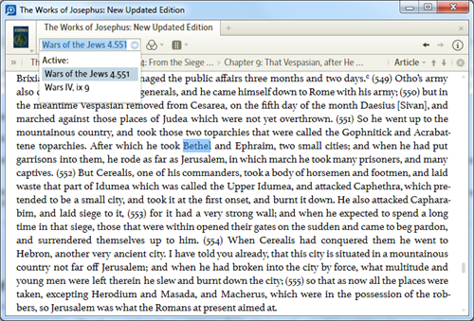

If you don't already know the name of the data type, or you don't know which reference matches your preferred datatype then we need to do a bit more digging. Click on the resource menu (the book cover with the drop-down arrow), and copy the current location to the clipboard. You can use any format except HTML, but for consistency with resource links it's best to use the Wiki format.
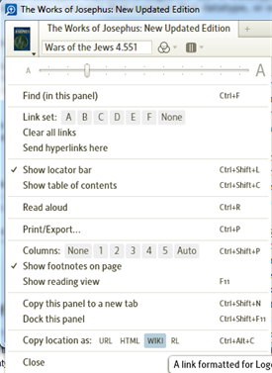

Now, paste the resulting link into your Personal Book. It will look like this: {{~ [[Wars of the Jews 4.551 >> logosres:josephus;ref=JosephusLoeb.Wars_4.551]] }}.
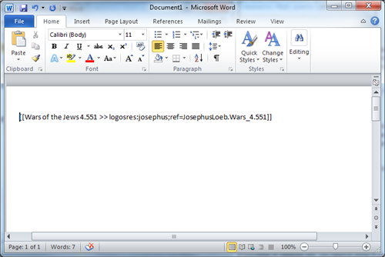

That's not a datatype link, that's a resource link. But we can convert it into a datatype link (or a milestone), by extracting the bit after ref= and before the semicolon or two sqaure brackets, and deleting everything else. In this case, we're left with JosephusLoeb.Wars_4.551. Now, replace any underscores after the period with a space (so Wars_4.551 becomes Wars 4.551). The bit before the first period is the datatype name (in this case JosephusLoeb). The bit after the period is the reference (Wars 4.551).
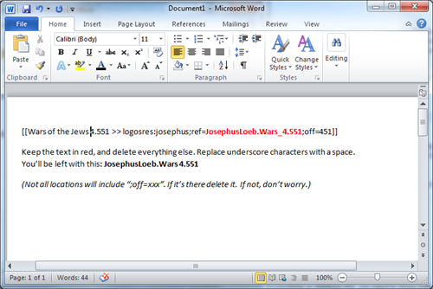

To construct our datatype link, we use the syntax above: {{~ [[label >> datatype:reference]] }}. If we've followed the method above, we'll have the datatype and reference separated by a period. So to get the syntax we need, we replace this period with a colon, wrap the whole thing in double square brackets, and optionally add a label (if so, we also add two right-angle brackets as a separator). So, in this case we end up with {{~ [[Bethel >> JosephusLoeb:Wars 4.551]] }}

Notes:

1. If you're struggling to find the exact syntax, you can ask for help in the Community forums.
2. Several resources include multiple datatypes, often for the same location. This is to ensure the widest possible support. Josephus and the Qumran scrolls, for example, both have two different reference schemes each with its own datatype. Some books will use one referencing system, other books another, but Logos supports them both. So before you copy your location to the clipboard, make sure the correct datatype shows in the resource location box. For Josephus that gives us a choice between JosephusLoeb.Wars_4.551 or JosephusWhiston.Wars_IV,_ix_9. (If you don't understand the differences between the datatypes listed, don't worry - just pick the one that looks right to you, or that is more precise. It's very likely both will work in a very similar way.)

If you own a resource that points to that datatype
[[@Headword:Finding right DataType name & ref – Resources that point to that datatype ]]
If you don't own the resource you want to link to, but you do own another resource that links to the same or a very similar spot, it's possible to work out the datatype and reference you will need. In this example, imagine that you don't own a resource that contains the Laws of Hammurabi. But you do own the Anchor Yale Bible Dictionary, and noticed that the article on Law (Biblical and ANE Law) contained a link to laws 1, 3 and 4. You also want to create a link to law 1, in your PB.

First, find the datatype link that you want to replicate in your PB. (Although you can search for these links using Logos' search facility, you can only use the search if you know the right syntax, and at the moment you don't!)
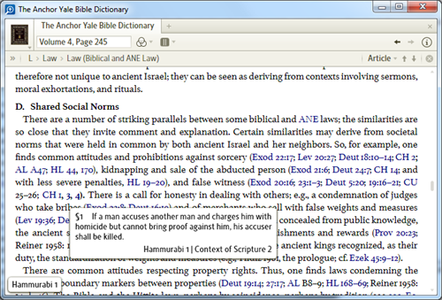

Then right click on the link, choose the datatype you're interested in from the right-hand side of the right click menu (in this example, it's The Law of Hammurabi) and then choose Search this resource from the left-hand side of the menu.
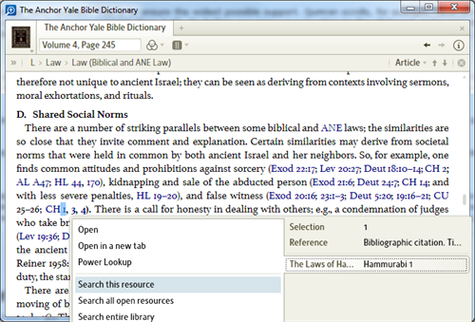

That will open a search window, and the syntax of the search will tell you all you need to know. In this example, the search syntax is <HammurabiLaws = Hammurabi 1>. We're interested in what's inside the angle brackets. The datatype is to the left of the equals sign (HammurabiLaws). The reference is to the right of the equals sign (Hammurabi 1).
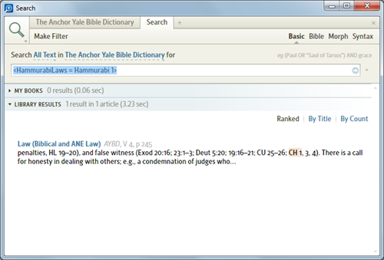

If we were creating a datatype link to this location, we would therefore use the syntax {{~ [[see the first of Hammurabi's laws >> HammurabiLaws:Hammurabi 1]] }}.

Notes:

1. Using this method sometimes produces slightly different reference names than the method referred to above. That's because Logos often has an abbreviated and full version of a reference (just like 1 Corinthians and 1 Cor and abbreviated and full versions of Bible references). The first method extracts the abbreviated version, and this method extracts the full version. Both the abbreviated and full version work in just the same way.
2. You can also use this method as an alternative to the first if you own a resource that supports the datatype. Instead of right-clicking on a link, right-click in the text itself, and choose the correct reference from the right-hand side of the right-click menu, and search this resource. Then follow step 3, above.

Reading Lists
[[@Headword:Reading Lists ]]Wiki page: Revision 55 Link

(and topic lists)

• Please watch Logos4 Tutorial videos
▪ Reading List 1
▪ Reading List 2
▪ Reading List 3
▪ Reading List 4
• Official Logos instructions on creating a reading list.
So what's the deal with reading lists? Are they worth your time and investment? Are they more difficult then they are worth? I hope this wiki will leave you with a positive impression of the value of reading lists because the more people involved with them, the more valuable they become.
Note: there is one special reading list "web resources" that is intended to provide quick access to websites of interest to Logos users.

Reading Lists Defined
[[@Headword:Reading Lists - Defined ]]

From Logos:
Reading Lists are lists of specific, targeted resources determined to be valuable by the Logos community for a given topic. They are intended to be more then just another list of commentaries and dictionaries. Buried within many libraries are journal articles, entire chapters and even entire books on topics that lay buried because they are never returned by the results of a guide. They add tremendous value to the discussion of a topic but they generally get overlooked because they are never returned by some automated source or they do not stand out in search results.

Reading lists are put together by Logos users, giving an intelligent element to the collection of resources. By putting the results of your hard, data-collecting work into a reading list, you not only benefit yourself when you come back to the topic in the future, you also benefit others who study that topic down the road. All those resources that are usually overlooked are now just a click away, as easily accessible as the Passage Guide results. My hope is that the potential of readings lists are realized and invested in so that it does not become another tool with potential that never bore fruit.

Examples
[[@Headword:Reading Lists - Examples ]]
There are three places where data in topics.logos.com is visible:

• the Reading List panel in Logos 4
• the Topic section of the search in Logos 4
• the topics.logos.com wiki

Using the example of the Magnificat, here is the reading list and basic search topic section generated from the topics.logos.com wiki entry shown below. Note that clicking on Edit in the reading list panel takes you directly to the wiki page.

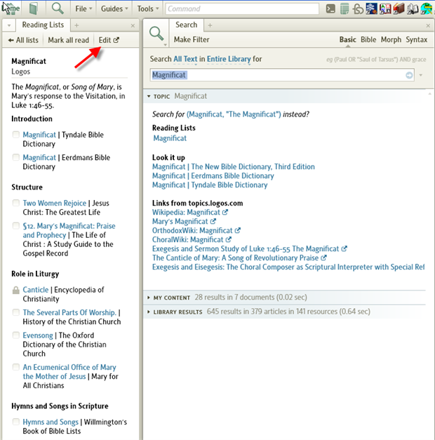

Note that the Reading List comes completely from the wiki. The Topic Section of the Search comes both from the wiki and from Logos resources that are tagged with Logos Controlled Vocabulary (LCV). In the Reading List the sections are created by users. In the Topic Section the sections are created by the software.

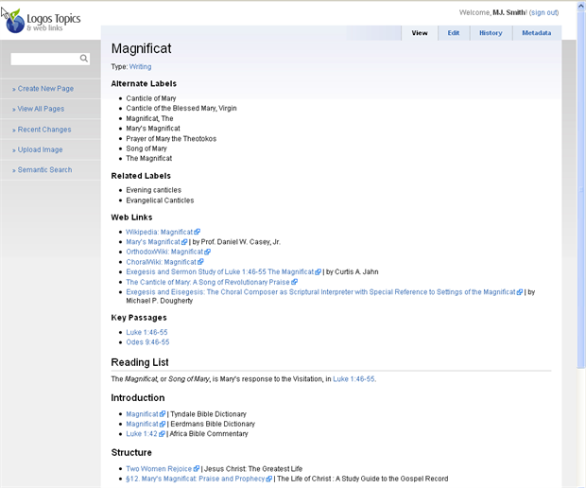

Notification when Reading Lists are created or updated is available on the ribbon of the Home Page:

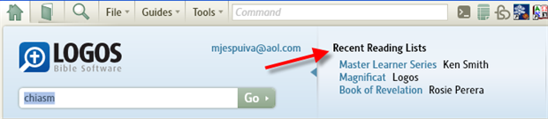

Using Reading Lists
[[@Headword:Reading Lists - Using ]]

If you click on a Reading List that appears on the ribbon of the Home Page, you will see the list displayed in the following format.

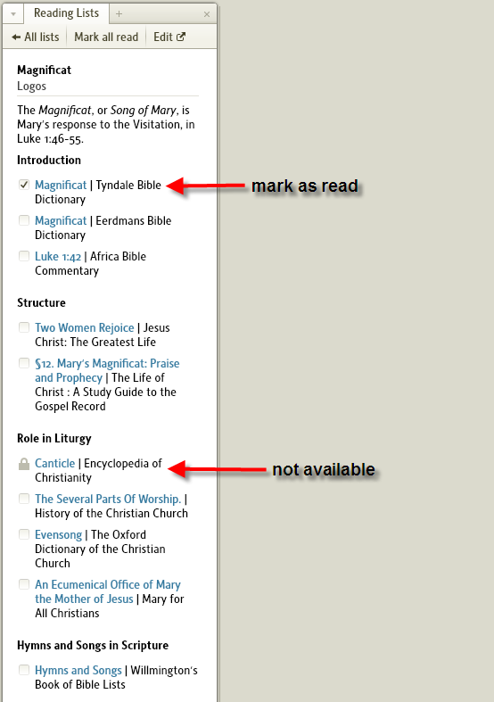
The symbol to the left of a reading shows 3 possible conditions:

• empty box - the reading has not been read
• box with check mark - the user has checked the box to indicate that they have read the reading or that they are not intending to read it
• padlock - the reading refers to a resource not currently available on this Logos installation. This can either mean that you do not own the resource or that you have hidden the resource.

Note the option at the top to mark all articles as read.

Accessing the Reading Lists
[[@Headword:Reading Lists - Accessing ]]
In the example above, the Reading List was accessed from the Home Page ribbon. One can also access the Reading List from the Tools menu.

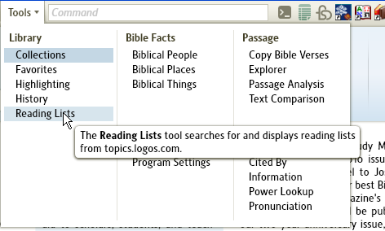

Access through the Tools menu presents a Search box for screening the available reading lists.

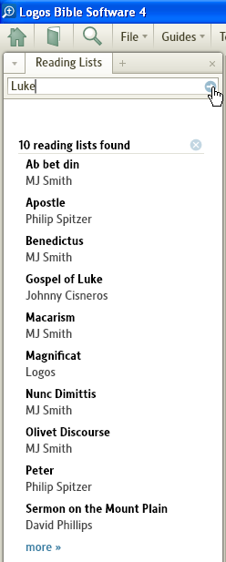

You can also reach the Search Reading Lists function from the All Lists option in the Reading List pane.

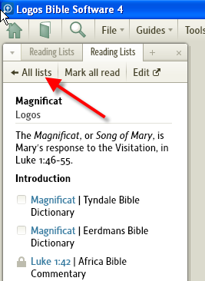

Summary

There are three ways to access Reading Lists in Logos 4:

• through the ribbon on the Home Page
• through Reading Lists under the Tools menu
• from the All Lists option of another Reading List

Editing
[[@Headword:Reading Lists - Editing ]]
Both the Topic Lists and Reading Lists are updated on wiki pages at http://topics.logos.com/. If you are in a Reading List, the Edit button provides direct access to the appropriate wiki page.

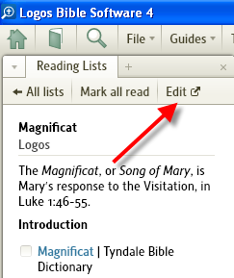

You may also enter the URL http://topics.logos.com/ into your browser. From this page you can enter the topic you wish to edit.

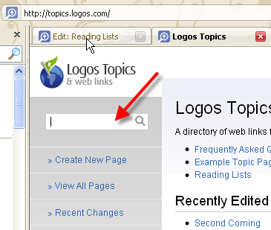

Notice you don't need to enter the precise name of the page you wish to edit. Alternative names are also recognized. From the list of pages returned by the search, select the page you wish to edit.

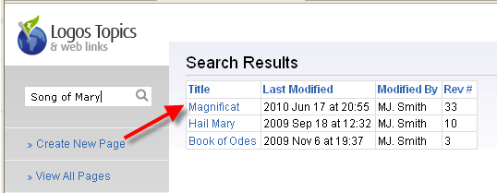

This will bring up the wiki page you wish to edit in view mode. Select the Edit tab to bring the page up for editing.

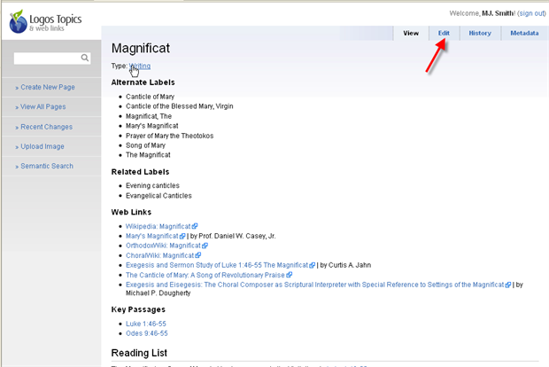

Summary

To bring up a topics.logos page for editing:

• Select Edit on a Reading List within Logos 4
• Select the Edit tab to bring the page up in edit mode

OR

• Enter http://topics.logos.com/ in your browser
• Enter the topic you wish to edit
• Select the page you wish to edit from the search results
• Select the Edit tab to bring the page up in edit mode

Generic Editing Features
[[@Headword:Reading Lists – Generic Edit Features ]]
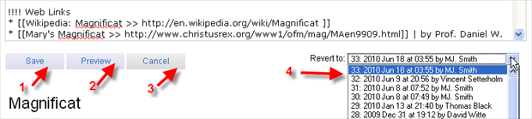

The four standard editing features are:

• Save (1) which saves the changes that you have made to the page. This should be done after you have checked your work with the Preview feature.
• Preview (2) which updates the display below the edit area to show how the page will look after your edits have been applied.
• Cancel (3) which deletes your changes in the edit area and returns you to the standard view of the page.
• Revert to (4) which allows you to delete you changes and go back to a version of the page prior to the changes. Note the former pages are identified version number, date, time and person. Take care not to erase the work of other users.

Editing the Topic List
[[@Headword:Reading Lists – Edit Topic List ]]
The wiki edit page has two parts:

• an edit window
• a preview area

Note that in this image, the topic page for Magnificat has been returned to the state it was in when Logos created entries for each topic in the Logos Controlled Vocabulary.

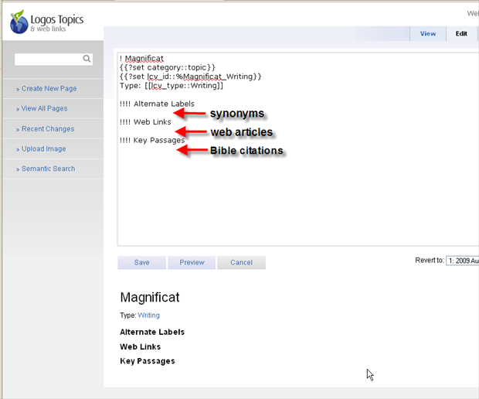

There are three areas for Logos users to update. Common courtesy says you should not remove entries added by other users. There are times when it is appropriate to change the sequence of entries (e.g. alphabetize, canonical order) or standardize an entry.

Alternative Labels

This area contains alternative names (synonyms) for the topic word. Each entry has its own line. The format is an asterisk, a space, the alternative name. In the display, the asterisks are converted to bullets.

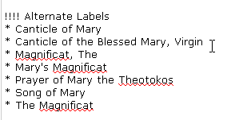
In this area, the more alternatives the better. The terminology changes from one set of users to another; this list makes it useful to a maximum number of people. The values here control the results of a search.

Key Passages

The key passages are to be just that - key. Simply enter the Biblical reference for each key passage in the format asterisk, space, reference. If the format for the reference is correct the text should turn blue in the preview indicating a live link.

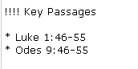

Web Links

The web links portion is intended to have links to useful related articles available on the web. Wikipedia is a standard entry. Note that it is specific articles rather than home pages of web sites that are intended. Choose those articles that you truly wish to recommend to your friends.

The format for these links was inconsistent until the links to Logos resources in the Reading Lists were standardized by automatic generation. The format is asterisk, space, two opening square brackets, article title, space, two greater than signs, URL of article, two closing square brackets, space, pipe character, space, author and occasionally additional information.

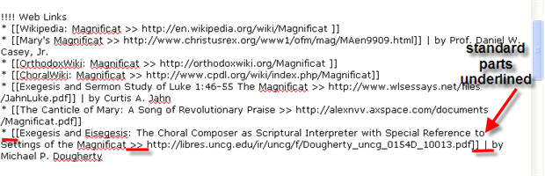

Related Labels

Before the use of topics was obvious, early adopters created a new section for labels that have meaning only in relationship to each other, e.g. major prophets, minor prophets. It is updated in the same manner as Alternate Labels. However, it has no official function in the Logos schema.

Use of Topic Data

In its current state, Logos 4 uses the data maintained under topics as follows:

• Alternative Labels are used as search elements within topics.logos.com
• Web links are displayed (along with a link to the Reading List) when:
▪ the search term is included in the Logos Controlled Vocabulary list and
▪ web links occur in the appropriate topic wiki page
• Key Passages does not appear to be used currently [please update this page if they are used.]

Editing the Reading List
[[@Headword:Reading Lists – Edit Reading List ]]
Creating a reading list is generally a simpler task. First navigate to the page you wish to edit in the same manner as for the Topic List. Unlike the topic section, the Reading List section is not pregenerated by Logos.

First one needs to learn one piece of wiki formatting. Exclamation points at the beginning of a line indicate that the line is a heading. The number of exclamation points matter. 3 exclamation points indicates that it is a subheading of a 2 exclamation point heading. To be more precise, a subheading of the next heading up the document that has fewer exclamation points.

To create a Reading List on an existing topic, begin by typing in the heading information. It comes after the Key Passages section of the Topic List.

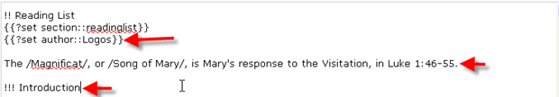

• Since the Reading List is a subheading under the topic, it begins with two exclamation points.
• The content of the first two lines never changes; simply copy them.
• The only portion of the third line that changes is the name of the creator, in this example "Logos". Replace "Logos" with your name
• Generally, you'll want to put a blank line after these three lines. It simply makes it easier to identify the parts of the Reading List
• The next line is an example of adding a line of text to the reading list. In this case it is a simple definition of Magnificat for people who may not be familiar with the text by its Latin name: "The Magnificat, or Song of Mary, is Mary's response to the Visitation, in Luke 1:46-55." Note that the slash marks indicate the word(s) are to be displayed in italics.
• For the same reason as before, you might want to leave a blank line
• Finally, enter the first heading for your reading list starting with 3 exclamation points (or more).

Some general guidelines:

• If a wiki page exists for your topic, please use that page rather than creating a duplicate page.
• Do not remove someone else's entries, although you may rearrange the entries or standardize the entry.
• If you are using the reading list for a class or to supplement reading a particular resource, do one of the following:
▪ Put a comment at the beginning and the end of your reading list requesting that your reading list not be changed but that additional resources be added below (or above) your list
▪ Put your entire reading list under a 3 exclamation point heading identifying the reading list as having fixed content for your purpose.
• There are no set patterns for organizing the references into headings and subheadings. Do something that works with the resources you are listing. If organization is not your thing, look at several similar reading lists to get ideas.

Types of resources:

• Books not available in Logos: These are often given their own heading titled "external sources". Preferable you would include complete bibliographic data but a title and author will do. Generally such entries begin with an asterisk and space.
• Web links: usually there is no need to duplicate the web links for the topic. However, it may be necessary for class reading lists. The format for these entries is the same as for the topics list (see above).
• Logos resources: these should be the bulk of your entries. Logos 4 provides a copy and paste link. You simply enter asterisk, space, then paste.

How to copy and paste:

• Open resource tab
• Click on RL (Reading List format)
• CTRL +V or right click to paste

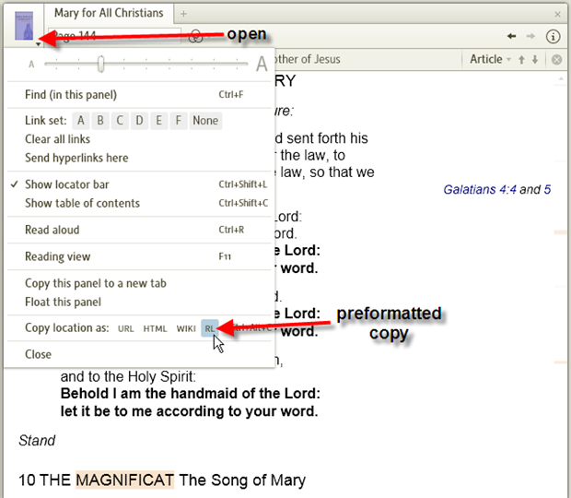

Special notes for Biblical references:

• If you simply enter a Biblical reference in the Reading List it will automatically link to bible.logos.com
• If you copy the RL link as you would for any other book link, it will link to that specific translation in Logos 4

Partial source for Magnificat Reading List

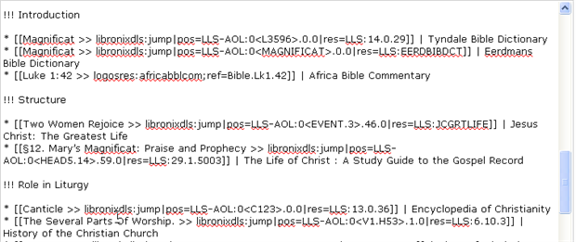

Creating
[[@Headword:Reading Lists - Creating ]]
From Logos:
When should you think about creating a reading list? Any time you find an article that you highly value as authoritative on a subject but that does not come up by one of Logos' automated means, you should either add it to a reading list (/see Editing/) or create one. Even if it's the only article on the reading list, it's worth having. The hardest part about a reading list is starting it. Once it's started it's relatively easy for others to add resources to it.

Steps in creating a reading list
[[@Headword:Reading Lists – Steps Creating Reading List ]]
• Find page for topic
• Add the reading list fixed lines
• Add reading list elements as described in the edit process above

Find page for topic

Enter a topic (person, place, writing, etc.) into the search box of the topics.logos.com wiki. If the topic is found, select edit mode. If the topic is not found, see the directions below for how to add a topic.

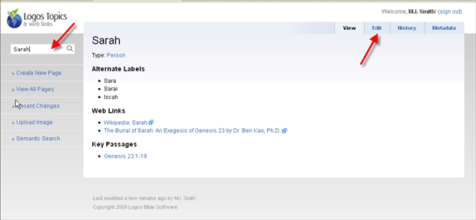

Add the 3 reading list fixed lines

The first two lines added after the end of the Key Passages section are always entered exactly as shown. The third line requires replacing "John Doe" with your name.

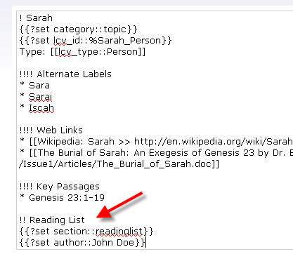

Add reading list items

The adding of reading items is done as described in editing a reading list. These is, as yet, no standard way to organize the readings.

Add a topic page
[[@Headword:Reading Lists – Add Topic page ]]
In general, Logos expects to preload the Logos Controlled Vocabulary topics into topics.logos.com. However, you will find topics that are not yet in the wiki.

Steps in adding a new topic:

• Verify that the topic does not exist before creating a blank topic
• Find a similar topic
• Add heading lines
• Add topic lines
• Add wikipedia entry
• Optionally, add reading list lines
• Preview and save

Verify that the topic does not exist before creating a blank topic.

For this example, we will take Susanna from the deuterocanonical (apocryphal) portion of Daniel. The first step is to search on the topic "Susanna". This returns only one result - the New Testament Susanna. So click on "Create New Page" to begin a new page for Susanna from the book of Daniel.

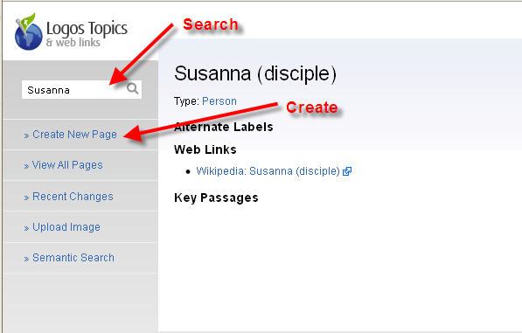

This will generate a nearly blank page.

Find a similar topic

The basic heading lines for a topic give its displayed name, the type and subtype and an internal name; in other words it contains the technical 'stuff' that makes the wiki work. The best way to fill this section is to find a similar entry, copy the lines into your new page, and modify them to fit your topic.

For a similar topic, take Susanna the disciple. In edit mode, copy the heading information:

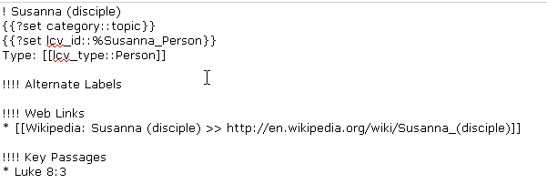

Add heading lines

Paste the heading information from the similar topic into the new topic page. Modify the Title and the lcv_id to be unique.

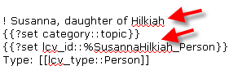

The header information varies by the category of the topic. These are typical examples:

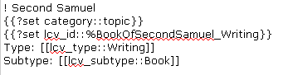

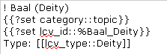

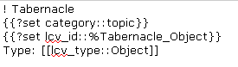

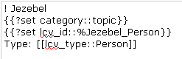

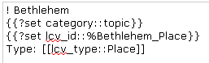

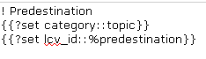

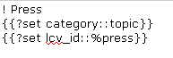

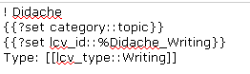

Until we are given a complete list of defined values, it is safest to simply copy and modify from a related page.

Add topic lines

The headings under topics have been discussed above. Simply insert the fixed lines:

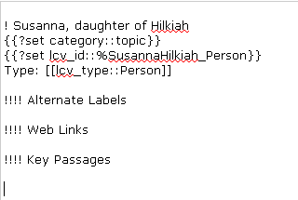

Add wikipedia entry

Logos has included wikipedia entries in the preloaded entries. If a wikipedia entry is available, add it to your new page.

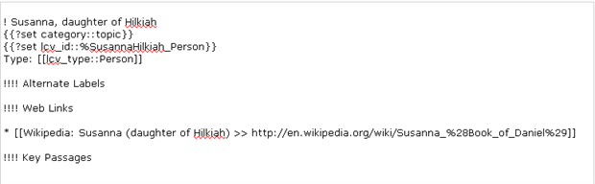

Optionally, add reading list lines

This is described in detail above. In other words, it is the same as adding a reading list to an existing topic.

Preview and save

Preview your new page by selecting the Preview button.

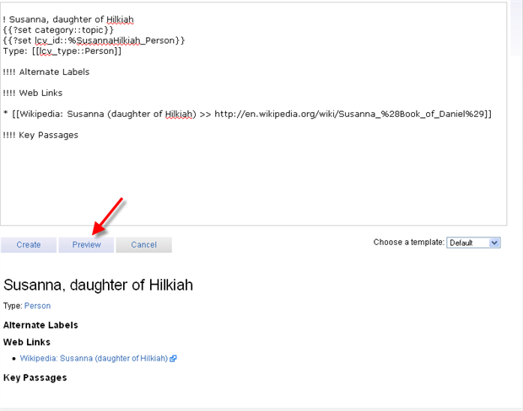

Make any required changes then click on the Save button.

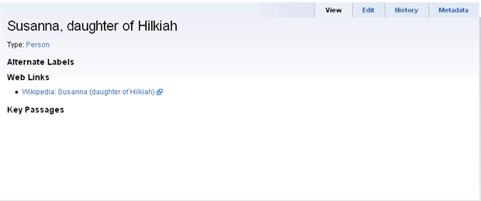

Recovering from a bad update
[[@Headword:Reading Lists – Recovering from bad update ]]
Occasionally, one may wish to undo a change. Be very careful not to lose other people's work. At the lower bottom of the topic update window is a "Revert to" box. Select the version you wish to revert to and you will remove the erroneous update.

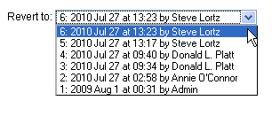

▪ Biblical Facts ▪
[[@Headword:Biblical Facts Section ]]
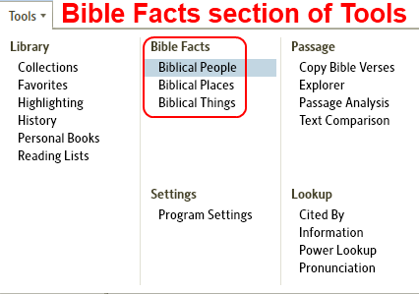

Biblical People
[[@Headword:Biblical People ]]Wiki page: Revision 31 Link

Videos
Tutorial Video Biblical People 1
Tutorial Video Biblical People 2
Logos4 Videos
Mark Barnes Video
Logos Tutorial Video #3 – Bible Facts

What is Biblical People?
[[@Headword:Biblical People – What is it ]]
• Biblical People is a new tool in Logos4 which will provide you with diagrams of people in the Bible along with detailed information.
▪ In many cases it will provide related images which are in your library to this person. (see Media Ribbon details )
▪ It can in some case provide you with different name of this person. (e.g. Jesus, Messiah, or Christ)
▪ It will have links of this person to different dictionaries in your library.
▪ It will have links to relatives of this person which are viewed in Biblical People.
▪ It can provide you with links to other people with this name. (e.g. Jesus, Joshua, Justus)
▪ It will often provide a link to wikipedia for this person.
▪ It may provide links to Things which might be related to this person.
• Please watch the Logos Video Tutorials Biblical People 1 and Biblical People 2.
• Please watch Mark Barnes video: Logos Tutorial Video #3 - Bible Facts

Opening Biblical People
[[@Headword:Biblical People - Opening ]]

From the Toolbar
[[@Headword:Biblical People – Opening from toolbar ]]
• You can open Biblical People from the Tools menu button.
1. Click on Tools button on the top menu bar.
2. Click on Biblical People in the center column of the drop down menu.

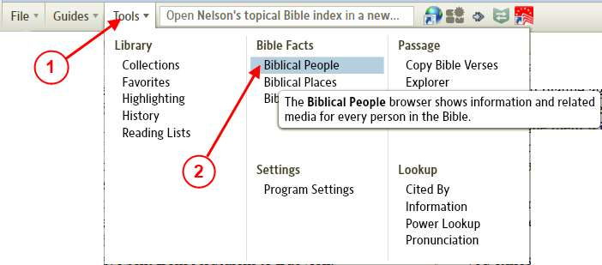
• Once you have Biblical People open, you can type in the name of a person found in the Bible into the Person box. As you are typing the person's name Logos4 will show a list of people which are in the database in the drop down list. Simply click on one of the people in the drop down list.
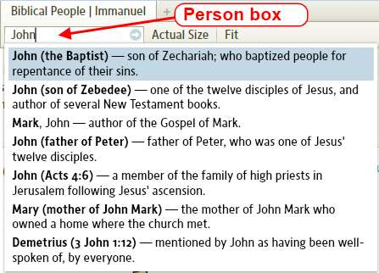

From a resource
[[@Headword:Biblical People – Opening from a resource ]]
• You can open Biblical People from a Bible.
1. In the Bible that you are using.
2. Find the name in a Bible passage which you want to view in Biblical People. Then right click on that name.
3. In some Bibles you may need to scroll down to see Person on the right side of the pop-up menu.
4. On the right side of the pop-up menu, click on Person.
5. Now on the left side of the pop-up menu, click on Biblical People.

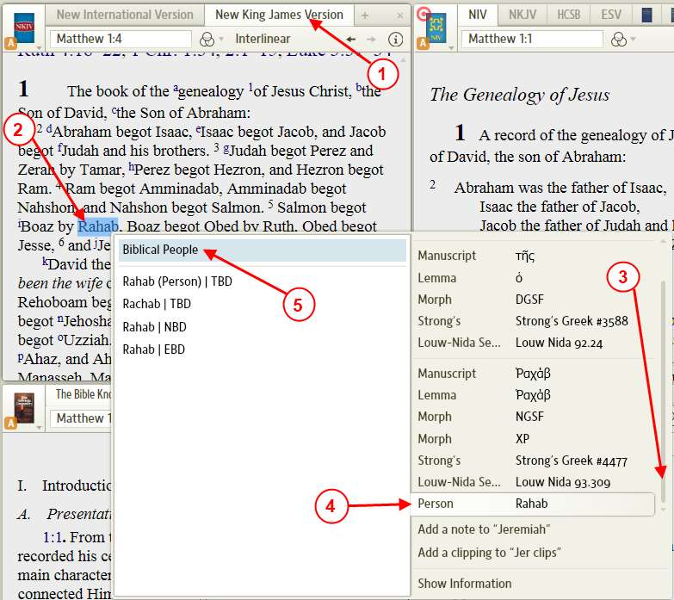
• Biblical People window will open with the name of the person that you selected in the Person box.
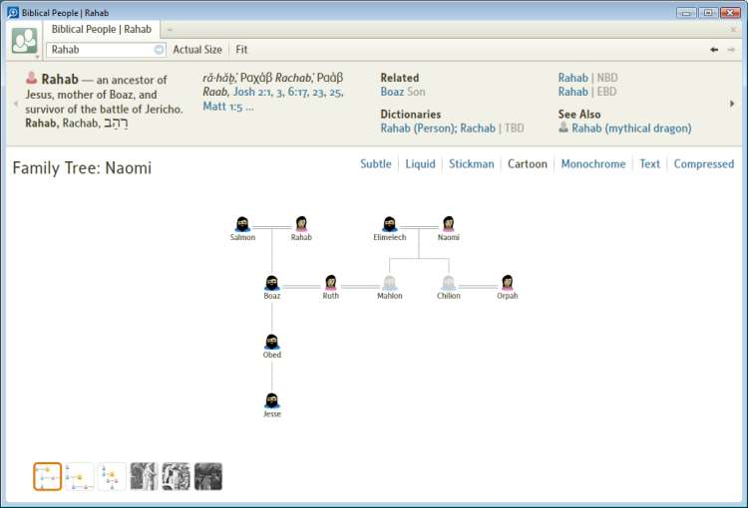

Tip: using scripture reference
[[@Headword:Biblical People – Tip: using scripture reference ]]
If you enter a scripture reference in the Person box, Logos4 will show you a list of people found in that scripture.
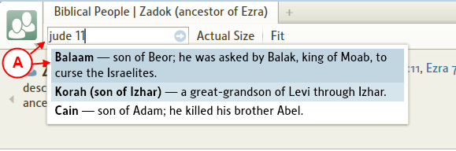

What are the parts of the Biblical People window?
[[@Headword:Biblical People - Parts ]]

a) Person box. When opening Biblical People, the last person's name will appear here. You can type a person's name here and Logos4 will show a drop down menu with choices for people with the name you typed. (also see Information on people in the diagram)

b) This is a diagram showing you family relations of the person that you have selected or groups of people associated with this person (e.g. apostles). Or if you navigate to an image relating to this person (see ). If the diagram appears too small, you may change the size of the diagram (see Diagram size).

c) This shows you the title of the diagram. (see Source/Link of information)

d) These provide you with different representation methods for your diagram. (see People representation in diagram) Note: with ver 4.1 there are more selections.

e) Information on your person is displayed in this ribbon. Logos4 will populate this ribbon with various information. In some cases the name of your person may fit multiple people in the Bible. (see Information Ribbon details)

f) When there is more information than will fit on the ribbon one or both of the arrows will allow you to scroll the information shown on the ribbon.

g) This media ribbon will show you different diagrams which are related to your person. These may be other people with the same name or different family members or images which relate to your person. The active diagram will have a brown box around the diagram icon. When you hold your mouse over one of the diagrams/images icons, Logos4 will flash a pop-up image for a few seconds to allow you to see the diagram/image. (see Media Ribbon details)

h) When there are more diagrams than will fit on this ribbon, then these arrow permit you to scroll through the different diagram icons.

i) These buttons will size the diagram. You may also use your mouse wheel to zoom in on the diagram. You can also grab and drag the position of the zoomed in diagram to position it for your viewing. (see Diagram size)

j) When you navigate to different diagrams, this will become active allowing you go backwards/forwards through the diagrams that you have viewed.

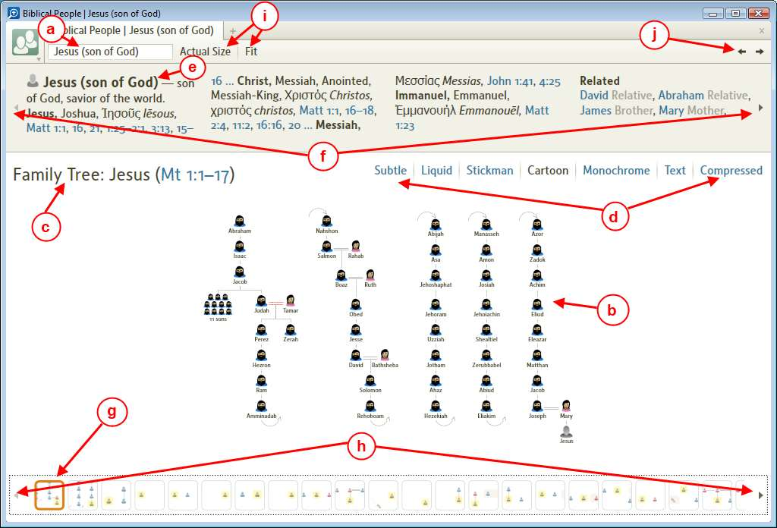
• You can click on different people in your diagram of people and it will change the diagram to that person. (see Information on people in the diagram)

In the Diagram area
[[@Headword:Biblical People – Diagram area ]]

Information on people in the diagram
[[@Headword:Biblical People – Diagram area [Info on people in diagram] ]]
Note: image icons were changed in version 4.1

• Hold your mouse over a person in the diagram (in the example we used Ruth). A pop-up will appear with information on this person.

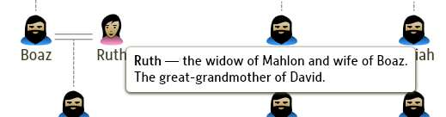

• When you click on this person in the diagram:

a) The name will appear in the person box.
b) The ribbon will now show information on this person.
c) The media ribbon will now display related diagrams/Images for this person.
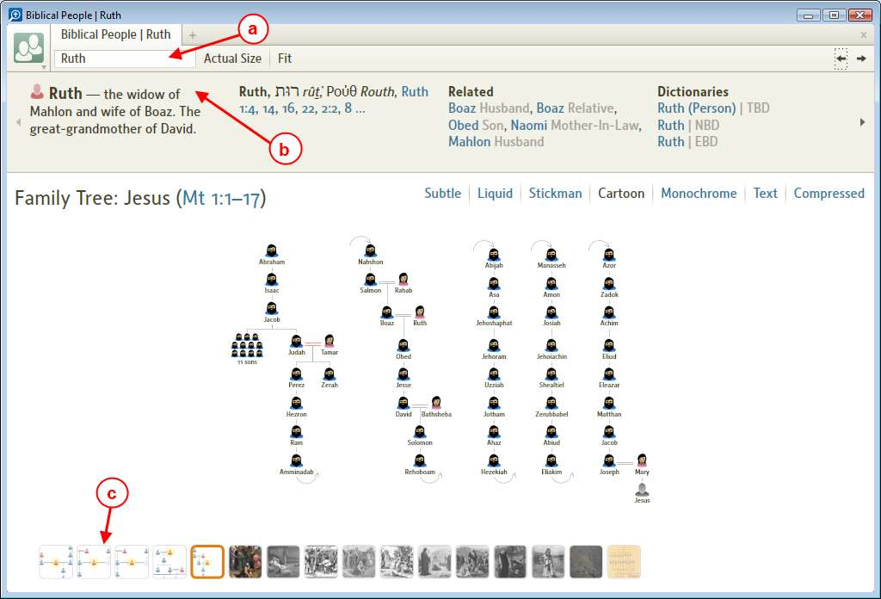
▪ You can use the Back and Forward arrows to return to previously viewed people after clicking on a person. (see Item J in What are the parts of the Biblical People window?)

Diagram size
[[@Headword:Biblical People – Diagram size ]]
• The diagram/Image in the viewing area may be zoomed/shrunk. (see Zooming and Panning)

• To the right of the Person box you will see two buttons (Actual Size and Fit). When clicked they will adjust the size of the diagram.
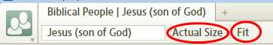
▪ Fit will size the diagram so that the whole diagram fits in the viewing area.
▪ Actual Size will size the diagram to a 1:1 view in the viewing area.

People representation in diagram
[[@Headword:Biblical People – Diagram styles ]]
• In the upper right portion of the viewing area of the diagram (when the diagram shows people) you will see a people representative selection. Note: with ver 4.1 there are more selections here.
• By clicking on different representations the icons in the people diagram will change.
Cartoon
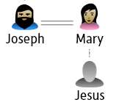
Subtle

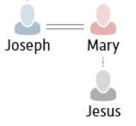

Source/Link of information
[[@Headword:Biblical People – Diagram [Source info] ]]
• On the left side of the diagram in the viewing area you will see the Title for the diagram. And in many cases there will be a link here to a resource (e.g. Bible passage or the book where this image came from).
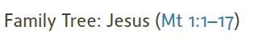

Information Ribbon details
[[@Headword:Biblical People – Ribbon parts ]]
a) Person details.
b) You may find other titles this person may have here.
c) These are Bible references for each title. You can click on any of these links to open it in your preferred Bible.
When there are numerous references, you will see the ‘…’ link. If you click on this link more references will be shown.
d) The next Topic is Related, here you will find links that you can click to see them appear in Biblical People.
(to view more info in this example we clicked on the arrow on the right, see What are the parts of the Biblical People window? item F)

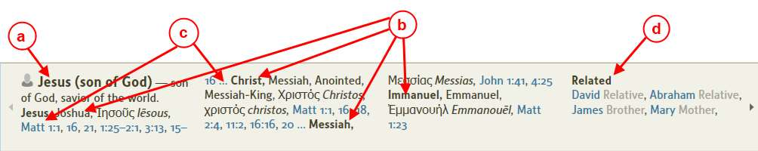
e) The next Topic is Dictionaries.
f) You can click on these link to open the dictionary topics in your dictionaries.

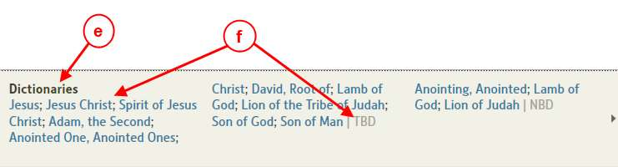
g) The next Topic is May be the same as ....
These will be links to other people which Biblical People can show which may be the same person. Addition details on the person may be viewed here.
h) The last Topic is See also.
Here you may find other people with this name which can be viewed with Biblical People.
i) You may also find Things which can be viewed with Biblical Things when clicking the links.

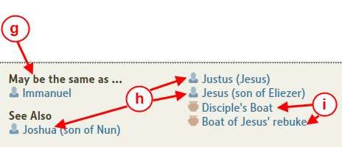
j) You can click here to have wikipedia open to this person. (it will try to open your browser to this location)

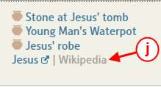

Media Ribbon details
[[@Headword:Biblical People – Ribbon details ]]
• The Media Ribbon is located along the bottom of the Biblical People window.
• It should contain one or more icons depending on how much information Logos4 has in its database related to the person you have selected.
• These icons represent other diagrams of people or images associated with the person you have selected in the Person box.

a) The icon with a brown rectangle around it is the currently selected diagram which is visible in the viewing area. By clicking on any of these icons, Biblical People will open that diagram/image in the viewing area.
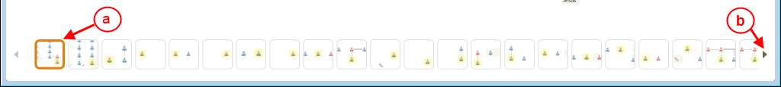
b) When there is more available diagrams/images than will fit on the ribbon, you will see this arrow active. It allows you to scroll through the icons making them visible in the ribbon. As you scroll you will notice that the corresponding arrow on the left side of the ribbon becomes active which allows scrolling through icons which were previously visible in the ribbon.

c) If you hold the mouse over an icon, a pop-up will appear for a short time allowing you to better view the contents of that diagram/image.
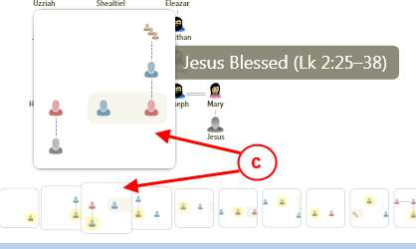
d) If Logos4 found any images which are associated to the person you are viewing, then icons for those images will appear in your ribbon.
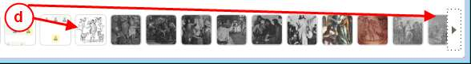
e) If you have clicked on a different diagram (than the one you originally opened for this person), you can use these arrows (in the top right area of the window) to sequence back through your previously viewed diagrams/images.
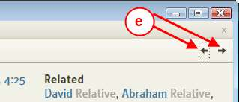

Copying/Saving/Printing/Exporting
[[@Headword:Biblical People – Copying/Saving/Printing/Exporting ]]
• By clicking on the Biblical People window's icon (see item a) a drop down menu appears.
• This provides options for Copying/Saving/Printing/Exporting (see item b) the diagram or image that you are currently viewing.
Note: with version 4.1 Print and Export have been replaced with Print/Export, see Print/Export
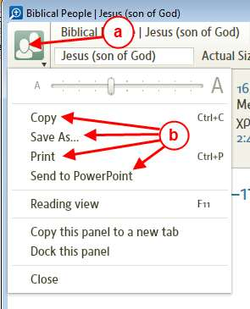
• You can also access these features by holding your mouse over an open area (not on a person icon) in the viewing area and right clicking. The pop-up menu below will appear.
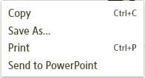

Copying
[[@Headword:Biblical People - Copying ]]
• This will copy the full view of the diagram/image in the viewing area to the windows Copy/Paste buffer (clipboard).
• You can then paste it into another windows program which accepts clipboard images.
• You may also use the keyboard shortcut Ctrl+C to copy the diagram.
• Regardless of how much you have zoomed the diagram/image in the viewing area, the whole image is copied when you use this features.

Saving
[[@Headword:Biblical People - Saving ]]
• When you select SaveAs in Biblical People drop down or pop-up menu, you will be able to save the diagram/image to a file.
• The Save dialog box will appear

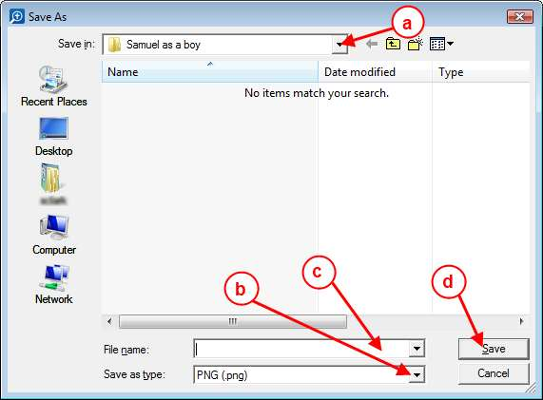
• Use the following steps (if you are not already familiar with saving an image)

a) Select the Folder in which you want to save your image.
b) Select the image file format. Logos4 allows saving it in two file types (png and jpg).
c) Enter the filename for your image.
d) Press the Save button to save the image.

Printing
[[@Headword:Biblical People - Printing ]]
Note: this has been replace in version 4.1 with Print/Export. Please see the wiki Print/Export for instructions.

• Select Print in the Biblical People drop down or pop-up menu or use the keyboard shortcut Ctrl+P, the print dialog box below will appear. This allows you to print the current diagram/image which is showing in your viewing area of Biblical People. Please note that this always prints the full size diagram/image regardless of how you have zoomed it in your viewing area.

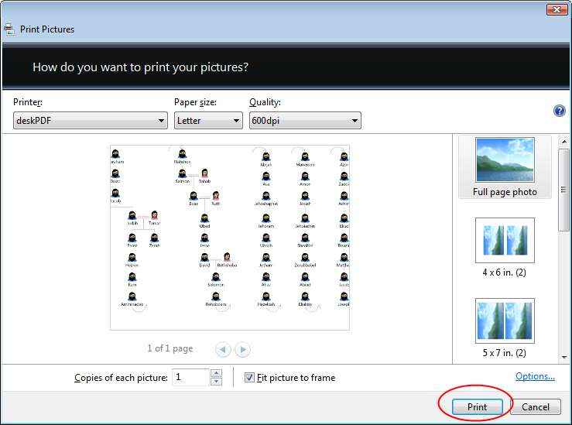
• The print dialog box supplies various controls [printer, paper size, resolution, etc]. Select all the settings that you prefer, then press the Print button.

Exporting
[[@Headword:Biblical People - Exporting ]]
Note: this has been replace in version 4.1 with Print/Export. Please see the wiki Print/Export for instructions.

• Logos4 provides exporting your Biblical People diagram/image to Microsoft PowerPoint slide when you select Send to PowerPoint from the drop down or pop-up menu.
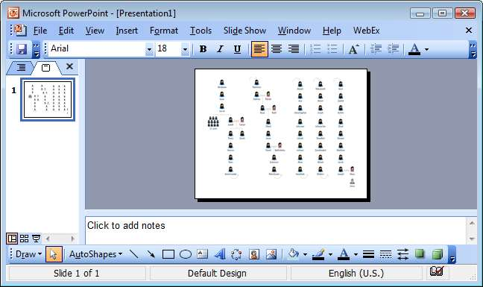
• Note: in Logos4 version 4.0a there appears to be a bug when using PowerPoint 2003. If PowerPoint is not already open, it will export a vertical bar to the slide (when stretched it is an image of a floppy disk) on the first export. To overcome this bug, simple have PowerPoint already open before you export.
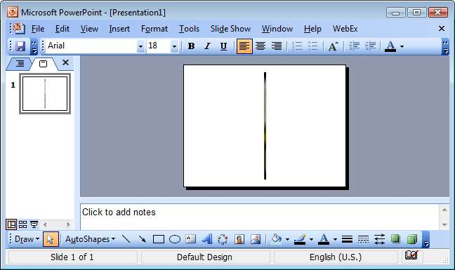

Adding to Favorites
[[@Headword:Biblical People – Adding to Favorites ]]
• You can add Biblical People to your Favorites and it will remember the person that you had showing when you added it to favorites.
• Make sure that you have Favorites open in your Layout (main window in Logos4).
1. Click on the tab in the Biblical People window.
2. Drag it into the Favorites window in your Layout.
3. Drop it in an open area of Favorites.

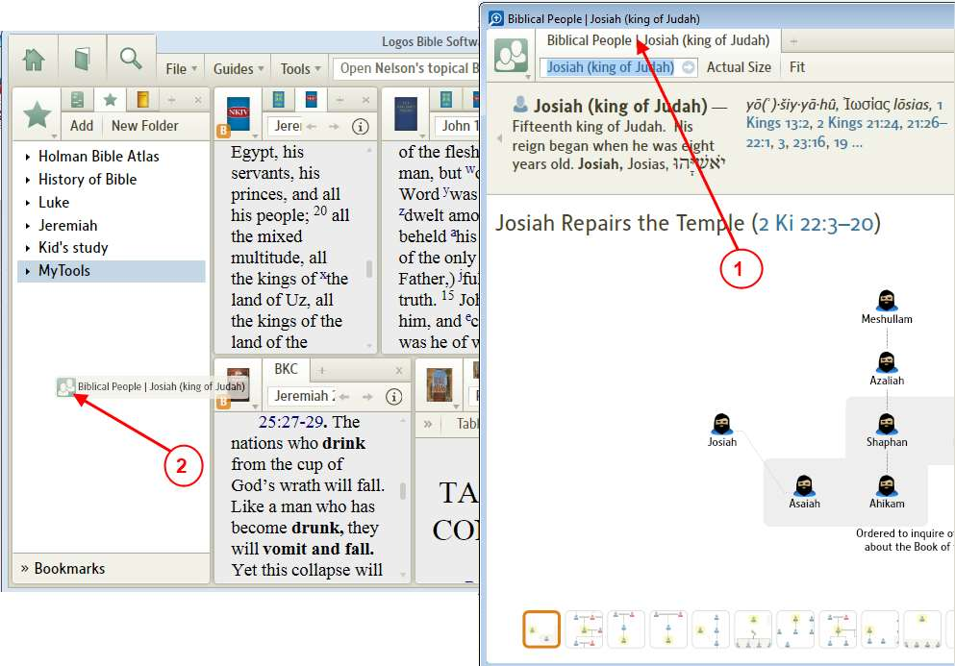
4. Right click on the new favorite and select Rename. Then rename the favorite.

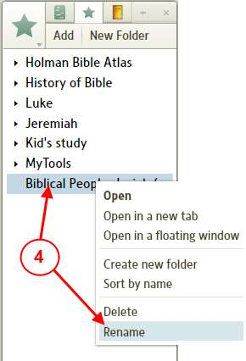
5. You can now move the new favorite into a folder if you would like. [note: to place a favorite in a folder, drag the favorite over the Folder Name and drop it there]

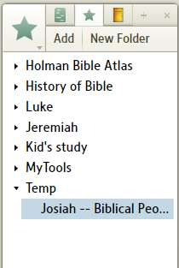

Adding to Shortcuts
[[@Headword:Biblical People – Adding to Shortcuts ]]
• You can drag the Biblical People tab to your shortcut bar. This will create a shortcut to Biblical People.
• Bug: as of Logos4 version 4.0aSr3, the shortcut for Biblical People does not retain the properties for the person (e.g. it will not remember the person that was in the Person box when the shortcut was created).

Moving to a window in your Layout
[[@Headword:Biblical People – Moving to Layout ]]
• Biblical People tool opens in a floating window. You can move it to a window in your Layout.
1. Click on the Biblical People tab.
2. Drag it to the window in your Layout that you want it to be in.
3. Drop it in the window of your Layout.
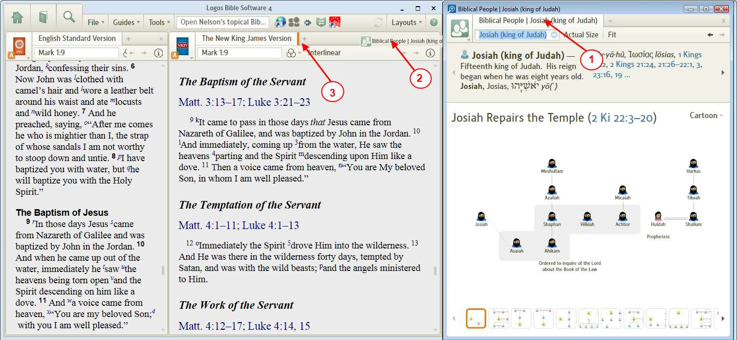
4. The floating Biblical People window will disappear and the Biblical People will appear in your window of your Layout.

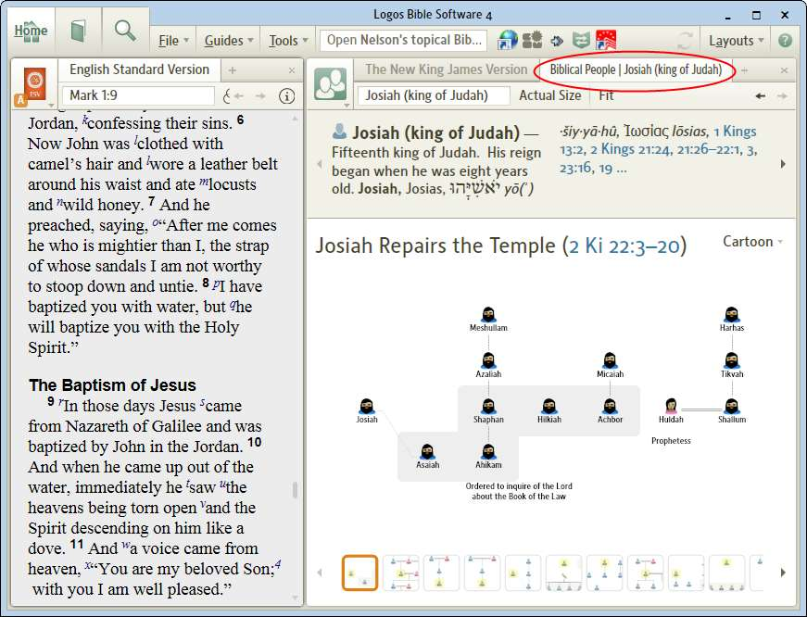

Zooming and Panning
[[@Headword:Biblical People – Zooming/Panning ]]
• You can Zoom in on an area of your diagram.
▪ Hold your mouse over an area of the diagram and roll the wheel of your mouse (or use Ctrl + = or Ctrl + - ). You can locate your mouse over an area to have Logos4 center on that area when zooming (e.g. over the lower right portion of the diagram)

Before

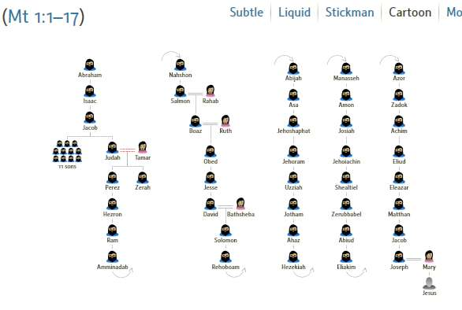
After

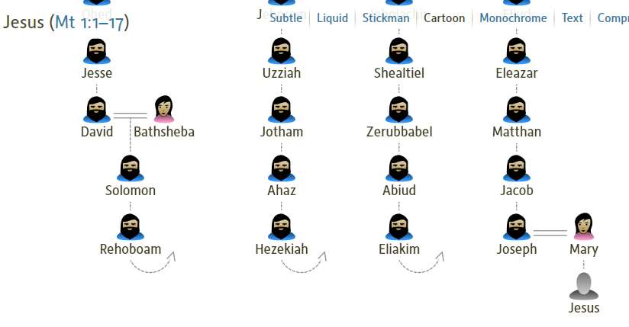
• Panning is repositioning the zoomed diagram to make different parts visible in the viewing area.
▪ Hold your mouse over an area of the diagram (until the cursor turns into an open hand).
▪ Hold down the left mouse button (the cursor turns into a closed hand), while keeping the mouse button down, move the mouse.
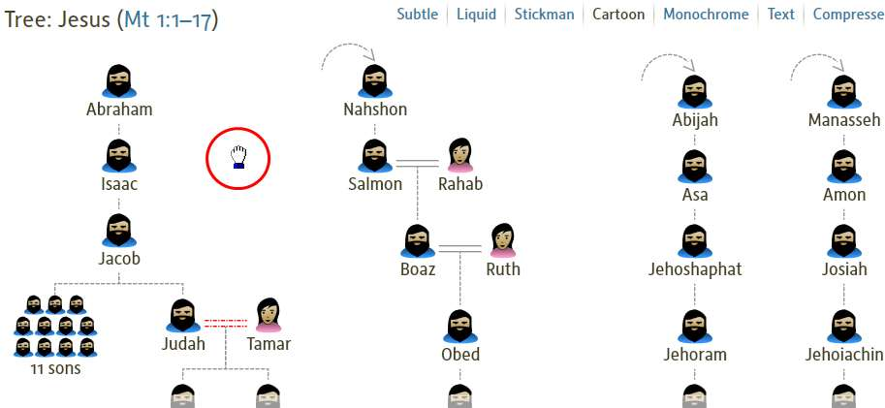

Biblical Places
[[@Headword:Biblical Places ]]Wiki page: Revision 10 Link

• Please watch these Logos 4 video tutorials
▪ Biblical Places - Dynamic Map
▪ Biblical Places - Information
▪ Biblical Places - Maps

• Also Mark Barnes has an excellent video: Logos Tutorial Video #3 - Bible Facts

• Also Morris Proctor wrote this blog: Logos 4: Quickly Access a Map

• To locate a specific city on the map:
1. In Biblical Places and it being the active window, press the key combination Ctrl F.
a. This brings up the Find Box.

2. In the Find Box, type the name of your city that you want to find.
a. Logos 4 will navigate to that city and zoom in on it, and in some maps it will highlight it in brown.
b. If the city is not found the Find Box turns light red.
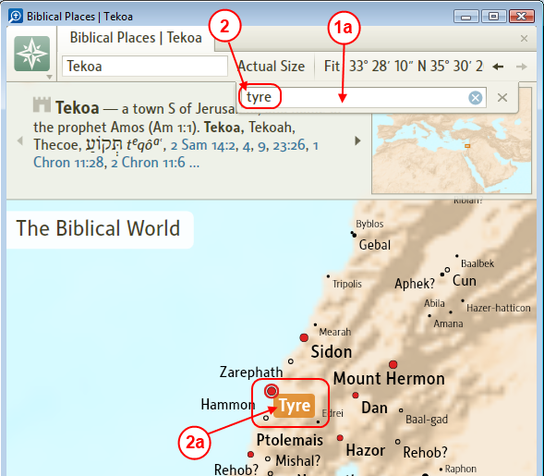

Biblical Things
[[@Headword:Biblical Things ]]Wiki page: Revision 5 Link

• Please watch this Logos 4 video tutorial: Biblical Things

• Also Mark Barnes has an excellent video: Logos Tutorial Video #3 - Bible Facts

▪ Settings ▪
[[@Headword:Settings Section ]]
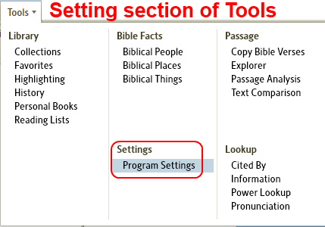

Program Settings
[[@Headword:Program Settings ]]Wiki page: Revision 16 Link

What does Program Settings do?
[[@Headword:Program Settings – What is it ]]
• Program Settings allows you to customize how your Logos 4 software works/displays.
• There are 7 categories in the Program Settings tool (as of version 4.0d)

How do I open Program Settings?
[[@Headword:Program Settings - Opening ]]
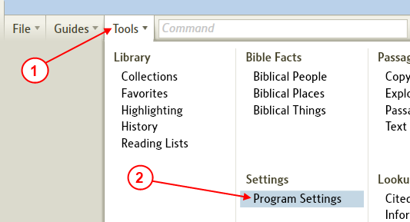

1. In the top menu click on Tools
2. In the drop down menu click on Program Settings.
3. Logos 4 will open Program Settings in a new panel.
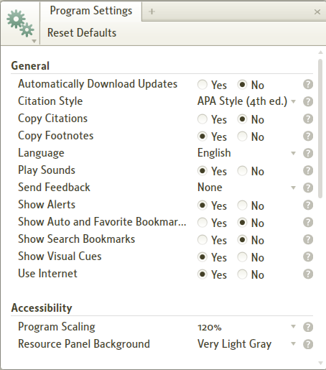

Program Settings Categories
[[@Headword:Program Settings - Categories ]]
• There are 7 categories as of Logos 4 version 4.0d.
Each category is discussed below.

• Please notice on the right of each category item a question mark with a circle around it.
By holding your mouse over this question mark Logos 4 will show you a brief help description for this item.
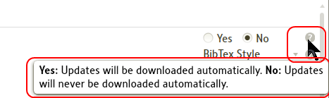

• Some category items will require closing Logos 4 program and reopening it for the effect to take place.
These which require this action will be specifically noted in the description(s) below.
Otherwise the effect is assumed to happen while you have the program open.

General
[[@Headword:Program Settings – General category ]]
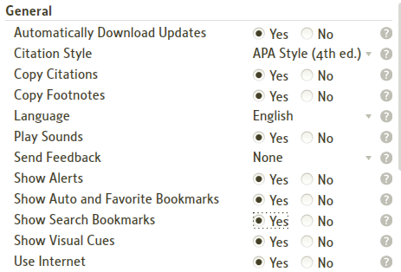

Automatically Download Updates
[[@Headword:Program Settings – General category [Automatically Download Updates] ]]
• Yes = when Logos 4 is open and you are working online, when an update to Logos 4 software is detected, the update will be downloaded.

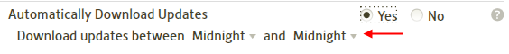

• No = updates will not be downloaded automatically.
But when you first open Logos 4 (within several seconds if online) if an update is available then a pop-up box in the lower right side of your Logos window will appear notifying you that an update is available. You can click the X to the right of Updates Available option in this box to prevent updating at this time (it will appear again the next time you start Logos 4) or you can click Click to download available updates option to start the downloading of updates.

▪ Restart required for changes to take effect.

Citation Style
[[@Headword:Program Settings – General category [Citation Style] ]]
• If you click the arrow to the right of the selection a drop down list will appear.
Select which citation style that you want to use (see Citation Styles examples)

• Citation Style allow you set the format of citations when you paste info from Logos 4 into other application (e.g. Microsoft Word).
▪ This is used when using
▫ Export Bibliography from the Collections tool.
▫ Using the Copy Bible Verses tool.
▪ This is not used
▫ When using Ctrl C to copy selections in a resource.

Copy Citations
[[@Headword:Program Settings – General category [Copy Citations] ]]
• Yes = citations are used when pasting in another application.
• No = citations are not used when pasting in another application.
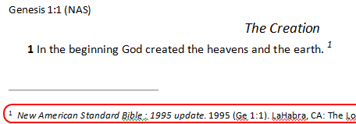

Note that citations are not created when the amount of text copied is smaller than 50 characters. This is because people sometimes copy small strings for pasting in a search edit box, or into Google, or other places where they don't want a full citation.

Copy Footnotes
[[@Headword:Program Settings – General category [Copy Footnotes] ]]
• Yes = footnotes are inserted when pasting in another application.
• No = footnotes are not inserted when pasting in another application.
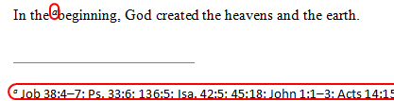

Language
[[@Headword:Program Settings – General category [Language] ]]
• If you click on the arrow to the right of the language, a drop down list will appear.
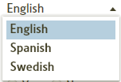
Select the Language which you want Logos 4 to use.

Play Sounds
[[@Headword:Program Settings – General category [Play Sounds] ]]
• Yes = Logos 4 will play sounds (e.g. upon opening the program).
• No = Logos 4 will not play sounds.

Send Feedback
[[@Headword:Program Settings – General category [Send Feedback] ]]
• Permit Logos 4 program to report how you use the software so they can use this info in determining how to improve the program.
• If you click on the arrow to the right of the selection a drop down list will appear.
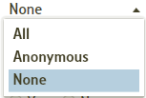
Select your preference.

Show Alerts
[[@Headword:Program Settings – General category [Show Alerts] ]]
• Yes = News alerts will be shown when the application starts.
• No = Alerts will never be shown.

Show Auto and Favorite Bookmarks
[[@Headword:Program Settings – General category [Show Auto & Favorite Bookmarks] ]]
• Yes = Show wear marks and Favorite markers in resource's scrollbar.
• No = do not show wear marks and Favorite markers in resource's scrollbar.

(see Visual Bookmarks)

Show Search Bookmarks
[[@Headword:Program Settings – General category [Show Search Bookmarks] ]]
• Yes = Show search markers in resource's scrollbar.
• No = do not show search markers in resource's scrollbar.
(see Visual Bookmarks)

Show Visual Cues
[[@Headword:Program Settings – General category [Show Visual Cues] ]]
• Visual cues are orange circles which appear momentarily to draw you attention to a location in a resource.
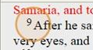

• Yes = Show visual cues in resources.
• No = do not show visual cues in a resources.

(see Visual Cues)

Use Internet
[[@Headword:Program Settings – General category [Use Internet] ]]
• Yes = Logos 4 will connect to the internet for various features.
• No = Logos 4 will not connect to the internet.

(see The Internet)

▪ Restart required for changes to take effect.

Accessibility
[[@Headword:Program Settings – Accessibility category ]]
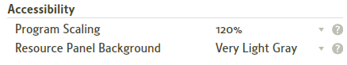

Program Scaling
[[@Headword:Program Settings – Accessibility category [Program Scaling] ]]
• Please watch the Logos 4 video tutorial Set Program Scaling
• Allows you to change scaling factor for your Logos 4 application.
Logos 4 will be larger or smaller depending on this setting. Text, button, and icons will all be scaled proportionally using the chosen percentage of your operating system's dots-per-inch (DPI) display setting.
• If you click on the arrow to the right of the selection a drop down list will appear.
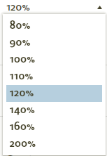
Select the desired scaling that you want for Logos 4.

Resource Panel Background
[[@Headword:Program Settings – Accessibility category [Resource Panel Background] ]]
• Allows you to change the background color of all resource panels in Logos 4.
Tool panels background color cannot be changed!
• If you click on the arrow to the right of the selection a drop down list will appear.
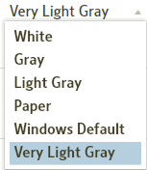
Select the desired background color that you want.

Bible
[[@Headword:Program Settings – Bible category ]]

Use Red Letter
[[@Headword:Program Settings – Bible category [Use Red Letter] ]]
• Allows you to turn ON/OFF words of Christ in red letter for Bibles that support red letters for words of Christ.
• Yes = show red letters for words of Christ.
• No = do not show red letters.
▪ You can generally view a Bible's info (the i within a circle icon on the right side of the resource's toolbar) and look in the Search Fields category on the left and look for words-of-Christ being present on the right (if present then red letters probably works in this resource, if not then don't expect red letters to work in it).
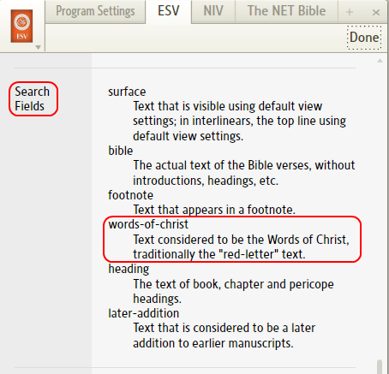

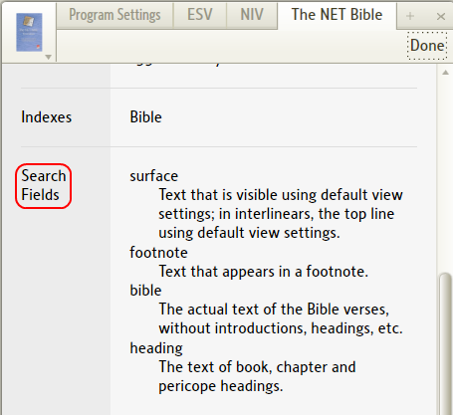

Fonts
[[@Headword:Program Settings – Fonts category ]]

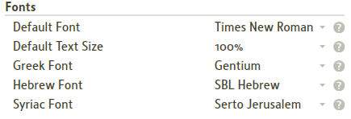

Default Font
[[@Headword:Program Settings – Fonts category [Default Font] ]]
• This font will be used by default in all resources.
• If you click on the arrow to the right of the selection a drop down list will appear.
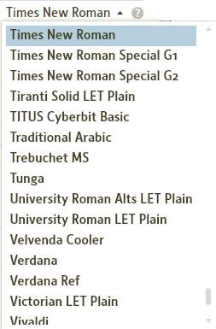
Select the desired font from the list.
(the list in the image is incomplete)

Default Text Size
[[@Headword:Program Settings – Fonts category [Default Text Size] ]]
• Text will be displayed at this size for all resource, document, guide, and tool panels.
Specifying the text size in any individual panel will override this setting.
• If you click on the arrow to the right of the selection a drop down list of available percentages will appear.

Select the desired percentage from the list.

Greek Font
[[@Headword:Program Settings – Fonts category [Greek Font] ]]
• This font will be used by default in Greek resources.
• If you click on the arrow on the right of the selection a drop down list will appear.
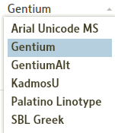
Select the desired font from the list.

Hebrew Font
[[@Headword:Program Settings – Fonts category [Hebrew Font] ]]
• This font will be used by default in Hebrew resources.
• If you click on the arrow on the right of the selection a drop down list will appear.
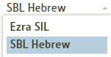
Select the desired font from the list.

Syriac Font
[[@Headword:Program Settings – Fonts category [Syriac Font] ]]
• This font will be used by default in Syriac resources.
• If you click on the arrow on the right of the selection a drop down list will appear.
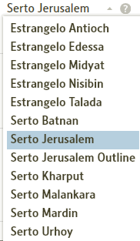
Select the desired font from the list.

Notes
[[@Headword:Program Settings – Notes category ]]

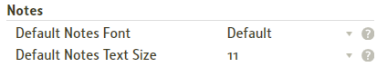

Default Notes Font
[[@Headword:Program Settings – Notes category [Default Note Font] ]]
• This font will be used by default by all notes.
• If you click on the arrow on the right of the selection a drop down list will appear.
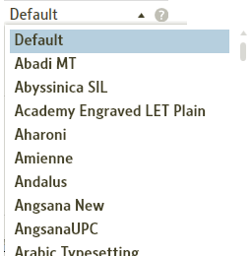
Select the desired font from the list.

Default Notes Text Size
[[@Headword:Program Settings – Notes category [Default Note Text Size] ]]
• Notes will have this font size by default.
• If you click on the arrow on the right of the selection a drop down list will appear.
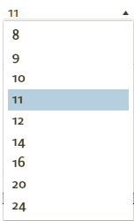
Select the desired font size from the list.

Transliteration Format
[[@Headword:Program Settings – Transliteration category ]]

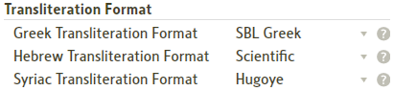

Greek Transliteration Format
[[@Headword:Program Settings – Transliteration category [Greek] ]]
• This format is the transliteration format used for Greek text.
• If you click on the arrow on the right of the selection a drop down list will appear.
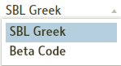
Select the desired font from the list.

Hebrew Transliteration Format
[[@Headword:Program Settings – Transliteration category [Hebrew] ]]
• This format is the transliteration format used for Hebrew text.
• If you click on the arrow on the right of the selection a drop down list will appear.
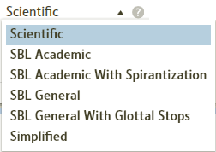
Select the desired font from the list.

Syriac Transliteration Format
[[@Headword:Program Settings – Transliteration category [Syriac] ]]
• This format is the transliteration format used for Syriac text.
• If you click on the arrow on the right of the selection a drop down list will appear.
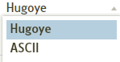
Select the desired font from the list.

Hidden Resources
[[@Headword:Program Settings – Hidden category ]]

• This is where you drag a resource from your Library to hide it.
• The resource will be removed from your computer. But its title is still in your Library database and can be reinstalled on your computer.
▪ Restart required for changes to take effect.
• Please see Hiding Books

▪ Passage ▪
[[@Headword:Passage Section ]]
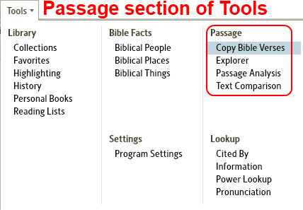

Copy Bible Verses
[[@Headword:Copy Bible Verses ]]Wiki page: Revision 19 Link

How to Use Copy Bible Verses
[[@Headword:Copy Bible Verses – How to use ]]
Use the Copy Bible Verses tool to copy Bible text from any Bible version in your Logos library, in a variety of styles, to paste in a word processing or other document. Please watch Mark Barnes excellent video which includes Copy Bible Verses: Logos Tutorial Video #13 - Export.
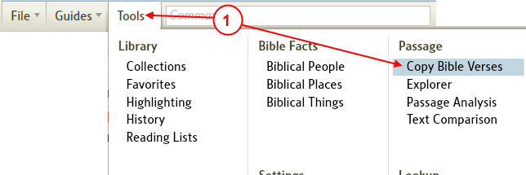
1. Click on Tools | Copy Bible Verses.
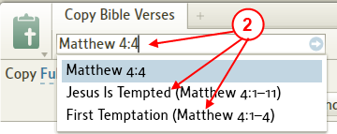
2. Type a passage or pericope in the Reference box and press Enter, or first choose a pericope and passage from the suggested matches displayed as you type.

a. When entering verse(s) manually, you may need to Turning off Follow in the Menu first.

b. When entering multiple verses which are not in sequence, use a comma or semicolon between verses. (see Entering Multiple verses)

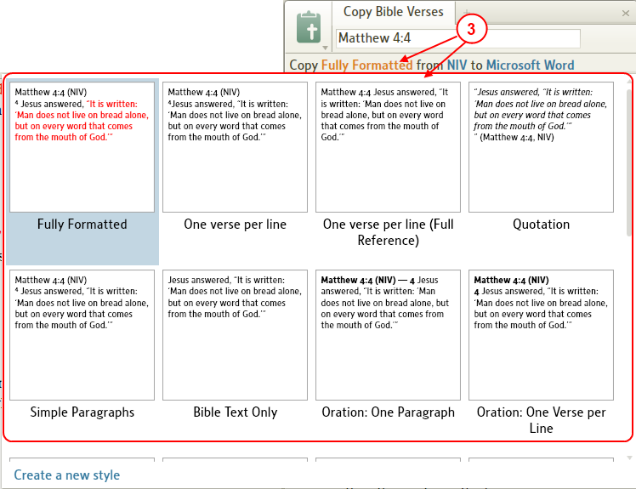
3. Choose a style from the style drop-down list. (Fully Formatted is the default.)
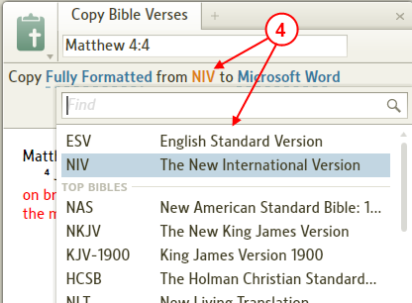
4. Choose a Bible version from the version drop-down list.
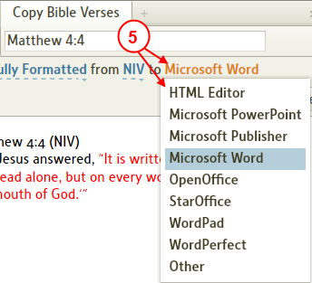
5. Choose a word processing or other program from the program drop-down list.
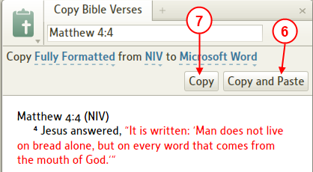
6. Click the Copy and Paste button, if available, to copy the text and paste it automatically into the document.

7. If Copy and Paste is grayed out, click on Copy to copy the text, then click into the open document in the other program, and click on its Edit | Paste menu to paste the text.

Note: There is a limitation on the amount size of the passage that can be "copied" using Copy Bible Verses. This will not normally be an issue, but if you were trying to insert the whole whole text of a bible book into your document then this would not be possible and you would need to break it down into smaller portions.

Copy Bible Verses Styles
[[@Headword:Copy Bible Verses - Styles ]]

Choose one of the built-in styles or create your own!
[[@Headword:Copy Bible Verses – Styles [Built-in or Create your own] ]]
1. Open the Copy Bible Verses tool.
2. Click on the style drop-down arrow to open the gallery of styles.
3. Choose the built-in style that best fits how you want the verse to appear in your document.
• A preview of each style is displayed to help you with your choice.
• If you want a style that will bring over footnotes and citations with the text, choose Fully Formatted with Footnotes.
• If none of the built-in styles works for you, you can create a new style.

Create a new style:
[[@Headword:Copy Bible Verses – Styles [Create a new Style] ]]
1. Choose the built-in style that is closest to the style you want.
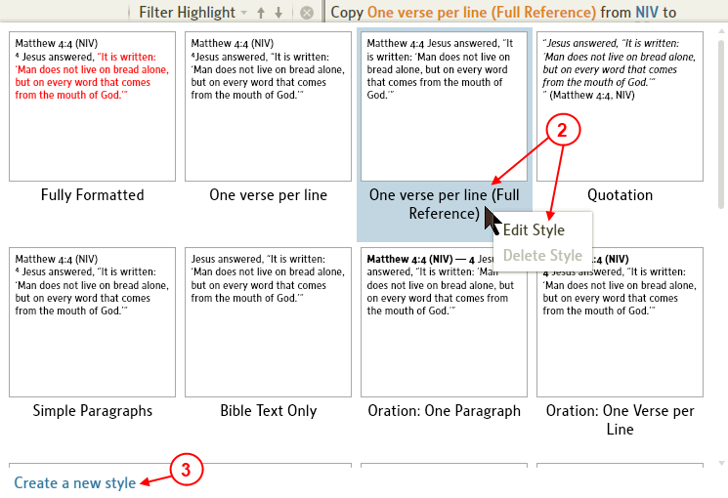
2. Click on the panel icon and choose Edit Style: [style name]. This will open a copy of that style template. The style name will have a “(2)” after it. You can keep that name or type a unique name for your style.

3. You can also click on Create a new style on the panel menu, or at the lower-left corner of the style gallery.
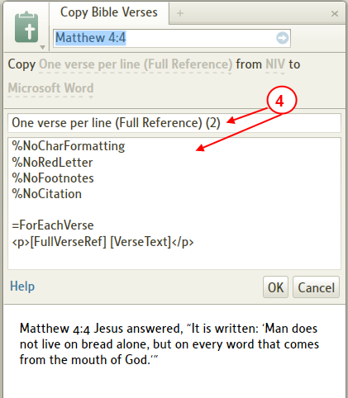
4. Below the style name are the formatting codes, flags, and replacement tokens that represent the different style components. To learn how to use these to create a new style, go to Copy Bible Verses Syntax help.

Copy Bible Verses Syntax
[[@Headword:Copy Bible Verses - Syntax ]]

Global Formatting Flags: (these flags will come first in your style template)
[[@Headword:Copy Bible Verses – Syntax [Global Formating Flags] ]]
%NoCharFormatting | remove character formatting, i.e., bold, italic, etc.
%NoParFormatting | remove paragraph formatting, i.e., poetry line breaks
%NoRedLetter | words of Christ will be in black text
%NoFootnotes | footnotes will not be copied
%NoCitation | bibliographic citations will not be copied
%UseBibleParagraphs | paragraphs will be copied as they appear in the Bible
%CopyAllText | all text will be copied, inc. cross-reference footnotes, verse numbers, etc.
%HeaderStyle = My Style Name | Word style for header
%ForEachVerseStyle = My Style Name | Word style for verse
%FooterStyle = My Style Name | Word style for footer
%FootnoteStyle = My Style Name | Word style for all footnotes, including citations
%CitationStyle = My Style Name | Word style for citation footnotes

Replacement tokens:
[[@Headword:Copy Bible Verses – Syntax [Replacement tokens] ]]
[FullPassageRef] | e.g., John 3:16-18
[ShortPassageRef] | e.g., Jn 3:16-18
[FullBookName] | e.g., John
[ShortBookName] | e.g., Jn
[ChapterNum] | e.g., 3
[VerseNum]* | e.g., 16
[FullVerseRef]* | e.g., John 3:16
[ShortVerseRef]* | e.g., Jn 3:16
[Version] | e.g., ESV
[VerseText]* | e.g., For God so loved ...

*Limited functionality can be used in “ForEachVerse” only cannot be used in header or footer

Formatting codes: (HTML tags)
[[@Headword:Copy Bible Verses – Syntax [Formatting codes] ]]
<p>...</p> | paragraph
<b>...</b> | bold
<i>...</i> | italic
<u>...</u> | underline
<sup>...</sup> | superscript
<sub>...</sub> | subscript

Example Copy Bible Verses Syntax
[[@Headword:Copy Bible Verses - Examples ]]
%NoCharFormatting
%NoRedLetter
%NoFootnotes
%NoCitation

=Header
<p>“
=ForEachVerse
<sup>[VerseNum]</sup>[VerseText]
=Footer
” ([FullPassageRef], [Version])</p>

Copy Bible Verses Shortcuts
[[@Headword:Copy Bible Verses – Keyboard Shortcuts ]]

Opening the Copy Bible Verse panel
[[@Headword:Copy Bible Verses – Keyboard Shortcuts [Opening the Panel] ]]
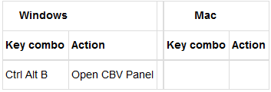

From the Copy Bible Verse panel and it being the active panel.
[[@Headword:Copy Bible Verses - Keyboard Shortcuts [Active panel] ]]
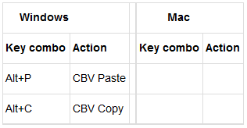

Copying Multiple Verses
[[@Headword:Copy Bible Verses – Multiple Verses ]]
Logos4 allows you to enter multiple verses in the reference box. But you will need to turn OFF the Follow method for Linking in the menu prior to entering your verse(s) in the reference box, or Logos4 may automatically change your verse(s) in the reference box.

Turning off Follow in the Menu
[[@Headword:Copy Bible Verses – Multiple Verses [Turning Off the Follow in the menu] ]]
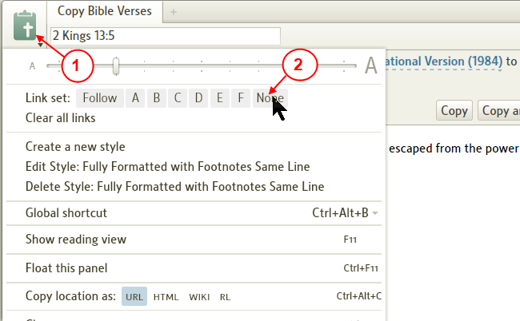
1. Click on the Copy Bible Verse panel's icon to view the menu.

2. Click on None to turn Off linking so that Logos4 will not automatically change the reference in the reference box.

Entering Multiple verses
[[@Headword:Copy Bible Verses – Multiple Verses [Entering multiple verses] ]]
You will need to separate non-continuous verse ranges with a comma or a semicolon. NOTE: If you end your list of verses with a semicolon, it will simply ignore you. Do not end your selections with a comma or semicolon.
Examples | details
Matt 1:1, Mark 1:2, Luke 1:1 | 3 separate verses
Matt 1:1–3; Matt 7:1–3 | 2 verse ranges within the same book
Matt 1:1–3, 7:1–3 | 2 verse ranges within the same book
Matt 1:1-2; 7:1-3; John 1:1-3 | 3 verse ranges, 2 in the same book and the other in a different book
Matt 1:1-2, 7:1-3, John 1:1-3 | 3 verse ranges, 2 in the same book and the other in a different book

Explorer
[[@Headword:Explorer ]]Wiki page: Revision 15 Link

What is the Explorer tool?
[[@Headword:Explorer – What is it ]]
• The Explorer tool acts like a mini-Passage Guide which will Follow the active resource or you can have it follow a linked resource. As mentioned, it is not a full Passage Guide. Unlike the Passage Guide, it can dynamically show you useful information without having to type a passage and search.
• To open Explorer, click on Tools in the top menu. Then select Explorer as shown below.

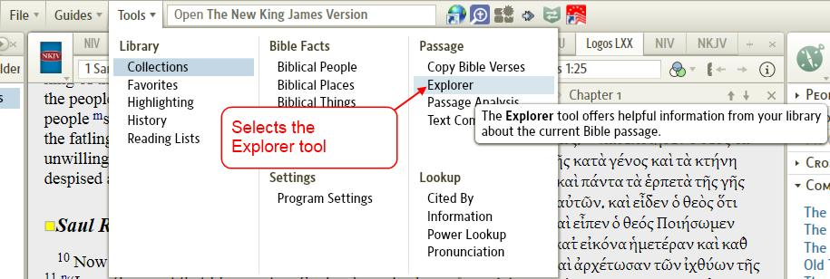

Explorer basic fields
[[@Headword:Explorer – Basic fields ]]
• As of version 4.0aSr3, there are 5 fields as shown below.
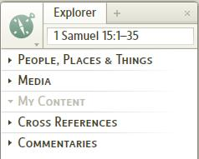

People, Places & Things
[[@Headword:Explorer – People, Places & Things ]]
• Searches for People Places Things pertaining to the passage shown in the reference box.
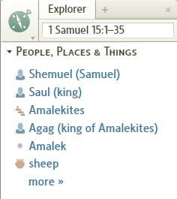

Media
[[@Headword:Explore - Media ]]
• Searches for Media pertaining to the passage shown in the reference box.
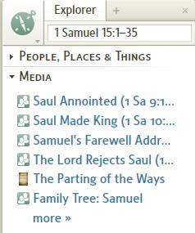

My Content
[[@Headword:Explorer – My Content ]]
• Searches for your notes pertaining to the passage shown in the reference box.
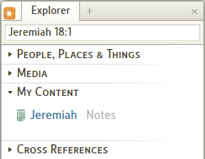

Cross References
[[@Headword:Explorer – Cross References ]]
• Searches for Cross References pertaining to the passage shown in the reference box.
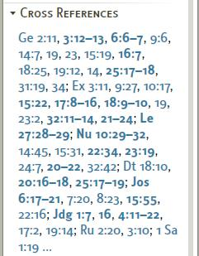

Commentaries
[[@Headword:Explorer - Commentaries ]]
• Searches your Commentaries pertaining to the passage shown in the reference box.
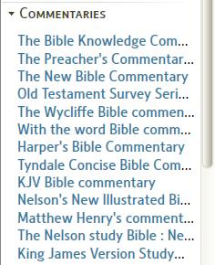

• By clicking on any of the links in these fields, it will open the appropriate resource in the associated window.

Linking Explorer
[[@Headword:Explorer - Linking ]]
• Linking Explorer works the same as most tools in Logos4.

Follow
[[@Headword:Explorer - Follow ]]
• Follow allows Explorer to follow which ever resource that you click (resources which are navigated via Bible passages).
• When Follow is selected, an Asterisk appears in the window's icon as shown below.

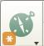

A,B,C,D,E,F
[[@Headword:Explorer –A,B,C,D,E,F ]]
• When linked to one of the standard Letters, it follows the Bible passage which the resource has in its reference box.
• See Linking Resources.
• If you are not familiar with Linking, please watch this video Bibles and Commentaries found at Logos4 Videos. About half way through it, it discusses Linking. Linking is a feature in Logos4 which links different resources together so that they will track each other (as you move along in a Bible then if the commentary is linked, it will track where you are in the Bible).

None
[[@Headword:Explorer - None ]]
• When None is selected, it follows what ever passage appears in the reference box. This might come in handy when you want to search for info on a particular passage. This would also work well when you want to use it from a Pop-up Menu (when you right click on a selection in a resource and you get a Pop-up Menu).

Pop-up Menu
[[@Headword:Explorer – Pop-up ]]
• When you select a word or series of words in a resource and click the right mouse button, a Pop-up Menu appears. Now if you select Reference (on the right side of the Pop-up), you should see Explorer on the left side of the Pop-up Menu. Then when you click it, the Bible passage will appear in Explorer and it will search for pertinent info.

Passage Analysis
[[@Headword:Passage Analysis ]]Wiki page: Revision 37 Link

Video
Tutorial video Word Tree
Tutorial video Morph River
Logos4 Videos

What is the Passage Analysis tool?
[[@Headword:Passage Analysis – What is it ]]
• Passage Analysis tool provides a set of tools to display a variety of graphical analyses of one or more Bible versions.
• These tools are available for those who have the base package Original Language Library or higher. (see comparison chart)
• There are 5 tools provided in the Passage Analysis. When you open Passage Analysis you will see the 5 tool icons at the bottom of the window. To select one of these tools, click on one of the tool icons.

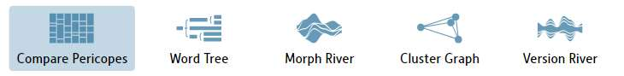

▪ Compare Pericopes graphically displays pericope boundaries for multiple Bible versions.
▪ Word Tree creates a tree structure that displays the context of a word or phrase in which it appears.
▪ Morph River creates a graphical representation of the grammatical attributes in a Greek or Hebrew morphologically-tagged text.
▪ Cluster Graph creates a graphical representation of the differences between multiple Bible versions, based on word variance.
▪ Version River creates a graphical display of the differences between Bible versions on a verse-by-verse basis, using one version as the base to which the others are compared.
▫ Above descriptions from: Inc. Logos Research Systems, Logos 4 Help (Logos Research Systems, Inc.; Bellingham, WA, 2009; 2009).
▪ These tools work with Pericope passage ranges for the Bible(s) that you select.
▫ Pericopes are the descriptions that you will find in many Bibles which describe a group of passages. (e.g. in the NKJV for Jeremiah 18:1 you will see above 18:1 the pericope The Potter and the Clay). Pericopes will vary from Bible to Bible. Some Bibles may have more or less pericopes.
▫ At the top of your Passage Analysis tool you will see the passage selection box. When you enter the passage Jeremiah 18 and click in the box (a), a drop down menu will appear showing Pericope verse ranges (to the left of the brace).

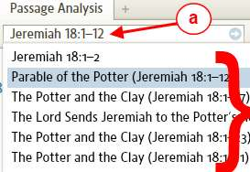

▫ Or if you enter in the passage box birth Logos4 will try to find pericopes which match that word as shown below.

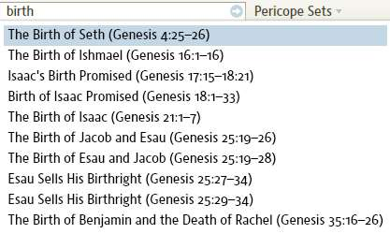

Compare Pericopes
[[@Headword:Passage Analysis – Compare Pericopes ]]
• Compare Pericopes is useful for
▪ Finding pericope using word(s) that fit the topic in which you want to find. (e.g. typing birth or transfigure)
▪ Determining which pericope that produces the verse range that you are interested in using with the Passage Analysis tools.
▪ Seeing how the different Bibles have varying pericopes.
• Click on the Compare Pericopes icon at the bottom of the Passage Analysis tool.
• You will need to set which Bibles that you want Pericopes displayed. When you click on Pericope Sets
a) A drop down menu will appear.
b) Notice the checkboxes next to each Bible version. Also notice the scrollbar on the right for viewing more Bibles. This menu shows you Bibles which Logos has pericopes for. Check the Bible version(s) that you want to view.

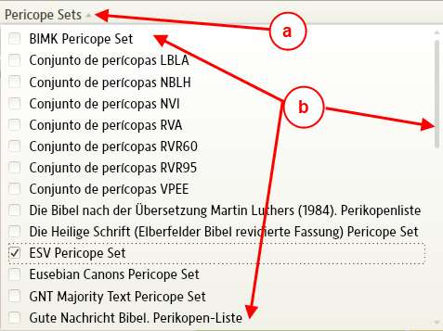

• Next enter a Bible reference (e.g. Jeremiah 18:3) or type a word (which might be in a pericope) in the passage selection box. When the drop down menu appears, select the pericope in which you are interested in viewing. (see What is the Passage Analysis tool? )

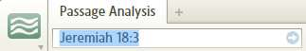

• Now in the Compare Pericopes window you should see the different Bibles that you have selected earlier when you clicked Pericope Sets and checked different Bible versions. The window parts are described below.
▪ a) Notice the Bibles that you have selected with Pericope Sets.
▪ b) Notice the different pericopes for each of you Bibles.
▪ c) This is your Bible passage. If you scroll the mouse wheel (or click on the arrows at either end of the scrollbar) you will notice that the verse range changes and you may see more or less pericopes being displayed in the window.
▪ d) As you change the verse range, you will see these arrows within a Bible's pericope column. The up arrow indicates that the pericope starts above the verse you see on the left. The down arrow indicates that the end of this pericope is below the last verse shown on the left.

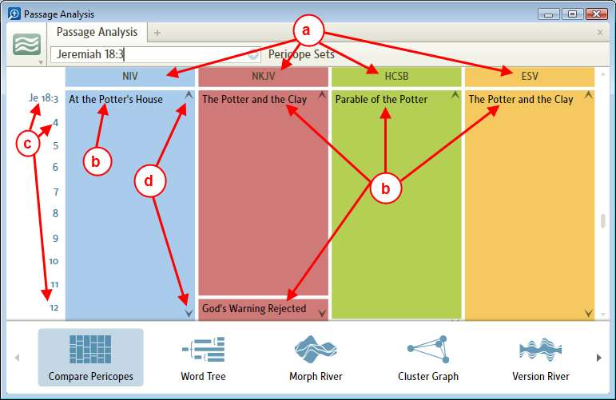

• As you change the range using the mouse wheel or the scrollbar, notice that in the passage selection box the passage changes.
• If you hover the mouse over a pericope, a pop-up box will appear showing you some of the text from you preferred Bible (Note: pericopes for different Bibles in the Compare Pericopes window will always show text from your preferred Bible which you setup from the Home Page ribbon. See Ribbon Items )
• If you click on a pericope in the window, Logos4 will open that version and position it to that pericope.
• To setup a range of verses which spans more than one pericope:
▪ Move the mouse to one of your Bible pericope display in an open area under the pericope.
▪ Hold the left mouse button down and turn the scroll wheel while keeping the left button down. You can also use the Ctrl key instead of the mouse button. Notice that the passage box changes the passage location. This is the end location for your range (or start if you scrolled before the starting pericope).
▪ When you find the area that you want release the button.
▪ If you clicked one of the other Passage Analysis tools (e.g. Word Tree), in the passage box you will see the range that you setup here in the Compare Pericopes tool.

Word Tree
[[@Headword:Passage Analysis – Word Tree ]]
• Please watch the Logos4 tutorial video Word Tree

• Word Tree is useful for
▪ Finding a word or phrase repeated in a Bible passage range.

• The key word or phrases will be shown in different degrees of size. The larger the word/phrase, the more often it was found in your passage.

• Pay attention to text in each text line. You may see repetitions of text, since in the same line of text your key word/phrase was found again. (e.g. in the image below you will find that the 4th line is partially found in the 3rd line. There are others in this image) Having a new line of text indicated how many occurrences were found in your passage!

• Below is a description of the parts/usage of the Word Tree:

a) Click on the Word Tree icon at the bottom of the Passage Analysis window to select Word Tree.

b) Change the passage in the passage selection box if it is not where you want it. (see What is the Passage Analysis tool?; I also find Compare Pericopes useful in setting passage ranges )

c) Select the Bible version that you want to use.

d) The Word Tree will show relevance to a word or phrase that you select (notice the large word angel in the image. This is the key word selected.) You can select the key word by typing it in the word box or by clicking on a word in the text in the Word Tree. If you click on a word in the text, you will see it appear in the word box. Sometimes when clicking on a word it may show only a few words in a single line. Don't panic. You can type a word in the word box to get back to viewing more text lines (often when this happens I will type the in the word box to show most if not all the lines).

e) When you see a group of words enlarged, the Word Tree is indicating this is a phrase. You can click on the phrase to have Word Tree set the phrase as the key word.

f) The ordering of the text lines can be adjusted here. Simply click on the highlighted ordering and a drop down menu appears. Click on your desired ordering (if you watch closely you will see some cute moving of the lines when the ordering has changed).

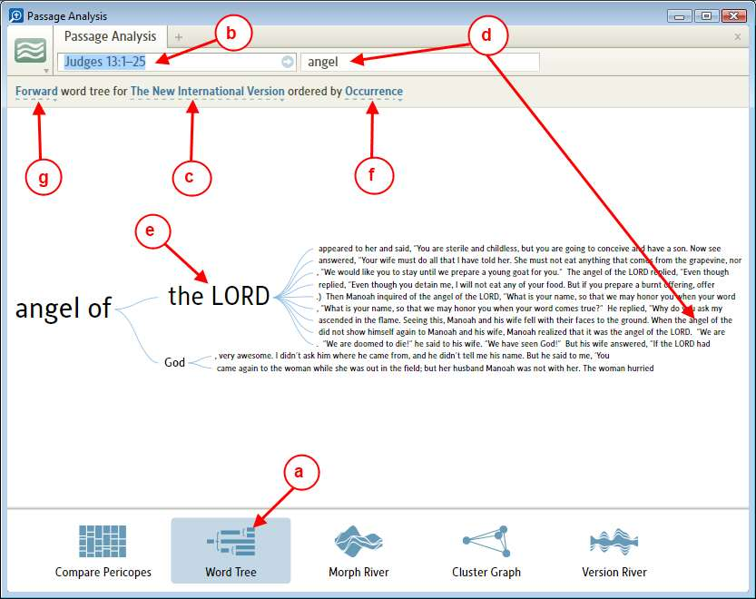

g) The direction of the Word Tree can be changed when you click on this item. A drop down menu will appear. If you click on Reverse (see image below) the text lines show text preceding the key word or phrase.

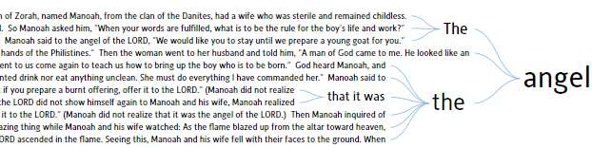

• You may see in the Word Tree many text lines and they may not be readable. This tool allows you to Zoom & Pan. This allows you to zoom in /out and then pan (move the image left, right, up, or down) it to where you want to view.

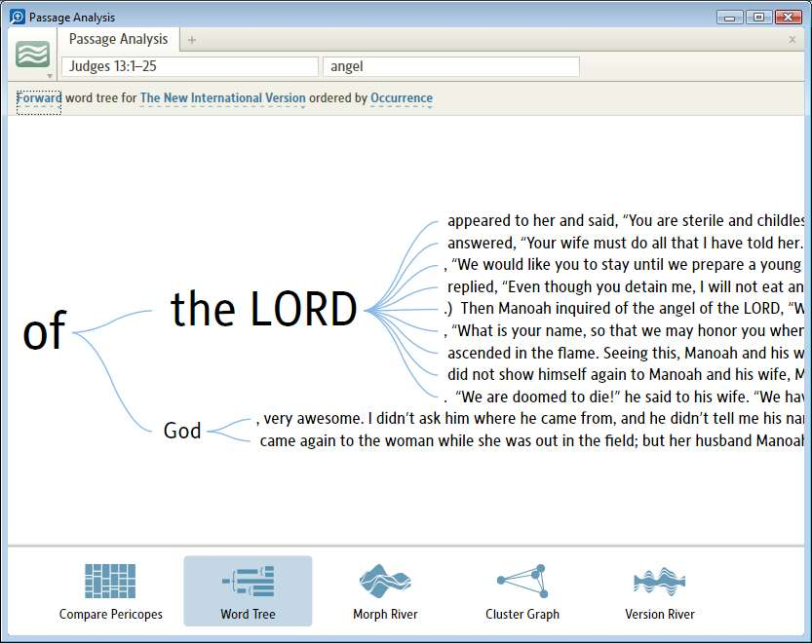

Morph River
[[@Headword: Passage Analysis – Morph River ]]

• Please watch the Logos4 tutorial video Morph River

• Morph River is useful for:
▪ Finding how parts of speech are used relative to their attributes in a passage range.
(it looks at Greek/Hebrew usage in English versions which have a Reverse Interlinear. Also works with original language versions.)

• Below is a description of Morph River:

a) Click on Morph River icon at the bottom of the Passage Analysis window to select Morph River.

b) Change the passage in the passage selection box if it is not where you want it. (see What is the Passage Analysis tool?; I also find Compare Pericopes useful in setting passage ranges )

c) Click and select the Bible version that you want to analyze.

d) Click here to select the Part of Speech that you want to view.

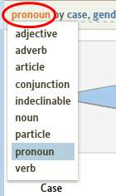
e) Click here to select the attributes for the part of speech (you selected in step d) that you want to view in the information area of this tool. You can check one or more of these.
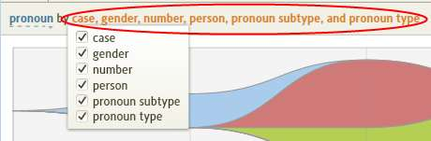
f) In the graphic (for the image below) there are 5 streams in your river. Each with different colors. Also notice to the left of the 1st column that there is a colored dot for each attribute combination. The colored dot identifies which colored stream that is associated with it in the river. Try holding your mouse over a stream in the river. Notice that it changes colors (continuously). Also notice that the colored dot for that attribute combination changes colors as the stream changes colors. This helps you identify the attribute combination in the stream. This also works in reverse, hold your mouse over the colored dot next to the attribute combination and the associated stream in the river will change colors.

g) These are the attributes that you selected in step e.

h) This column show the percentage of how many times this attribute combination was found for this part of speech in this passage range.

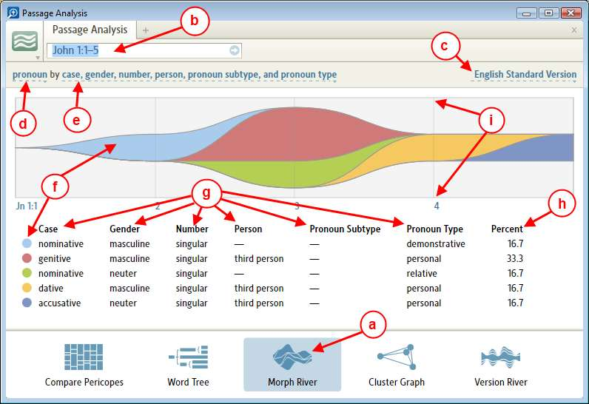
i) The vertical lines in your river graph are verse markers. If you hold your mouse over one of the lines, a pop-up window will appear for that verse. (see image below).

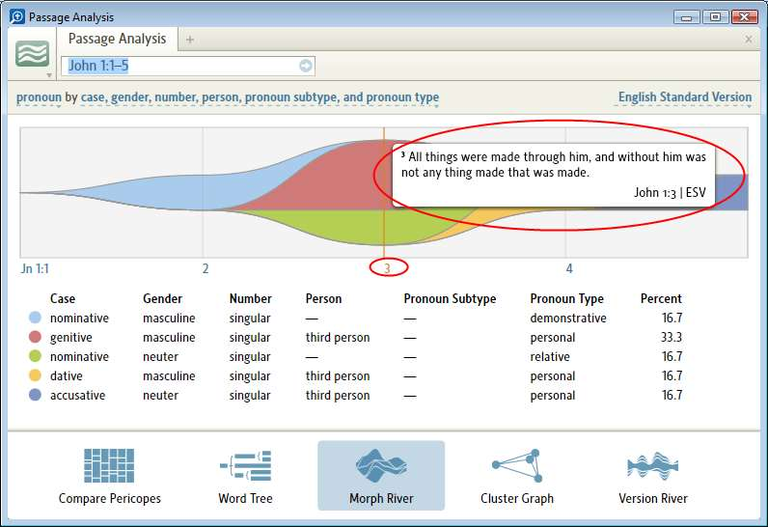

• For help with Parts of Speech and Attributes see Glossary of Morpho-Syntactic Database Terminology (a book in your Library). [Look in the table of Contents of this book]
▪ Or you might look in your Library and in the Find box enter title:glossary.
• This Morph River tool can be zoomed and panned. (see Zooming & Panning)

Cluster Graph

• To be added

Version River
[[@Headword:Passage Analysis – Version River ]]
• Version River is useful for
▪ Seeing the variations between Bible versions graphically relative to a base Bible version that you set up.

• Your base Bible version is the one that appears first in your Bible list (see item c in the image below) to be compared.

• Below is a description of the parts/usage of the Version River:

a) Click on the Version River icon at the bottom of the Passage Analysis window to select Version River.

b) Change the passage in the passage selection box if it is not where you want it. (see What is the Passage Analysis tool?; I also find Compare Pericopes useful in setting passage ranges )

c) The 1st Bible in this list is your base Bible version. In this Bible versions box start typing a Bible versions abbreviation and a drop down menu will appear with Bible versions. Click on the Bible version you want. To add more Bible versions to be compared, type a comma after the last one in your list and start typing the next version's abbreviation. Remember to press the blue arrow on the right when you have all the versions that you want to compare!

d) Notice in the body of Version River under the heading Resource that your versions from the list appear. Also notice that your base version (1st one in your list) does not appear. The base version does not appear since the other versions are being compared to it.

e) In the graphic (for the image below) there are 4 streams in your river. Each with different colors. Also notice under Resource that there is a colored dot to the left of each version. The colored dot identifies which colored stream that is associated with it in the river. Try holding your mouse over a stream in the river. Notice that it changes colors (continuously). Also notice that the colored dot for that resource changes colors as the stream changes colors. This helps you identify the resource in the stream. This also works in reverse, hold your mouse over the colored dot next to the resource and the associated stream in the river will change colors.

f) The numbers to the right of the resource indicate the difference between this resource and your base version.

g) This link indicates your base version that the other versions are being compared with. If you click on this base version link, it will take you to this Bible resource (either one already open or it will open it for you).

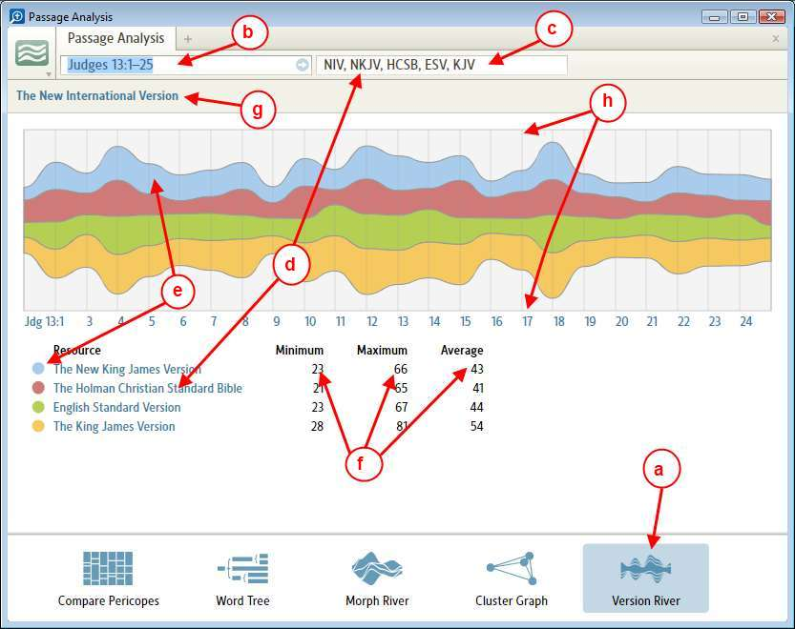
h) The vertical lines in your river graph are verse markers. If you hold your mouse over one of the lines, a pop-up window will appear for that verse showing it in all the versions in your version box list. (see image below). [see also the Text Comparison tool. You may find it useful to have Version River and the Text Comparison tools open at the same time.]

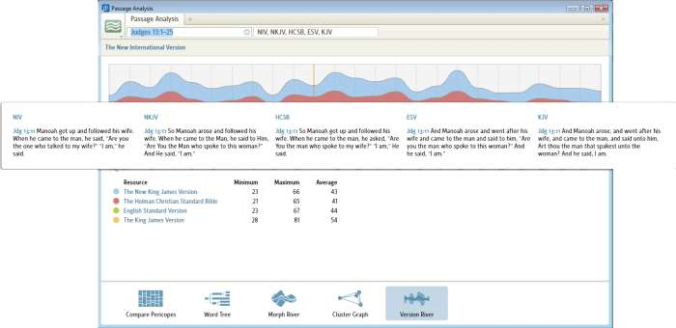
(example of Version River shown with the Text Comparison tool)
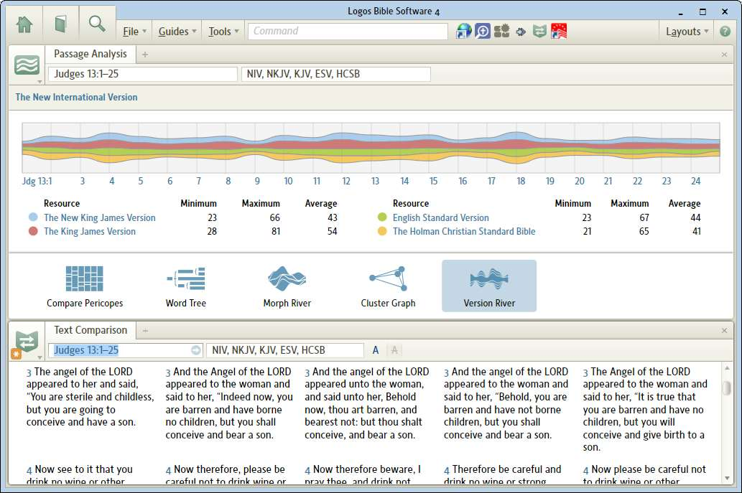
• This Version River tool can be zoomed and panned. (see Zooming & Panning )

Zooming & Panning
[[@Headword:Passage Analysis – Zooming & Panning ]]
• Zooming
▪ To zoom in or out use your mouse wheel over the view area of your tool. Or from a touch pad use the vertical scroller. The keyboard shortcuts for scrolling do not work here. See example below of normal view (when many text lines are present).

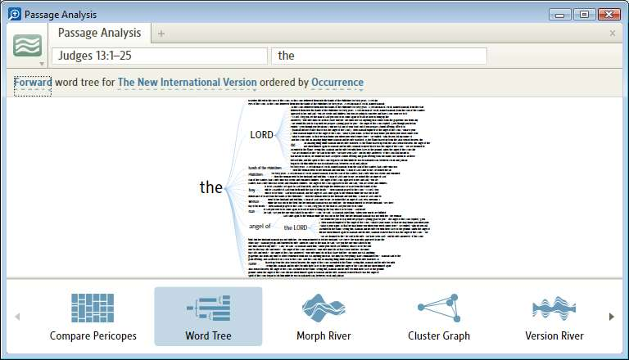
When zoomed in some, see view below.

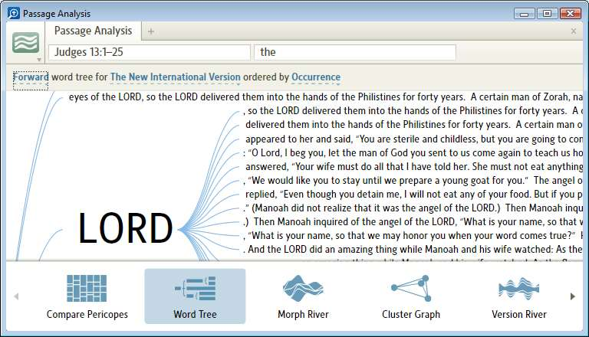
▪ You can place your mouse over an area of the screen in which you want to zoom from. (e.g. by holding your mouse close to the left edge of your Passage Analysis tool area, then turning your mouse to zoom, Logos4 will attempt to zoom while trying to preserve the position to the left.) This can help limit the amount of panning that you need to do after zooming.

• Panning
▪ Panning is grabbing and dragging a screens location.
▪ To pan, place your mouse over an empty area of the screen and you will see the cursor change to an open hand. Now hold the left button down (keep the button down while dragging) and move the mouse. When you release the mouse button, dragging will stop. You cannot drag the screen image until you have zoomed and part of the screen image is not visible on the screen.
▪ Below is an example of the screen prior to panning.

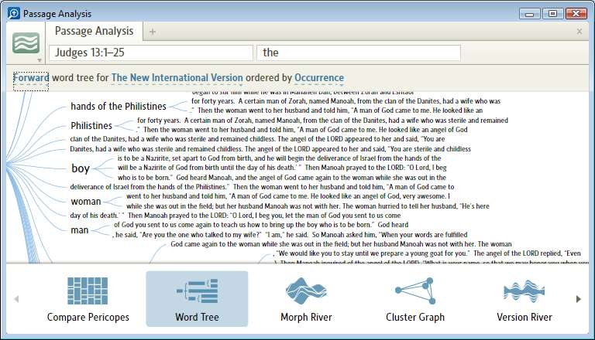
The image below was panned to the right.

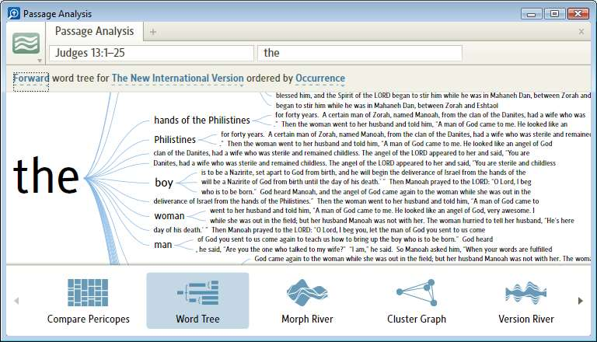

Text Comparison
[[@Headword:Text Comparison ]]Wiki page: Revision 58 Link

Video
Feature Video Text Comparison
Tutorial Video Text Comparison
Logos4 Videos

What is the Text Comparison tool?
[[@Headword:Text Comparison – What is it ]]
Please view Logos 4 tutorial short video which is found in Logos Videos and is called Text Comparison
Also on that same site is a Feature video named Text Comparison. (these are 2 different videos with the same name. But one is filed under Tutorials and the other is filed under Features)

• The Text Comparison tool will allow you to view multiple Bible translations. For those with Original Languages base package or higher (see Text comparison missing features?), there are also comparison features available. Show Differences highlights difference in other Bibles relative to the first Bible in your list. Show Base Text shows text found in the first Bible (with a strike-thru) relative to each of the other Bibles. (watch the 1st video)
• When linked, the Text Comparison will update as you move through your Bible (watch the 1st video).
• When the alignment is set to Automatic, the Bible verses in Text Comparison will automatically adjust as you re-size the window (watch the 1st video).
• When you select verses in your Bible, the Text Comparison text will automatically follow what you have selected (watch the 1st video).
• To open Text Comparison tool:
1. Click on Tools in the top menubar.
2. Click on Text Comparison in the drop down menu.

.

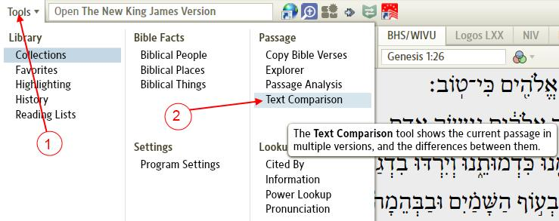

• Or see When hovering in a Bible

Text comparison missing features?
[[@Headword:Text Comparison –Is it missing ]]
The Show Differences and the Show Base Text features don't seem to be available for base packages lower than Original Languages package per the Logos Comparison website.
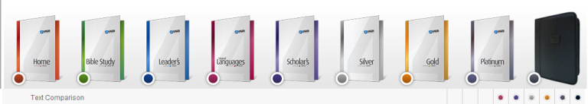

Menu bar descriptions
[[@Headword:Text Comparison – Menu bar ]]
1. Reference box. Enter your Bible reference here.
2. Bible list box, this are which Bibles to display. Enter your Bible abbreviations separated by commas or select from the drop down menu. The first entry is used as the reference Bible which the others can be compared to.
3. Show differences toggle button.
4. Show Base Text (differences between base text are shown with strike-thru text)

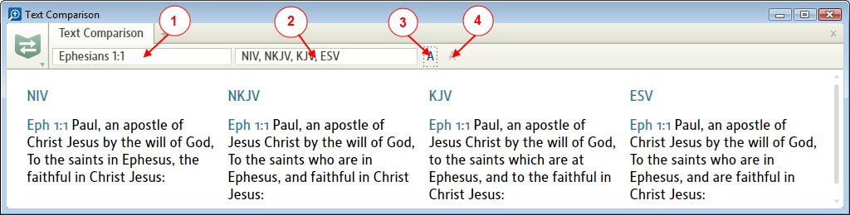

Reference box
[[@Headword:Text Comparison – Reference box ]]
• In the Reference box, just start typing in a Bible reference and Logos4 will show you a drop down list of the verse you are entering along with pericopes (headings).

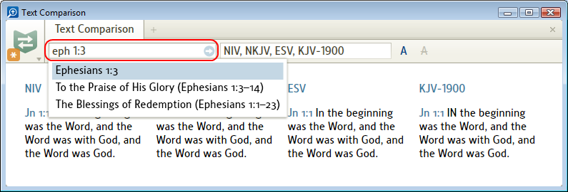

Bible list box
[[@Headword:Text Comparison – Bible list box ]]
• In the Bible list box, if you clear the entry and then start typing in the initials of a Bible, a drop down list of Bibles will appear.

Note: to have only 2 Bibles in the list box you will need to make sure that you have at least 2 Bibles setup in your Prioritization, otherwise Logos4 will force a third Bible to be added to your list. (see this post)
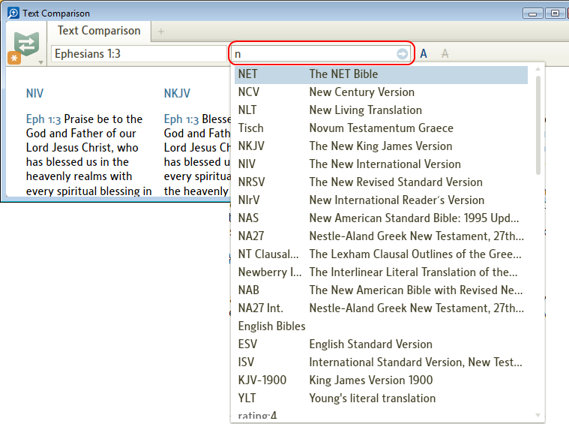

• To enter more Bibles, type in a comma after the last Bible. Then start typing the initials of another Bible and the list will drop down.
Continue the process (adding commas and Bibles) until you get the Bibles that you want.

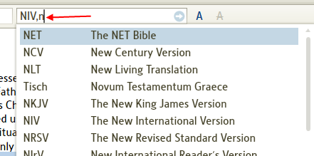

• Once that you have your list complete make sure that while the cursor is still in the Bible list box that you press Enter on your keyboard. (this tells Logos4 to lock in your new selections)

• If you have entered lists in here before, you can just click at the end of the list in the Bible list box to place your cursor there. Then Logos4 will drop down a list of recent Bible groupings that you have done. Then you can select one of these.
(seems that Logos4 associates the recent with an active resource or layout. So the recent may vary with resource/layout.)
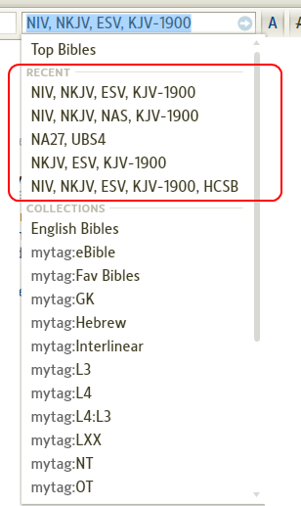

• In the Bible list box, you can also select tagged resources (those that you have tagged in your Library window) and Collections (those which you have created into a named collection). This might be convenient for original language resources.
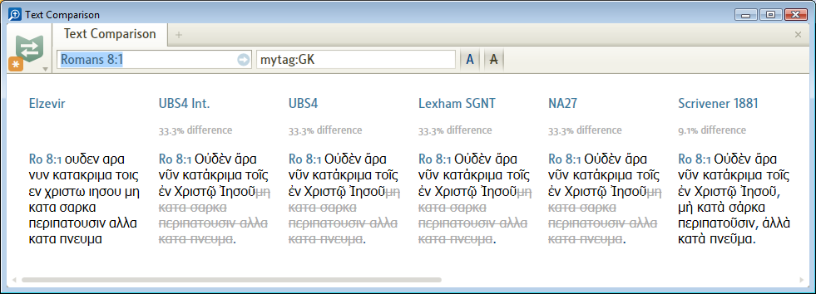

▪ In the image above, I have used Additional controls used with Comparison Features to ignore Case & Marks.
▪ When doing this you might notice a problem setting up your Base text version. (See How to use a Collection in Text Compare )

Show Differences
[[@Headword:Text Comparison – Show Differences ]]
• Show Differences will allow you to see difference between Bible translations relative to the base version (first Bible in your list).

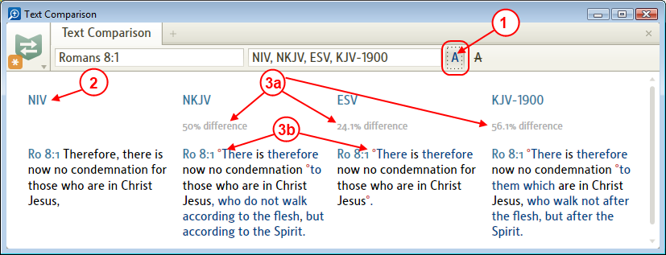

1. Click on the Show Differences button (the first A to the right of the Bible list box).
(if it is disabled, please see Text comparison missing features? )

2. Notice your base version is the first Bible on the left. (e.g. the Bible which the other versions are compared to).

3. The other Bible version(s) to the right of the base version are compared to the first Bible.
a. Notice the percentage difference under each compared version.
b. Notice the red degree symbol (small red superscripted circle) next to the blue text. These are differences between the base version's text.

4. If you click on the Show Differences again, it removes the visual difference markings.

• If you are using Original language Bible versions you might find it useful to use these additional controls. (Additional controls used with Comparison Features )

Show Base Text
[[@Headword:Text Comparison – Show Base Text ]]
• Show Base Text works with Show Differences.
• If you have Show Differences turned OFF, notice that Show Base Text button is disabled.
Thus you will need Show Differences turned ON before you can use the Show Base Text.
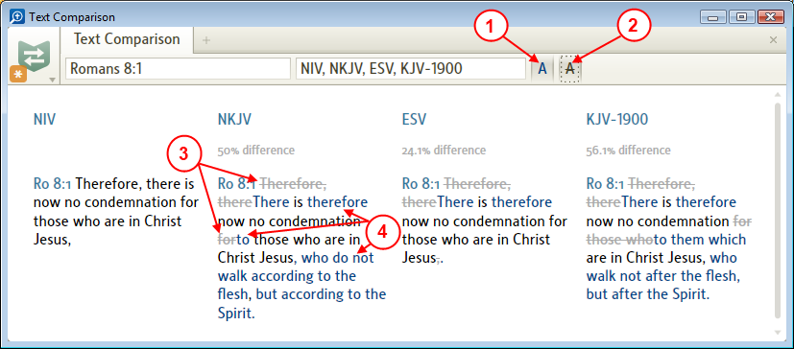

1. Click on the Show Differences button to turn it ON.
2. Click on the Show Base Text button.
3. Notice that the words that are crossed out are the words from the Base text which were not found in this position of the compared Bible version.
4. Notice that words which were different from the Base text version are blue.
5. Clicking on the Show Base Text button again will turn OFF the Show Base Text.

• If you are using Original language Bible versions you might find it useful to use these additional controls. (Additional controls used with Comparison Features )

Window options
[[@Headword:Text Comparison – Window options ]]
• When you click on the icon for this tool, the windows options drop down appears:

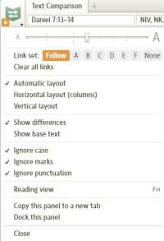

Layout orientation options
[[@Headword:Text Comparison –Layout Orientation ]]
• You can pick one of the following.

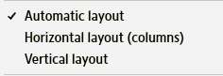

• Automatic

This will determine the best method (Horizontal or Vertical) depending on the pane's width.

• Horizontal

Display Bibles horizontally (columns)

• Vertical

Display Bibles vertically (similar to paragraphs)

Comparison Features
[[@Headword:Text Comparison – Comparison Feature ]]
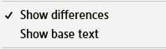
• Show Differences

Corresponds to the left A button on the menu bar.

• Show Base Text

Corresponds to the right A button on the menu bar.

Additional controls used with Comparison Features
[[@Headword:Text Comparison – Addition controls ]]
• You can turn On/Off any or all of these when Show Difference is active.
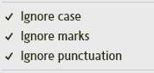

• Ignore Case

When checked, the comparisons will ignore the case of the letters.

• Ignore marks

When checked, the comparison will ignore the accents and breathing marks. (e.g. Greek text)

• Ignore punctuation

When checked, the comparison will ignore punctuation marks.

When hovering in a Bible
[[@Headword:Text Comparison - Hovering ]]
• You can get a pop-up version of Text Comparison to appear when you are in your Bible or a Commentary.
• Hover over a word in your Bible, then press F7 and a pop-up version will appear.
Mac note: if "Use all F1, F2, etc. keys as standard keys" in Keyboard preferences is unchecked, then (fn) key needs to be pressed with F7
▪ If you click on the Text Comparison pop-up, it will open Text Comparison tab in your main window.
▪ To hide the pop-up Text Comparison, click in your Bible.
▪ Bible versions in the pop-up are those which you last had showing when you had the Text Comparison tool open.

Example:

1. Hover your mouse over a word in your Bible resource.
2. On your keyboard press F7. The Text Comparison pop-up appears.
3. Notice that the Text Comparison reference is the same as that which appears in the Bible reference box.
4. Click on your Bible reference to hide the Text Comparison pop-up.
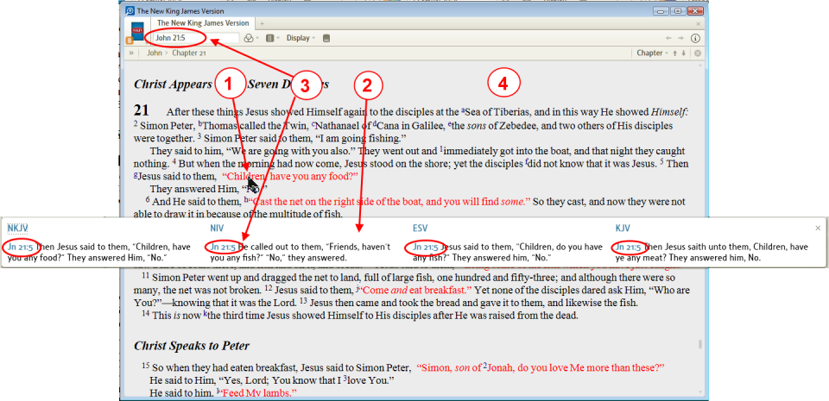

Why does Show Base Text appear disabled?
[[@Headword:Text Comparison – Show Base is Disabled? ]]
• Show Differences needs to be enabled first. Then Show Base Text will be enabled.

Linking Text Comparison
[[@Headword:Text Comparison - Linking ]]
• Linking Text Comparison works the same as most tools in Logos4.

Follow
[[@Headword:Text Comparison - Linking [Follow] ]]
• Follow allows Text Comparison to follow which ever resource that you click (resources which are navigated via Bible passages).
• When Follow is selected, an Asterisk appears in the window's icon as shown below.

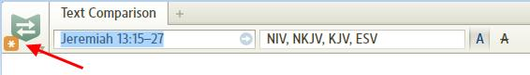

A,B,C,D,E,F
[[@Headword:Text Comparison – Linking [A,B,C,D,E,F] ]]
• When linked to one of the standard Letters, it follows the Bible passage which the resource has in its reference box.
• See Linking Resources.
• If you are not familiar with Linking, please watch this video Bibles and Commentaries found at Logos4 Videos. About half way through it, it discusses Linking. Linking is a feature in Logos4 which links different resources together so that they will track each other (as you move along in a Bible then if the commentary is linked, it will track where you are in the Bible).

None
[[@Headword:Text Comparison - Linking [None] ]]
• When None is selected, it follows what ever passage appears in the reference box. This might come in handy when you want to search for info on a particular Bible passage.

How to use a Collection in Text Compare
[[@Headword:Text Comparison – Use a Collection ]]
Note: to have only 2 Bibles in the list box you will need to make sure that you have at least 2 Bibles setup in your Prioritization, otherwise Logos4 will force a third Bible to be added to your list. (see this post)
• When using a Collection or a Tagged resource set you may have noticed that you have no control in selecting a Base version for comparison.
▪ Example:

▫ If I used a tagged resource set (or collection), then I have no control over which Base version will be used.

▫ But to overcome this problem you can manually enter which Bible that you want to use as a Base version in the Bible List box in front of your tagged set or collection (as shown below) and separate it with a comma and then press Enter. Logos4 will use it as the Base version and ignore repeating it from the tagged set or collection.
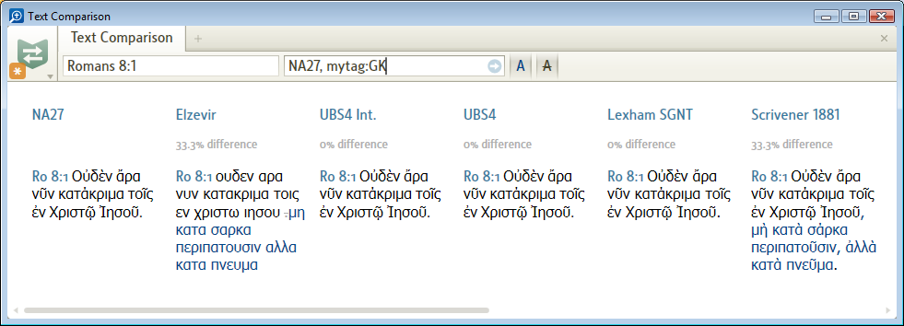

Tip: how to navigate Text Compare Verse-by-Verse
[[@Headword:Text Comparison – Navigate Verse-by-Verse ]]
• You may have noticed that there is no Locator bar in the Text Comparison tool.
• Here is a work around which will allow you to navigate Verse-by-Verse in your Text Comparison tool.
▪ You will need to open a Bible in one window (see Opening resources from your Library).
And the Text Comparison tool in another as shown below (see What is the Text Comparison tool?).
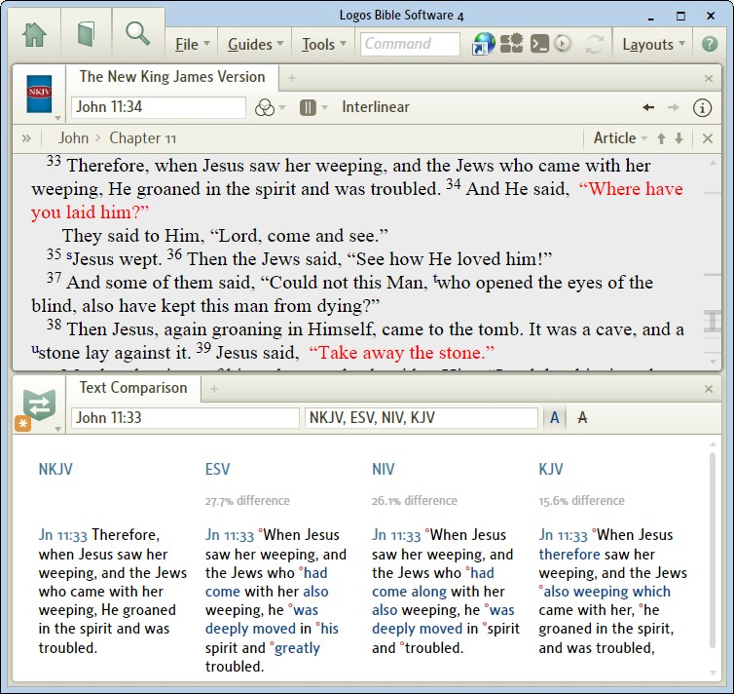

1. Link your Bible and the Text Comparison tool.
(see How do I link resources? ).
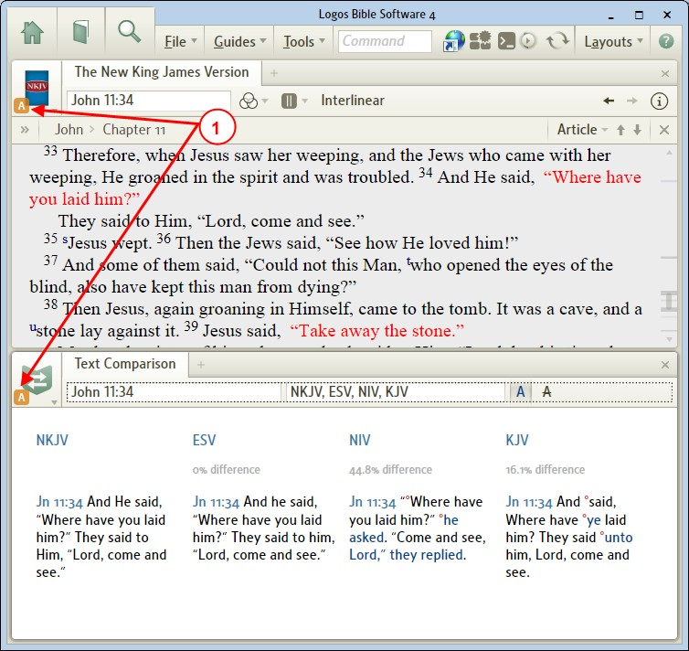

2. Change the navigation method to Verse.
(see Typical Navigation choices)
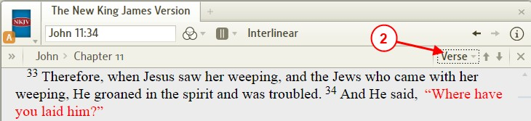

3. Now by clicking the Locator bar's navigation arrows in the Bible's Locator bar, the Text Comparison tool moves verse at a time relative to your Bible.
(see Using the Forward and Backward arrows)
Or you can use your keyboard arrows with the Alt key (see Navigating using the keyboard)
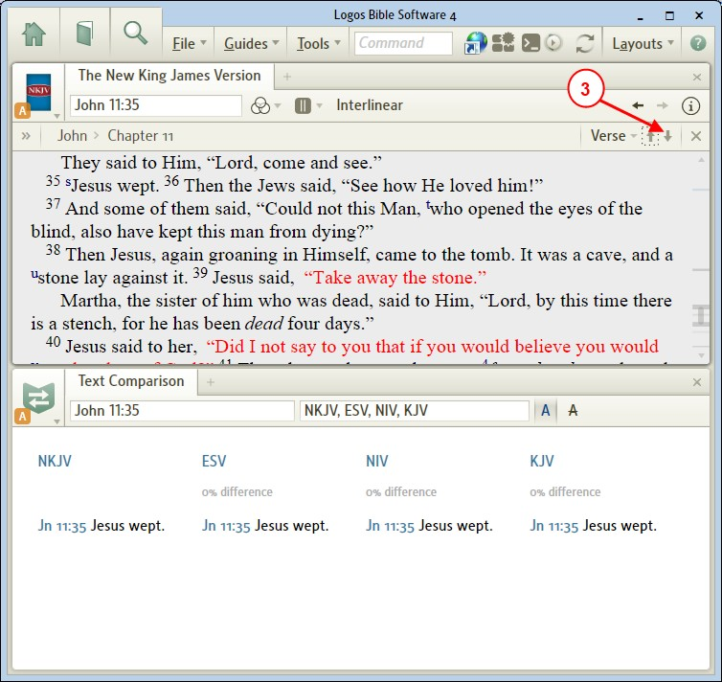

▪ Lookup ▪
[[@Headword:Lookup Section ]]
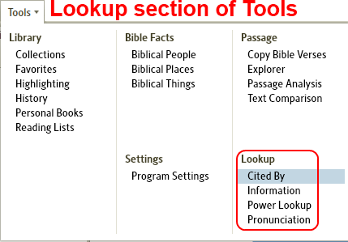

Cited By
[[@Headword:Cited By ]]Wiki page: Revision 19 Link

Video
Tutorial Video Cited by Tool
Logos4 Videos

What is the Cited By Tool?
[[@Headword:Cited By - What is it ]]
• Please watch the Logos4 Tutorial Video Cited By Tool.
• The Cited by Tool can find citations for a Bible passage (relative to the linking mode) in your resources (according to what you have turned on for this tool )

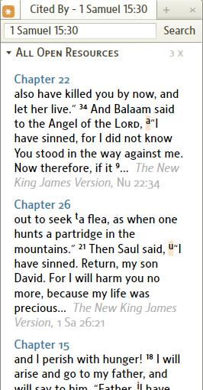

How do I Open the Cited By tool?
[[@Headword:Cited By - Opening ]]
1. Click on Tools in the top menu.
2. Click on Cited By on the right side of the drop down menu.

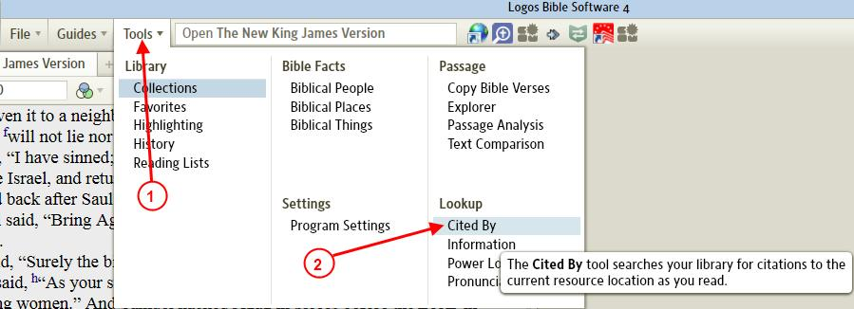

Window options
[[@Headword:Cited By – Options [Menu] ]]
• When you click on the Cited By window icon (as shown below #1), you will see the Cited By window options.

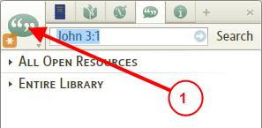

Link modes
[[@Headword:Cited By – Options [Link modes] ]]
• See Linking Cited By

Expanded/Compressed View
[[@Headword:Cited By – Options [Expand/Compress] ]]
• You can select one of the following.

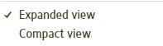
• Expanded produces more info from a citation (example below)

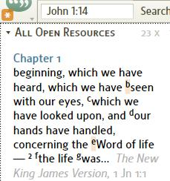
• Compressed produces only the reference info for the citation (example below)

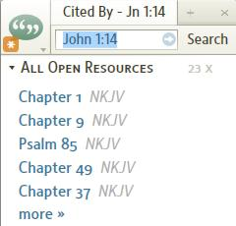

Sorting Order
[[@Headword:Cited By - Options [Sorting] ]]
• Sort by results by search rank, sorts the results for each resource by how close to the exact Bible passage was found.
• Sort results by book, sorts the results according to the specific resource (book).

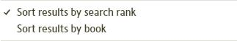

Resources to show in Cited By
[[@Headword:Cited By – Options [Show Resources] ]]
• All Open Resources in your workspace
• Entire Library, all resources in your Library which are keyed by Bible Passages.
• Collections, collections that you have created (the image only shows 2 collections, but on your Logos4 screen you will see a list of all the collections that you have created)

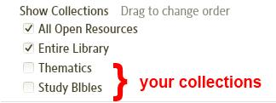

Linking Cited By
[[@Headword:Cited By - Linking ]]
• Linking Cited By works the same as most tools in Logos4.

Follow
[[@Headword:Cited By – Linking [Follow] ]]
• Follow allows Cited By to follow which ever resource that you click (resources which are navigated via Bible passages).
• When Follow is selected, an Asterisk appears in the window's icon as shown below.

A,B,C,D,E,F
[[@Headword:Cited By – Linking [A,B,C,D,E,F] ]]
• When linked to one of the standard Letters, it follows the Bible passage which the resource has in its reference box.
• See Linking Resources
• If you are not familiar with Linking, please watch this video Bibles and Commentaries found at Logos4 Videos. About half way through it, it discusses Linking. Linking is a feature in Logos4 which links different resources together so that they will track each other (as you move along in a Bible then if the commentary is linked, it will track where you are in the Bible).

None
[[@Headword:Cited By – Linking [None] ]]
• When None is selected, it follows what ever passage appears in the reference box. This might come in handy when you want to search for citations on a particular passage. This would also work well when you want to use it from a Pop-up Menu (when you right click on a selection in a resource and you get a Pop-up Menu [Reference only]).

Pop-up Menu
[[@Headword:Cited By – Linking [From Right-Click] ]]
• When you select a word or series of words in a resource and click the right mouse button, a Pop-up Menu appears. Now if you select Reference (on the right side of the Pop-up), you should see Cited By on the left side of the Pop-up Menu. Then when you click it, the Bible passage will appear in Cited By and it will search for pertinent citations.

What does the Search button do?
[[@Headword:Cited By – Search Button ]]
• The Search button will open the search tool (in a new Tab) to search for the Bible passage showing in the reference box. It will have the search tool search your Entire Library.

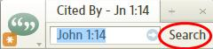

What does the More link inside Cited By do?
[[@Headword:Cited By – More Link ]]
• The More link can appear under any of the categories that you have being shown when there are several citations showing for that category. When you click on the more link, it will open the search tool (in a new Tab) to search for the Bible passage showing in the reference box. This is much like the Search button. But the difference is that the search tool will search only the resource range (e.g. All Open Resources, Entire Library, specific collection) which it is under.

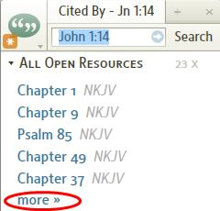

How can I view a compressed link's info?
[[@Headword:Cited By – View Link Info [compressed info] ]]
1. Hover your mouse over a link.
2. A pop-up information box will appear with some information for that link.

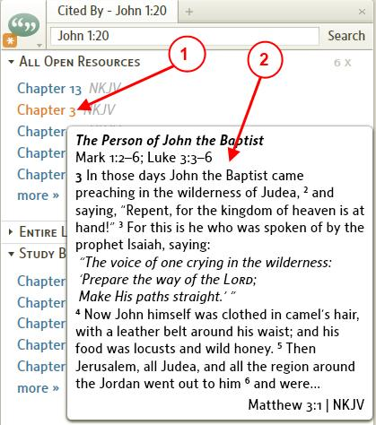

Information
[[@Headword:Information ]]Wiki page: Revision 20 Link

See Also
Power Lookup
Cited By

What is the Information window?
[[@Headword:Information – What is it ]]
• Use the Information tool to display extra information about any word you hover your mouse over.
▪ The Information window can be used with virtually any book in your library.

• With Logos version 4.0b:
▪ You can direct which information will show up in the Information window. (see Setting up your Information window)
▪ And you can direct which manner that you want to control when the information appears (by Hovering or by Clicking). (see Hover/Click option)

• Information which might appear in the Information window
▪ Definitions, Footnotes, Gloss, Lemma, Morphology, Strong's Numbers, Other references

• Please watch Logos: Feature video Information Window

How do I open the Information window?
[[@Headword:Information - Opening ]]

From the Tool menu
[[@Headword:Information – Opening [from the Tool menu] ]]
1. On the top menu click on Tools
2. In the drop down menu click on Information
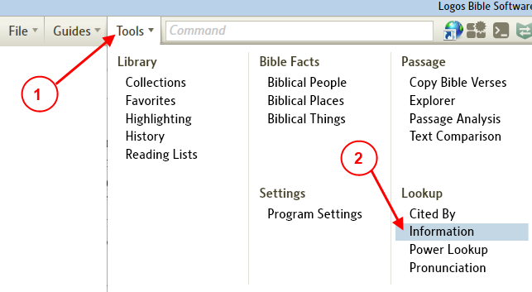
• This will open the Information window on the right side of your layout.
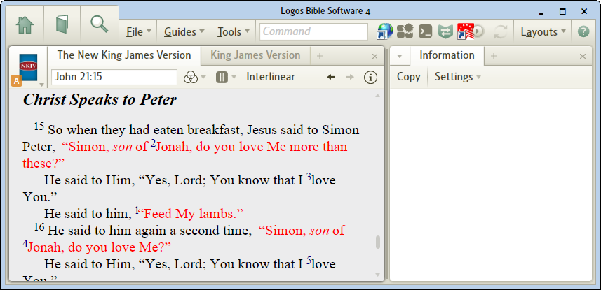

From your resource
[[@Headword:Information – Opening [from your Resource] ]]
1. In your resource right click on a word or footnote.
2. A pop-up menu will appear. On the right side of this menu, look at the bottom and click on Show Information.
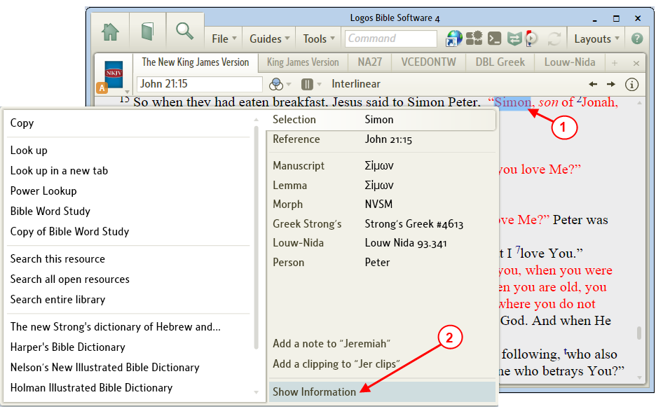

• This will open the Information window on the right side of your layout and populate it with info on this word.
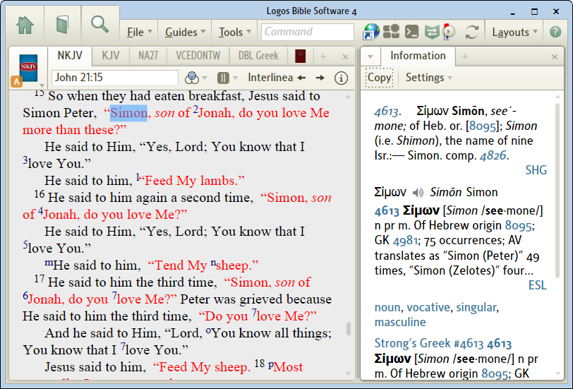

How to get information in the Information window
[[@Headword:Information - How to get Info in the Information window ]]
• You will need a resource open.

• In any open resource, hover over a word or data type reference link.
An entry from a dictionary, lexicon or encyclopedia may come up in Information, as well as text of references and footnotes.
• Moving the mouse cursor over another word in the text will bring up information on the new word.
• To move the cursor without changing the content, hold the Ctrl key down.
• Click a link in the Information panel to open the resource to the referenced location.
▪ (from: Logos 4 Help. Logos Research Systems, Inc.; Bellingham, WA, 2009; 2009)

• For these examples please set the Update Information on setting to Hover (See Hover/Click option )
• Also enable all items in settings (See Setting up your Information window)
• These are the defaults if you haven't changed anything.

• Example 1, info on a word:

a) Now we hovered the mouse over Jonah in the NKJV resource. (you may have to hover for several seconds on slower PCs. Logos4 will show the spinning circle icon while it is searching for the info to put in the Information window.)

b) Notice in the Information window the Definition for Jonah from the Nelson's Illustrated Bible Dictionary

(your dictionary may be different depending on how you prioritized your dictionaries in your library. See Prioritizing)
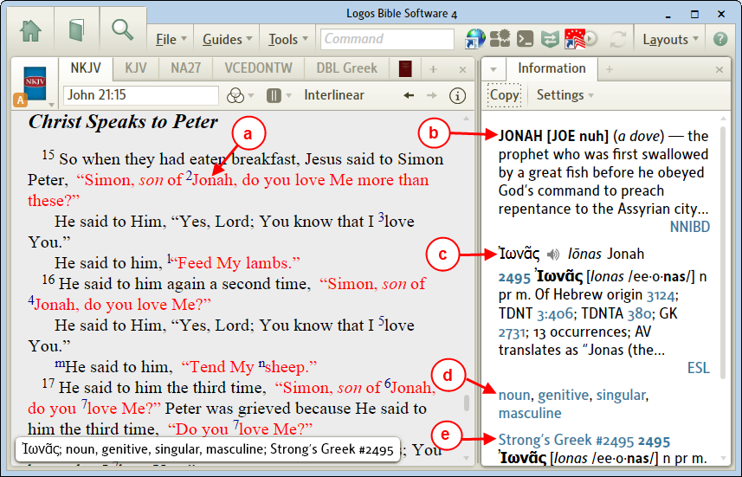
c) Notice the description from your Lexicon.
d) Notice the Morphological information for this word.
e) Notice the Strong's Number for this word with its meaning.

• Example 2, info on a footnote:

a) Hover your mouse over the footnote n.
b) Notice that the footnote information now appears in the Information window.
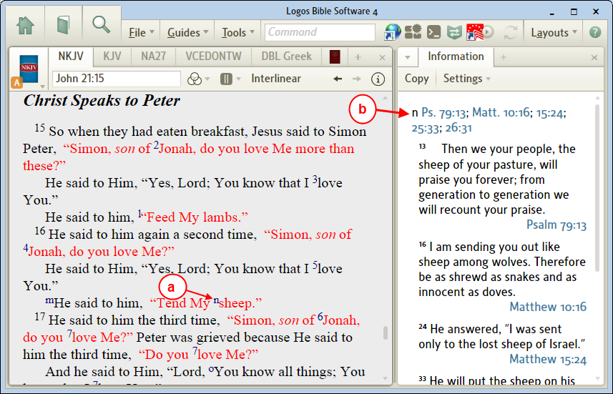

Setting up your Information window
[[@Headword:Information – Settings [on the toolbar] ]]
• The Information window allows you to control what information is visible in its window.
▪ This can be useful when your system may be slow. You can disable many of the items that you don't normally use.
▪ This can be helpful when too much info is showing in the window, you can turn off what you don't need.

1. On the Information toolbar click on the button Settings.
2. In the drop down menu you can set which info will appear in the Information window.
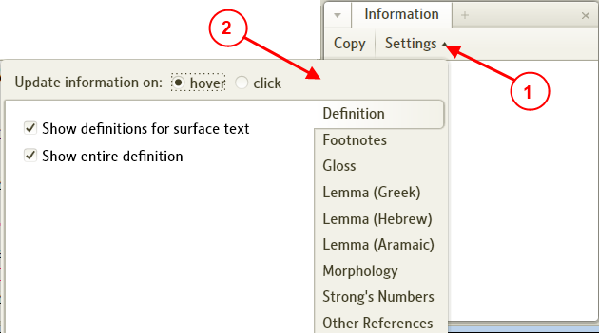
• When you disable a category in the settings (see item a below), notice the red circle with a line through it (disabled). This will help you more quickly notice those categories which are disabled when you view Settings.
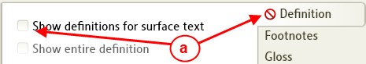

• More details on the Information settings categories below:

Hover/Click option
[[@Headword:Information – Setting [Hover/Click] ]]
• You can direct the way that Logos4 identifies which word, footnote, etc that will appear in the Information window.
a) In the Information toolbar click on Settings, a drop down menu will appear.
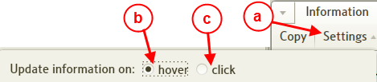
b) Hover -- when this is selected, updates information automatically when mouse hovers over a word for a few seconds (default).

c) Click -- when this is selected, updates information only when word is clicked. [This may be a better choice if you are running on a slower computer. It will prevent Logos4 from searching for what to populate in the Information window until you click.]

Definitions
[[@Headword:Information – Settings [Definitions] ]]
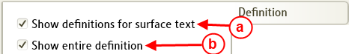

• When checked:

a) Show Definitions for surface text -- shows word definition when you hover/click on a word in your resource.
b) Show entire definition -- shows full definition (abbreviated definition when unchecked).

▪ Example: (when Show Definitions is checked)

a) If you hovered or click on the word love in John 21:15 in your Bible resource...
b) In your Information window you will see the definition.
c) Don't forget that if it is long that you may need to use the scroll bar to view the entire definition.
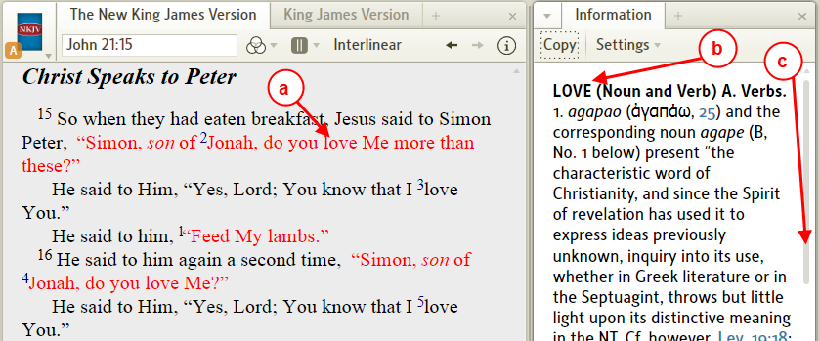

Footnotes
[[@Headword:Information – Settings [Footnotes] ]]

• When checked, footnotes in your active resource are shown.

▪ Example: (when Footnotes is checked)

a) If you hovered or click on this footnote
b) You will see the the pop-up reference over your resource.
c) In the Information window you will see these references and could read/scroll through them.
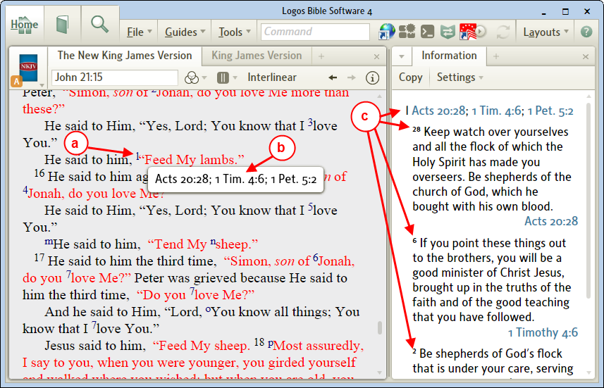

Gloss
[[@Headword:Information – Settings [Gloss] ]]

• When checked (and the lemma is enabled), and you hover over a word in your resource then the Gloss for that word will appear in the Information window.
▪ A Gloss is a brief english meaning for a word in the original language.

• Example: (gloss of a word)

a) If you hover over the word Follow
b) Logos4 will show a pop-up at the bottom of your resource which gives you information on this word.
c) In the Information window you will see the gloss for the word.
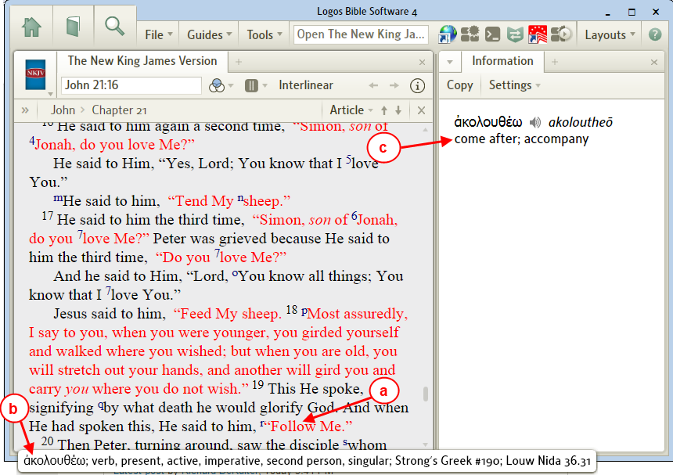

Lemma
[[@Headword:Information – Settings [Lemma] ]]
• Lemma is the root form of a word that you would look up in a dictionary (Lexicon in this case).
• The Bible's original language is in 3 primary languages.
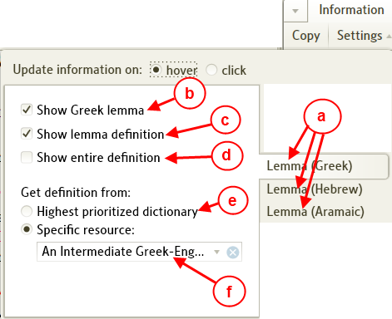
a) You will notice that Lemma is settable for each of these languages.
b) Show Greek lemma (Hebrew or Aramaic) -- when checked the lemma will be shown when over an appropriate word (e.g. a word found in your Bible).
c) Show lemma definition -- along with the lemma (item b must be checked for this to work) its definition is displayed as well.
d) Show entire definition -- when checked the full definition is shown, otherwise an abbreviated definition is shown.

▪ Get definition from

e) Highest prioritized dictionary -- this is the default, as it states the definition is drawn from the highest prioritized dictionary in your Library.

(see Prioritizing)

f) If you click in this box, Logos4 will show a pop-up menu for other dictionaries in your Library which work for this language. In this example we chose a dictionary which was not the highest in my prioritized list.

• Example info on lemma: (Greek since we are using the New Testament)

a) If you hold your mouse over the word Lord.
b) You will see the lemma in the Information window.
c) If you have a Logos4 base package of Scholar's or higher you will notice the speaker icon (when lemma is Greek). If you click on this Logos4 will pronounce the lemma.
d) Notice the abbreviation for the dictionary which the definition comes from (in this case it is not the highest prioritized dictionary in my Library). Also notice that it is a link, if you click on it, it will open your dictionary and locate it to this lemma.

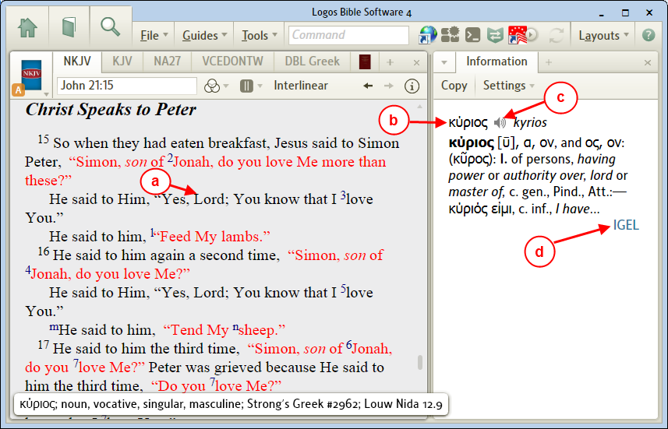

Morphology
[[@Headword:Information – Settings [Morphology] ]]
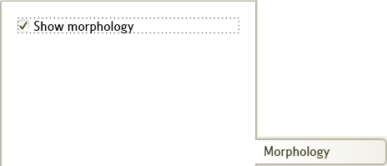

• When checked and you hover your mouse over a word in your active resource, the morphology information is shown in the Information window.
▪ Morphology identifies the structure of a word's usage (see wikipedia Morphology)

▪ Example:

a) If you hover your mouse over the word love.
b) Logos4 will show a pop-up at the bottom of your resource which gives you information on this word.
c) The morphology information is shown in the Information window.

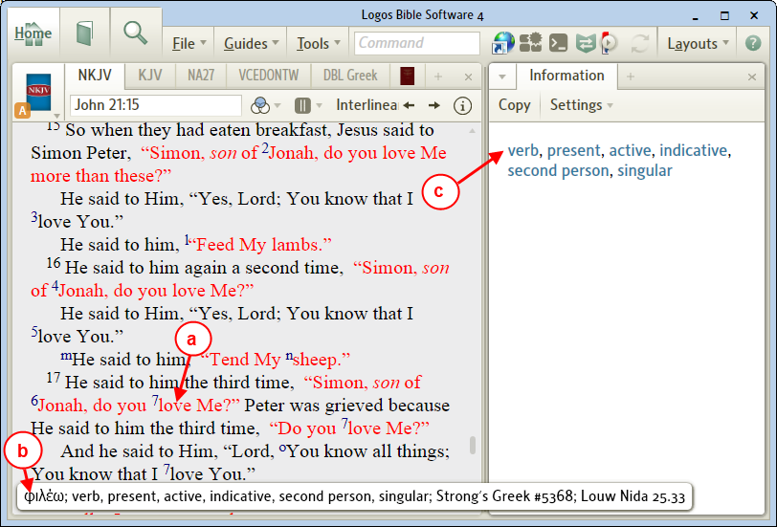

Strong's Numbers
[[@Headword:Information – Settings [Strong’s] ]]
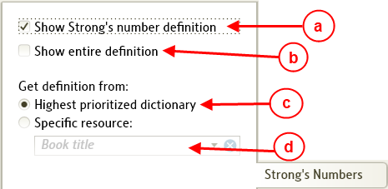

• When enabled and hovering with your mouse over a word from the Bible, the Strong's Number will appear in the Information window.
▪ Strong's Numbers are numbers which represent a word from the original language of the Bible (see wikipedia Strong's Numbers)

a) Show Strong's number definition -- when checked the Strong's number will appear in the Information window.
b) Show entire definition -- when checked the full definition appears in the Information window, otherwise an abbreviated definition appears. (item a must be checked for this to work)

▪ Get definition from

c) Highest prioritized dictionary -- this is the default, as it states the definition is drawn from the highest prioritized dictionary in your Library.
(see Prioritizing)

d) If you click in this box, Logos4 will show a pop-up menu for other dictionaries in your Library which work using Strong's Numbers.

• Example info on Strong's Number:

a) If you hover your mouse over the word lambs
b) Logos4 will show a pop-up at the bottom of your resource which gives you information on this word.
c) In the Information window you will see the Strong's Numbers for this word. (two Strong's numbers appear for this word, since an article is associated with it.)
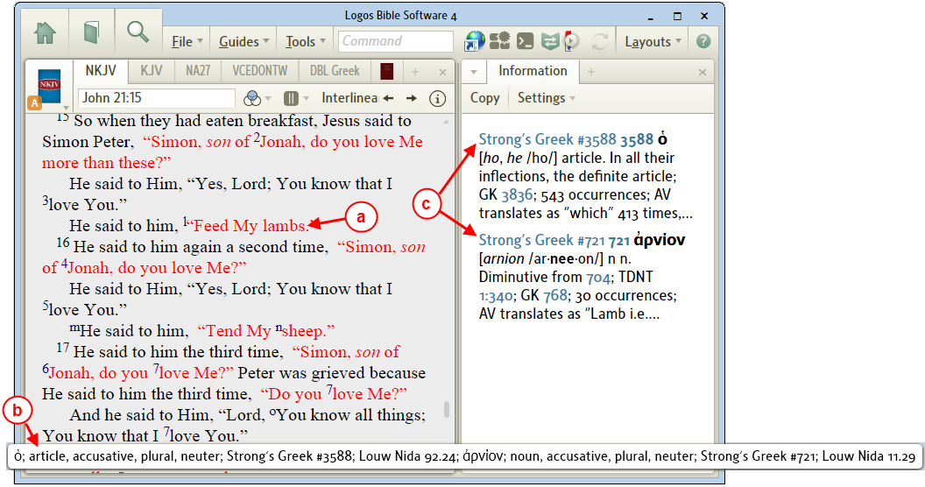

Other References
[[@Headword:Information – Settings [Other Refs] ]]
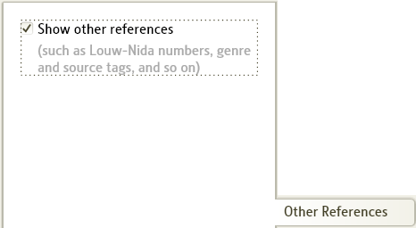

• When checked and you hover your mouse over Other references (Bible references, Louw Nida numbers, see note in image above for others) then info will appear in the Information window.

• Example: (Bible Reference in Vines Expository Dictionary)

a) Hover your mouse over a Bible reference.
b) In the Information window you will see that verse.
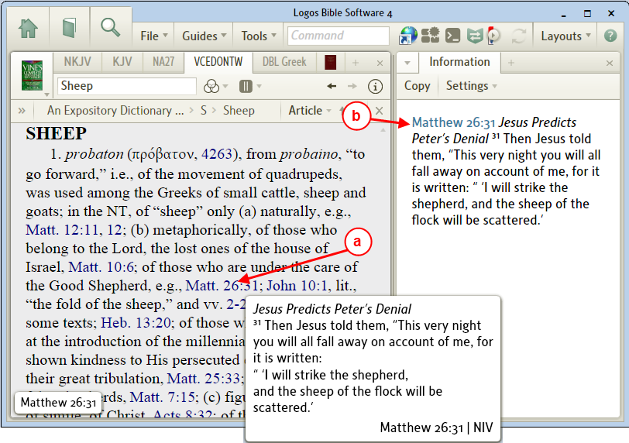

Copy Information window contents for pasting into other apps
[[@Headword:Information - Copying ]]
• You can copy the contents of the Information window to Windows Clipboard. Then paste it into another Windows app.

1. Hover your mouse over the word Jesus.
2. (Optional, this keeps the Info window from changing as you move your mouse)
After you see the Information window populate with the info, hold the Ctrl key down as you move the mouse away from the word Jesus.
3. In the Information window click on Copy found in the toolbar.
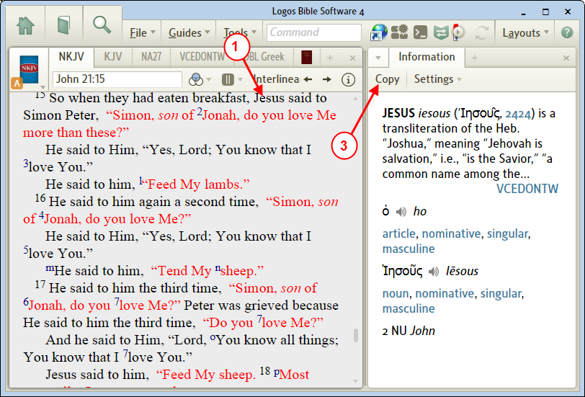

4. Now the information from the Information window is copied into Windows Clipboard.

• In this example we will paste the clipboard contents into Microsoft Word.
5. Position the cursor in Microsoft Word where you want to paste your info.
6. Right click on the cursor location. A pop-up menu will appear, click on Paste.
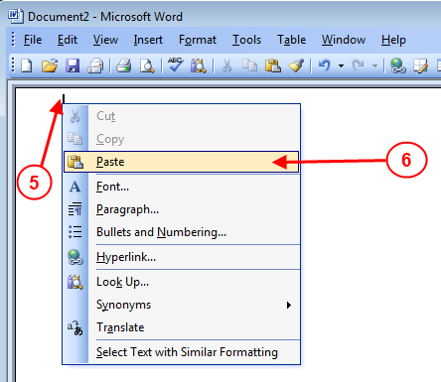

7. Now your info appears in your Word document.
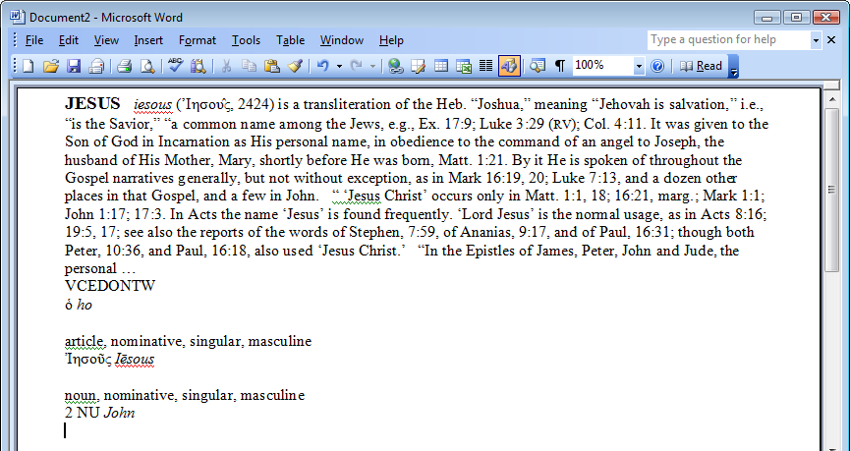

Power Lookup
[[@Headword:Power Lookup ]]Wiki page: Revision 31 Link

Video
Tutorial Video Power Lookup Tool
Logos4 Videos

Tips on the Forum
Power Lookup & BDAG
Verse Lists, & copying Multi References

What is the Power Lookup tool?
[[@Headword:Power Lookup – What is it ]]
Please watch the video Power Lookup which is a short Logos4 video tutorial found in [[http://www.logos.com/videos]] and named Power Lookup.

• This tool will display references and footnotes from a resource as shown below.

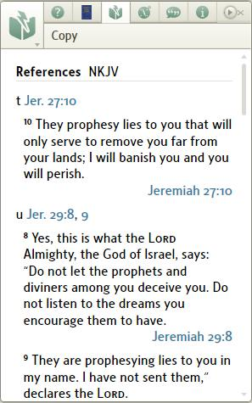
• To open Power Lookup tool:
1. Click on Tools in the top menubar.
2. Click on Power Lookup in the drop down menu.

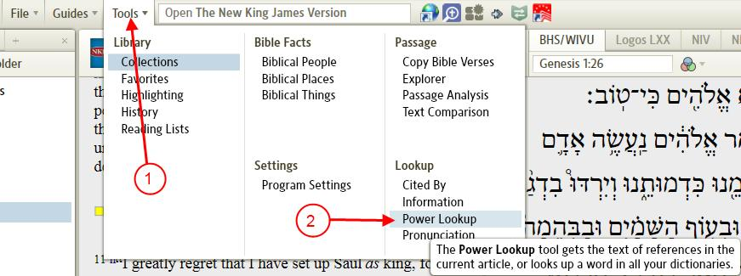

Why does it jump from book to book?
[[@Headword:Power Lookup – Why does it jump? ]]
• As with Bibles, Commentaries and other resources it can be linked. There is a new link type (other than A, B, C, etc) which is called Follow. This is the default link for Power Lookup. So when the link is set to Follow, Power Lookup appears to jump from book to book.

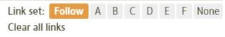
• Follow will display the references and footnotes for the current active resource. So if you click in a different resource, Follow will update its display for that resource. When in this mode you will notice a red Asterisk in the tab.

• You can set the link to None and right click on a resource and select Power Lookup in the pop-up menu to have it statically display info for that particular resource.

Power Lookup from the right click menu
[[@Headword:Power Lookup – from Right Click ]]
• In your resource if you right click on a word a pop-up menu will appear.
Notice on the right that there are several category choices (Selection, Reference, etc).
These categories vary depending on which type of resource that you are in.

• Using the right click menu provides you with information on the word, reference, Strong's number, Louw-Nida number, etc. See the categories below which you can use to open the Power Lookup tool to retrieve your information.

▪ Note: In some cases you may not see your category on the right side of the pop-up menu

1. Make sure that the resource that you are in supports the category that you are looking for.
(e.g. Bibles don't have Head Word, Dictionaries don't have Lemma)

2. Also don't forget to check for a scrollbar in the category area
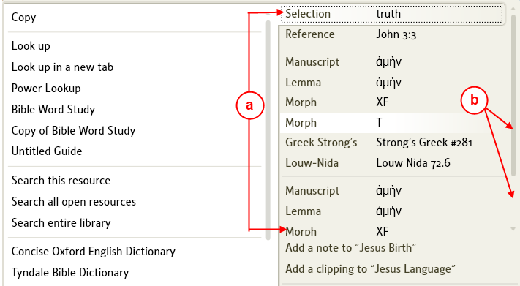

a. Notice that the categories fill up the area
b. Also notice that a scrollbar appears for the category area, use the scrollbar to view the remaining categories.

Using Selection
[[@Headword:Power Lookup - from Right Click [Selection] ]]
• This method will provide you with definitions for your word.

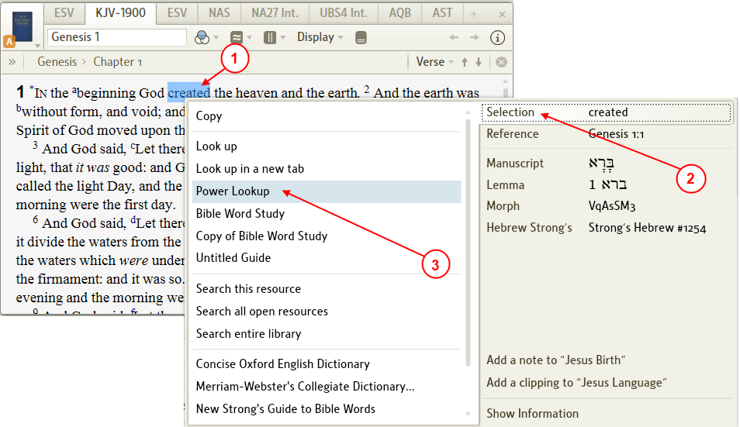

1. Right click on a word in your resource.
2. A pop-up menu will appear. On the right side of the menu select Selection.
3. On the left side of the menu, click on Power Lookup.
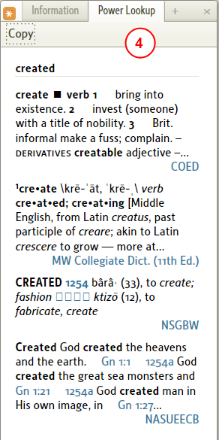

4. In the Power Lookup window (if not open then Logos4 will open it), you will find the definition(s) for your word.

Using Reference
[[@Headword:Power Lookup - from Right Click [Reference] ]]
• If the resource is a Bible or Commentary, then this method will provide you with a list of this reference from multiple Bibles in the Power Lookup window.
• The list in the Power Lookup window may contain that passage from all your Bibles as well as your Commentaries and references from Treasury of Scripture Knowledge and other resources (the list can be quite long).

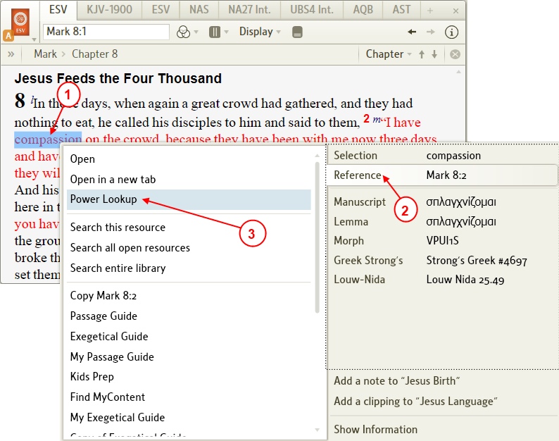

1. Right click on a word in your resource.
2. A pop-up menu will appear. On the right side of the menu select Reference.
3. On the left side of the menu, click on Power Lookup.
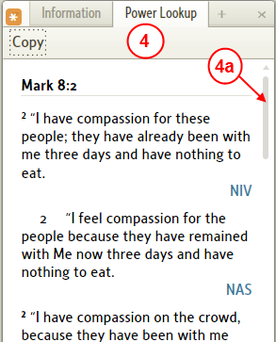

4. In the Power Lookup window (if not open then Logos4 will open it), you will find a list of this passage from different Bibles plus quite a bit of other info from your different resources.
a. Don't forget to use the scrollbar to fully view your list.

Using Lemma
[[@Headword:Power Lookup - from Right Click [Lemma] ]]
• If the resource is a Bible, then Lemma will appear as a category on the right side of the pop-up menu.
• When selecting Power Lookup it will show you definitions for the lemma of your word in the Power Lookup window.

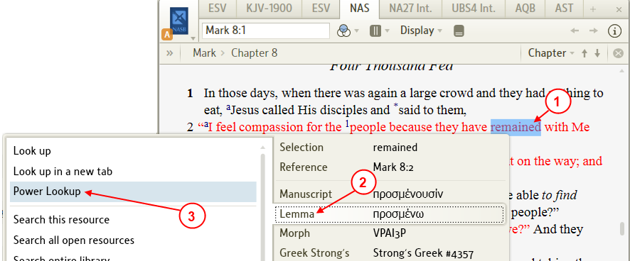

1. Right click on a word in your Bible.
2. A pop-up menu will appear. On the right side of the menu select Lemma.
3. On the left side of the menu, click on Power Lookup.
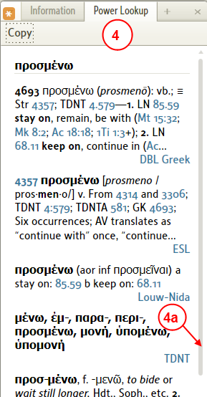

4. In the Power Lookup window (if not open then Logos4 will open it), you will find a list of definitions for the lemma of your word.
a. Don't forget to use the scrollbar to fully view your list.

Using Hebrew/Greek Strong's
[[@Headword:Power Lookup – from Right Click [Strong’s] ]]
• If your resource is a Bible then Strong's is a category which will appear on the right side of the pop-up menu.
• Hebrew will appear if you are in the Old Testament and Greek will appear if you are in the New Testament, next to the Strong's.

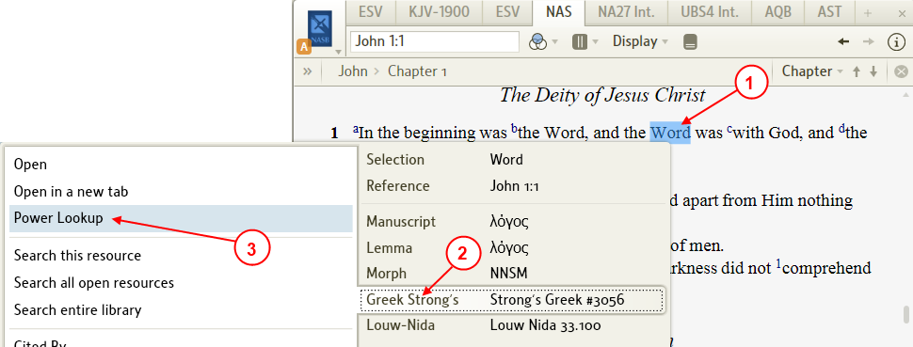

1. Right click on a word in your Bible.
2. A pop-up menu will appear. On the right side of the menu select Hebrew Strong's if in the OT or Greek Strong's if in the NT.
3. On the left side of the menu, click on Power Lookup.
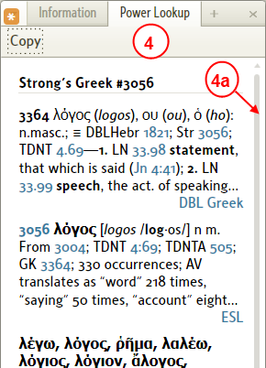

4. In the Power Lookup window (if not open then Logos4 will open it), you will find a list of definitions for this Strong's number.
a. Don't forget to use the scrollbar to fully view your list.

Using Louw-Nida
[[@Headword:Power Lookup – from Right Click [Louw-Nida] ]]
• If your resource is a Bible and you are in the New Testament, then Louw-Nida will appear as a category on the right side of the pop-up menu.
You will need to have the Louw-Nida as a resource in your Library.

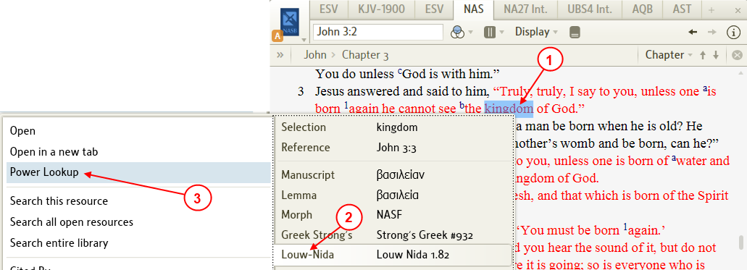

1. Right click on a word in the New Testament of your Bible.
2. A pop-up menu will appear. On the right side of the menu select Louw-Nida.
3. On the left side of the menu, click on Power Lookup.
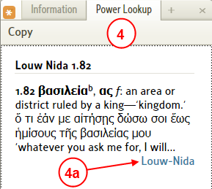

4. In the Power Lookup window (if not open then Logos4 will open it), you will find a the Louw-Nida definition (it may be abbreviated).
a. If you click on Louw-Nida Logos4 will open your Louw-Nida resource to the LN number.

Using Head Word
[[@Headword:Power Lookup – from Right Click [Head word] ]]
• When using your dictionaries, the word that you looked up is referred to as a Head Word by Logos4.
• When using your dictionary with Power Lookup it will find the definition in multiple dictionaries for you Head Word.

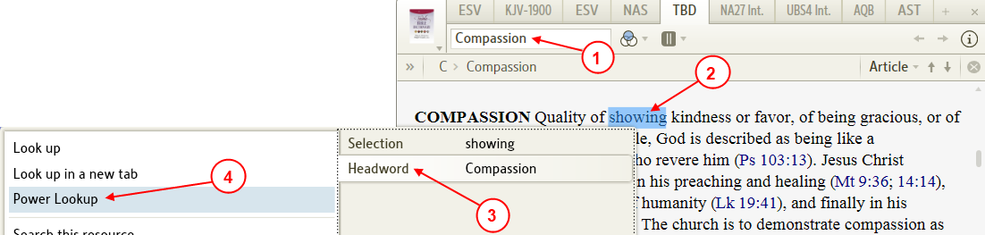

1. Notice the word in your reference box of your dictionary. This is the Head Word.
2. Right click on a word in your Dictionary.
You don't necessarily have to click on the Head Word, so you can click on a word (which is not a link, i.e. blue in color) which is inside of the definition.
Logos4 will use the Head Word and not the word that you clicked on.
3. A pop-up menu will appear. On the right side of the menu select Head Word.
4. On the left side of the menu, click on Power Lookup.
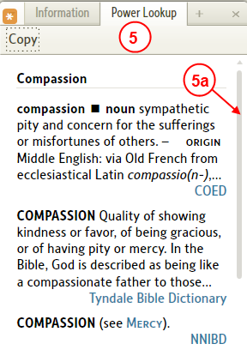

5. In the Power Lookup window (if not open then Logos4 will open it), you will find a list of definitions from other dictionaries.
a. Don't forget to use the scrollbar to fully view your list.

Tip - locating reference in resource
[[@Headword:Power Lookup – Tip Locating... ]]
You can use Power Lookup to locate the reference in your resource.

1. Click on a different reference in the Power Lookup tool. (must be different for it to activate the locator)
2. Watch the resource, you will see the red locator circles flash over the reference.

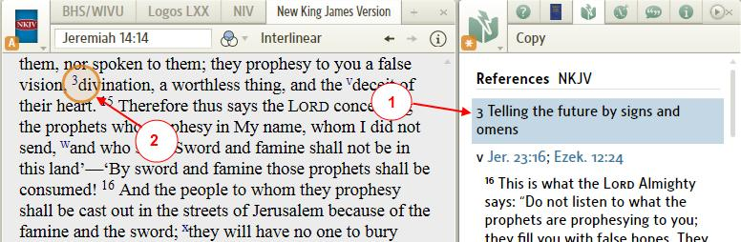

Linking Power Lookup
[[@Headword:Power Lookup - Linking ]]
• Linking Power Lookup works the same as most tools in Logos4.

Follow
[[@Headword:Power Lookup – Linking [Follow] ]]
• Follow allows Power Lookup to follow which ever resource that you click (resources which are navigated via Bible passages).
• When Follow is selected, an Astrix appears in the window's icon as shown below.

A,B,C,D,E,F
[[@Headword:Power Lookup – Linking [A,B,C,D,E,F] ]]
• When linked to one of the standard Letters, it follows the Bible passage which the resource has in its reference box.
• See Linking Resources.
• If you are not familiar with Linking, please watch this video Bibles and Commentaries found at Logos4 Videos. About half way through it, it discusses Linking. Linking is a feature in Logos4 which links different resources together so that they will track each other (as you move along in a Bible then if the commentary is linked, it will track where you are in the Bible).

None
[[@Headword:Power Lookup – Linking [None] ]]
• When None is selected, it tries to lookup info on passages in your open resources.

Pop-up Menu
[[@Headword:Power Lookup – Linking [from Right-click] ]]
• When you click the right mouse button in a resource, a Pop-up Menu appears. Now if you select Reference (on the right side of the Pop-up), you should see Power Lookup on the left side of the Pop-up Menu. Then when you click it, Power Lookup will show info on passages in your open resources.

Examples using Follow
[[@Headword:Power Lookup – Examples using Follow ]]
• When you have the Power Lookup tool open and set its linking to Follow, the tool will update whenever you click in a different resource.
• Below are a few examples. Try opening a variety of resources and see how the Power Lookup tool works with them.

In NKJV
[[@Headword:Power Lookup – Examples [NKJV] ]]
1. In this example we have the New King James Version of the Bible open.
2. We have the Power Lookup tool open with its linking set to Follow.
3. Notice the footnote ^{e}, when you hold your mouse over it the pop-up reference appears. Also note that in the Power Lookup tool the reference ^{e} is present.
4. Notice in the Power Lookup tool the reference ^{e} is present and the references that it referred to are shown under the reference.
5. On the page showing in the NKJV there are 3 other references ^{f}, ^{g} , ^{h} visible. These are also shown in the Power Lookup tool. But the last two references are not visible in the tool. You can scroll down in the tool to see these references.
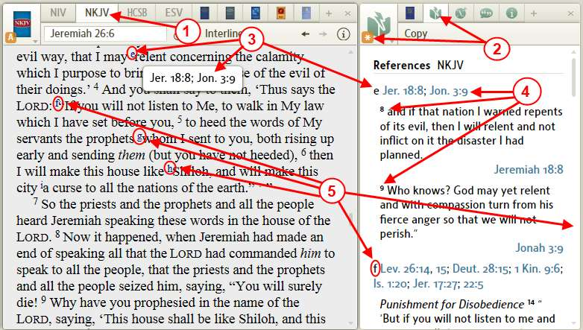

• As you scroll or page down in the NKJV, the Power Lookup will update to show the references which are visible on the page you are viewing in the NKJV.

In Bible Knowledge Commentary
[[@Headword:Power Lookup – Examples [BKC] ]]
• When you have Power Lookup open and set the linking to Follow, you can click in your commentary (the BKC is shown in this example) and the Power Lookup tool will show references that are visible on the screen of your commentary in the Power Lookup tool.
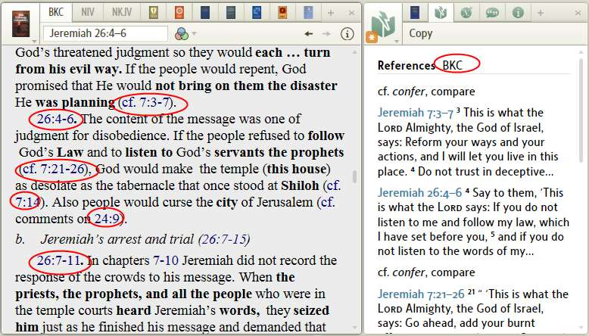

• Clicking on a link in the Power Lookup will take you to that location in the appropriate resource.

In Holman Bible Atlas
[[@Headword:Power Lookup – Examples [Holman Bible Atlas] ]]
• When you have Power Lookup open and set the linking to Follow, you can click in a reference book (the Holman Bible Atlas is shown in this example) and the Power Lookup tool will show references that are visible on the screen of your reference book in the Power Lookup tool.
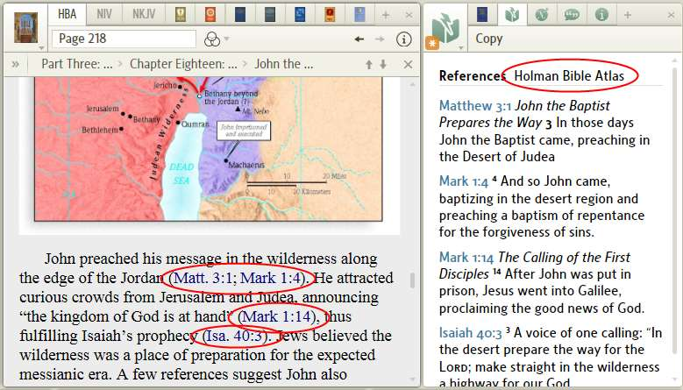

• Clicking on a link in the Power Lookup will take you to that location in the appropriate resource.

In Theological Workbook of the Old Testament
[[@Headword:Power Lookup – Examples [TWOT] ]]
• When you have Power Lookup open and set the linking to Follow, you can click in a dictionary or lexicon (the TWOT is shown in this example) and the Power Lookup tool will show references that are visible on the screen of your dictionary or lexicon in the Power Lookup tool.
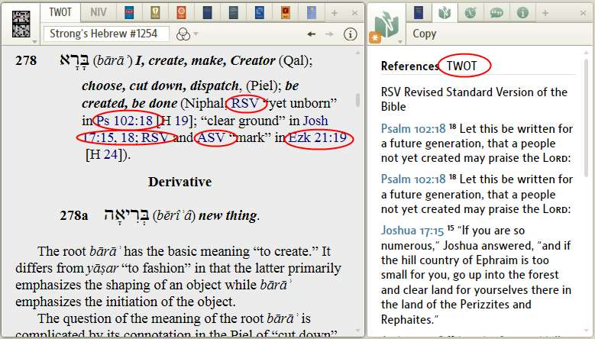

• Clicking on a link in the Power Lookup will take you to that location in the appropriate resource.

Related forum posts
[[@Headword:Power Lookup - Posts ]]
• Fixing Power Lookup on a topic: see post.

Pronunciation
[[@Headword:Pronunciation ]]Wiki page: Revision 10 Link

Video
Logos4 Videos

What is the Pronunciation tool?
[[@Headword:Pronunciation - What is it ]]
• The Pronunciation tool will speak the lemma version of a Greek word.
▪ The lemma words are those which you would find in a dictionary.
▪ Hebrew and Aramaic words are not supported at this time.
• The Pronunciation tool comes with Logos4 base packages Scholar's and up. (see Logos Comparison Chart)

Using the Pronunciation Tool
[[@Headword:Pronunciation – Using the Pronunciation Tool ]]

From the Tools menu
[[@Headword:Pronunciation – Using [from the Tools menu] ]]
• The Pronunciation tool window is opened from the Tools menu.
▪ It opens a window on the right side of the Logos4 main window.
▪ In this window you will find a list of Greek lemma words in Greek alphabetical order.
1. In the top menu, click on Tools.
2. In the drop down menu, click on Pronunciation.
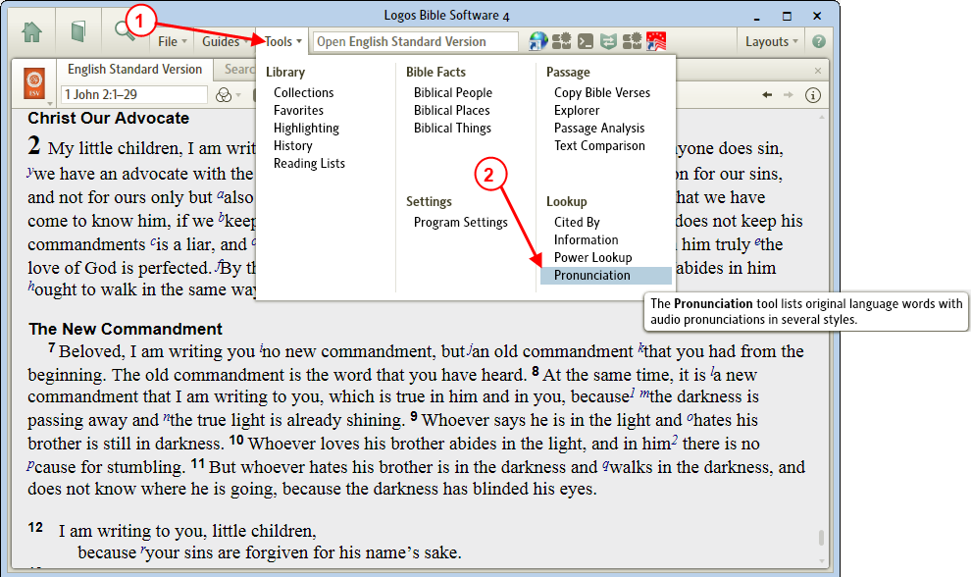

3. Logos4 will open the Pronunciation tool window on the right side of the main window.
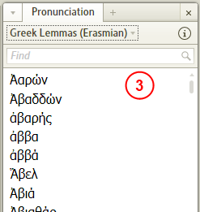

Selecting and hearing a word
[[@Headword:Pronunciation – Using [in the Pronunciation Tool] ]]
• This is the simplest and obvious way to use the tool.

1. Find your word in the Pronunciation window.
(Don't forget that the vertical slider on the right side of the window can be used)

2. Once found, click on the word.
(make sure that you have the windows volume turned up loud enough to hear it)
You will hear the word spoken.
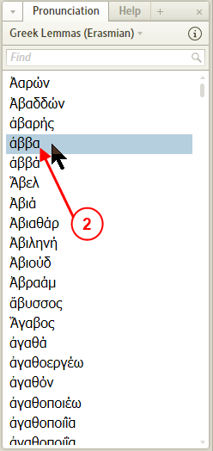

Entering a word via the Keyboard
[[@Headword:Pronunciation – Using [Entering a word via the Keyboard] ]]
• You can enter the Greek word via the keyboard (see image a below). (see Greek keyboard)

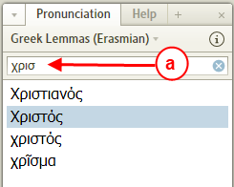

• Or you can type in a transliteration for a Greek word (see image b below). (see Greek transliteration)

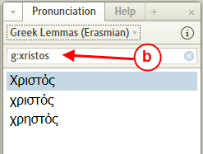

Dragging a word to the Find box
[[@Headword:Pronunciation – Using [Dragging a word to the Find box] ]]
• Example 1: (from a Greek New Testament)
▪ In this example we will use the Nestle Aland Greek New Testament.
▪ You need to select words which are shown in the lemma form.
1. In the NA27, with your mouse select the word by dragging over it (including all letters).
2. Now click on the selected word and drag it to the Find box in the Pronunciation window.

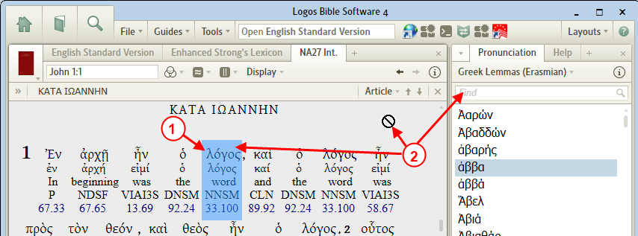

3. Now you will see the Greek word in the Find box.
4. If you click on the word Logos4 will pronounce it.

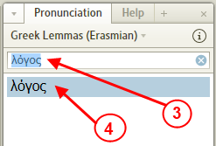

• Example 2: (from a Greek lexicon)
▪ In this example we will use the Nestle Aland Greek NT and the Greek-English Lexicon for the New Testament (or your default Greek lexicon).

1. In the NA27, click on the Louw Nida number (you will need this turned on with the Display setting in the NA27 toolbar).
2. The Greek-English Lexicon is opened if it was not already open.
3. Logos4 positions the lexicon to the word (via the LN number) which we clicked on in the NA27.

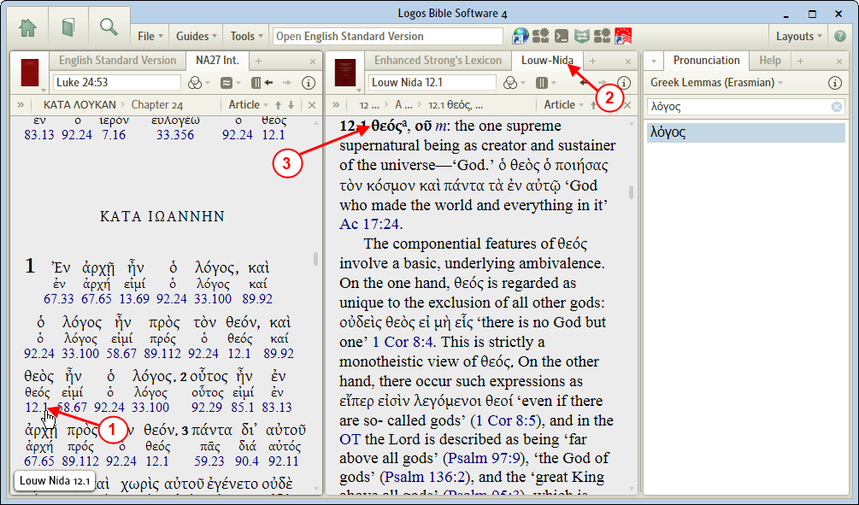

4. Now in the Pronunciation's Find box :

a) If there is anything in the Find box.

b) Click on the x on the right side of the Find box to clear the Find box.

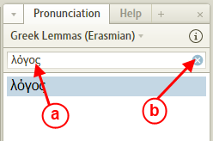

5. Now select the word in the lexicon, then drag it to the Find box of the Pronunciation window.

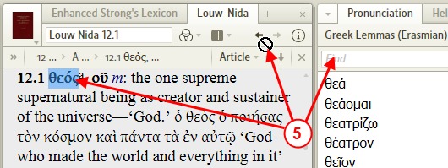

6. In the Pronunciation window locate the word and click on it.
Logos4 will pronounce the word for you.
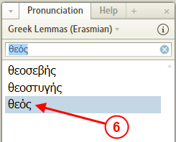

Changing the Style of the pronunciation
[[@Headword:Pronunciation – Changing the Style of the pronunciation ]]
• Logos4 provides two Styles of pronunciation.
▪ Erasmian -- this is the Ancient Greek phonology
▪ Modern -- this is the modern style of pronunciation.
1. In the Pronunciation toolbar click on the Greek Lemmas.
2. In the drop down menu, click on the desired pronunciation Style.

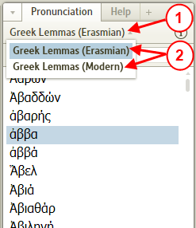

3. Now when you click on Greek words you may hear the selected pronunciation style.

Tutorial of pronunciation of Greek letters/vowels
[[@Headword:Pronunciation - Tutorial ]]
• Logos4 provided pronunciation tables (for both Styles of Pronunciation. see Changing the Style of the pronunciation)
▪ These provide helpful tutorials of pronouncing letters & vowels in Greek (phonetic pronunciation).

1. On the right side of the Pronunciation toolbar you will notice a circle with an i button Click on it.

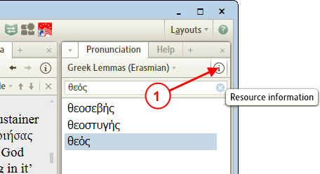

2. The pronunciation tables will appear in the Pronunciation window as shown below.
(Notice the Style as mentioned above, the tables are shown relative to which style you have selected)

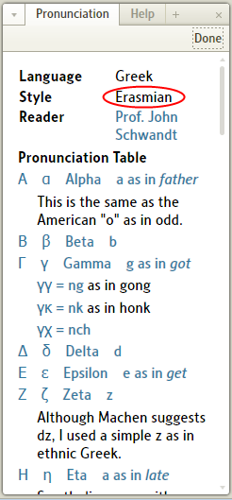
a) The upper case form of the letter.
b) The lower case form of the letter.
c) The name of the letter.
d) Phonetic sound of the letter.
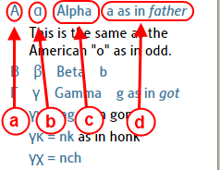

3. To hide this pronunciation table, click on the Done button.

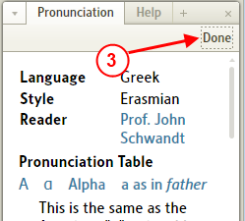

Using Pronunciation from a Resource
[[@Headword:Pronunciation – Using Pronunciation from a Resource ]]
• You can have Logos4 pronounce a word without using the Pronunciation tool window.

1. If you are using a Greek Bible, right click on a Greek word.
2. In the pop-up menu on the right side select Lemma.
3. Then on the left side of the pop-up menu click on Pronounce.

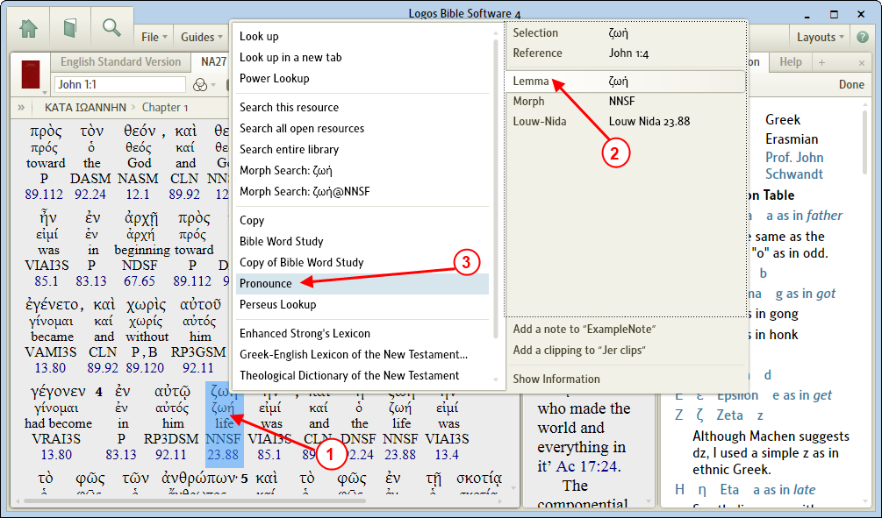

4. Or when you have the Reverse Interlinear open in one of your Bibles. You can right click on a Greek word in the Reverse Interlinear.
5. In the pop-up menu on the right side select Lemma.
6. Then on the left side of the pop-up menu click on Pronounce.

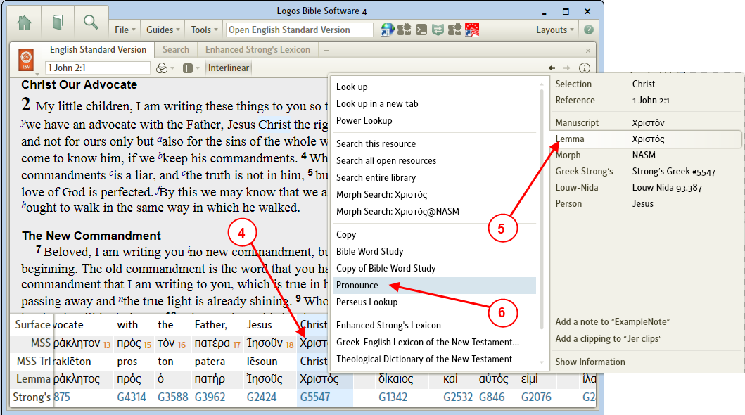

• In some tools you may see a speaker icon next to a Greek word.
▪ In the Information window.

1. By holding your mouse over a word in a resource which is Greek ...
2. In the Information window you will notice the Greek word and its definition.
3. You will also see a speaker icon, Click on this icon to have Logos4 pronounce the Greek word.

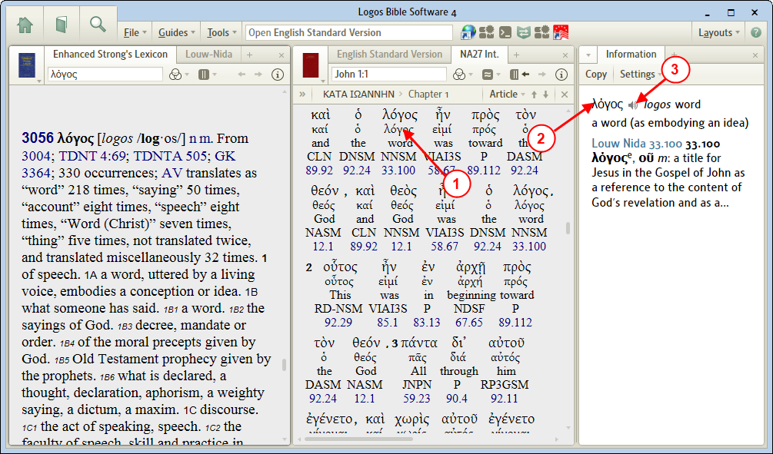

• So when in your Logos4 tools you see the speaker icon you can click on it to hear the Greek word pronounced by Logos4.
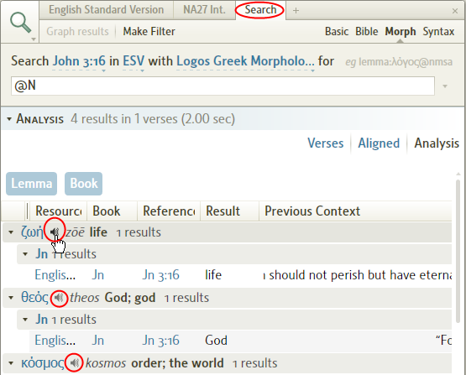

Other Features
This section describes features which are in Logos4 but are not found in the main menu. It is broken up into 3 subsections:

  - Items on a resource’s toolbar
  - Things you can do in a Resource
  - Resource’s Menu

▪ Items on a Resource’s toolbar ▪

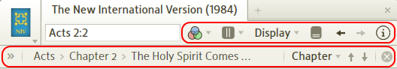

Visual Filter Menu
[[@Headword:Visual Filter Menu ]] Wiki page: Revision 19 Link

Video
Visual Filter – Notes

What is the Visual Filter Menu?
[[@Headword:Visual Filter Menu – What is it ]]

• Visual Filter Menu is found on the toolbar of most resources.

▪ It allows you to control what is visually shown in your resource(s).
▪ When you click on the Visual Filter Menu a drop down menu appears:
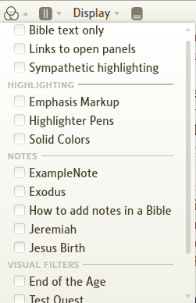

▪ See the section Using the Visual Filter Menu below
▪ Contents of this menu may differ depending on the resource and documents or highlighting that you have.

• This is not to be confused with Visual Filters (which are created from the File menu).
• Please watch the Logos 4 tutorial video Visual Filter - Notes.

Using the Visual Filter Menu
[[@Headword:Visual Filter Menu – Using the Visual Filter menu ]]
• There are 5 sections that are shown in the Visual Filter Menu [top or general, Highlighting, Notes, Reading Plans, Visual Filters].
Each section is explained below.

• When an item is checked, it will be active or visible (Link all Open resources, Sympathetic Highlighting are active, others are visible).
Likewise when it is unchecked it is inactive or not visible.

• Hint:
▪ Right click on an item in the Visual Filter Menu will allow you to turn ON/OFF that item in all resources.
▫ Show in all appropriate resources: will turn ON in all resources when clicked.
▫ Do not show in any resource: will turn OFF in all resources when clicked.
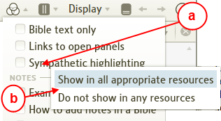
a) Click on the Visual Filter Menu item. (e.g. Sympathetic highlighting)
b) Select either Show in all appropriate resources or Do not show in any resource.
c) Now that item has been turned ON/OFF in all open resources.

Top section (general controls)
[[@Headword:Visual Filter Menu – Top section [general controls] ]]

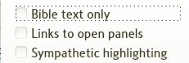

• Bible text only
▪ When unchecked your Bible resource is shown normally.
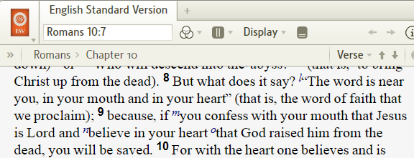

▪ When checked your Bible resource is shown without formatting/footnotes/references in a verse-by-verse display.
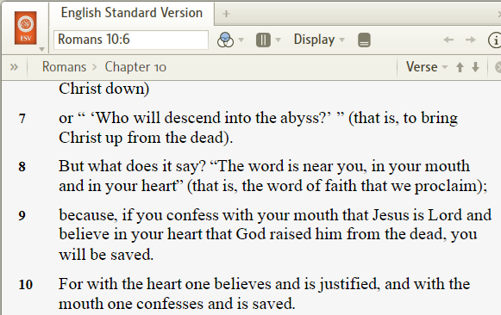

• Links to open panels
▪ When checked this enables your open Bible(s) which also have this checked to highlight references in other resources which have this checked.
When unchecked this resource will not show highlighting.
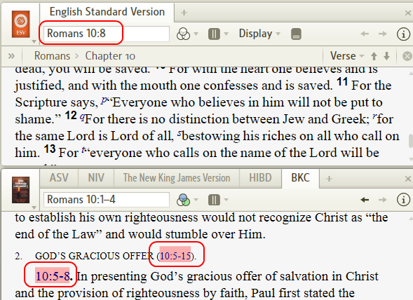
(in the image above, we have the ESV Bible and the Bible Knowledge Commentary both checked with Link to open panels.
Notice that the Bible is open to Romans chapter 10 and that Logos4 highlights this reference in the BKC)

• Sympathetic highlighting
▪ When checked this enables Sympathetic highlighting to work in this resource with other resources that have this checked as well.
When unchecked this resource will not show Sympathetic highlighting.
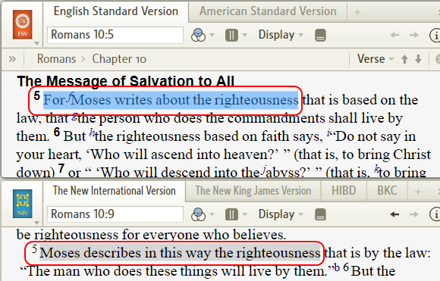
(please see Sympathetic highlighting)

Highlighting section
[[@Headword:Visual Filter Menu – Highlighting section ]]
Note: This has been removed in version 4.5
• This section will appear if you highlighted in that resource.
▪ You may also see your custom highlighting in this section if it was used in this resource.
(checked items are custom palettes in image)
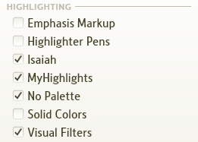
[If you have several highlighting styles used, don't forget to use the scrollbar to see them all]

• When checked highlighting will be visible in your resource.
When unchecked highlighting will not be shown.
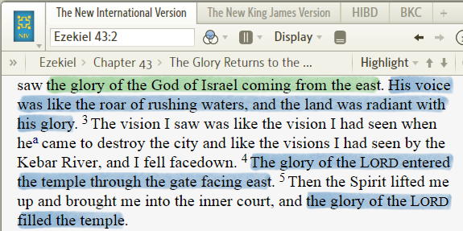

▪ Please see wiki page Highlighting to learn how to highlight
▪ Also this wiki page might be useful Highlight Navigation
▪ Also this wiki page might be useful Finding Highlighted Text

Notes section
[[@Headword:Visual Filter Menu – Notes section ]]
Note: In version 4.5, highlighting has been added to this section
• This section will appear for resources which have Notes linked to it.

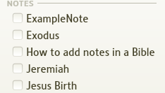

▪ Notes which have Reference used as a note type and are indexed by Bible reference. (e.g. Bibles, Commentaries)
▪ Notes which are tied to this resource via Selection.

• The items in this section will have the filename of the note.
• When checked your notes that are tied to this resource will be visible.
When unchecked your note markers will not be visible.
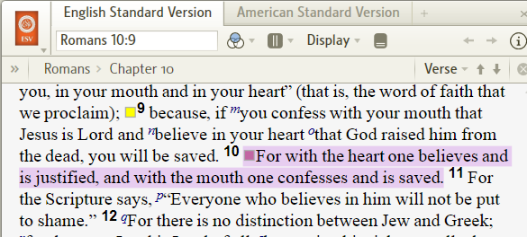

▪ See the wiki page Notes.

Reading Plan
[[@Headword:Visual Filter Menu – Reading Plan section ]]
• This section will appear for a resource in which you have added a Reading Plan.

▪ It allows you to Show/Hide the message in your resource (as shown below).
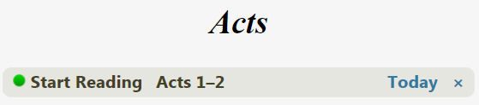

▪ To open and go to a Reading Plan:
1. Go to your Home page
2. In the blue ribbon at the top, scroll to locate your Reading Plan(s) and click on the link next to Today (or the day which you want to read). Logos4 will open your resource to the area for that day's reading.
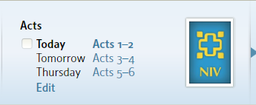

• For the basics on Reading plans see Reading Plan (Basics)
• For more info on Custom Reading Plans see Reading Plans

Visual Filters section
[[@Headword:Visual Filter Menu – Visual Filter section ]]
• This section will appear for resources which have Visual Filters (those created with Visual Filters from the File menu) that specify this resource or its type.
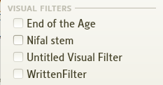

• Items in this section will have the filename that you named your Visual Filters.
• When checked your Visual Filter highlighting will be visible.
When unchecked your Visual Filter highlighting will not be shown.
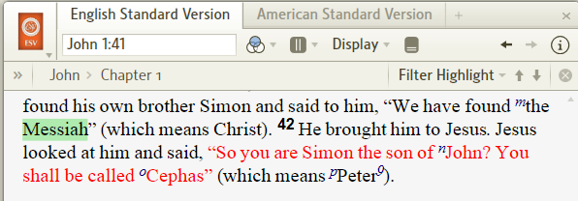

▪ See the wiki page Visual Filter to learn how to make Visual Filters.
▪ Also you might find this wiki page Finding Highlighted Text useful.
▪ Also you might find this wiki page Using Passage List to limit Visual Filters useful.

Equivalent Resources
[[@Headword:Equivalent Resource ]] Wiki page: Revision 16 Link

What are Equivalent Resources?
[[@Headword:Equivalent Resource – What is it ]]

• You may see this button on a few of your resource's toolbars.

• This indicates that Logos4 is aware of Equivalent resources and provides you with the ability to switch to one of these resources in the same panel (tab) that your resource is in.
• This Equivalent resource is usually the same book, but a different version. (e.g. the KJV 1900, KJV 1795 Authorized).
• This can be useful as some equivalent resources may contain Reverse Interlinears or Morphologies while other equivalents may not.
• So far the only Equivalents I have found are Bibles and they are few. At least in my Scholar's library.

Using Equivalent Resources
[[@Headword:Equivalent Resource – Using Equivalent Resources ]]
• Open a resource which shows the Equivalent Resource button (e.g. KJV)

1. Click on the Equivalent Resource button
(clicking on the button again will hide the ribbon showing Equivalent Resources)

2. Notice that a ribbon appears at the top of your resource showing you equivalent resources.

3. Also notice that a red bar appears under one of the resources. This shows you which resource that you currently have open.

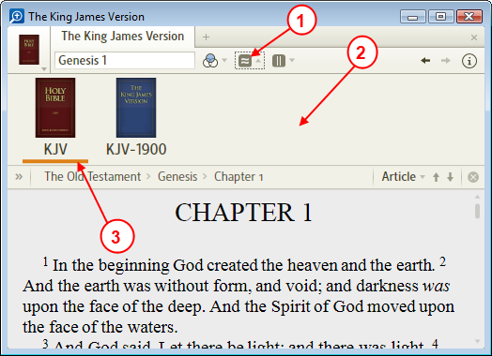

4. Hold your mouse over a book in the ribbon. Notice that a pop-up will show you information for that book.
(a light red bar will appear under the resource for which the pop-up info appears)
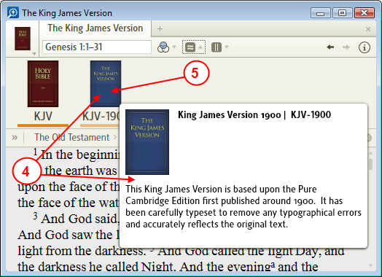

5. Click on one of the resource in the ribbon (one without the dark red bar under it).

6. Now you should see the Equivalent resource in your panel (tab).
a) Notice the icon in your resource's tab has changed.
b) You may also see different buttons or lack of buttons on the resource's toolbar (depending on what is available for the new current resource).
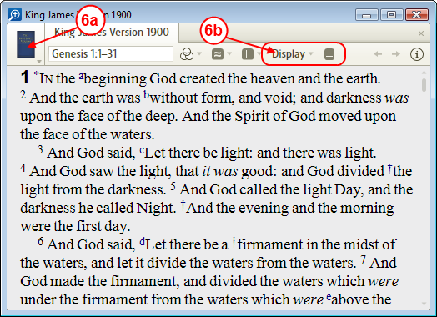

• If you have Scholar's library or greater package, then try using the Equivalent Resources with the Nestle-Aland 27th edition.

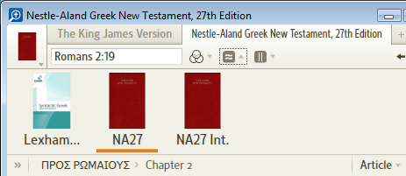

• Try other resource to discover it they have Equivalent Resources.

Keyboard shortcut for ER's
[[@Headword:Equivalent Resource – Keyboard shortcuts ]]
• You can use your keyboard to sequence through Equivalent Resources.
▪ Open a resource with Equivalent Resources
▪ Click in the body of the resource (put focus on the resource's content).
▪ Use Ctrl Shift right to change to the previous Equivalent resource.
▪ Use Ctrl Shift left to change to the next Equivalent resource.

Books known to have Equivalent Resources
[[@Headword:Equivalent Resource – Book with Equivalent Resources ]]
KJV Bible 1900 edition | Authorized Version of the KJV
Logos LXX | Lexham LXX | Septuaginta
AFAT | Lexham Interlinear
NA27 | Lexham Syntactic | NA27 Interlinear
USB4 | Lexham Clausal Outlines | USB4 Interlinear

Parallel Resources
[[@Headword:Parallel Resources ]] Wiki page: Revision 20 Link

Video
Logos4 Videos
Mark Barnes Video on 4.0b changes

What are Parallel Resources?
[[@Headword:Parallel Resources ]]
- Parallel Resources are those resources which are indexed similarly.
Bibles - different Bible versions are considered parallel resources.
Dictionaries - different dictionaries are considered parallel resources.
Commentaries - different commentaries are considered parallel resources.
- Parallel Resources allow you to quickly change the resource in the current tab to that of another resource using the same reference (e.g. same Bible verse).
- Parallel Resources described here were added to Logos4 version 4.0b.
- When Parallel Resources are available for a resource you will notice the icon in the resource's toolbar.
- Parallel Resources will always have the default column All Parallel Resources.
It can have an additional column for a Collections (see Collections & Parallel Resources).
- Not all books will have Parallel Resources.
  - Books which don't have a Reference box (e.g. ALONE WITH GOD)
  - Books which have only page numbers in the reference box.

How to I open Parallel Resources?
[[@Headword:Parallel Resources – How to Open Parallel Resources ]]
- Open a resource (book) which has the icon

1. Click on the Parallel Resource icon
2. Notice the drop down Parallel Resource menu. (you may see another column for collections, see Collections & Parallel Resources)
3. A list of parallel resources are present in the menu. Notice that one of them has an orange bar next to it. This is the currently opened resource.

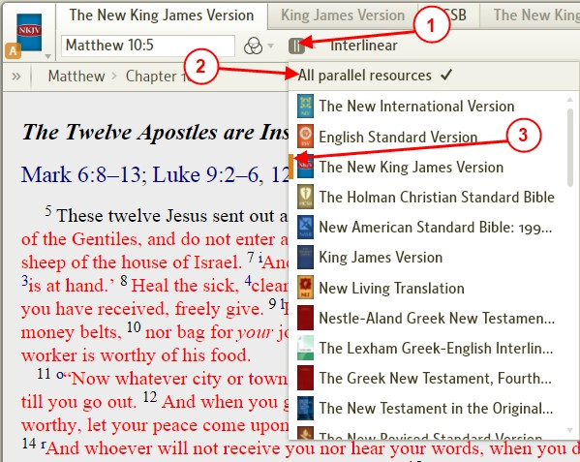
4. Click on one of the resources in the list. It will change to that resource in your tab.

Collections & Parallel Resources
[[@Headword:Parallel Resources – Collections & Parallel resources ]]

How do I get a Collection to appear in Parallel Resources?
[[@Headword:Parallel Resources – How to get a Collection to appear in Parallel resources? ]]
- You will need to setup your Collections prior to using them in Parallel Resources. (see Collections)

1. Click on Tools in the top menu.
2. Click on Collections in the drop down menu.
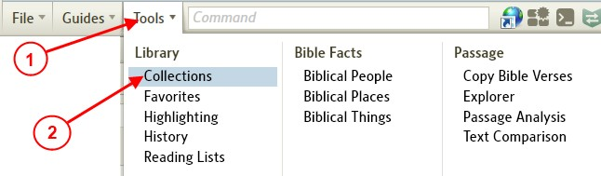

  - Logos4 will open a tab for Collections.

3. Click on the Open button in Collections toolbar and open the collection that you want to tag for use in Parallel Resources. (see Opening Collections)
4. Click on the checkbox.
When the box is checked this collections is used with Parallel Resources.
When the box is unchecked this collection is not used with Parallel Resources.
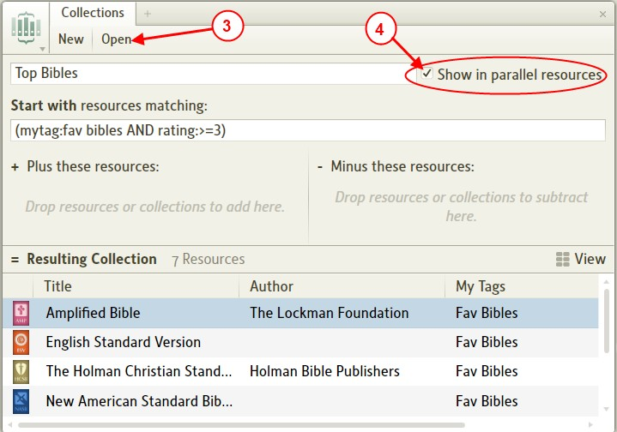

5. Repeat steps 4 & 5 to enable/disable any Collections which you want to use with Parallel Resources.

- As mentioned above, you can use this same process to disable Collections from being used with Parallel Resources.
- Note that Parallel Resources will only use your collection if it has books in it which are similar.
  - For instance, if you have Bibles in your collection and the resource you are trying to view Parallel Resources with is a Bible, then you should see that Collection.
  - So not every Collection that you have enabled shows up in every resource. Only those with similar resources present.
  - See also Why don't I see my Collection in Parallel Resources?

Why don't I see my Collection in Parallel Resources?
[[@Headword:Parallel Resources – Why don’t I see my Collection? ]]
- Make sure that you have your Collection tagged to be used with Parallel Resources. (see How do I get a Collection to appear in Parallel Resources?)
- Your entry in the reference box may not be found in any of your resources for that Collection.
The Reference box is where you enter text for navigating that resource (see image below)

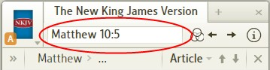

- Try changing the value in your reference box
  - If its a Bible, change the passage to something very general like John 1:1 or Gen 1:1.
  - If its a dictionary, change the word in it to something very general which should show up in most dictionaries.
  - Etc..
- Is the value in the reference box a page number?
Then you will need to change the Visual Filter.
a) Click on the Visual Filter icon (the 3 circle thingy).
b) Uncheck the Show Page Number entry.
c) You may also need to type a usable reference in the reference box (i.e. Bible verse, dictionary word, etc).

- The resource that you are currently in must be in the collection for that collection to appear in the Parallel Resource drop down menu.
Example

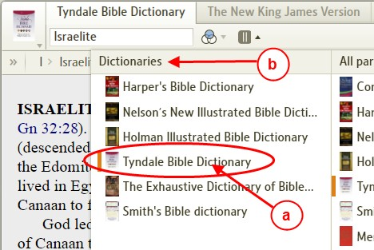
a) If Tyndale Dictionary is missing from my collection Dictionaries,
b) Then the collection Dictionaries will not show up in Parallel Resources drop down menu.

(the image below shows the absence of Tyndale Dictionary in my collection Dictionaries)

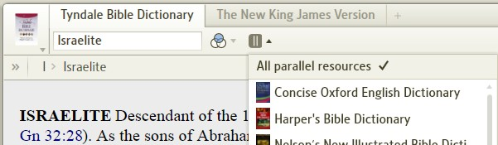

- Check your Collection and make sure that books in it are similar to the resource.
  - If you are in a Bible, then make sure that Bibles which cover the same passage range are in your Collection.
  - If you are in a Dictionary, then make sure that other dictionaries are in your Collection.
  - You get the idea, make sure your Collection has similar books to that of the resource.

- If you have more than one Collection which applies to this resource, you may need to change the Parallel Resource page. (see later part of What shows up in the Parallel Resources?)

What shows up in the Parallel Resources?
[[@Headword:Parallel Resources – What shows up in the Parallel resource? ]]
- Resources which are indexed similarly to the current resource.
- Parallel resources which match the reference in your reference box.
  - All parallel resource may not have a match (e.g. all dictionaries may not have an entry for Ark of the Covenant). So those which don't will be missing in the list.
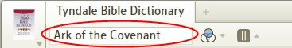

- A Collection which has books that are considered parallel resources.
  - The Collection must be checked to appear. (see How do I get a Collection to appear in Parallel Resources?).
  - You may not see your Collection even if it is checked. (see Why don't I see my Collection in Parallel Resources?).
  - More than one Collection may appear in the Parallel Resources menu.
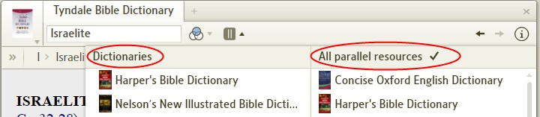

- If more than two or more collections are available you will see a page changer at the bottom of the drop down menu.
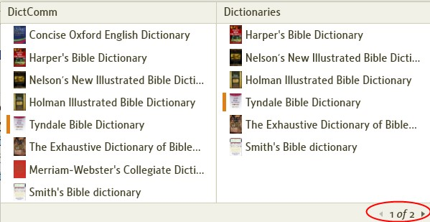

I don't see the Parallel Resources icon
[[@Headword:Parallel Resources – I don’t see the Parallel resource Icon ]]
- If your resource's window is too small the icon will not show up.
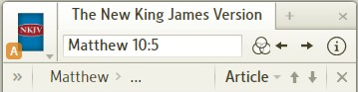

  - Try making your resource's window larger until your see the Parallel Resource icon.
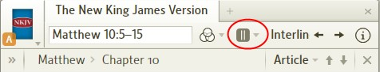

- Do you have Logos4 version 4.0b or higher?
  - If you don't you will not see this feature.
  - Consider updating your Logos4. go to the forum here

- Make sure that you have a valid reference in the reference box.
  - (e.g. page number, even if you have Show Page Numbers OFF in Visual Filters.)
a) Notice that a page number is showing in the reference box.
b) Notice that the Parallel Resource icon is missing.
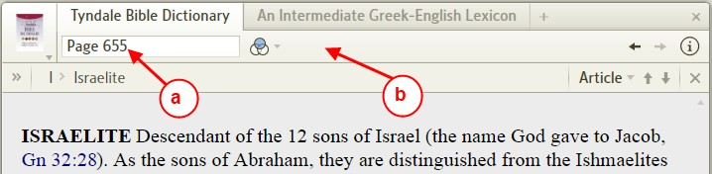
c) Notice that there is a valid reference in the reference box.
d) Notice that the Parallel Resources icon is present now.
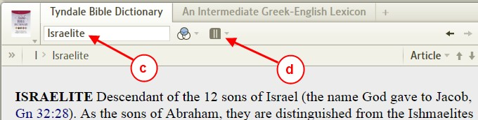

- Not all books will have Parallel Resources.
  - Books which don't have a Reference box (e.g. ALONE WITH GOD)
  - Books which have only page numbers in the reference box.

What is the order of Books in Parallel Resources?
[[@Headword:Parallel Resources – What is the order of Books in Parallel resources? ]]
- The ordering of Books that you see in the Parallel Resources drop down menu appear as follows
  - First they follow the order that you have set in your Library's prioritization. (see Prioritizing)
  - Secondly they appear only if a match to what was in your reference box was found in that resource.
  - Thirdly in the All Parallel Resources column will have other resources which you may not have prioritized.

- Example
  - This is my current Prioritized list for commentaries
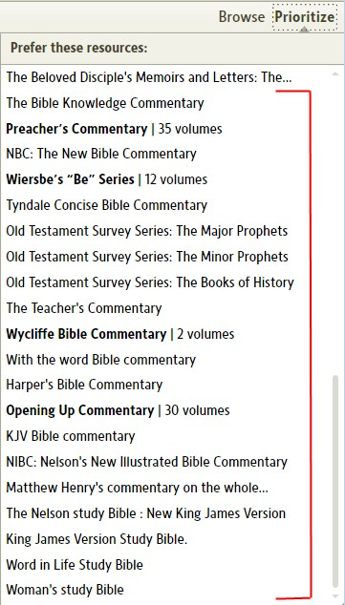

- The Parallel Resource list that shows (when over the BKC for Matt 10:5-15)

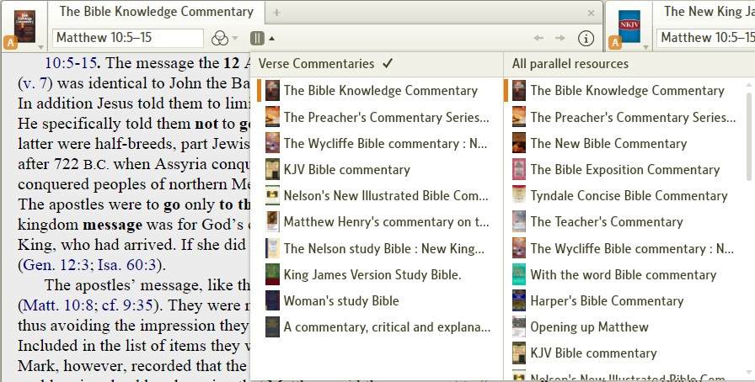
- In the All Parallel Resources column:
  - Notice that the order is the same as that of my Prioritized list.
  - Notice that it skipped over the Old Testament Survey series (since Matthew is NT)
- In the Verse Commentaries column (this is one of my collections):
  - Notice that the book again follow my Prioritized list.
  - Since you cannot see what's in that Collection, you cannot see that it also jumped over books in which Matt 10:5-15 was not found.

Tip: you can use the keyboard to navigate the Parallel Resources
[[@Headword:Parallel Resources – Tip-> you can use the keyboard to navigate PR ]]
- In an active window which supports Parallel Resources (you need to also click in the text/viewing area of this window, not on the toolbar)
  - You can use the Left/Right arrows on your keyboard to sequence through the books in your Parallel Resources.
[Mac Users: Cmd-Left and Cmd-Right]
  - Once that you have passed the last book, it will start at the beginning of the list.

- If you have a Collection tagged for use with this resource:
  - You can tag which Parallel Resource Column to use with your keyboard sequence.
a) First click on the Parallel Resource icon.
b) Then click on the column to use.
(Notice the Checkmark over the column. This tells Logos which Parallel Resource source to use with the keyboard)
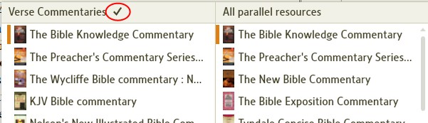

Tip: quick way to sequence through PR's that you've viewed
[[@Headword:Parallel Resources – Tip-> quick way to sequence through PR’s you’ve viewed ]]
- If you have used Parallel Resources to change one or more different resources:
  - You can use the History arrows to sequence back and forth through those resources.
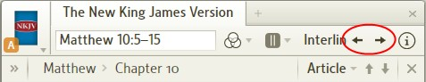

- This can save you some time if you selected resources which were not in sequential order in your Parallel Resource list.
- The bad news is that if you have scrolled or changed locations in the resource, then it will methodically sequence through those too.

Reverse-Interlinear/Interlinear Bibles
[[@Headword:Reverse-Interlinear Bibles ]] Wiki page: Revision 28 Link

Video
Logos4 Videos
Reverse Interlinear
Mark Barnes
Logos Tutorial Video #5 - Reverse Interlinears
New Features in 4.0c

See also
Reverse Interlinear I
Reverse Interlinear II
Reverse Interlinear III
Reverse Interlinear IV

What is an Interlinear/Reverse Interlinear Bible?
[[@Headword:Reverse-Interlinear Bibles – What is it]]
- Please watch Mark Barnes excellent video Logos Tutorial Video #5 - Reverse Interlinears
- Most Logos4 base packages contain Reverse-Interlinear Bibles.
- Logos4 base packages which contain Interlinear Bibles are available in Original Language and Scholar's Library and up. (see Comparisons)
- Logos4 introduced a Reverse-Interlinear ribbon which can appear at the bottom of Bibles which have a Reverse-Interlinear available.
- With version 4.0c, Logos4 introduced the Full page Reverse-Interlinear.
  - Both the Full Page and Ribbon Reverse Interlinear are available.
- An Interlinear is a Bible which has translations under the predominate language, which has a Display button plus morphological tagging.

Interlinear Bible / Resource | Abbreviated Title | Old Testament | New Testament
The Greek New Testament, Fourth Revised Edition (Interlinear with Morphology) | UBS4 Int. |  | Logos Greek
Lake's Apostolic Fathers in English | LakeAF |  | Logos Greek
The Lexham Clausal Outlines of the Greek New Testament | NT Clausal Outlines |  | Logos Greek
The Lexham Discourse Greek New Testament | LDGNT |  | Logos Greek
The Lexham Greek-English Interlinear New Testament | LGNTI |  | Logos Greek
The Lexham Greek-English Interlinear New Testament:SBL Edition | LGNTI:SBL |  | Logos Greek
The Lexham Greek-English Interlinear Septuagint | Lexham LXX Interlinear | Logos Greek
The Lexham Greek-English Interlinear Septuagint, Alternate Texts | Lexham LXX Interlinear Alt. | Logos Greek
The Lexham Hebrew-English Interlinear Bible; Bible. O.T. Hebrew | LHI | Anderson-Forbes
The Lexham Syntactic Greek New Testament | Lexham SGNT |  | Logos Greek
Nestle-Aland Greek New Testament, 27th Edition with McReynolds English Interlinear | NA27 Int. |  | Logos Greek
The OpenText.org Syntactically Analyzed Greek New Testament | OpenText.org GNT |  | Logos Greek
Septuagint with Logos Morphology | Logos LXX | Logos Greek

Note: Logos LXX is an interlinear Bible that does not have an English translation.

How can I tell what Reverse Interlinear Bibles I have?
[[@Headword:Reverse-Interlinear Bibles – Which RI Bibles do I have? ]]
- Doing a Bible Word Study and select "Settings" from the Translation word ring. The dropdown will show you a list of your Reverse Interlinears, including any non-Bible RIs. (This is new as of 4.1)
- You can always tell if any Bible you've got open has RI capability because there will be special RI controls along the top of it. See what they look like below.
- Logos RI uses Anderson-Forbes Aramaic Morphology (for parts of Ezra & Daniel), Anderson-Forbes Hebrew Morphology (for the rest of Old Testament), and Logos Greek Morphology (for the New Testament, Septuagint, plus Apostolic Fathers). To search of all RI Bible passages (Genesis through Revelation), you can use Logos Aramaic Inscriptions Morphology and Logos Semitic Inscriptions Morphology

Reverse Interlinear (RI) Bible | RI Abbr. | Old Testament | New Testament
The Cambridge Paragraph Bible of the Authorized Version | AV 1873 | Anderson-Forbes | Logos Greek
English Standard Version | ESV | Anderson-Forbes | Logos Greek
King James Version | KJV 1900 | Anderson-Forbes | Logos Greek
The Lexham English Bible | LEB |  | Logos Greek
New American Standard Bible: 1995 Update | NASB95 | Anderson-Forbes | Logos Greek
The New International Version (1984) | NIV84 |  | Logos Greek
The New King James Version | NKJV | Anderson-Forbes | Logos Greek
The New Revised Standard Version | NRSV | Anderson-Forbes | Logos Greek
New Living Translation | NLT |  | Logos Greek

What is the difference between an Interlinear and a Reverse Interlinear Bible?
[[@Headword:Reverse-Interlinear Bibles – What is the difference between Interlinear & Reverse-Interlinear? ]]
- Dan DeVilder explained this in this forum post A silly question: reverse interlinear vs interlinear
  - An interlinear will have the original language written in the order it was written: you can see which words had priority of placement (eg, at the beginning of a sentence for emphasis, etc), how the sentence was structured originally.

(example from the Nestle-Aland Greek New Testament, Matt 5:43)

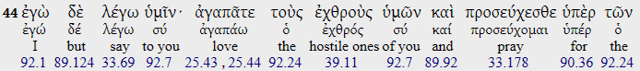

- A reverse interlinear "works backward". It shows the translated passage in order, and rearranges the original language underneath it, out of order compared to its original state, but tied closely to the translated text so we can tell what phrase or word was used to translate the original language.

(example from the New King James Version, Matt 5:43)
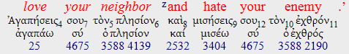

Interlinear at the bottom of a Bible Resource
[[@Headword:Reverse-Interlinear Bibles – Interlinear at the bottom of a Bible ]]

Turning On/Off an Interlinear (ribbon)
[[@Headword:Reverse-Interlinear Bibles – Turning On/Off an Interlinear (ribbon) ]]
- Bibles which have a Reverse-Interlinear will have the above icon in the Bible's tool area.

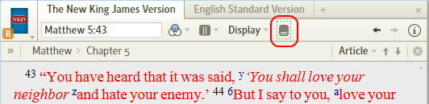

- Click on the icon to show the Reverse-Interlinear ribbon at the bottom of the resource.
- Click on the icon again to hide the Reverse-Interlinear ribbon at the bottom of the resource.
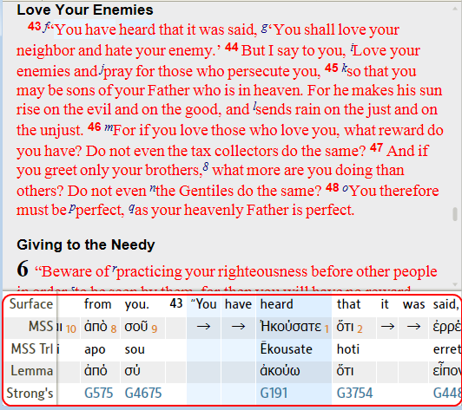

Selecting which words appear in Interlinear ribbon
[[@Headword:Reverse-Interlinear Bibles – Selecting which words appear in Interlinear ribbon ]]
- Please watch Mark Barnes excellent video Logos Tutorial Video #5 - Reverse Interlinears
- Please watch the Logos tutorial video Reverse Interlinear.
- Select your Bible with a Reverse-Interlinear and turn on the Interlinear so that it shows at the bottom of your resource.
(see Turning On/Off an Interlinear (ribbon))

- Locate a word that you want to view in the Interlinear ribbon and click on it. (Logos4 will select it by highlighting it in blue).

- Notice the word appears in the Interlinear ribbon and that the column for that word is highlighted in blue.

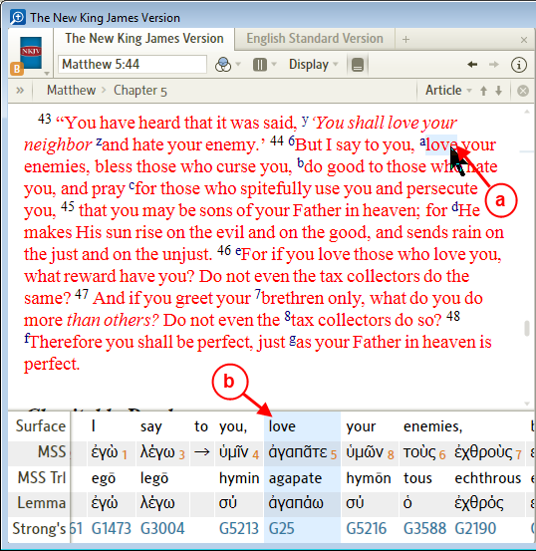

Selecting rows which appear in the Interlinear (ribbon)
[[@Headword:Reverse-Interlinear Bibles – Selecting rows which appear in the Interlinear (ribbon) ]]
- Make sure that you have the Interlinear ribbon showing at the bottom of your resource.
(see Turning On/Off an Interlinear (ribbon))

- Right click on the row labels on the left side of the Interlinear ribbon.

- Check/Uncheck an item which you want to show/hide in the Interlinear ribbon by clicking on it.

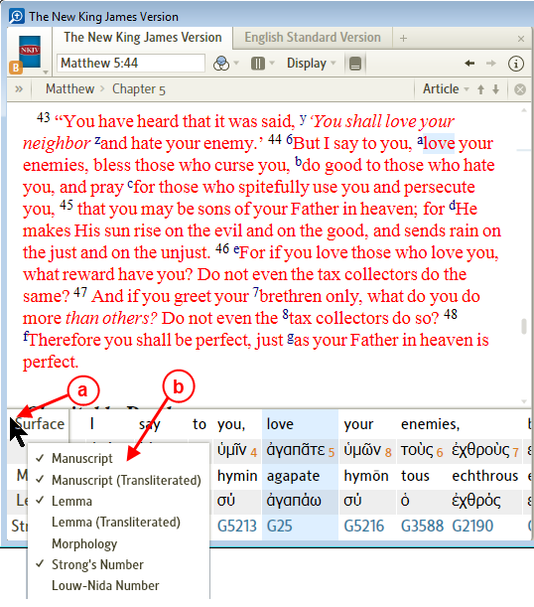

- The Interlinear row options will vary (e.g. Louw-Nida Number will be available only in New Testament).
- Manuscript -- the form of the word as it appeared in original text for this location.
- Manuscript (Transliterated) -- how to pronounce it with English letters (phonetic pronunciation).
- Lemma -- the root form of this word which you would find in a dictionary/lexicon.
- Lemma (Transliterated) -- how to pronounce it with English letters (phonetic pronunciation).
- Morphology -- initials which represent information for the parts of speech for this word. See further documentation of Morphology Codes.
- Strong's Number -- Strong's number for this word (relates to Strong's Concordance).
- Louw-Nida Number -- Louw-Nida number for this word (see your resource Greek-English Lexicon of the New Testament based on Semantic Domains).

Full Page Interlinear Bible Resource
[[@Headword:Reverse-Interlinear Bibles – Full Page Interlinear Bible Resource ]]
- This feature is only available in Logos4 versions 4.0c and up.

Turning On/Off an Interlinear (full page)
[[@Headword:Reverse-Interlinear Bibles – Turning On/Off an Interlinear (full page) ]]
- Select your Bible with a Reverse-Interlinear
(note some Bibles may only have the New Testament ready at this time.
If you have the Inline checked and the resource is not available, you will see the resource's text only.).

- On the Bible resource's toolbar click on the Display button.

- In the drop down list, click to check Inline. (when Inline is checked the Reverse Interlinear will be shown)
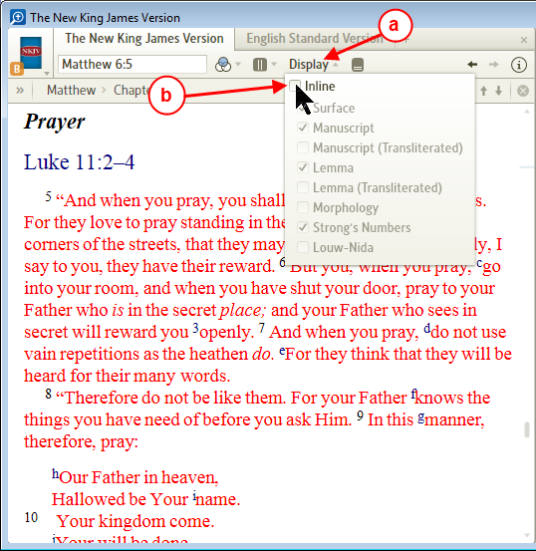

- Now you will see your Bible resource displayed with the Full Page Interlinear showing.
The number of rows for each word may appear different from the image below.
(see Selecting rows which appear in the Interlinear (full page))

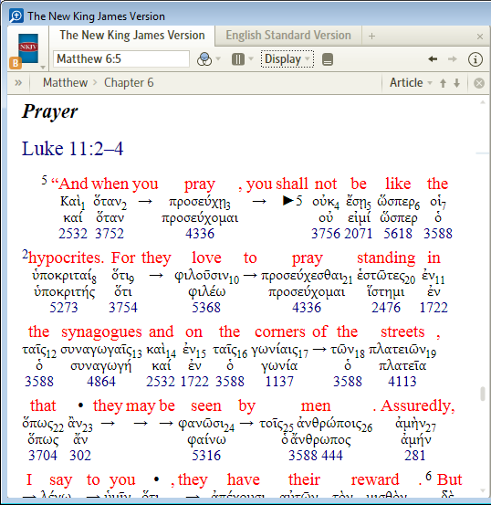

- To hide the Full Page Interlinear simply click on Display and uncheck Inline.

Selecting rows which appear in the Interlinear (full page)
[[@Headword:Reverse-Interlinear Bibles – Selectin rows which appear in the Interlinear (full page) ]]
- You can select what you want to appear when displaying a Reverse Interlinear.

- Click on the Display button in your resource's toolbar.

- A drop down list will appear. (to hide the list, click on Display again or in another part of your resource)

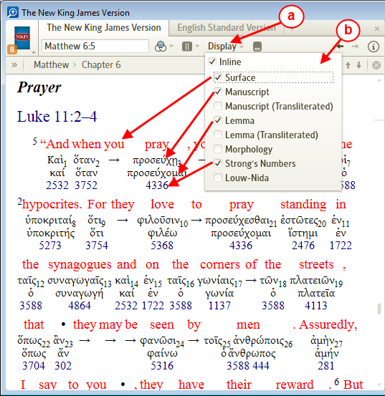

- Inline -- turns on the Reverse Interlinear when checked.
  - The Interlinear row options will vary (e.g. Louw-Nida Number will be available only in New Testament).
  - Surface -- shows the normal text of your resource when checked.
  - Manuscript -- the form of the word as it appeared in original text for this location.
  - Manuscript (Transliterated) -- how to pronounce it with English letters (phonetic pronunciation).
  - Lemma -- the root form of this word which you would find in a dictionary/lexicon.
  - Lemma (Transliterated) -- how to pronounce it with English letters (phonetic pronunciation).
  - Morphology -- initials which represent information for the parts of speech for this word. See further documentation of Morphology Codes.
  - Strong's Number -- Strong's number for this word (relates to Strong's Concordance).
  - Louw-Nida Number -- Louw-Nida number for this word (see your resource Greek-English Lexicon of the New Testament based on Semantic Domains).-

- Be sure to remember that when you turn OFF too many items that the Reverse Interlinear may appear unreadable
(Just remember that you can turn ON the items again by checking them. Especially the Surface item)

Understanding notations in the Reverse Interlinear
[[@Headword:Reverse-Interlinear Bibles – Understanding notations in the Reverse-Interlinear ]]
- Jeff in the forum pointed out: In the Reverse Interlinear: what are these?
  - There was a four part series on the Logos blog back in 2006 that explained the symbols used in the ESV Reverse Interlinear, which I believe is still applicable. They can be found on the blog at the links below:
    - Reverse Interlinear I
    - Reverse Interlinear II
    - Reverse Interlinear III
    - Reverse Interlinear IV

What is the subscript number next to manuscript words?
[[@Headword:Reverse-Interlinear Bibles – What is the subscript number next to manuscript words? ]]
- The word order of the translation rarely matches the word order of the original manuscript.

- The number in subscript to the left of the word is the order that this word appeared in the original manuscript.

- Note the order here in the original manuscript.
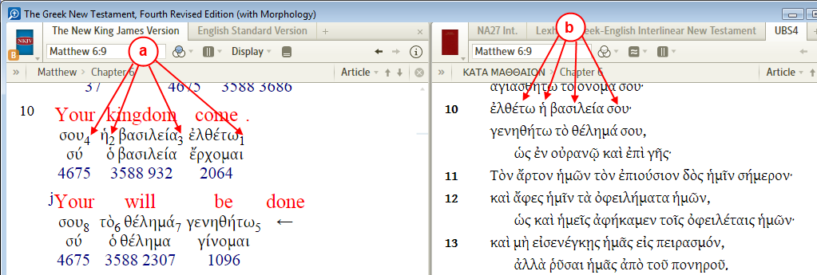

Bold arrow & numbers
[[@Headword:Reverse-Interlinear Bibles – Bold arrow & numbers ]]
- Information LaRosa Johnson supplied in forum post In the Reverse Interlinear: what are these?
  - The arrow with the number means that the English text corresponds to the Greek word with the "5" subscript in that verse...

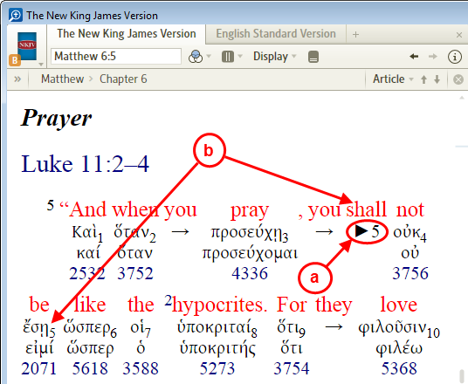
- The Arrow with a 5 next to it.

- Indicates that the English word Shall corresponds to the Greek word ἔσῃ which has a subscript of 5 next to it (5th word of the verse as found in the original text).

Thin arrows which point to words
[[@Headword:Reverse-Interlinear Bibles – Thin arrows which point to words ]]
- Information LaRosa Johnson supplied in forum post In the Reverse Interlinear: what are these?
  - The arrow pointing forward (or back) means that the entire phrase or group of words was translated from that one Greek word (mainly because Greek verbs include person, number, gender, mood, etc.)
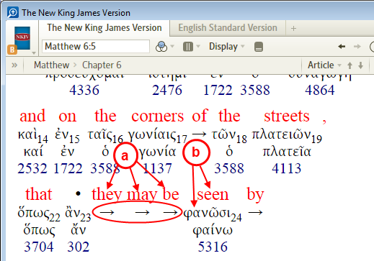
- The phrase they may be seen is a translation from ...

- the Greek word φανῶσι.

Bold dots in the Surface text
[[@Headword:Reverse-Interlinear Bibles – Bold dots in the Surface text ]]
- Information LaRosa Johnson supplied in forum post In the Reverse Interlinear: what are these?
  - for the dot in the English text, it means that the Greek word wasn't directly translated into English
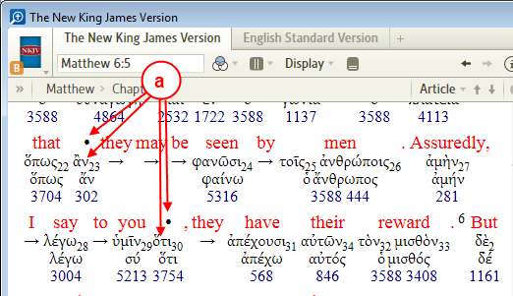
- The Greek words ἂν and ὅτι required no direct translation into English.

Resource's Information Window
[[@Headword:Resource Info Window ]] Wiki page: Revision 8 Link

Introduction
[[@Headword:Resource Info Window ]]
Most if not all your resources will have an Info icon on the right side of the resource's toolbar. When you click on the icon Logos 4 will show you information about that resource. The contents of this information page will be similar to the one that you can view in your Library (see item #3 in The Library’s toolbar). But the resource's information will contain several items of more specific information which can be useful to your understanding on how Logos 4 uses this resource.

Not all resource information windows will have all the items populated in them. This varies somewhat relative to the resource. Below is typically what you will find in a resource's info window.

- Image of the cover of the book
- General information on the book
  - The Rating which you have assigned for this book
  - Tagging which you have assigned for this book
- Citation information for this book
- Copyright information on this book
- Index information on how Logos 4 relates to this book
- Search Fields which Logos 4 can search within this book
- Support Info details specific for Logos 4

some resources may have other items not shown above. (e.g. Reverse Interlinear)

Viewing a Resource's Info
[[@Headword:Resource Info Window – Viewing a Resource’s Info ]]
Open a resource in your Logos 4 layout area (see Opening your resources (books)). Then look on the right side of your resource's toolbar for the info icon and click on it to view the resource's info window.

To hide the info window look on the right side of the toolbar for the Done button and click on it to hide the info window. This returns you back to where you were viewing in your book.

General Info area
[[@Headword:Resource Info Window – General Info area ]]
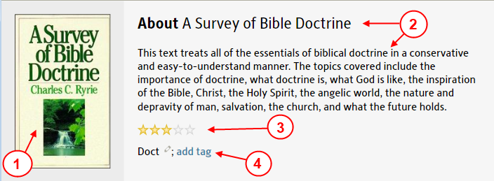
- An image for the front cover of the book.
- General information about the book.
- The Rating that you have assigned to this book
  - To change the Rating click on the star at which you want to change the rating to (the further to the right that you click equals the higher the rating). You can learn more about Ratings on the wiki page Ratings.
  - To clear the Ratings, right-click on the star and in the pop-up click on Clear.
- The Tagging that you have assigned to this book
  - To add a Tag click on the add tag link, then type in the tag name that you want. (please see the wiki page Tagging for more details about tagging)

Citation area
[[@Headword:Resource Info Window – Citation area ]]
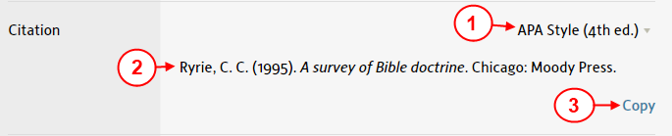
- The is the current citation style. If you click on it you can change the citation to another style.
- Citation info for this book relative to the style you have selected in step #1.
- If you want to copy the citation info for this book to the clipboard for pasting elsewhere, then click on the Copy link.

Copyright area
[[@Headword:Resource Info Window – Copyright area ]]
This area will show you information about which version of your book that is in Logos 4, (e.g. the copyright date for which your book was created from). Logos 4 will have more information here for some books. For instance in the ESV Bible] you will find information regarding how much text that you may legally copy into a paper that you are writing.

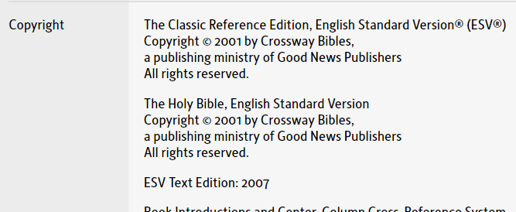

Indexes area
[[@Headword:Resource Info Window – Indexes area ]]
This area is particularly useful in knowing how Logos 4 can access this book. Not all books have values for this area. For instance the book A Survey of Bible Doctrine has no Logos 4 indexes applied to it. But most other books will have information here. Some may have only one index method and others like a lexicon may have quite a few methods listed.

To help you understand what an Index method is used for, think of the Reference box in a Bible. You can enter a Bible reference in its reference box and Logos 4 navigates to that scripture book) chapterverse. So if you were to look in the Indexes area of that Bible's info window you would see Bible. Likewise if you were to enter a Word in a dictionary in the reference box then Logos 4 navigates to that word in that dictionary. Some books have a wider variety of Index methods that Logos 4 has assigned to them. For instance the Enhanced Strong's Lexicon has several methods which can be used to navigate to original language words that are found in it (e.g. Strong's numbers, original language word, TDNT, TDOT).

So you may ask what all this means to you. Well if you understand how certain books are Indexed then it would help you better arrange them in your Prioritization in your library. For instance books which use Strong's numbering as an index might be prioritized higher in your prioritization of lexicon if you use Strong's numbering when seeking information on original language words. Also when setting up a reading plan, knowing how a book is indexed can help you set the range that you want to read each day. So you see this area of information in your book's info window can open up a lot of understanding on how Logos 4 will use it.

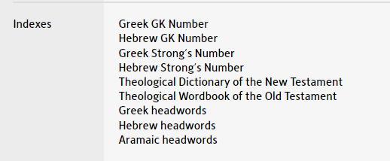
(Indexes for the Enhanced Strong's Lexicon)

Search Fields area
[[@Headword:Resource Info Window – Search Fields area ]]
This is another area which can help you understand how Logos 4 handles areas in which it searches a specific book.

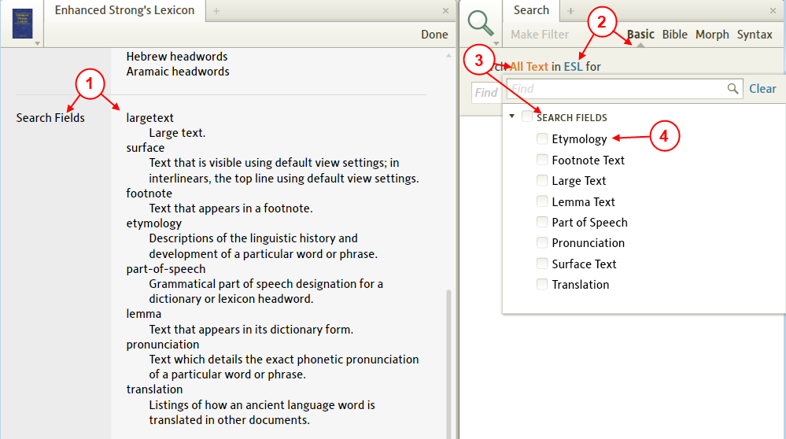

- The Search Fields area shows you all the specialized fields that Logos 4 can limit your search area to for that specific book.
- If you open a Search window and use Basic search in your specific book (same one that you are looking at it's Info window), then ...
- if you click on All text and then click on Search Fields, ...
- you will see that Logos 4 has your search fields for your book listed here.

This can be useful to know how you can narrow down your search by using one or more of these fields which are available in your book.

Support Info area
[[@Headword:Resource Info Window – Support Info area ]]
Information in this area may or may not be useful to you. But if you ever contact Logos Tech support or ask a question on the Forum, then you might be asked to supply some of this information found in this area.

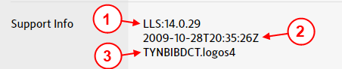

- This is Logos 4's resource ID name for this book. They use it internally in the Logos 4 program.
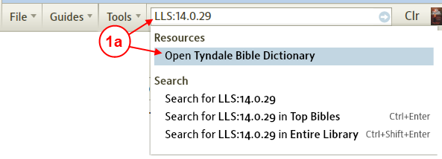

  - The resource ID can be used inside of Logos 4 if you were to paste or type it into the Command box. Logos 4 will search to discover what the resource's book name is and show it to you in the drop down menu.
- This is specific version information on your book.
- This is the filename for your book that Logos has it stored under.

Navigating a Resource (controls in the Locator bar)
[[@Headword:Navigating a Resource ]]
[[@Headword:Locator Bar ]] Wiki page: Revision 30 Link

Video
Logos4 Videos
Mark Barnes Video on 4.0b changes

What is the Locator bar?
[[@Headword:Locator Bar – What is it ]]
- The Locator bar is available on each of your resources.
- It contains some tools and location details.
(the image below has a red rectangle around the Locator bar)
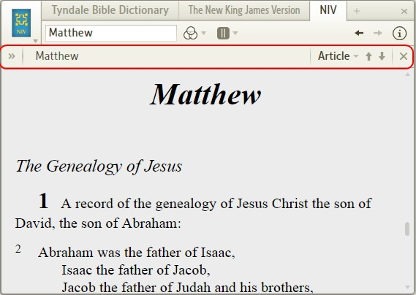

What are the tools on the Locator bar?
[[@Headword:Locator Bar – What Tools are on the Locator bar? ]]
- The Locator bar contains the following tools
- Table of Contents toggle button.
allows you to open or close the table of contents.

- Contents location :
shows you where you are relative to the table of contents.

- Navigation choice (New with 4.0b) :
shows which navigation choice that you have selected.
If clicked on, a drop down list appears with selections.

- Navigation arrows :
navigates forward or backward relative to the navigation type selected in item c.

- Close button :
closes the Locator bar.
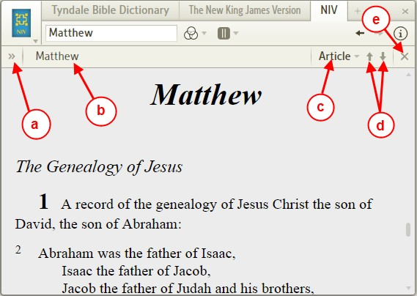

I don't see the Locator bar
[[@Headword:Locator Bar – I don’t see the Locator bar ]]
- You may have closed the Locator bar.
To open it follow these steps:

1. Click on the resource window icon.
2. In the resource window menu, click on the Show locator bar.
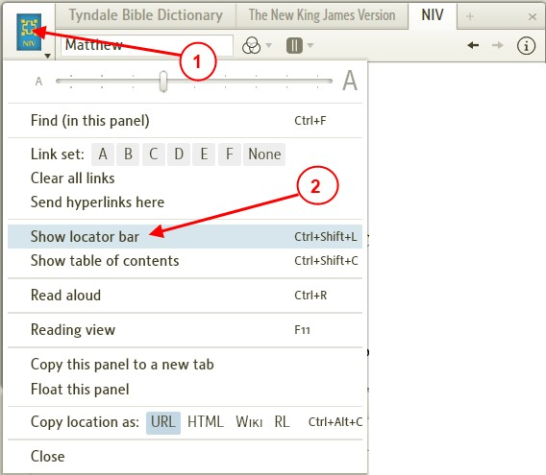

- Or make sure that the resource is active (by clicking in the viewing area of the resource), then press Ctrl+Shift+L key combination.

Navigating using controls on the Locator bar
[[@Headword:Locator Bar – Navigating using controls on the Locator bar ]]
- In Logos4 version 4.0a only the Forward and Backward navigation arrows were available.
This only moved a page view of your resource at a time.

- Starting with Logos4 version 4.0b you can select the navigation method.
These change the way the navigation arrows function. (see navigation choices below)

Using the Forward and Backward arrows
[[@Headword:Locator Bar – Using the Forward and Backward arrows ]]
- These arrows will move your location in your resource per the Navigation choice. (available in 4.0b)
See the Navigation choices in sections below.

  - The up arrow moves to the previous navigation point.
  - The down arrow moves to the next navigation point.

- Your current Navigation choice appears on the Locator bar to the left of the Navigation arrows.

Typical Navigation choices
[[@Headword:Locator Bar – Typical Navigation choices ]]
- These choices are typically what you will see in the Navigation list

- Click on the current navigation choice on the Locator bar.
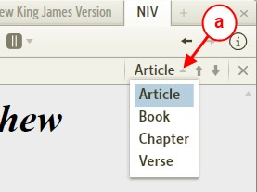

- Article -- moves to next/previous heading
- [pericope in a Bible, heading in commentary, or next dictionary entry]

- Book -- moves to the next/previous book in your Bible.
- [works with books that use Bible indexing (e.g. verse/chapter/book), n/a in other books]

- Chapter -- move to the next/previous chapter.
- [works with books that use Bible indexing, n/a in other books]

- Verse -- moves to the next/previous verse.
- [works with books that use Bible indexing, n/a in other books]

Search Navigation choice
[[@Headword:Locator Bar – Search Navigation choice ]]
- If you are using Search, the search results can be used by the navigation arrows in your book(s) when changing the navigation selection to Search Result.
- In the example below
- We are searching the NIV Bible.
- For the phrase Kingdom of Heaven.
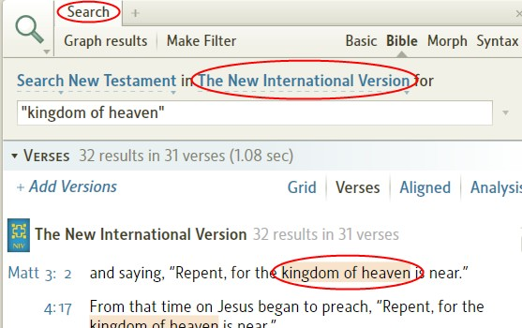

- If we look at the NIV in another tab, we will see a new item (Search Result) appears in the navigation list.
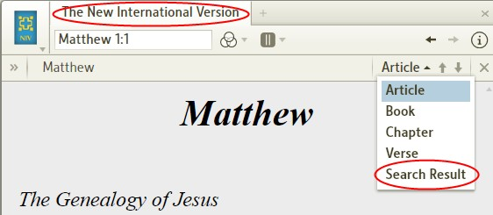

- If we select Search Result in the navigation list. Then press the down navigation arrow, it will move the location in your NIV resource to the next search result in the NIV.
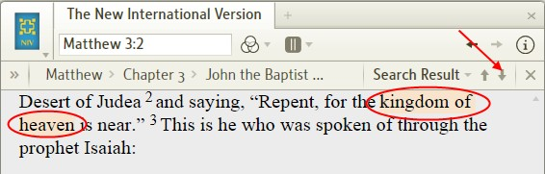

- If you had set the Search for All Bibles, then you would have been able to set the navigation method to Search Result in each of your open Bibles. Then you could navigate each Bible to search results.

- If you use Basic Search, then you could use this navigation method in any of the resources which appeared in the search results.

Highlight Navigation choice
[[@Headword:Locator Bar – Highlight Navigation choice ]]
- See Highlighting for information on how to use Highlighting
- If you have Highlighted text in your resource, then a new navigation item (Highlight) will appear in the navigation list.
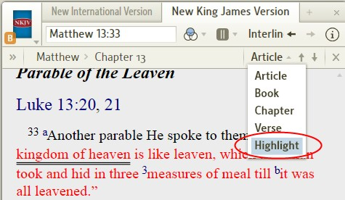

- When the Highlight navigation choice is selected, you can use the navigation arrows to move forward/backward to Highlighted text in your resource.

- Example:
- In this example we have highlighted the phrase the kingdom of heaven in 3 locations of the NKJV using the highlighting tool.
The image below show those highlighted phrases. They use the double underline highlighting.
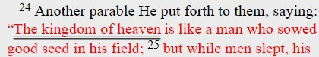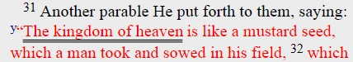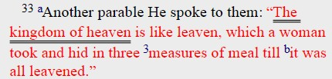

- Make sure that Highlighting is turned On in the Visual Filters as shown below.
a) Click on Visual Filter icon.
b) Click to check the Highlighting box in the drop down list.
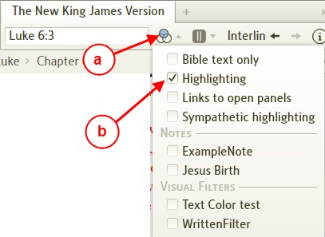

- Now we will select Highlight in the navigation list as shown below.

a) Click on the navigation choice.
b) Click on Highlight item in the drop down list.
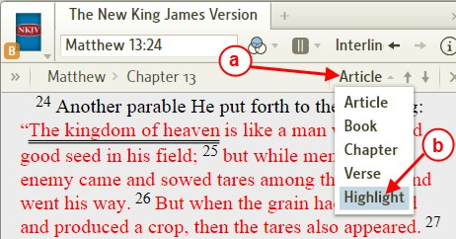

- We start with the NKJV at the first highlighted text.
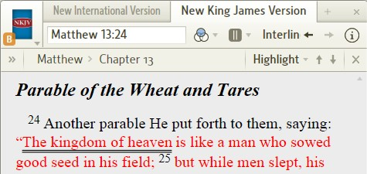

- Now when the Down navigation arrow was pressed, the position was changed to the image shown below.
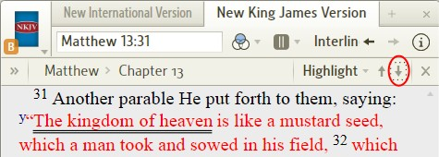

- Again when the Down navigation arrow was pressed, the position was changed to the image shown below.
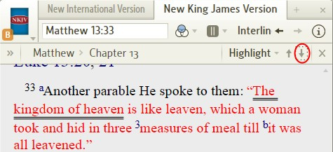

- In like manner you could use the Up navigation arrow to move the position to the previous highlighted text.

- This feature might come in handy when trying to locate highlighted text which you want to erase the highlighting for.

- To remove Highlight from the navigation list:

a) Click on the Visual Filter icon.
b) Click to uncheck the Highlighting box.
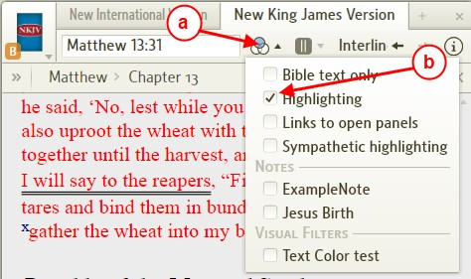

Visual Filter Navigation choice
[[@Headword:Locator Bar – Visual Filter Navigation choice ]]
- See Visual Filter for setting up Visual Filters.
- If you have Visual Filters setup and turned ON in your resource, then a new navigation item (Filter Highlight) will appear in the navigation list.
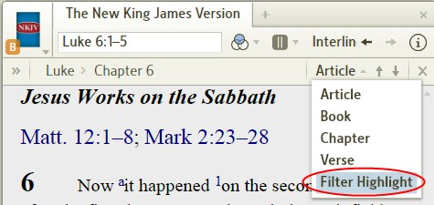

- Example:
- In this example we have created a Visual Filter named WrittenFilter which sets the word written in Luke's Gospel in the NKJV to use outline formatting.
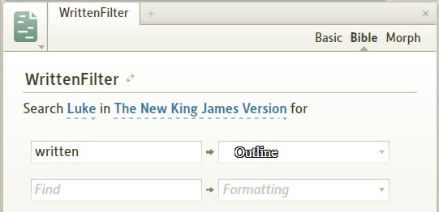

- Now we will make sure that the Visual Filter for WrittenFilter is turned On as shown below.

a) Click on the Visual Filter icon.
b) Click to check the WrittenFilter box in the drop down menu.
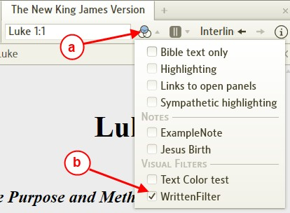

- Now we will select Filter Highlight in the navigation list as shown below.

a) Click on the navigation option.
b) Click on Filter Highlight in the navigation drop down list.
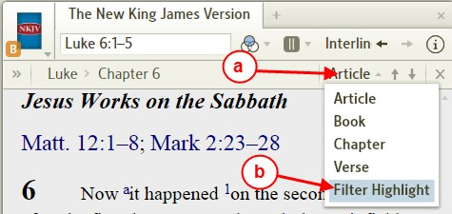

- Now we start with Luke's Gospel in the NKJV. (notice that the navigation option is Filter Highlight)
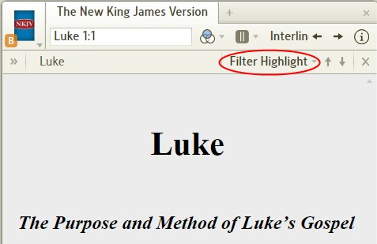

- Now we use the navigation Down arrow to position to the word written in the NKJV.

- By clicking 3 times on the Down navigation arrow.
- This is positioned on the 3rd occurrence of written (which is the first occurrence of Jesus speaking this in Luke).
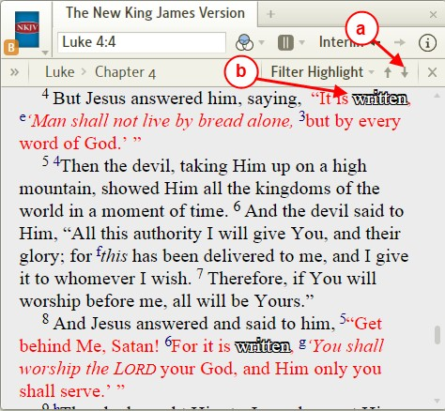

- In like manner you can continue to use the navigation arrows to move to other occurrences of written in Luke's Gospel.

- To turn Off the Visual Filter WrittenFilter follow the steps below.

a) Click on the Visual Filter icon.
b) Click to uncheck WrittenFilter box in the drop down menu.

Navigating using the keyboard
[[@Headword:Locator Bar – Navigation using keyboard ]]
- You can navigate within your resource using your keyboard.
This mimics using the navigation arrows
- The keyboard shortcuts are:
- Forward -- key combination Alt + DownArrow
- Backward -- key combination Alt + UpArrow

- If you need to change the navigation method before using the keyboard arrows,
- see Typical Navigation choices and the choices below this for other navigation methods
- If you don't see the Locator bar, then see I don't see the Locator bar) (it shows how to hide/show the Locator bar)
You can always hide it after changing to recover more viewing space.

Table of Contents
[[@Headword:Locator Bar – Table of Contents ]]
- On your Location bar there are two Table of Contents items.
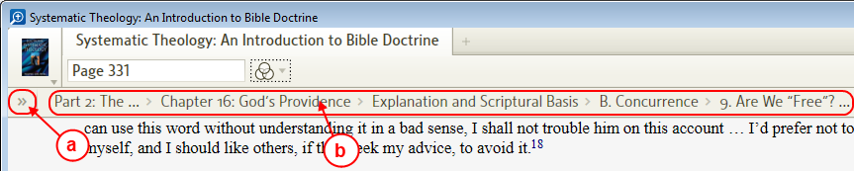

a) This chevron Opens/Closes the full Table of Contents.
b) This link(s) show you your current Contents Location in your book.

Contents Location
[[@Headword:Locator Bar – Contents Location ]]

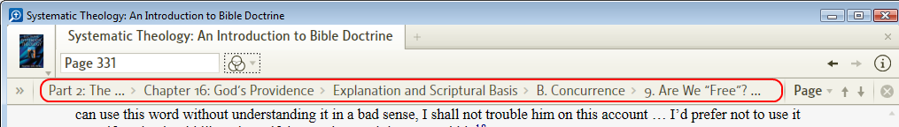

- As you navigate through your resource this Contents Location changes to show you where you are within your resource.
- It is more than just a contents text identifier. It is a series of links.

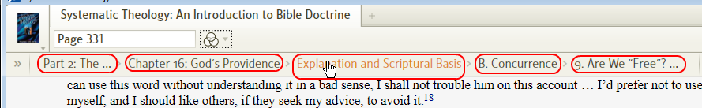

- You can quickly navigate backwards to:
- Sub headings
- Beginning of the chapter

Viewing the Table of Contents
[[@Headword:Locator Bar – Viewing the Table of Contents ]]

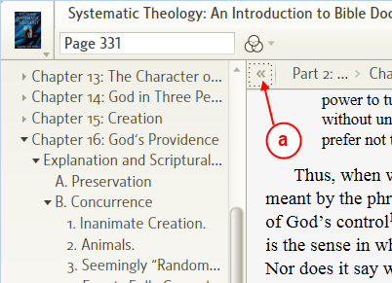
- Clicking on the chevron you can show or hide the Table of Contents. The contents will open in a panel on the left of your resource.

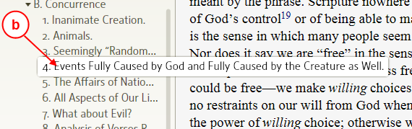
- For items that are not fully visible, you can hold your mouse over that item and a pop-up will appear with the full item.

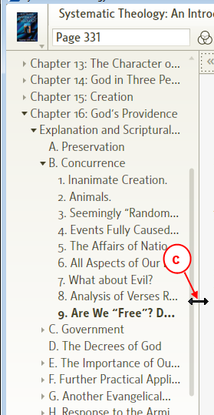
- You can also resize the Table of Contents panel by grabbing the right vertical edge and dragging it.

▪ Things you can do in a Resource ▪
This section has wiki pages which show you features in which you can use inside of a resource.

Right Click Menu
[[@Headword:Right Click Menu ]]
Wiki page: Revision 27 Link

Video
Thomas Black
Using the Right Click menu
Mark Barnes
Logos Tutorial Video #5

What is the Right Click Menu?
[[@Headword:Right Click Menu – What is it ]]
- The Right Click Menu is a pop-up menu which appears when you right click on a word in one of your resources.
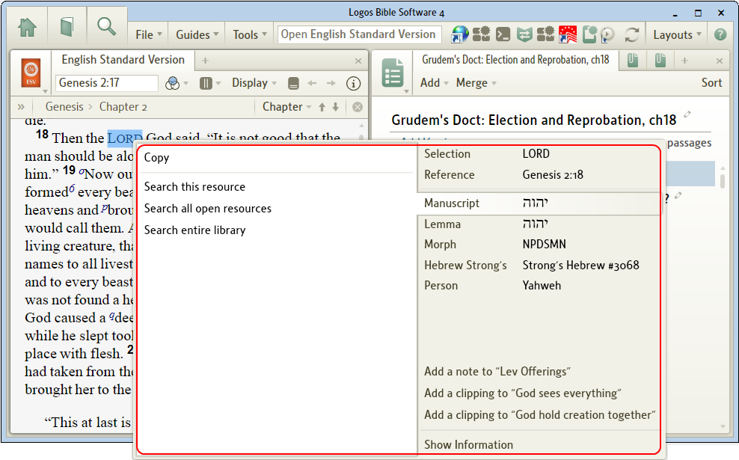

- It provides various access to tools within Logos 4 to help you with the word that you right clicked on.
- In the pop-up menu please notice that on the right side are categories.
And on the left side are available selections which change when you change a category on the right.
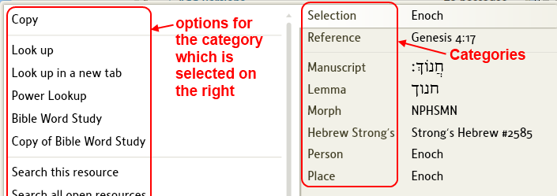

- The category selection changes according to the word that you have selected in your resource.
So you may see more or less categories depending on what word that you right clicked on.
- On the category side at the bottom you may see Notes, Clippings, Passage lists files which you have open.
- On the category side please pay attention to the scroller if visible on the right!
This will usually appear when you have several files open in Logos 4 and there is insufficient room in the pop-up to show all the categories.
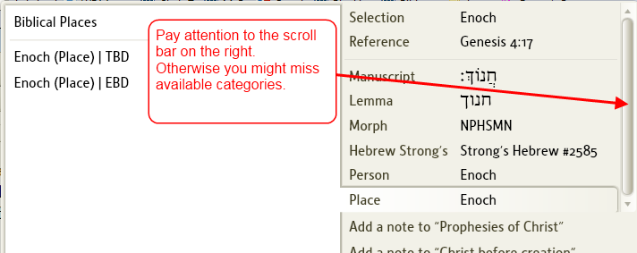
- Also pay attention to the left side of the pop-up menu, it may have a scrollbar too.
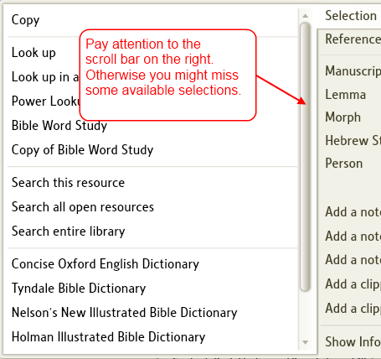

- You also can use Right Click to copy selected text or select an image to your clipboard for pasting elsewhere.
- Thomas Black has made a video Using the Right Click menu, please watch it.

Available selections per Category
[[@Headword:Right Click Menu – Available selection per Category ]]
- Right click on a word in your resource and the pop-up menu will appear.
- On the right side of the pop-up menu are categories. Below are descriptions for each of these categories.

Selection
[[@Headword:Right Click Menu – Available selections [Selection] ]]
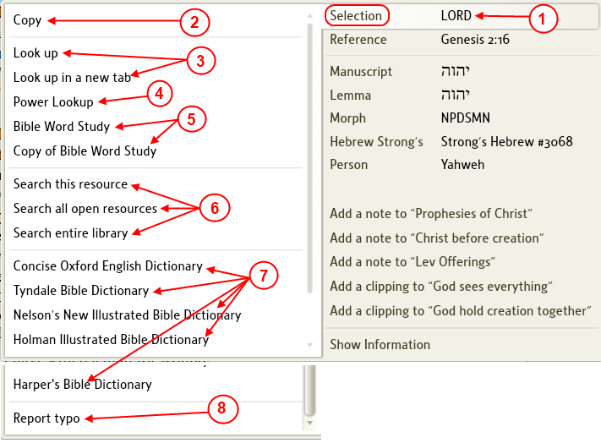

- This is the word that you right clicked on in your resource.
- Copy: clicking on this will copy your selection into the window's clipboard.
Once it is in your clipboard, you can paste it to another place.
- Lookup: will open a tab with a dictionary lookup of your word.
- Power Lookup: will open the Power Lookup tool which provides multiple dictionary lookups on your word.
(see also the Power Lookup wiki page)
- Bible Word Study: will open the Bible Word Study tool to the word that you right clicked on.
- Search: will open the Search tool using the word that you right clicked on as the word to search for.
- Dictionaries: will open the dictionary to the word that you right clicked on.
- Report Typo: will open the report typo dialog which will allow you to report a typo in your open resource.
You will need internet access for this to work.
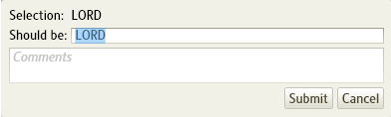

Reference
[[@Headword:Right Click Menu – Available selections [Reference] ]]
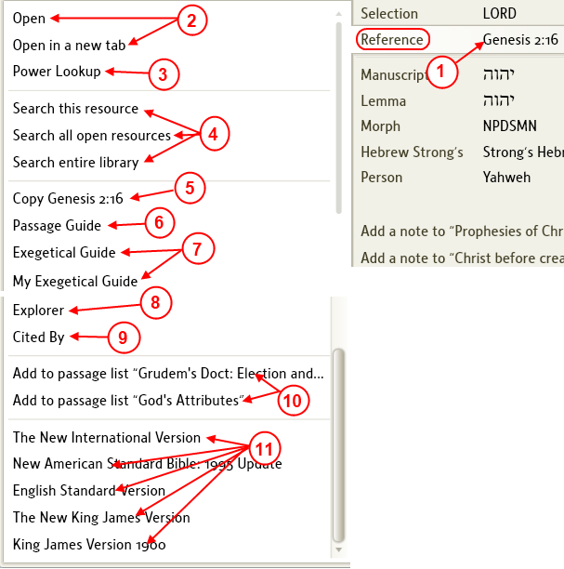

1. This is the scripture reference where you clicked on you word.

2.
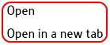
These options appear when you are in a Bible other than your preferred Bible. They will allow you to open this scripture reference in your preferred Bible.

3.
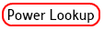
Will open the Power Lookup tool to this reference.
(see also the Power Lookup wiki page)

4.
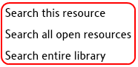
will open the Search tool using the scripture reference.

5.
will copy your scripture reference to the window's clipboard.

6.
will open the Passage Guide tool to your scripture reference.
(see also Passage Guide wiki page)

7.
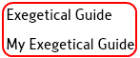
will open the Exegetical Guide tool to your scripture reference.

8.
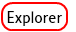
will open the Explorer tool to your scripture reference.
(see also Explorer wiki page)

9.
will open the Cited By tool to your scripture reference.
(see also Cited By wiki page)

10.
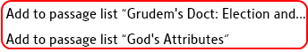
will add this scripture reference to an open Passage List file.
(see also Passage List wiki page)

11.
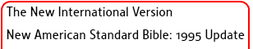
will open one of these Bibles to your scripture reference.
(The Bibles in this list appear according to how you prioritized them. See A Sample Prioritize List wiki page for suggested prioritization or the wiki page Prioritizing for more information on prioritizing your resources)

Manuscript
[[@Headword:Right Click Menu – Available selections [Manuscript] ]]
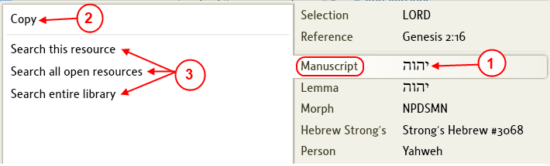

- This is the word in the original language manuscript that you clicked on. This word form is useful when you want to search for the specific form of an original language word (not necessary the Lexicon lookup form).
- Copy: will copy the manuscript form of the word into the clipboard for pasting elsewhere. This can be very useful when you want to paste a Hebrew/Greek/Aramaic word into a search's find box or similar area and want it to be the exact manuscript word from the original language.
- Search: will allow you to open the Search tool to find the manuscript form of the word that you clicked on.

Lemma
[[@Headword:Right Click Menu – Available selections [Lemma] ]]
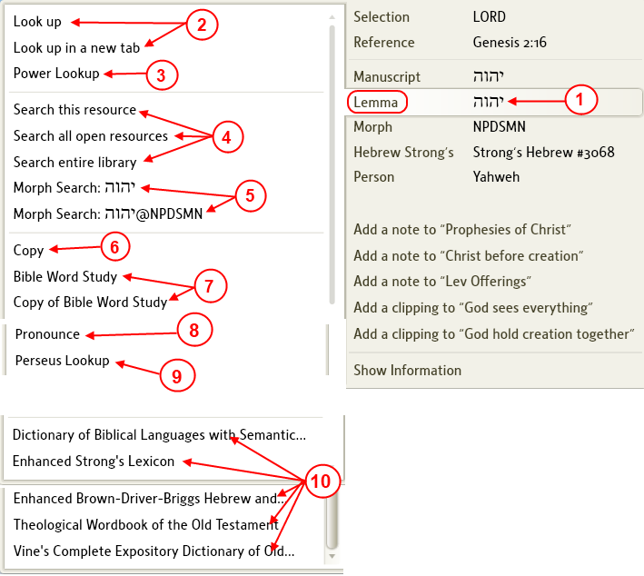

- Pay attention to Lemma categories, sometimes you may see more than one lemma. This often occurs when other parts of speech are connected with the root word.

1. This is the word in the original language Lemma form that you clicked on. This word form is useful when you want to search for the dictionary/Lexicon form of an original language word.

2.
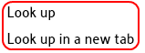
will open a tab with a Lexicon lookup of your word.

3.
Will open the Power Lookup tool using the Lemma form of the word that you clicked on.
(see also the Power Lookup wiki page)

4.
will open the Search tool using the Lemma form of the word that you clicked on as the word to search for.

5.
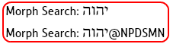
will open the Search tool using Morphological search method.
(see also Morphological Search wiki page)
a. the lower morph search will also look for the lemma along with the morph tagging.

6.
will copy the Lemma form of the word into the window's clipboard for pasting elsewhere. This can be very useful when you want to paste a Hebrew/Greek/Aramaic word into a search's find box or similar area and want it to be the Lemma form of the word from the original language.

7.
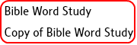
will open the Bible Word Study tool to the Lemma form of the word that you right clicked on.

8.
will pronounce the lemma form of the word that your right clicked on.

9.
will open the website Perseus Digital Library to your word.

10.
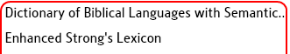
will open a Lexicon to the Lemma form of the word that you right clicked on. The list of lexicons here are sorted per your prioritization. See A Sample Prioritize List wiki page for suggested prioritization or the wiki page Prioritizing for more information on prioritizing your resources.

Morph
[[@Headword:Right Click Menu – Available selections [Morph] ]]
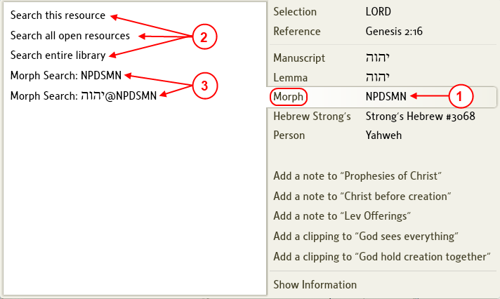

- This is the morphological tagging for the word that you right clicked on.
(see also the wiki page Morphology Codes for description on the codes. Also see the wiki page Morphological Search on how to use the morphological search method)

2.
will open the Search tool using the morphological tagging for the word that you right clicked on to search for all words that match this tagging.

3.
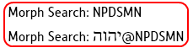
will open the Search tool using the morphological tagging for the word that you right clicked on in the Bible that you were in when you clicked on it.
a. the lower morph search will also look for the lemma along with the morph tagging.

Hebrew Strong's / Greek Strong's / Louw-Nida
[[@Headword:Right Click Menu – Available selections [Strong’s / Louw-Nida] ]]
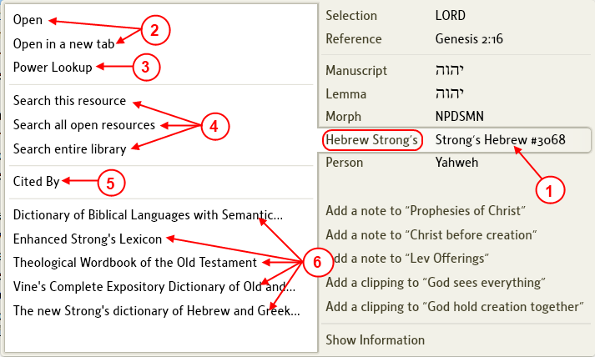

- Strong's number are numbers assigned to words found in Strong's concordance. (see Wikipedia Strong's Concordance for a better description.)
- Strong's number are tied to the original language words, thus you will notice Hebrew Strong's numbers and Greek Strong's numbers.
- In New Testament when you right click on a word if the resource is tagged for the Louw-Nida words you will see this category on the right side of the pop-up. References to number below will show Strong's, but keep in mind when using Louw-Nida can be used as well.

1. This shows the Strong's number for the word that you right clicked on. (or Louw-Nida when selected)

2.
will open a lexicon or dictionary to this Strong's number according to how you have them prioritized (according to the first one in the prioritized list that this number is found).

3.
will open the Power Lookup tool to the Strong's number.
(see also the Power Lookup wiki page)

4.
will open the Search tool using the Strong's number and search for occurrences of this Strong's number.

5.
will open the Cited By tool to this Strong's number.
(see also Cited By wiki page)

6.
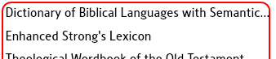
will open the resource from this list to the Strong's number. The reference resources here appear according to how they are prioritized and the first ones where the Strong's number is found. See A Sample Prioritize List wiki page for suggested prioritization or the wiki page Prioritizing for more information on prioritizing your resources.

Person / Place
[[@Headword:Right Click Menu – Available selections [Person/Place] ]]
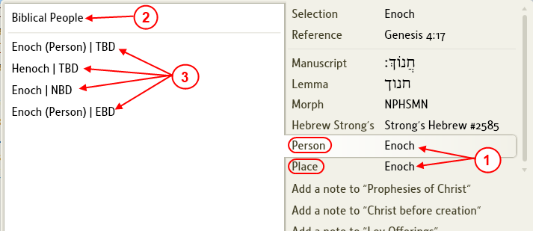

- The image here happens to show both Person and Place. This is not the usual case. So when you right click on a person's name you will see Person and when you right click on a city or country you will see Place.

1. This is the Person or Place that you right clicked on.

2.
or
This will open either Biblical People or Biblical Place tool for the name/place that you right clicked on.
(see also Biblical People wiki page)

3.
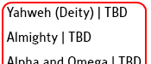
will open a dictionary to the person or place that you right clicked on.

Show Information
[[@Headword:Right Click Menu – Available selections [Show Info] ]]
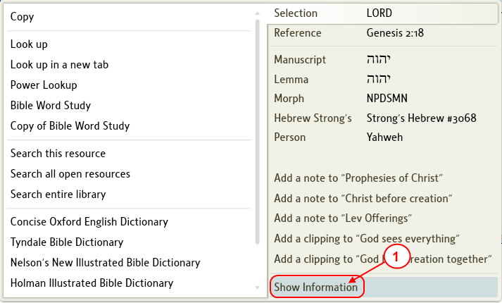

- On the pop-up at the bottom of the right side below categories/files is an option Show Information.

- When you click on this Logos 4 will open the Information tool to show you information on the word that you right clicked on.
(see also Information wiki page)

Copying Selected Text or Image
[[@Headword:Right Click Menu – Copying Selected Text or Image ]]
- You cannot select both text & image at the same time to be placed into your clipboard. You will need to select an image separately.

Selecting Text
[[@Headword:Right Click Menu – Copying [Selected Text] ]]
Logos4 will add Citation & Footnotes to your clipboard if they are turned ON in Program Settings. So you will need to have these set accordingly prior to using the Right Click to copy your selection.

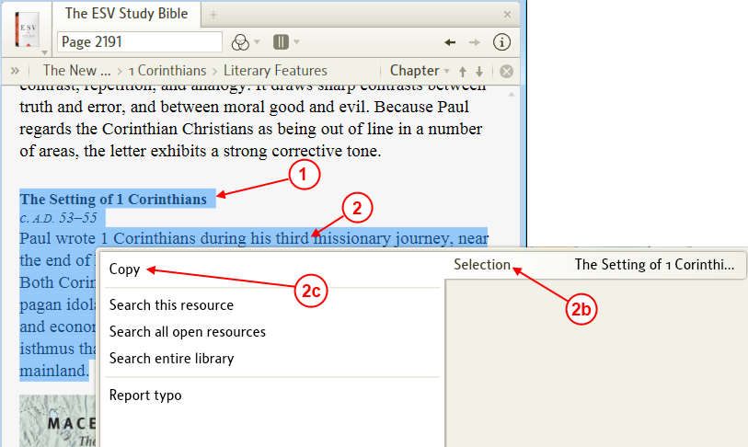

- In your resource use your mouse to select the text which you want to copy by dragging over the text with your mouse.
- With your mouse over the selected text, right click
  - The Right Click menu will appear.
  - Make sure that on the right side of the menu Selection is selected.
  - On the left side of the menu click on Copy.
  - Now your selected text is in your clipboard ready for pasting elsewhere.

Selecting an Image
[[@Headword:Right Click Menu – Copying [Selected Image] ]]
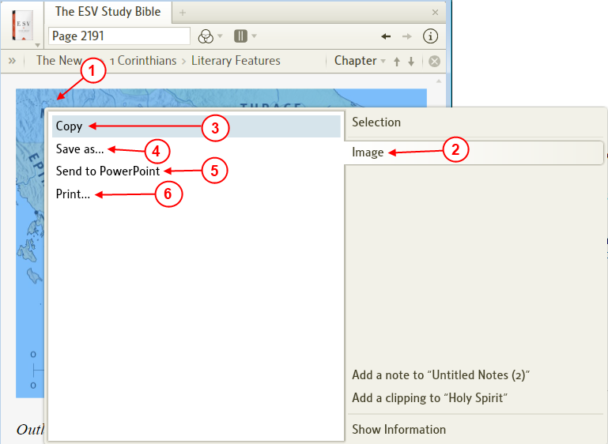

- In your resource, right click on an image which you want to copy, save, export, or print.
- The Right Click menu opens. On the right side of the menu click on Image.
  - On the left side of the menu...
- Copy will add your image to the clipboard for pasting elsewhere.
- Save as will bring up a file dialog box allowing you to save your image on your hard-drive in formats available with your operating system.
- Send to Power Point will export your image to Power Point.
- Print will bring up windows Print Pictures dialog box which will allow you to select how you want your picture printed.

Sympathetic highlighting
[[@Headword:Sympathetic Highlighting ]] Wiki page: Revision 22 Link

Video
Tutorial Sympathetic Highlighting
Logos4 Videos

What is Sympathetic Highlighting?
[[@Headword:Sympathetic Highlighting – What is it ]]
- Please watch the Logos tutorial video Sympathetic Highlighting)
- Sympathetic Highlighting works with Bibles which have an Interlinear.
- Logos4 uses the original language to determine which words are/(to be) highlighted.
- It also works with Original text (not all work, see How can I tell if an Original Language edition will work with Sympathetic Highlighting? ).
- Using Original Languages may require you to have a Base Package which includes these (e.g. NA27 for NT greek or LXX or BHS for OT).
- Sympathetic Highlighting allows you to highlight text in one Bible and Logos4 will highlight the corresponding text in the other Bible(s).
- You will need to check Sympathetic Highlighting in the Visual Filter (the 3 circle icon in your resource) in each Bible.
- It is advised to have your Bibles linked together so that the same passage is showing in all Bibles that you want to use Sympathetic Highlighting.
- This can be useful in seeing how different translations represent the same words.
- This can be useful when viewing an Original Language and you want to see where/how a word is translated into English.

How can I tell if an Original Language edition will work with Sympathetic Highlighting?
[[@Headword:Sympathetic Highlighting – How can I tell if an OL edition will work with Sympathetic Highlighting? ]]
- Open the Original Language resource and look in the Visual Filter (the 3 circle icon in your resource). If you see Sympathetic Highlighting in the drop down list, then this resource will work with Sympathetic Highlighting.

Tip: Turning On/Off Sympathetic Highlighting in multiple resources
[[@Headword:Sympathetic Highlighting – Tip-> Turning On/Off Sympathetic Highlighting in multiple resources ]]
- You can turn On/Off Sympathetic Highlighting in all appropriate resources quickly.

- In one of your Bibles click on the Visual Filters icon.

- Right click on the Sympathetic Highlighting in the drop down menu.

- Another pop-up menu will appear.

- Click on Show in all appropriate resources to turn On Sympathetic Highlighting in all resources that support this.
- Click on Do not show in any resources to turn Off Sympathetic Highlighting in all resources.

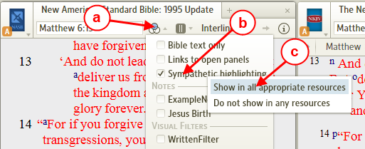

Examples
[[@Headword:Sympathetic Highlighting - Examples ]]

Basic Example
[[@Headword:Sympathetic Highlighting – Examples [Basic Ex.] ]]
- In this example we will be using the New American Standard, New King James Version, and the Nestle Aland 27th edition (if you don't have the NA27, you can still use this example to see how it works with the NAS and the NKJV).
- Open the Bibles as shown below.
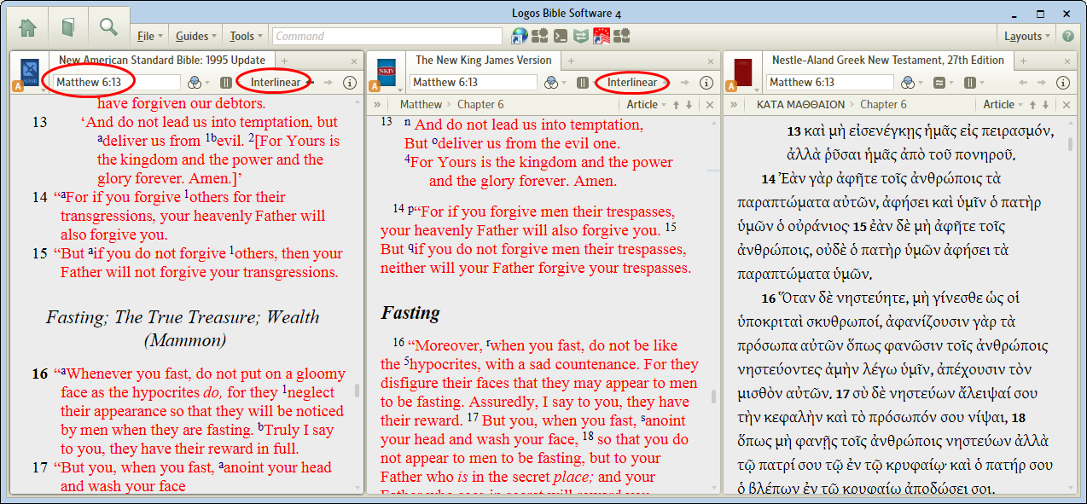

- Notice that the NAS95 and the NKJV are Interlinear. This is required since the Original Language is searched by Logos4 when you highlight words.
- Since we are also using the NA27, you will need to ensure that the passage in the Bibles is a New Testament verse (NA27 is for Greek New Testament only).
- Let's link all 3 Bible together: [this is optional, but helps keep the same text visible in all the windows which prevents us from having to scroll to see the highlighted text]

- Click on the resource's icon to have the resource window menu drop down.
- Select link A. [repeat steps 1 & 2 for each Bible]
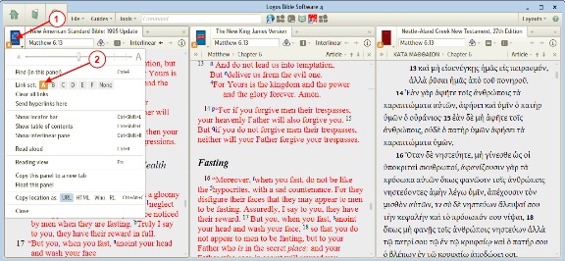

- Let's set each Bible to use the Visual Filter Sympathetic Highlighting.

- Click on the Visual Filter icon.
- Check Sympathetic Highlighting. [repeat steps 3 & 4 for each Bible or see Tip: Turning On/Off Sympathetic Highlighting in multiple resources ]
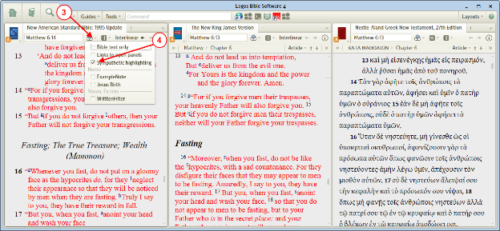

- Now let's highlight a word in the NAS95

- Highlight a word in the NAS95.
- Notice that the other 2 Bibles have a word(s) highlighted. This is the Sympathetic Highlighting in action.
- Note: sometimes I found if I have just made a change (new passage, just turned on Sympathetic Highlighting, etc) that if you click on the tab (so as not to deselect the text) that this will get Logos4 to resume or catchup with the highlighting. If your computer runs Logos4 a little slow (like mine), then this may take a few seconds.
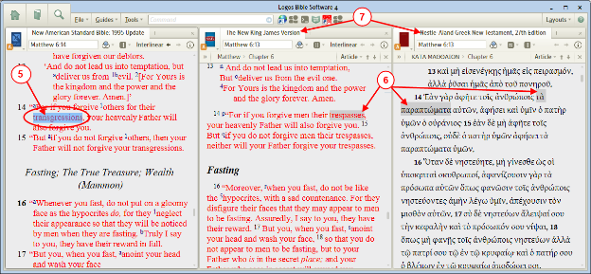

- Now let's try using the Na27 to see how the Greek word is translated into English.
- Note: you may need to click in an open area of the NAS95 to deselect text first!

- Highlight a Greek word in the NA27 Bible.
- Notice that Logos4 has highlighted a word(s) in the other 2 Bibles.
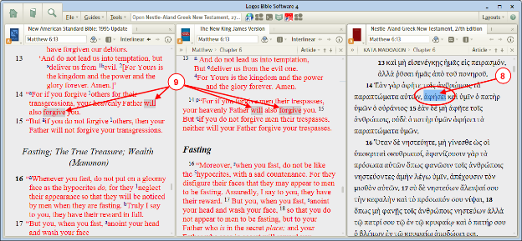

- Experiment and have fun.

Finding the Names of God in Greek & Hebrew
[[@Headword:Sympathetic Highlighting – Examples [Finding the Names of God in Greek & Hebrew] ]]
- You can find many uses for Sympathetic Highlighting.
- This example will show you how to find the Names of God from a resource:
- Then you will use Sympathetic Highlighting in an English Bible to highlight the name to show the name as shown in Greek and in Hebrew.

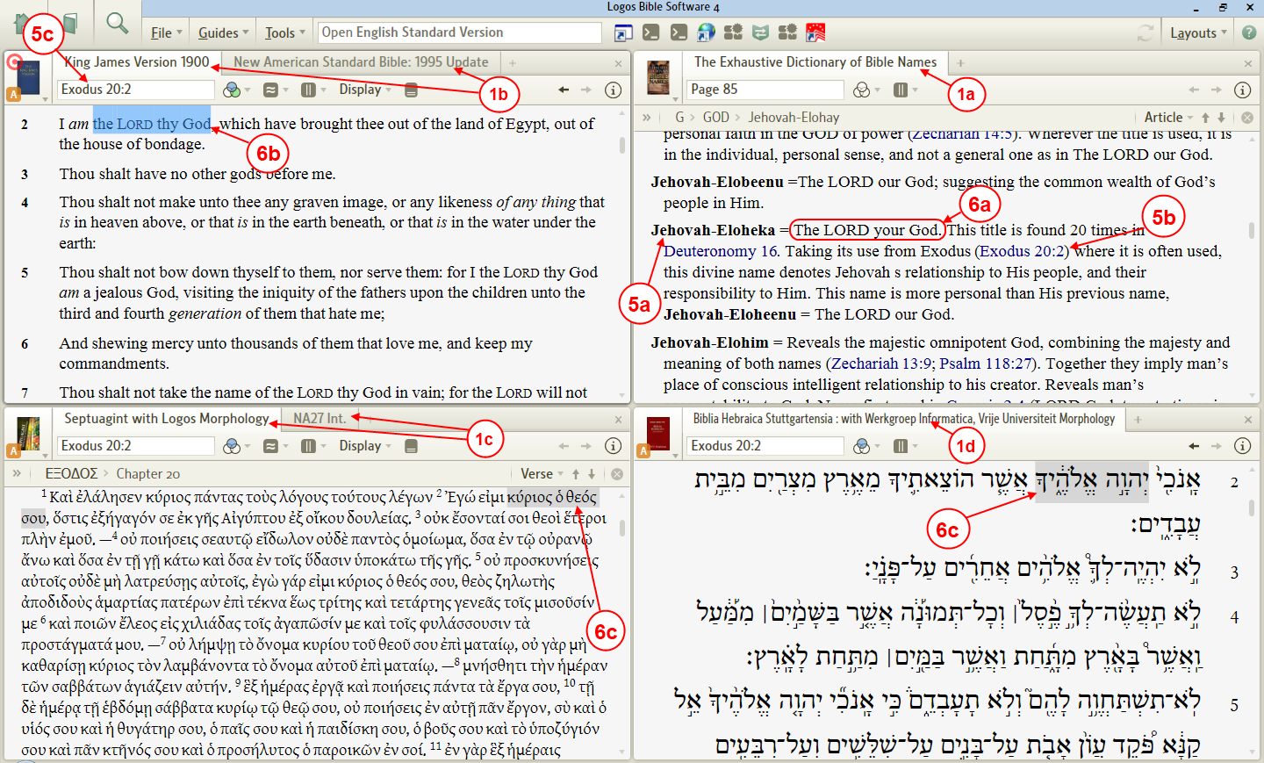

- Open the following resources: (click on the links to have Logos4 open your resources)
- The Exhaustive Dictionary of Bible Names
(if you use the link it will take you to page 85,
this article GOD = self-revealing names of GOD in the Old Testament starts on page 81)
- KJV (1900) and the NAS95.
(we open 2 English Bibles, the different wording might be useful when looking for Names of God )
- Septuagint with Logos Morphology and the NA27 int.
(we open 2 here for Greek, one for OT [Septuagint] and one for NT [NA27])
- BHS (for OT Hebrew).
- You might want to arrange the resources as shown in the above image to help you while using this example.
- Now we need to link the Bibles together so the same verses will show in each window
(see wiki page [[Linking]] for help)
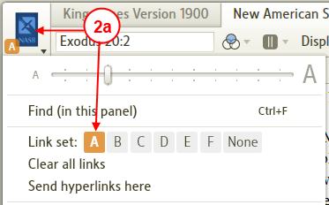

- Click on the Bible's icon, in the drop down menu click on Link set A.
- Repeat this for all Bibles: KJV, NAS95, Septuagint, NA27, BHS.

- Now we need to turn ON Sympathetic Highlighting:
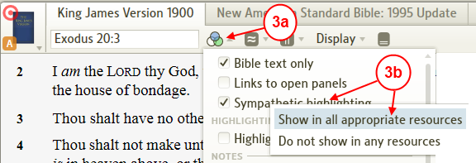

  - In one of your Bible's, click on the Visual Filters icon in the Bible's toolbar.
  - In the drop down menu, right click on Sympathetic highlighting. In the pop-up, click on Show in all appropriate resources (this will turn ON Sympathetic Highlighting in all your Bibles).

- Next we want to make the KJV the default when we click on a scripture
(in case you use a different Preferred Bible)
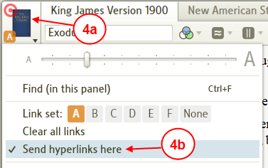

  - In the KJV Bible, click on the KJV icon.
  - In the drop down menu, click on Send hyperlinks here.

- Now we are ready to identify Names of God in the 3 languages using Sympathetic Highlighting.

- Now lets find a Name of God in the dictionary and locate it in the English Bible:
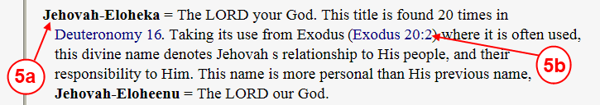

  - In The Exhaustive Dictionary of Bible Names locate a Name of God.
  - Find a scripture reference to this Name of God and click on it.
  - Notice that after step 5b, the KJV reference box shows that scripture and the KJV is positioned to it.

- Now in the Dictionary:
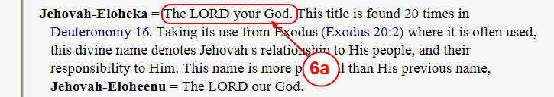

  - Identify which words for this Name of God that we need to find in our Bible.
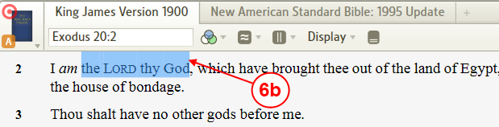

  - In the KJV (or the NAS95) locate the words from step 6a and use your mouse to drag over those words to select them.
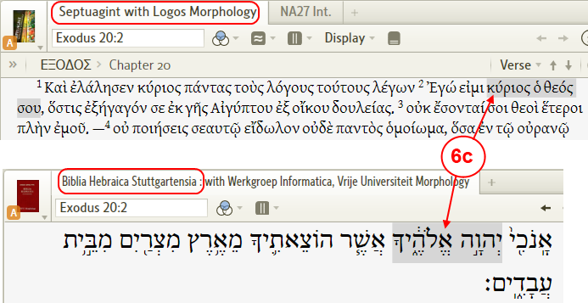

  - Notice that Logos4 has highlighted these words in the Septuagint and the BHS. (it may take several seconds for Logos4 to highlight these)
(if you are using a NT scripture, then look in the NA27, but remember you will not see highlighting in the BHS for NT scriptures)

- Now that Sympathetic Highlighting has identified the words in the Septuagint (Greek) and the BHS (Hebrew), you can use your mouse to select these words then use the keyboard to copy them (*Ctrl C*).
  - You could paste them into MS Word or another word processor.
  - I have copied most of them into this Word document.

Visual Bookmarks
[[@Headword:Visual Bookmarks ]] Wiki page: Revision 8 Link

Q) What are these gray marks along the scrollbar in my book?
[[@Headword:Visual Bookmarks – Q) What are these gray marks? ]]

A) They're called "Visual Bookmarks." Some call them "Wear Marks."
[[@Headword:Visual Bookmarks – A) They’re called ‘Visual Bookmarks’ or ‘Wear Marks’ ]]
- Grey is "page wear;" it's the last several locations you've actually been. The official term is "Auto Bookmark."
- Orange is the current search term(s).
- Blue is the favorites you've saved.

Q) How do you hide the Visual Bookmarks ?
[[@Headword:Visual Bookmarks – Q) How do you hide the Visual Bookmarks? ]]

A) Turn them off in Program Settings.
[[@Headword:Visual Bookmarks – A) Turn them Off in Program Settings ]]
- Click on Tools on the top menu.
- Then click on Program Settings.
- Under General, you will see Show Auto and Favorite Bookmarks and Show Search Bookmarks. Click on No next to the type(s) of bookmarks you do not wish to see.

Visual Cues
[[@Headword:Visual Cues ]] Wiki page: Revision 10 Link

Video
Logos4 Videos

See Also
Visual Bookmarks

What are Visual Cues?
[[@Headword:Visual Cues – What is it ]]
- Visual Cues are those quickly appearing circles over your books which briefly appear when you have navigated to a location.
  - When you navigate using the Locator bar, you will notice that Visual Cues mark the new location in your resource.
[below we have used the navigation arrow to move to the next verse (Acts 1:9 from Acts 1:8). Notice the orange circle (i.e. Visual Cue).]
[For information on Locator bar see Navigating a Resource)
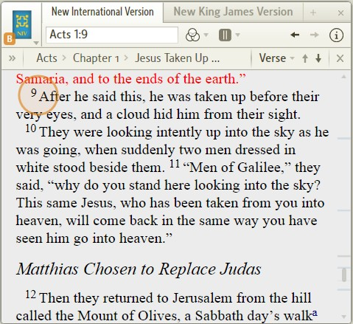

- When you enter a passage verse in a Bible, you will see the Visual Cue appear on the pericope (heading).
[Below we entered Mark 1 in the reference box and pressed Enter.]
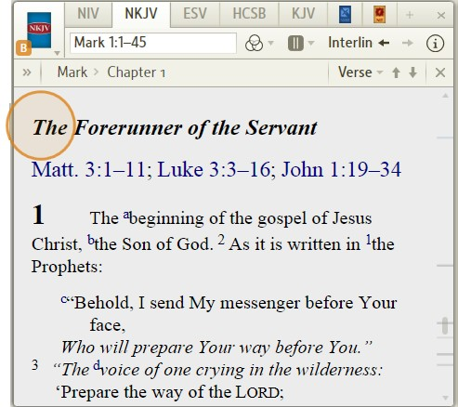

- When using Power Lookup tool (see Power Lookup) and you click on a reference in it, Logos4 will use a Visual Cue to mark where that reference occurs in your resource.
[Notice that in the Power Lookup tool on the right that we have clicked on text under the ^{r} reference, and Logos4 uses a Visual Cue to show where that reference occurred in the resource as shown on the left.]
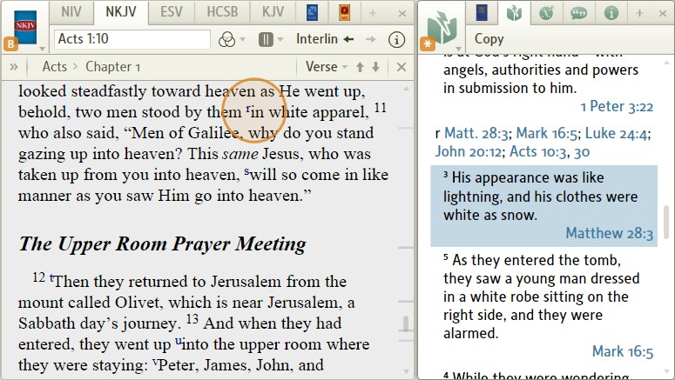

How can I turn them On/Off?
[[@Headword:Visual Cues – How can I turn them On/Off? ]]
- Visual Cues can be controlled in the Program Settings which is found under Tools in your menu bar.

- In your menu bar click on Tools.
- In the drop down menu, click on Program settings.
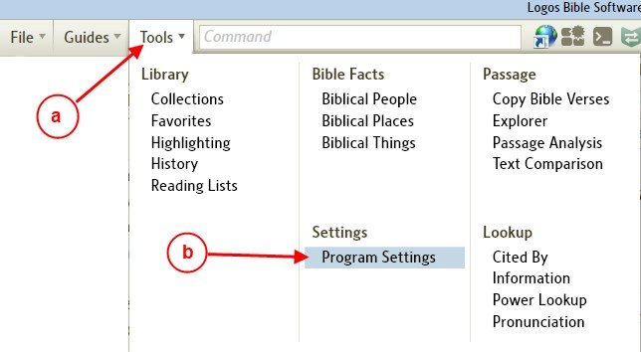

- When Program settings opens, look under General and you will see Show Visual Cues.
  - Setting it to No will turn it Off (no Visual Cues will be shown).
  - Setting it to Yes will turn it On (Visual Cues will be shown when ever Logos4 want to bring your attention to a new location).

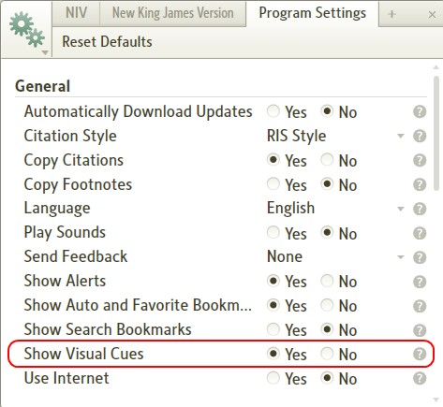

Reading View
[[@Headword:Reading View ]] Wiki page: Revision 3 Link

- Please watch the Logos4 Tutorial Video Reading View

Drawing Mode
[[@Headword:Drawing Mode ]] Wiki page: Revision 5 Link

Please watch Logos4 Tutorial Videos:
Drawing Mode
Reading View

Drawing Mode on a Mac:
- Click FN button + COMMAND button to start drawing mode
- Scroll the mouse (2 finger scroll on MacBook) to change colors
- Click FN button + COMMAND button to clear current drawing (Logos' on screen instructions are incorrect).
- Click ESC button to Escape Drawing Mode.

Drag-and-drop
[[@Headword:Drag-and-drop ]] Wiki page: Revision 6 Link

Logos 4 is VERY GOOD at allowing you to Drag-and-Drop stuff in most parts of the application.

A few examples:

- You can highlight some text in Logos4, and drag a copy into Notepad or MS Word etc.
- You can drag a copy of a verse from a Bible into a Logos4 Note FIle
- You can drag a command, such as "Update Now" from the Command Box, onto the Toolbar or Faviorites
- You can drag a whole Note from one Note File to a different Note File
- You can drag selected text into a Clippings document
- You can drag from a variety of sources into Favorites (see How do I add favorites to the Favorites window?)

• You can drag a Book to Bookmarks (see How do I set a bookmark?)

How do I Drag and Drop?
[[@Headword:Drag-and-drop - How do I Drag and Drop? ]]
- Hover your mouse over the object that you want to Drag.
- Hold the left mouse button down (don't release it).
- Move the object by moving the mouse with the left button down to where you want it placed.
- When you get over the object where you want it placed/added, release the left mouse button.

Using the Find box
[[@Headword:Find box ]] Wiki page: Revision 9 Link

Video
Mark Barnes
Tutorial Video #11 – Managing your content

What is the Find box?
[[@Headword:Find box – What is it ]]
In most of your resources you can open a Find box. The Find box is a small bar which drops down just below that resource's toolbar.

In the Find box you type a word and Logos4 will search for that word in your resource starting where-ever you are in the resource and going forward. If no occurrences of your word (or partial word) is found you may notice the Find box turns red. This quickly helps you determine if your word is present. Once that your word is found you can use the Up/Down arrow to the right of the Find box to sequence to the previous or next occurrence of your word. It is similar to Find in your browser or other software tools.

The Find box is not meant to replace the Search tool. It's best purpose is to help you locate a word in your resource which might be close by where are reading in that resource. You will also find that the Find box useful in locating areas in your Note and Clipping files. All this is covered in Mark Barnes video: Logos Tutorial Video #11 - Managing your content at about 7 minutes into the short video. Please take time and watch it!

How to Open & Use a Find box in a resource
[[@Headword:Find box – Opening & Using ]]
The following steps work in most of your resources: Bibles, Commentaries, Dictionaries, and other books.

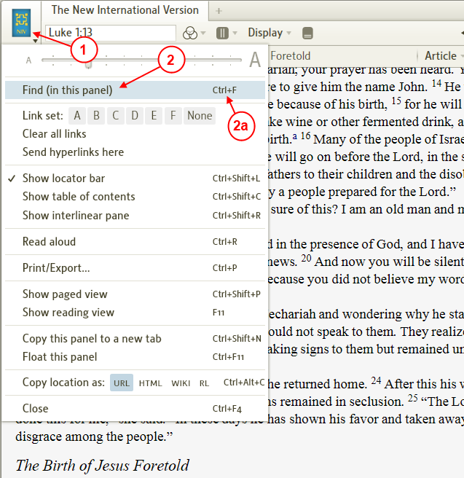

- In your resource click on the book icon in the upper left corner of the resource's panel.
- In the drop down menu click on Find (in this panel).
  - Or you can use the keyboard shortcut Ctrl F
Mac user: Cmd F.

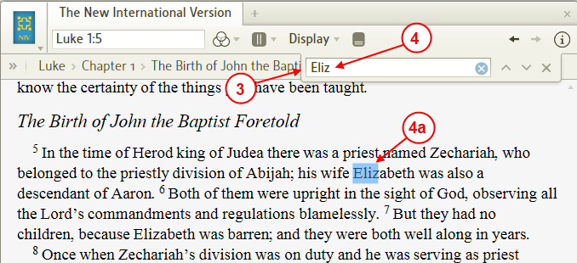

- Logos4 will show the Find box under the resource's toolbar.
- In the Find box start typing the word which you want to locate.
  - As you start typing the word Logos4 will highlight the word in the resource. Notice that you may not need to type the whole word.
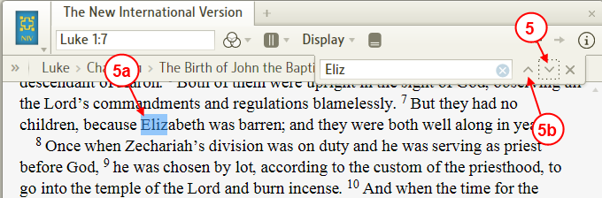

- Click on the Down arrow to locate the next occurrence of your word.
  - Logos4 will move to the next occurrence and highlight it.
  - To find previous occurrences you can click on the Up arrow.
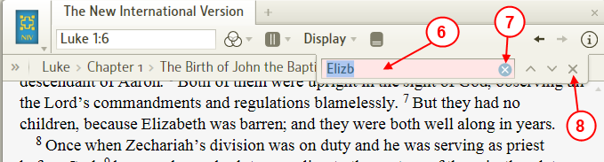

- If you type a word (or mistype) which is not found, Logos4 will shade the Find box red. This helps you check your spelling or change the word.
- Notice the blue circle with the x. If you click on it Logos4 will clear the word that you entered in the Find box.
- When you are done using the Find box you can close it by clicking on the X on the right side of the Find box.

How to Use the Find box with Notes/Clippings
[[@Headword:Find box – Using Find box with Notes/Clippings ]]
The Find box works slightly different in Notes & Clippings files. When you type a word into the Find box, Logos4 will hide individual Notes or Clippings which do not contain your word (they are still present in your Note or Clipping file). The steps below will show you what I mean.

• First we will look at a Clipping file
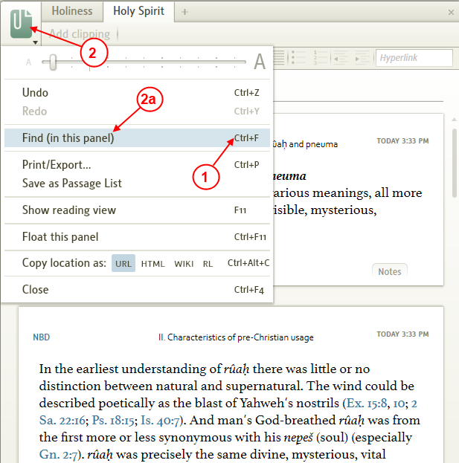

- On your keyboard press the key combination Ctrl F.
Mac user: Cmd F.
- Or click in the clipping icon of your open Clipping file.
  - In the drop down menu click on Find (in the panel).

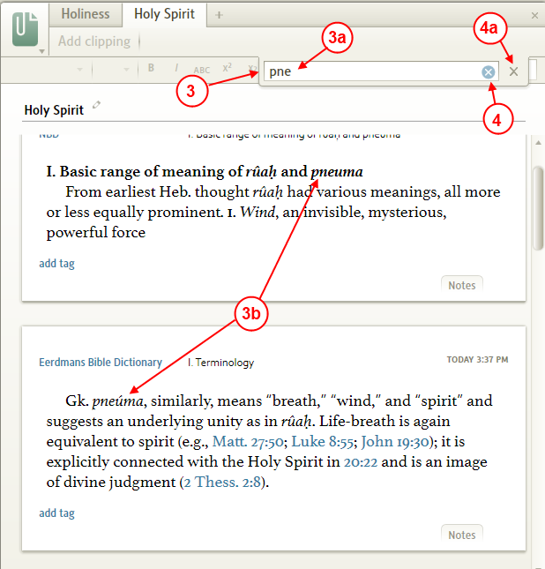

- Logos4 shows the Find box under the clippings toolbar on the right.
  - When you start typing a word that would appear in one or more of your clippings...
  - Logos4 will show the clippings where this word is found. Notice that clippings which do not have your word have disappeared. Do not panic, Logos4 has just hidden them.
- Click the blue x to clear the Find box. All your clippings will now appear.
  - When you are done using the Find box, click on the gray X on the right side of the Find box bar. Logos4 will hide the Find box and all your clippings will be shown again.

• Now let's take a look at a Note file .
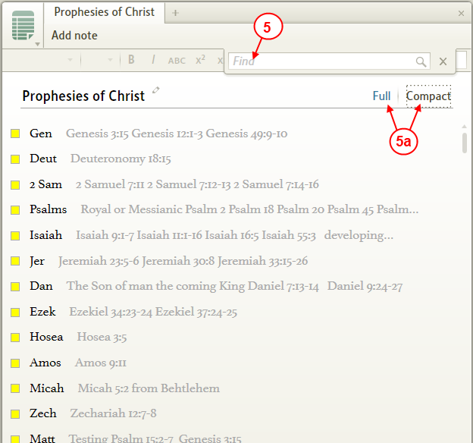

- Open the Find box in your Note file (see steps 1 or 2). In the Find box start typing the word that you want to find in one or more of your notes.
  - Notice all the notes in the image above (they are shown in the Compact view). You can use Find to locate your word in either view mode (Full or Compact) as Logos4 searches both the Title and the note contents. When searching a Note file with many notes it is often useful to start with the Compact view so you can see which notes have your word.

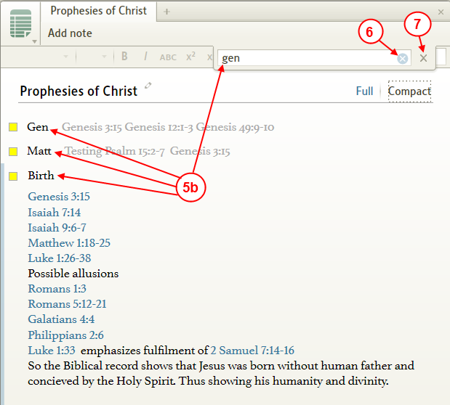

  - When you type your word (or part of it) in the Find box Logos4 will show you notes which contain your word. If you are using the Compact view, just click on one of the notes to expand that note.
- To view all your notes again just clear the Find box (by clicking on the blue x).
- When you are done using the Find box click on the gray X on the right side of the Find box bar.

How to use the Find box in Biblical Places
[[@Headword:Find box – Using in Biblical Places ]]
You can use the Find box in Biblical Places to locate cities or regions. This only works with newer Logos4 maps which are tagged in a database. There are 2 ways to tell if a map will allow you to use the Find box:

- If the map is labeled as a newer Logos4 map as shown below.
- Check if Find (in this panel) appears in the menu.

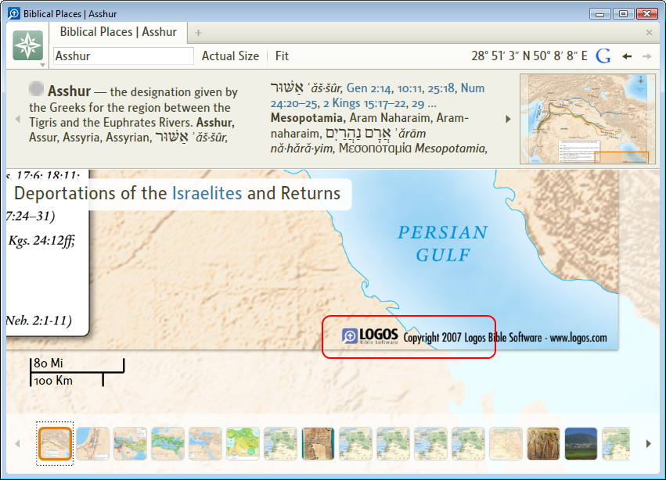

• Now we will use the Find box to locate a city
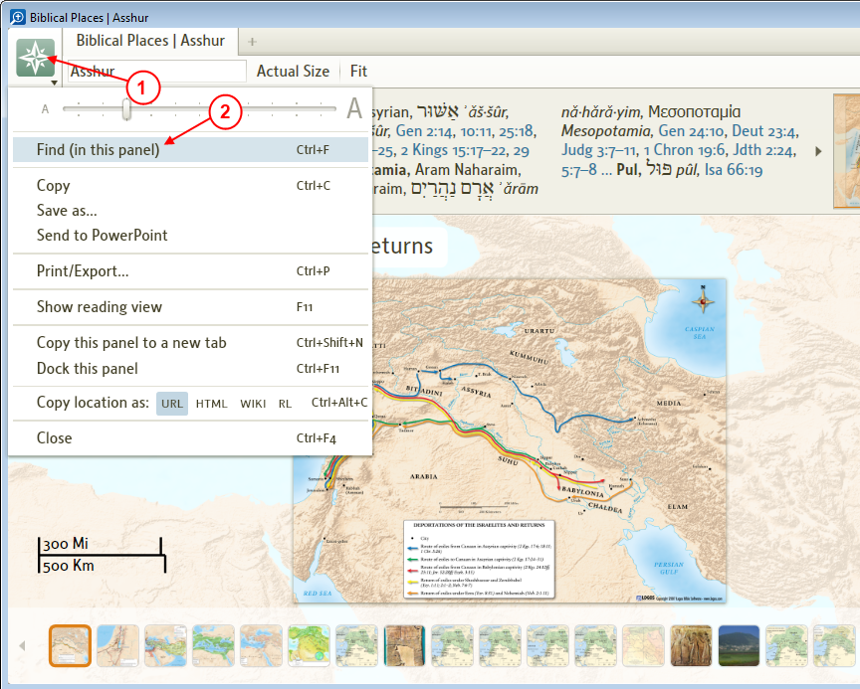

- Click on the icon in the upper left corner of the Biblical Places panel.
- In the drop down menu click on Find (in this panel).
This will not show up here in maps which are not Logos4 maps with database entries.

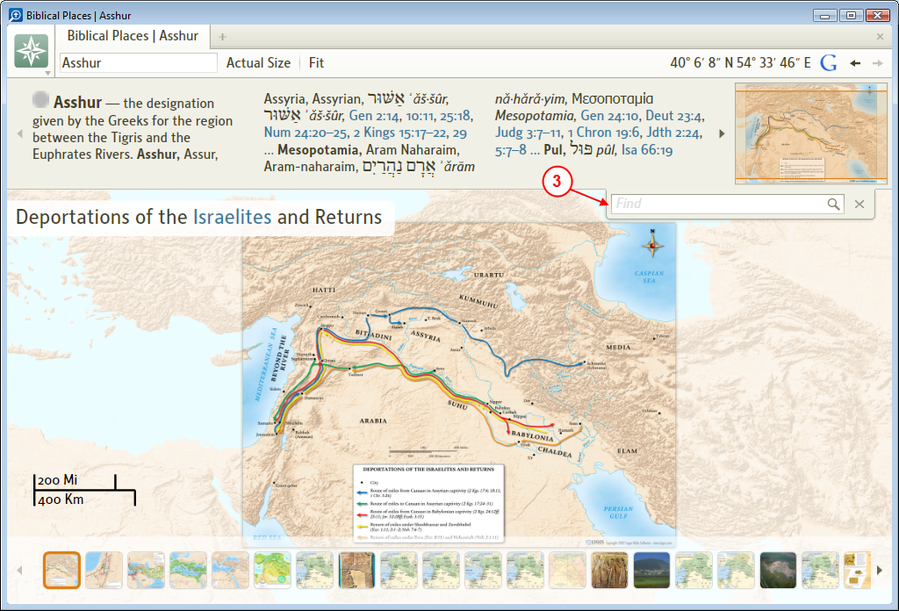

- Logos4 shows the Find box under the information panel.
Notice the size and scale of the map in this image.

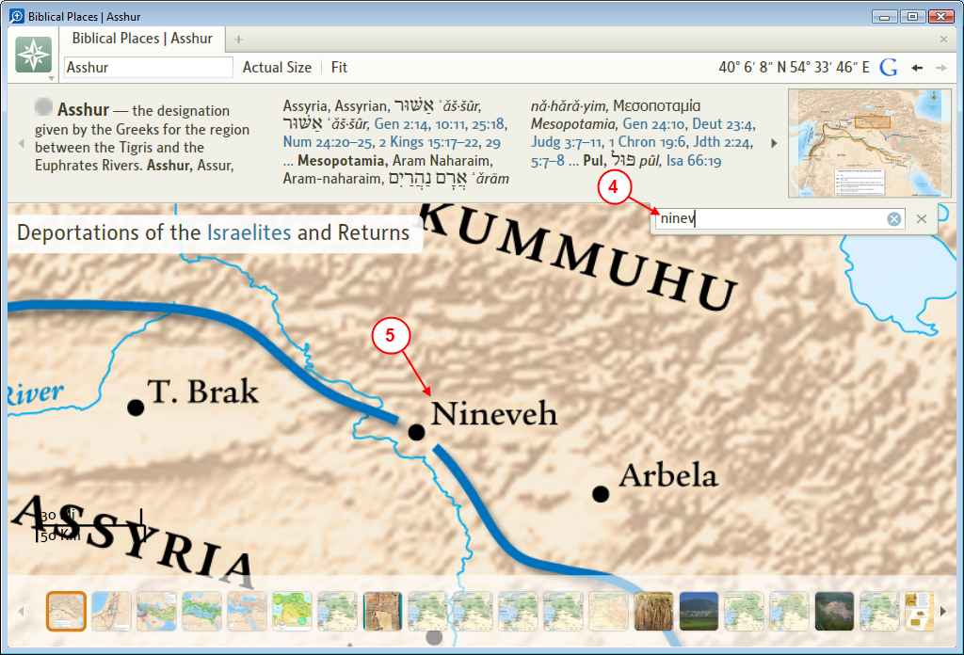

- In the Find box type the name of a city or region that you want to locate.
- Notice that Logos4 will zoom and position the map to the city that you entered in the Find box.
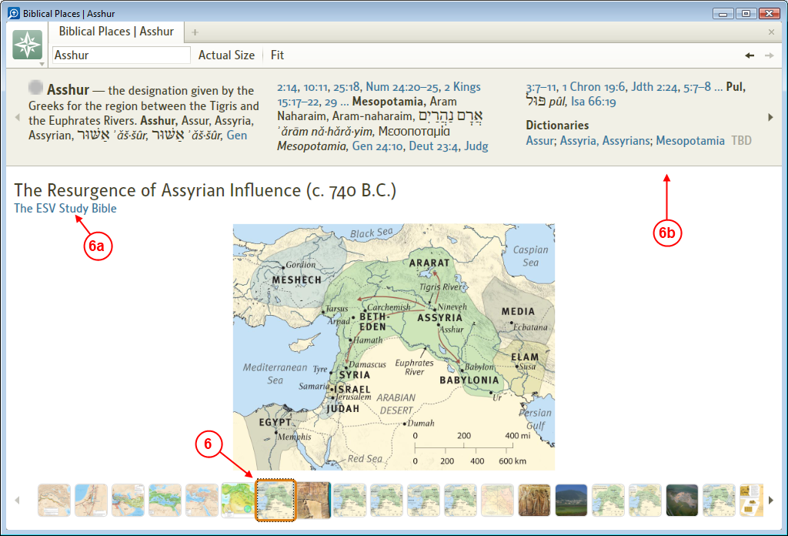

- Now when we click on another map and open it...
  - Notice that it is a map from the ESV Study Bible.
  - Notice that the Find box disappeared. Since the map is not a Logos4 map with a database, the Find box is not available.

Sync User Data
[[@Headword:Sync User Data ]] Wiki page: Revision 3 Link

• Please watch Logos4 tutorial video Sync User Data

Gestures
[[@Headword:Gestures ]] Wiki page: Revision 10 Link

What is a Gesture ?
[[@Headword:Gestures – What is it ]]
A “Gesture” is a mouse movement which causes Logos 4.1 or higher to perform a specific action. The allow you to perform common tasks without having to uses menus or keyboard shortcuts.

Executing a Gesture
[[@Headword:Gestures – Executing a Gesture ]]
To execute a gesture:

- Click and hold down the right mouse button.
- Move the mouse in the direction/shape of the gesture.
- Release the right mouse button.
- The associated action is performed and a tip window briefly displays (approx 3 secs) an iconic image of the gesture.

Note: If you are trying to execute multiple gestures in a row, e.g. multiple Go Back/Foward or Previous/Next Article you may will need to wait for the Tip window to disappear before executing the another gesture.

Gestures Quick Summary
[[@Headword:Gestures – Quick Summary ]]
The specific actions that can be initiated by gestures in Logos 4 are as follows:

left = Go Back
right = Go Forward
up = Previous Article
down = Next Article
down, right = Close Tab
down, up = New Tab
“C” shape = Toggle Contents Pane on or off
“star” shape = Add to Favorites (to draw star shape try this: up right, down right, up left, right, down left)
up/right diagonal = Reading View
down/left diagonal = Escape Reading View
right angle bracket (down/right, down/left) = Start Read Aloud
square (down, right, up, left) = Stop Read Aloud

Gestures for Navigating a Resource
[[@Headword:Gestures – for Navigating a Resource ]]
NB: For more information on other techniques in addition to gestures see Navigating a Resource

Toggle Contents Pane ON / OFF
[[@Headword:Gestures – Toggle Contents Pane ]]

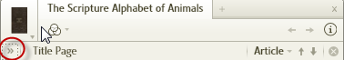

The Toggle Contents gesture is the equivalent of clicking on the chevron on the left hand side of resource locator bar (>>) or using the keyboard short-cut: CTRL+SHIFT+C

Gesture: | Toggle Table of Contents On/Off
Mouse Movement: | Right Click Mouse and Drag ‘C’ shape
Visual: | 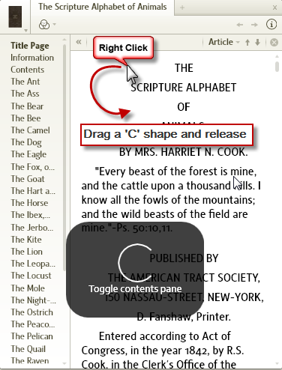

Go Back / Go Forward
[[@Headword:Gestures – Go Back/Forward ]]

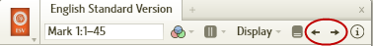

The Go Back / Go Forward gestures are the equivalent of clicking on the back and forward arrows found on a resource toolbar. They allow you to navigate back or forwards through your browsing history within the resource.

Gesture: | Go Back |  | Go Fowards
Mouse Movement: | Right Click Mouse and Drag to Left |  | Right Click Mouse and Drag to Right
Visual: | 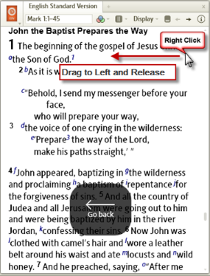 |  | 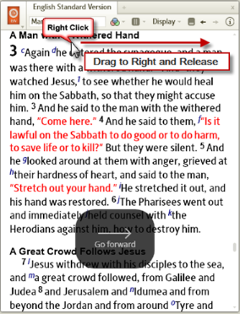

Previous Article / Next Article
[[@Headword:Gestures – Previous/Next Article ]]

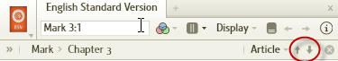

The Go to Next/Previous gestures are the equivalent of clicking the up and down arrows on the right hand side of the locator bar, near the heading article. The allow you to navigate through the 'Articles' within a resource.

Gesture: | Go to Previous Article |  | Go to Next Article
Mouse Movement: | Right Click Mouse and Drag Up |  | Right Click Mouse and Drag Down
Visual: | 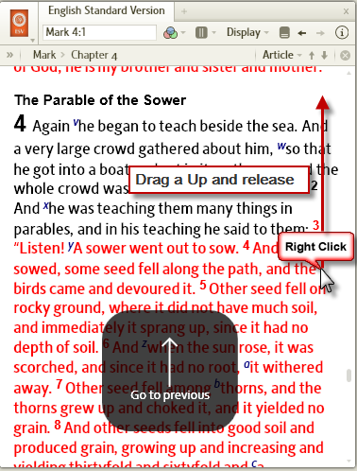 |  | 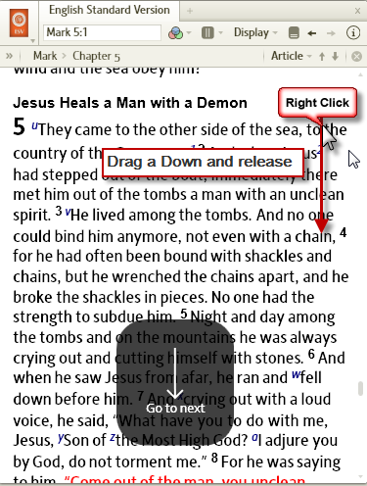

Gestures for Reading Assistance
[[@Headword:Gestures – Reading Assistance ]]
Logos 4 includes two features to assist you in reading. The first, reading view allows you to put the active resource in Full Screen Mode, what is known as Reading view. The second is Read Aloud uses a computer generated voice to read the resource to you.

Reading View / Escape Reading View
[[@Headword:Gestures – Reading View ]]
NB: Reading View can be entered and exited using the Keyboard Short-Cut: F11

Gesture: | Enter Reading View (Full Screen Mode) |  | Exit Reading View (Full Screen Mode)
Mouse Movement: | Right Click Mouse and Drag Up/Right Diagonal |  | Right Click Mouse and Drag Down/Left Diagonal
Visual: | 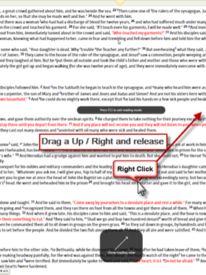 |  | 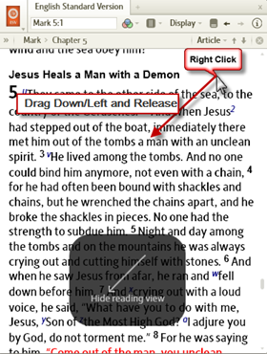

Start Read Aloud / Stop Read Aloud
[[@Headword:Gestures – Read Aloud ]]
NB: Read Aloud can also be started and stopped using the keyboard short-cut: CTRL-R

Gesture: | Start Read Aloud |  | Stop Read Aloud
Mouse Movement: | Right Click Mouse and Drag Down/Right, Down Left (Right angle bracket) |  | Right Click Mouse and Drag a ‘Square’ shape.
Visual: | 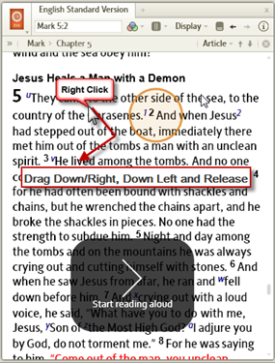 |  | 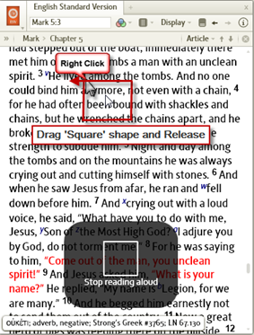

Gestures for Managing Tabs and Adding to Favorities
[[@Headword:Gestures – Managing Tabs & Adding Favorites ]]

New Tab / Close Tab
[[@Headword:Gestures ]]

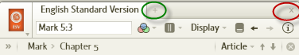

The New Tab / Close Tab gestures are equivalent to click on the '+' next to the resource title to open a new tab and clicking on the 'x' to close a tab.

Gesture: | Open A New Tab |  | Close Active Tab
Mouse Movement: | Right Click Mouse and Drag down and then up |  | Right Click Mouse and Drag down and then to right.
Visual: | 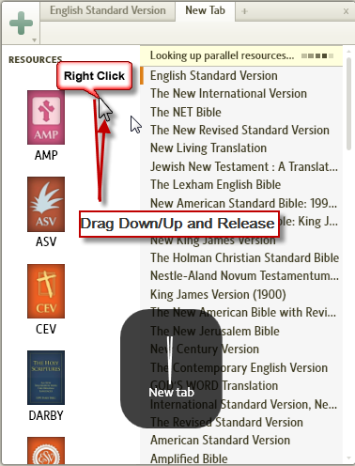 |  | 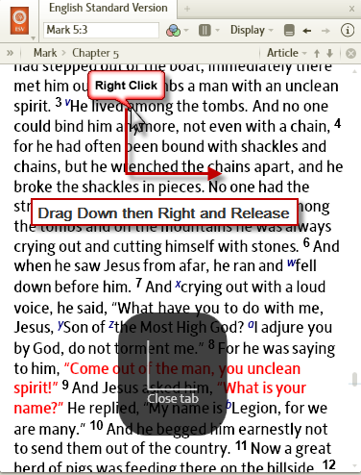

Add current location to Favorities
[[@Headword:Gestures – Add current location to Favorites ]]

Gesture: | Add to Favorites
Mouse Movement: | Right Click Mouse and Drag ‘Star’ shape
Visual: | 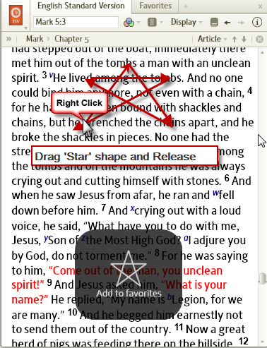

Smart Tags
[[@Headword:SmartTags ]] Wiki page: Revision 6 Link

What are Logos Smart Tags ?
[[@Headword:SmartTags – What is it ]]
“Smart Tags” are a feature of Microsoft Office that allow you to perform actions within the office application that would normally require you to open another application.

When you type a bible reference in your office document Logos 4 smart tags will recognise that reference and you will be able to:

- replace the typed reference with the text of the passage
- open up the passage in your preference bible in Logos 4
- open the copy bible verses panel for additional formatting options before pasting the passage text in your document

Note: When using the replace with Passage action, Logos Smart Tag will only insert plain text. If you want to insert formatted text then you must use the Copy Bible Verses action

Requirements for Using Logos Smart Tags
[[@Headword:SmartTags – Using L4 Smart Tags ]]
In order to use Smart Tags you must have Logos 4 WIN (4.1 or higher), and Office 2003, 2007, or 2010 (32 bit). Microsoft does not support Smart Tags on the 64bit edition of Office and so 64bit Windows users are recommended to install the 32bit version if they wish to use Logos Smart Tags. The Logos 4 Smart Tag doesn't work in PowerPoint 2010. Additionally, Smart Tags are not supported in MAC versions of Office.

Note: Logos Smart Tags are installed as part of the Logos installation so there are no additional installation requirements beyond the Logos application itself.

An Alternative for MAC and other Windows applications users
[[@Headword:SmartTags – Alternative for Mac and other Windows apps ]]
If you are a MAC user or use other Windows applications besides Office then you should use the copy bible verses panel for pasting a verse or passage into your document. Please note that Microsoft has not included Smart Tags functionality in Microsoft OneNote and so if you are using this application you would also need to use the copy bible verses panel.

Using Logos Smart Tags
[[@Headword:SmartTags – Using L4 Smart Tags ]]
Note the implementation of Smart Tags between Office 2010 and earlier Office versions has changed.

Smart Tags: | Office 2007 or earlier |  | Office 2010
Descritpion: | Type in a reference. A dotted purple line will appear under the reference. Hover over reference the and click on the Info icon to access the Logos Smart Tag actions. |  | Type in a reference. Right click on the text and open the additional actions sub-menu to access the Logos Smart Tag options.
Visual: | 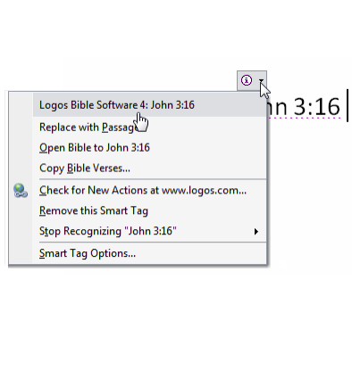 |  | 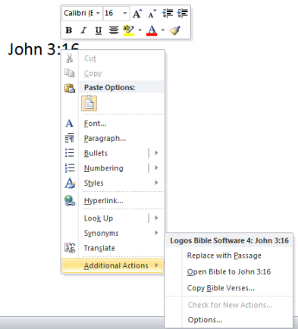
Notes: |  |  | Note: In 2010 the purple dotted line does not appear to prompt you that a Logos Smart Tag has been recognised. This is a Microsoft decision outside the control of Logos Bible Software developers.)

Logos Smart Tags Troubleshooting
[[@Headword:SmartTags - Troubleshooting ]]
- Ensure you are running the correct version of Logos 4 i.e. 4.1 or higher in Windows.
- Ensure you have the correct version of Office installed i.e. must be Office 2003, 2007 or 2010 for Windows. Microsoft Office OneNote does not support Smart Tags. The Smart Tag doesn't work in PowerPoint 2010 (but does work in earlier versions of PowerPoint).
- If applicable, uninstall Logos Smart Tags for Libronix (L3) from Window's Control Panel.
- Ensure both Logos 4 and your Office application are running and that they are not running in administrator mode.
- On Windows Vista Smart Tags will not work if User account control is disabled. Either re-enable UAC or install Microsoft Hot Fix 971138
- Ensure Smart Tags are enabled in your Version of Office. For detailed steps on doing this in Office 2003, 2007 and 2010 see the Logos Bible Software Support Article on Smart Tags

If you are unsure how to proceed with any of these steps or they do not resolve your problem then please post a question on the Logos 4 forum. If you are new to the fourms and unsure how to ask for help see the following instructions

Note: There is a limitation on the amount size of the passage that can be "copied". This will not be normally an issue but if you were trying to insert the whole whole text of a bible book into your document then this would not be possible and you would need to break it down into smaller portions.

Paged View
[[@Headword:Paged View ]] Wiki page: Revision 5 Link

What is Paged View?
[[@Headword:Paged View – What is it ]]
Logos4 added Paged View with version 4.2. It was named Paged View in the beta and later renamed Columns. Paged View shows your resource in multiple columns as you might see in a paper book. This new feature can make reading easier, especially when you have your book open in a large panel/window. The number of columns depends on your panel size (when using Auto). New with version 4.2a Logos4 allows you to fix the number of columns. When setting Columns to None removes the Paged View mode and the vertical scrollbar will appear again in your resource. Logos4 will remember when you have a resource set in this mode when you save a layout or when opening Logos4 after closing it (on the layout screen).

How to set a resource to Paged View
[[@Headword:Paged View – How to set a resource to Paged View ]]

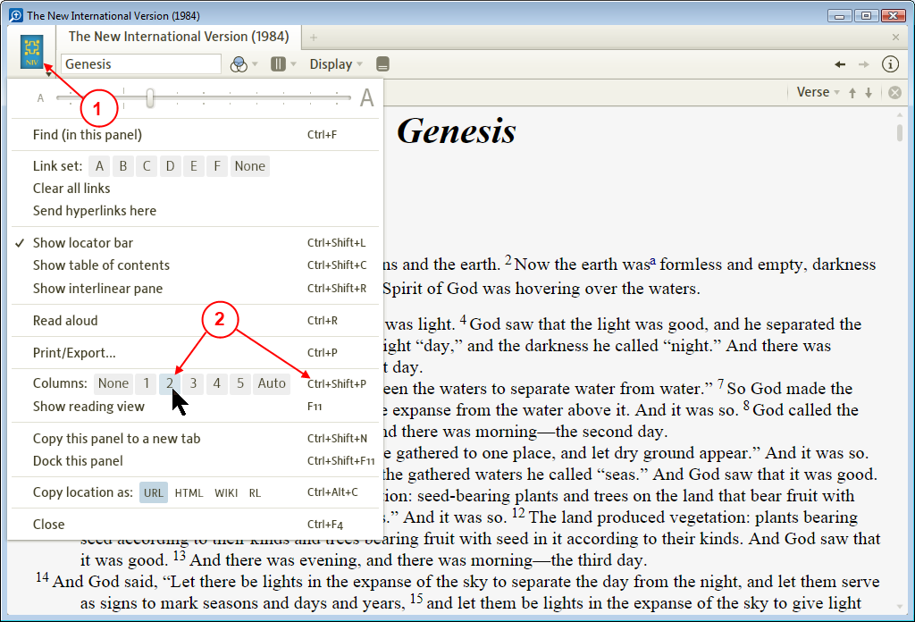

- In the resource that you want to view in the Paged View mode, click on it's icon to open the resource's menu.
- In the drop down menu click on the number of Columns that you want to show in your resource (Note: Columns is new with version 4.2a). Also notice that you could have used the keyboard shortcut Ctrl Shift P (Mac users: Shift Cmd P).
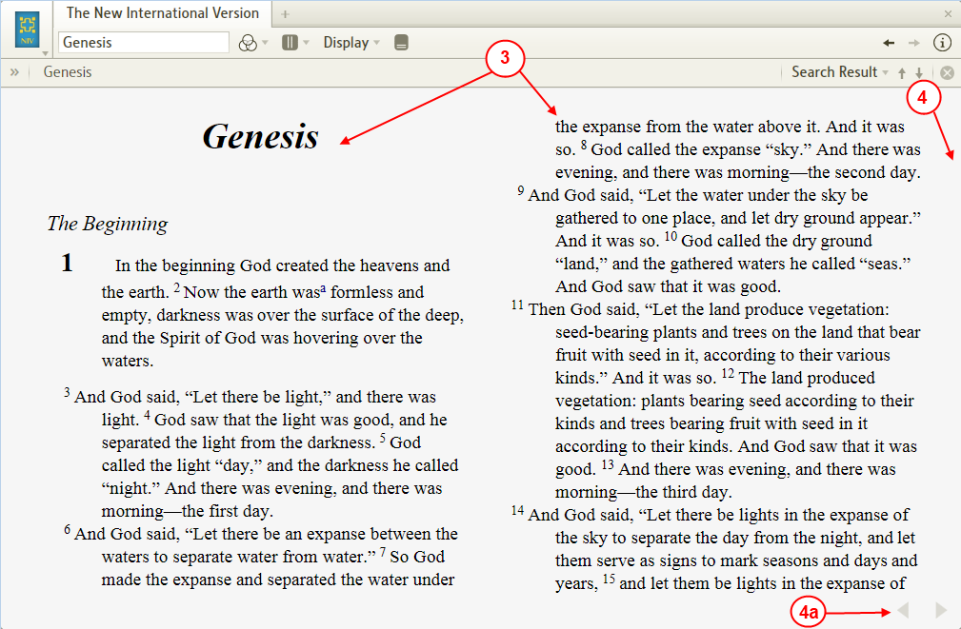

- Notice that Logos4 has changed the number of columns in your resource. If you do not see more than one column, enlarge the panel for that resource (e.g. make it a floating window).
- Also notice that the vertical scroll bar is missing. In the Paged View you will need to use the methods below to change pages as you are reading:
  - Notice the arrows in the lower right corner of your resource. These are for changing pages.
  - Or you can use Page Up & Page Dn keys on your keyboard. (Mac users: use fn-Up Arrow & fn-Down Arrow)
  - Or you can use the Up & Down arrows on your keyboard.

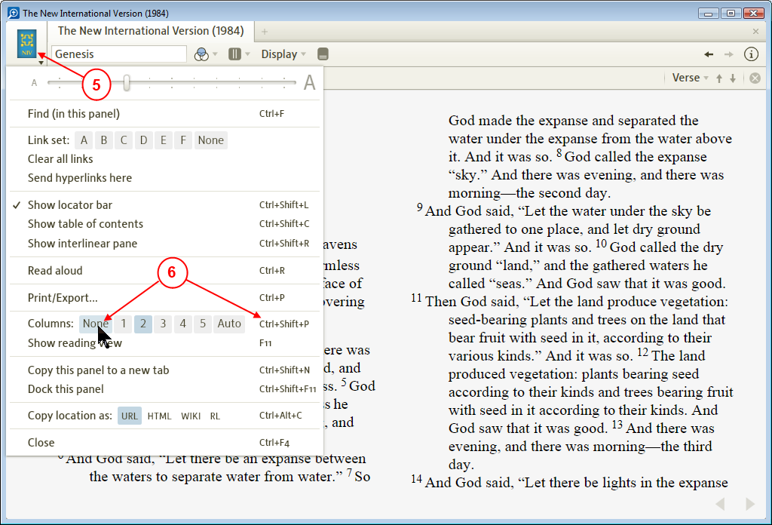

- To exit the Paged View mode, click on the resource's icon.
- Then click on None to the right of Columns.
  - Or to skip 5 & 6, on your keyboard press the key combination Ctrl Shift P (Mac users: Shift Cmd P).

Tip: selecting text across page boundaries
[[@Headword:Paged View – Tip-> selecting text across page boundaries ]]
If some text you want to highlight happens to span across a "page" break in paged view, you can't drag and scroll. But you can drag out the selection to the end of the page, then hit PageDown and then Shift+Click where you want the selection to end, and it retains what was selected at the end of the previous page as part of the selection.

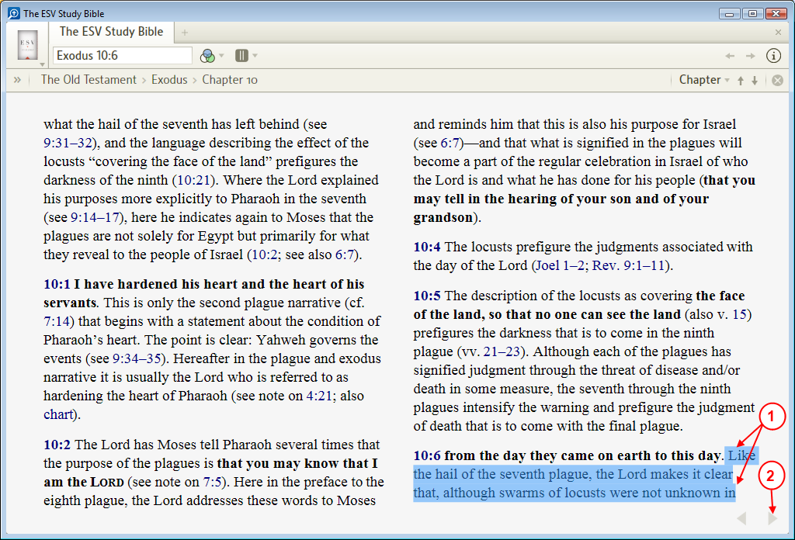

- Use your mouse to select your text on the first visible page. Make sure to select to end of the page.
- Change to the next page by clicking on the right arrow.
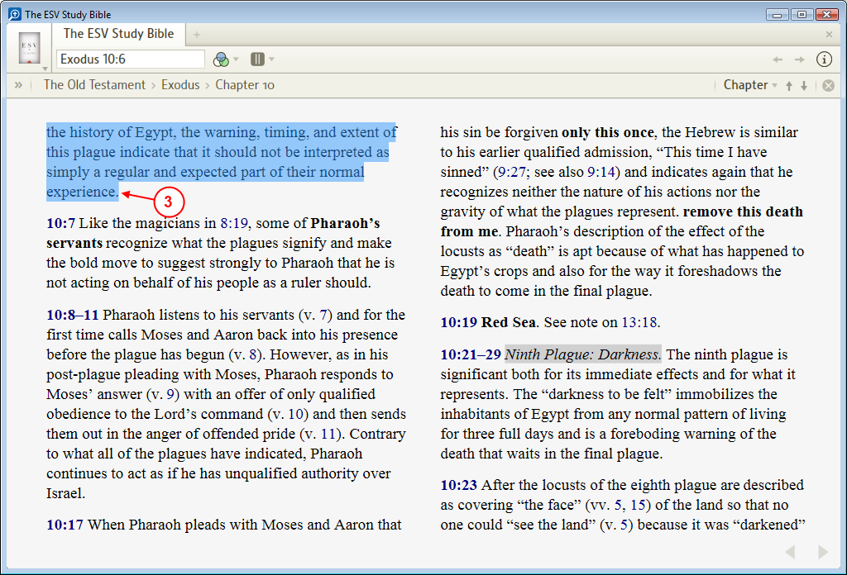

- Now locate the end of the text that you want to be selected and hold the shift key down and click there. Logos4 shows the text on this page as selected. But Logos4 also remembers the text on the prior page that you selected.
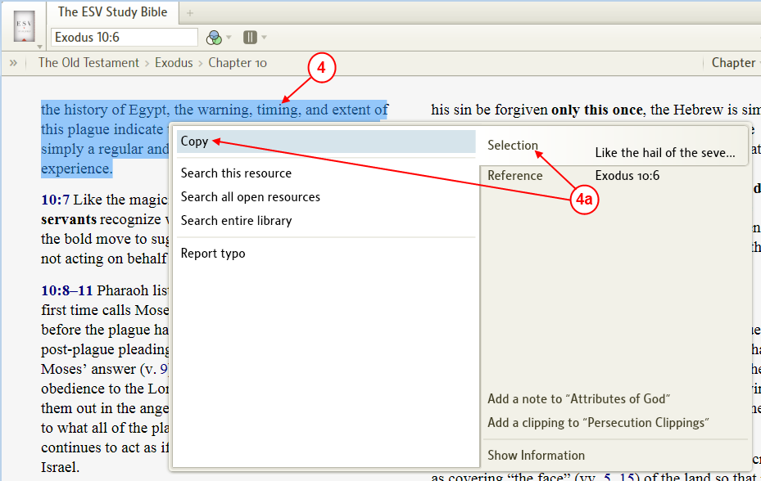

- Now you can copy the selected text to your clipboard. Right click on the selected text.
  - In the pop-up menu click on Selection on the right and then click on Copy on the left.
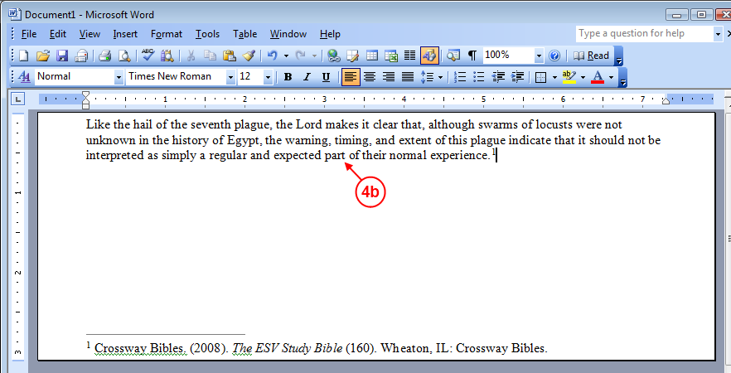

  - Now you can paste your selected text into another document (e.g. Microsoft Word). Notice that all of the text that you selected across both pages of your resource was pasted into your document.

Viewing Footnotes, Links, & other information in your book
[[@Headword:Viewing Footnotes/Links/info in your book ]] Wiki page: Revision 3 Link

See also:
Right Click Menu
Information
Power Lookup
Reverse-Interlinear/Interlinear Bibles

Footnotes
[[@Headword:Viewing Footnotes/Links/info - Footnotes ]]
Logos4 provides several ways to view footnote information within your resource.

Clicking on a Footnote
[[@Headword:Viewing Footnotes/Links/info – Footnotes [Clicking on a Footnote] ]]
If you click on a footnote in your resource Logos4 will show you a pop-up box with the info for that footnote

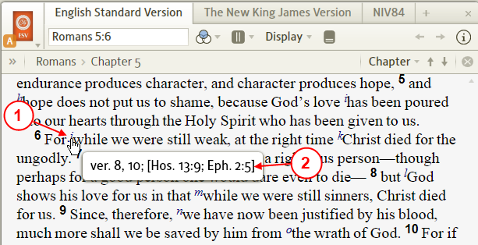

- Hover your mouse over a footnote.
- Logos4 will show you a pop-up box with the footnote information in it.
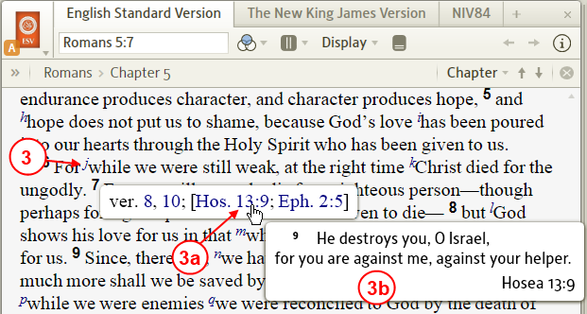

- Click on the footnote...
  - Logos4 will show you a pop-up box and it will remain on the screen even if you move your mouse away from the footnote. If you hover your mouse over a link in the pop-up box ...
  - Logos4 will show you another pop-up box with information regarding that link.
  - Click somewhere in your resource away from the pop-up boxes to hide the pop-up boxes.

Using the Information tool
[[@Headword:Viewing Footnotes/Links/info – Footnotes [Using Information tool] ]]
You can use the Information tool to view your footnote information.

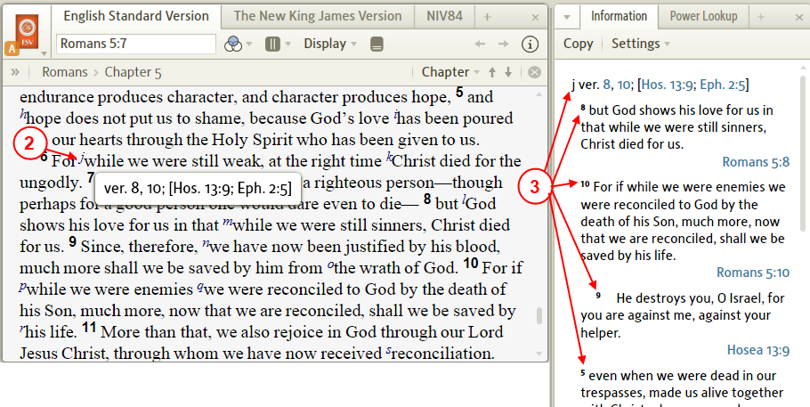

- Open your Information tool (see the wiki Information)
Set the Settings for Information panel to Hover.
- In your resource hover your mouse over a footnote.
- In the Information panel you will notice details on your footnote.

Using the Power Lookup tool
[[@Headword:Viewing Footnotes/Links/info – Footnotes [Using Power Lookup tool] ]]
You can use the Power Lookup tool to view information on all visible footnotes in a resource.

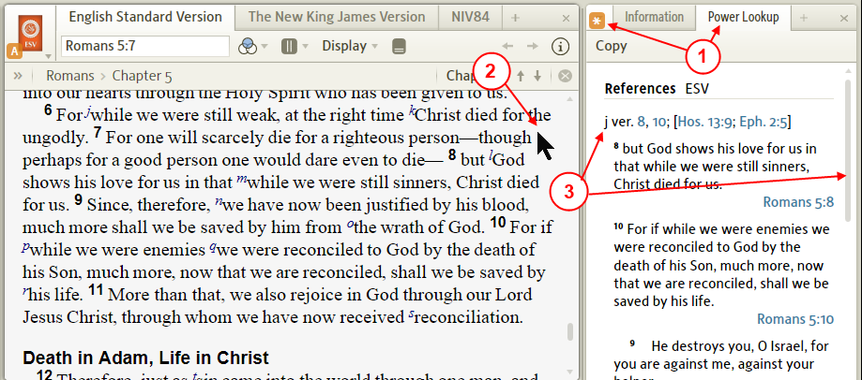

- Open your Power Lookup tool (see wiki Power Lookup)
Set the Linking to Follow.
- Now click in your resource.
- Logos4 will show you all the footnotes (which are visible in your resource's panel) in the Power Lookup panel. You may need to use the scrollbar to locate your footnote.

View in a Resource at the bottom
[[@Headword:Viewing Footnotes/Links/info – Footnotes [View at bottom of a Resource] ]]
- New in version 4.5, you can view footnotes in your resource when you view the resource in one of the Column modes.
  - Footnotes will appear at the bottom of each column when they appear in the surface text.
    - References (usually subscript lowercase letters will not appear in the bottom).
  - When you turn Off Column mode (e.g. set Column to None) the footnotes will not be shown.
  - Reading view defaults to Auto Column mode which shows the footnotes.

Turning ON Footnotes
[[@Headword:Viewing Footnotes/Links/info – Footnotes [turn ON in Column view] ]]

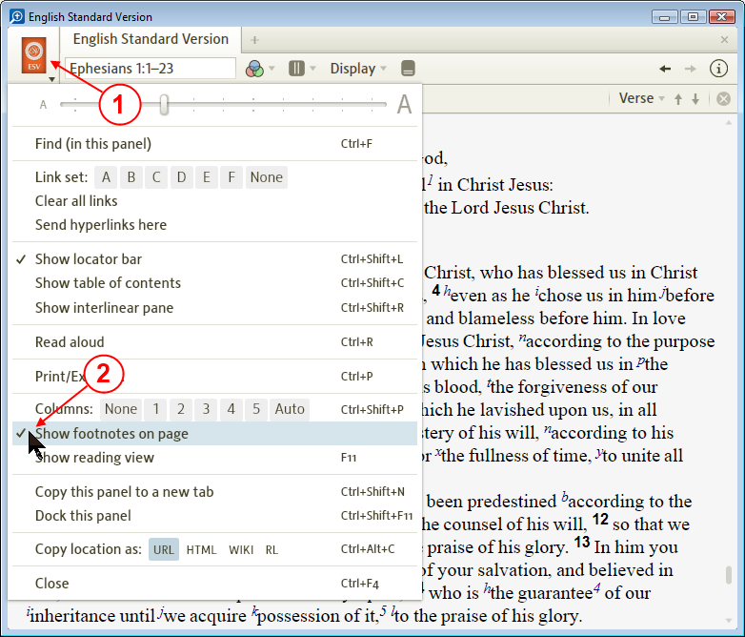

- Click on the resource's icon to view the resource's menu.
- Click to check Show footnotes on page.
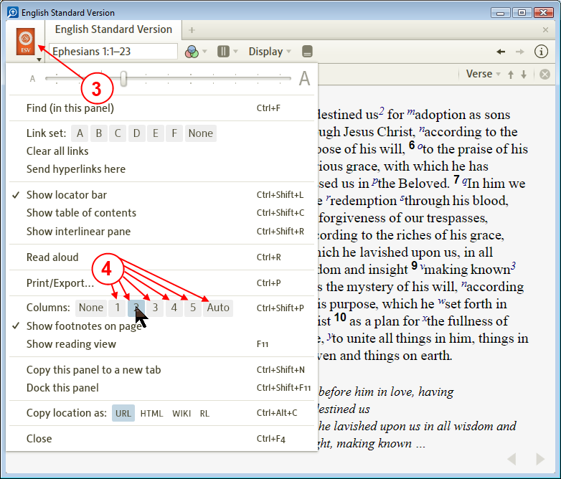

- Click on the resource's icon to view the resource's menu again.
- Click on one of the Column modes (not None) to enable the Column viewing mode.
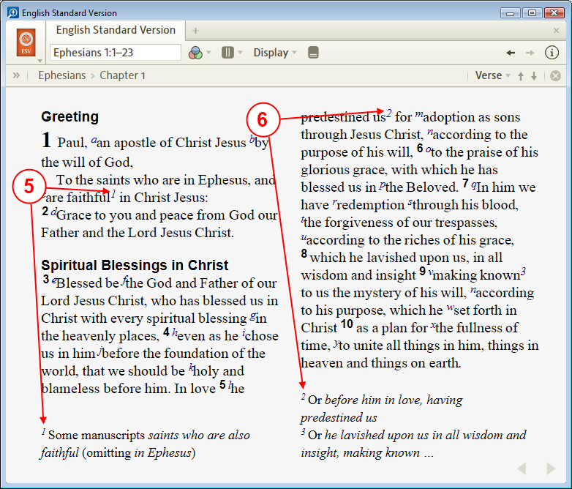

- Notice that your footnotes are found under the column.
- Also notice that Logos4 places your footnote under the column in which it was found.

- To turn Off footnotes you can either:
  - Uncheck Show footnotes on page in the menu.
  - Or you can turn Off the Column mode (e.g. set Column to None).

Links
[[@Headword:Viewing Footnotes/Links/info - Links ]]
In Logos4 you can view or open a Link which is in a resource.

Snapshot view of Link info
[[@Headword:Viewing Footnotes/Links/info – Links [Snapshot view of Link info] ]]
You can see a pop-up box showing you information from where a Link points.

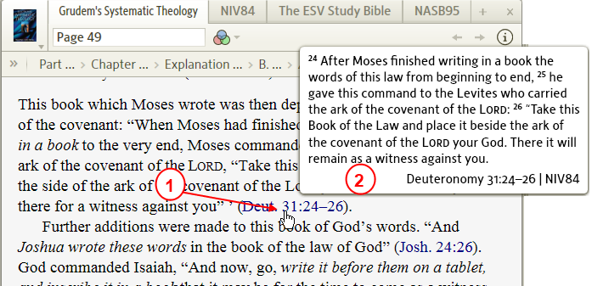

- Hover your mouse over a Link in your resource.
- Logos4 will show you a pop-up box which shows a snapshot of what your link points to.

Opening a Link
[[@Headword:Viewing Footnotes/Links/info – Links [Opening] ]]
Opening a Link to a specified Bible version using Send Hyperlinks here. This can be very useful in that it allows you to keep a copy of your Bible open without disturbing your reading. It will require that you have more than 1 copy of your Bible open and set to Send Hyperlinks Here.

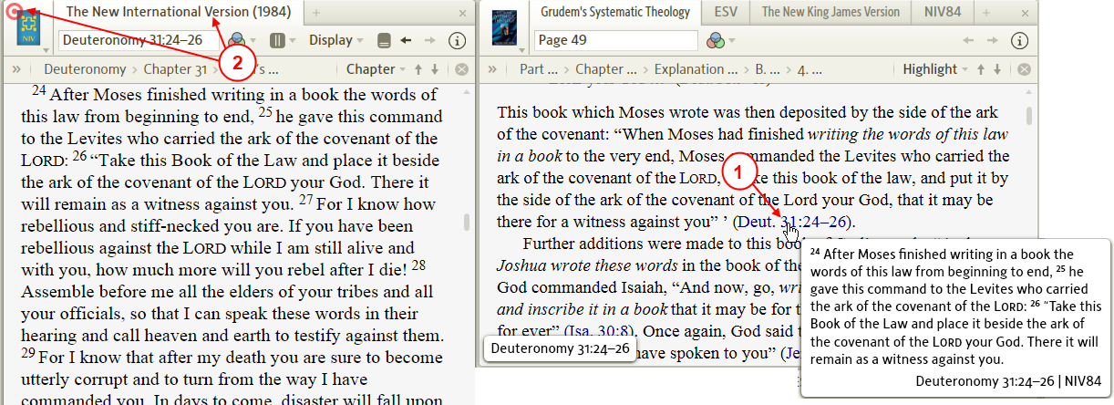

- Open a Bible where you want Hyperlinks to be sent.
Set Send Hyperlinks Here (See wiki page Send Hyperlinks here)
- In your resource click on a Link to have it opened in your Bible that you have set to receive hyperlinks.

Information on a Word in your Resource
[[@Headword:Viewing Footnotes/Links/info – Info on a Word ]]
Logos4 has powerful features which can assist you in finding definitions, original language translation and other info on a word in your resource.

Quick view of Original Language for a Word
[[@Headword:Viewing Footnotes/Links/info – Info on a Word [Quick view] ]]
Logos4 will show you the Original Language word for an English word in a Bible (if your Bible has a Reverse-Interlinear version) by simply holding your mouse over an English word. This pop-up information box will appear at the bottom of your resource's panel. Some find this annoying and want to turn it Off, but it is not possible to disable this feature.

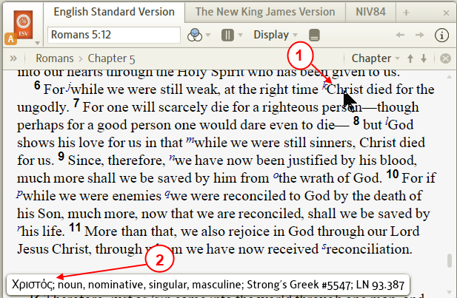

- In your resource hover your mouse over a Word.
- Look at the bottom of your resource's panel and you will see a pop-up box showing you Original Language information on your word.

Use the Right Click for information on a Word
[[@Headword:Viewing Footnotes/Links/info – Info on a Word [Right-Click] ]]
You will find the Right Click Menu a powerful tool while studying or reading in your books. Logos4 provides a wealth of tools to assist you.

Looking up definitions
[[@Headword:Viewing Footnotes/Links/info – Info on a Word [Looking up Definitions] ]]
When you right click on a word you can use Selection to lookup the definition in an English dictionary or a Bible dictionary.

Looking up Original Language definitions
[[@Headword:Viewing Footnotes/Links/info – Info on a Word [Looking up Original Language Defs] ]]
When you right click on a word in a Bible you can use Lemma to lookup the definition to the original language word in a Lexicon.

Looking up Biblical People/Place/Things
[[@Headword:Viewing Footnotes/Links/info – Info on a Word [Biblical People/Place/Thing] ]]
When you right click on a word that is a Person or Place or Thing you can open Biblical People/Place/Things tool to information on that item.

Using a Reverse/Interlinear for information on Words
[[@Headword:Viewing Footnotes/Links/info – Info on a Word [Reverse/Interlinear] ]]
In Logos4 you will find several Bibles which have a Reverse-Interlinear (Bibles which are linked to the Original Language). Logos4 provides 2 methods for viewing Reverse Interlinear information on these Bibles.

Using the Ribbon Reverse Interlinear
[[@Headword:Viewing Footnotes/Links/info – Info on a Word [Reverse/Interlinear (Ribbon)] ]]
This method shows a ribbon at the bottom of your Bible's panel. You may find it less distracting while reading in your Bible while supplying a wealth of original language information.

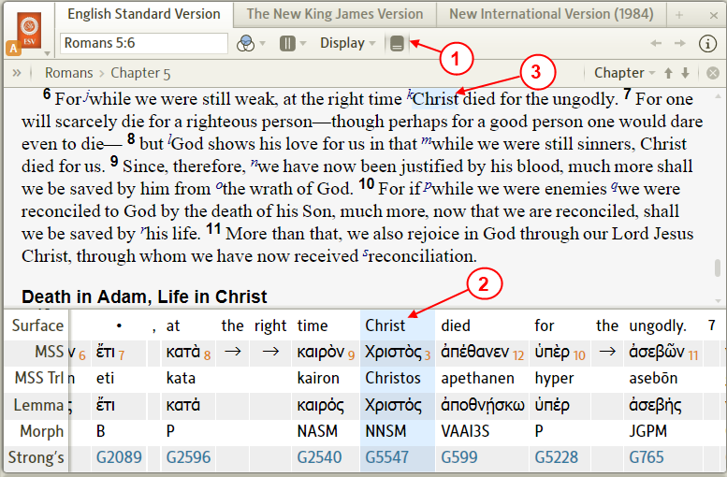

- Click on the Reverse Interlinear ribbon icon.
- Logos4 will open the Reverse Interlinear ribbon at the bottom of your panel.
- Click on a word in the body of your Bible to have Logos4 position the ribbon to your original language word.
- To close the ribbon, simply click on the Reverse Interlinear ribbon icon again.

(see the wiki page Reverse Interlinear for more information about Ribbon Reverse-Interlinear viewing)

Using the Full page Reverse Interlinear
[[@Headword:Viewing Footnotes/Links/info – Info on a Word [Reverse/Interlinear (full page)] ]]
You can also view the Full page Reverse Interlinear. This comes in handy when you want to view several original language words in a Bible at the same time.

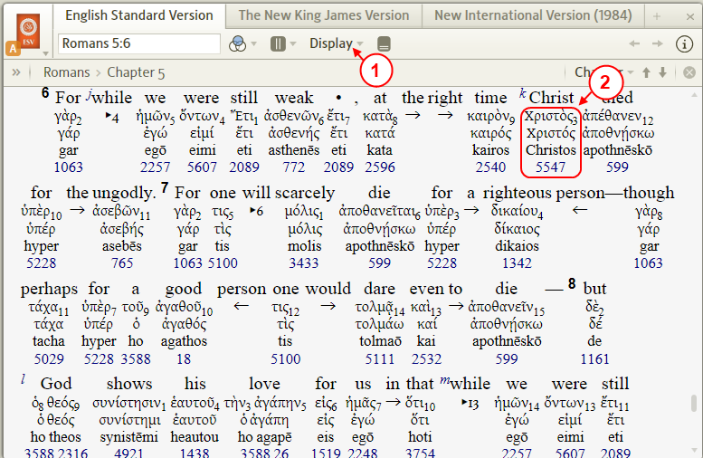

- Click on Display in the toolbar of your Bible and in the drop down menu click on Inline to check it.
- Logos4 will show you the original language words under the English words of your Bible.
- To hide this view, repeat step #1 to uncheck Inline.

(see the wiki page Reverse Interlinear for more information about Full Page Reverse-Interlinear viewing)

▪ Resource’s Menu ▪
This section has wiki pages (or articles) which correspond to what you might see in a Resource’s drop down menu.
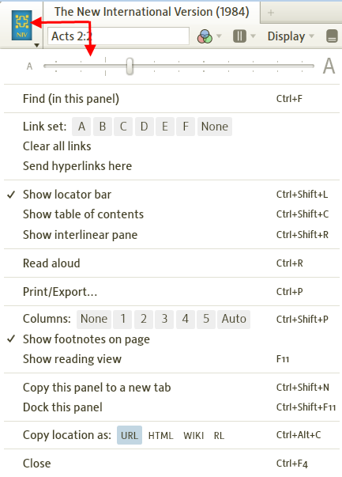

Some of these item are found as articles within other wiki pages, so below are links to them

- Find (in this panel)
- Linking
- Clearing all Links
- Send hyperlinks here
- Show locator bar
- Show table of contents
- Show interlinear pane
- Read aloud
- Print/Export
- Columns
- Show footnotes on page
- Show reading view
- [[Copy this panel to a new tab >> ]] (page not added to PB yet)
- Copy location as
- Close (no wiki page)

Linking Resources
[[@Headword:Linking Resources ]] Wiki page: Revision 19 Link

Videos
Feature Video Bibles and Commentaries
Mark Barnes
Logos Tutorial Video #14 – Layouts
See also
Layouts for saving

What is Linking ?
[[@Headword:Linking Resources – What is it ]]
- Please watch Mark Barnes video Logos Tutorial Video #14 - Layouts
and the Logos Feature video Bibles and Commentaries.

- Linking ties like resources together so that they track each other as one is moved.
  - For instance, if you have two Bibles open (these are considered like resources since they both use Bible book/chapter/verse) you can link them so that they will track each other.
  - You can link Dictionaries together, since they are indexed via words.
  - You can link Lexicons together, since they are indexed via Strong's Numbers.

- You can use a different link letter to link different resource types (e.g. use A for Bibles, use B for Lexicons).

How many resources can I link together?
[[@Headword:Linking Resources – How many resources can I link together? ]]
- You can Link each resource that you have open. Remember they need to be like resources for them to track each other. So you could have 12 Bibles open and have them all linked together with the same Link letter.

- Logos4 provides six links denoted by letters A to F (see below)

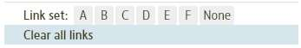

How do I link resources?
[[@Headword:Linking Resources – How do I link resources? ]]
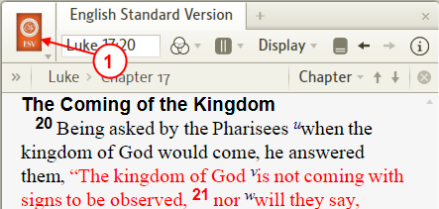

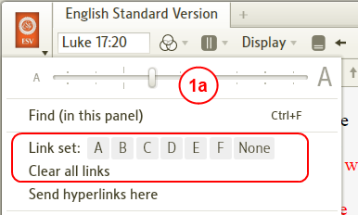

- Click on the icon in your resource.
  - A drop down menu for the resource will appear. Notice the linking options.
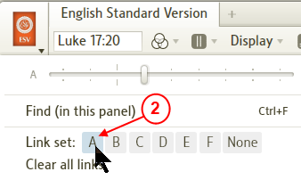

- Click on a link letter that you want to use.

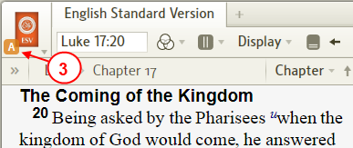

- After setting the link, notice the link letter appears next to your icon for that resource.
- Now repeat steps 1 to 3 for another resource using the same link letter. (remember your resources need to be of the same type)

- See Examples for step-by-step details and other ideas.

How do I turn Off a Link on a single resource?
[[@Headword:Linking Resources – How do I turn OFF a Link on a single resource? ]]
- Click on the resource's icon found in the upper left area of your resource's window.
- Click on None to the right of the Link letters.

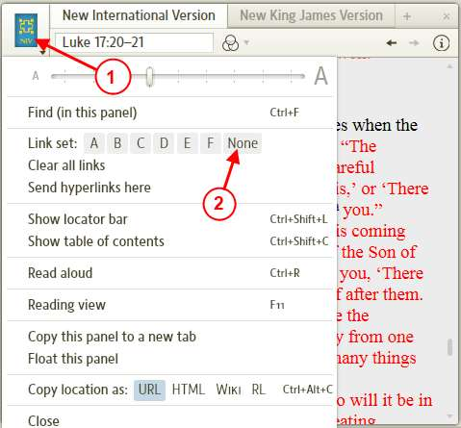

- Notice that the link letter disappeared from the resource's icon on the upper left of the window.

How do I clear all links?
[[@Headword:Linking Resources – How do I clear all links? ]]
- Click on the resource's icon found in the upper left area of your resource's window.
- When the window's drop down menu appears, click on Clear all links.

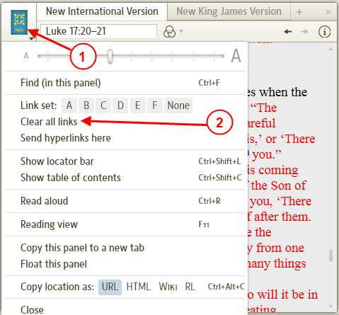

- Notice that all link letters disappeared from all the resource's icons in each window.

How can I save the way that my resources are linked?
[[@Headword:Linking Resources – How can I save the way that my resources are linke? ]]
- When you save your Layout (how all your windows/books are organized), it saves your resource linking. (this is the safest way)
  - See [[Layouts]]

- Logos4 will save your current Layout when you close it. Thus your resource linking is saved.
  - But if your computer crashes or Logos4 crashes, you might loose the way your resources were linked (if they were different that the last time you closed Logos4).
  - So saving your Layout is a safe way to ensure that your resource linking and windows/resources layout is saved.

Examples
[[@Headword:Linking Resources - Examples ]]

Linking 2 Bibles together
[[@Headword:Linking Resources – Examples [Linking 2 Bibles together] ]]
- Open two Bibles similarly as shown below. (see [[Opening resources from your Library >> Layouts # Opening resources from your Library]] or [[Opening resources from the Command box >> Layouts # Opening resources from the Command box]])

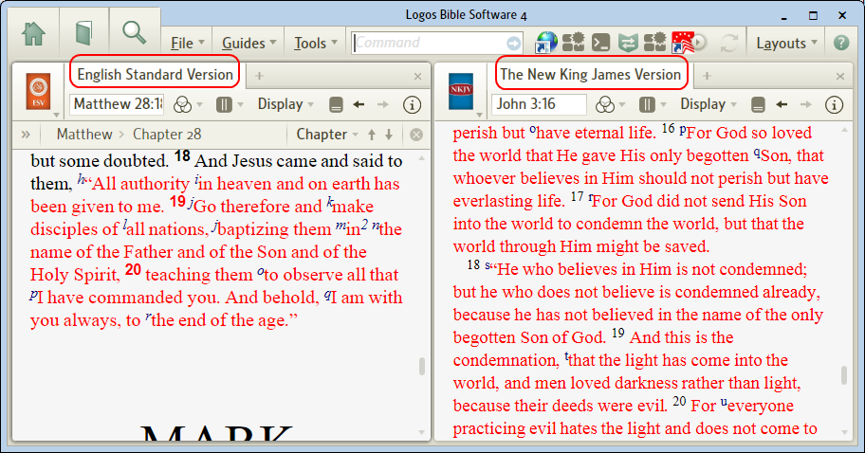

- In this example, notice that the passages for each Bible are at different locations.
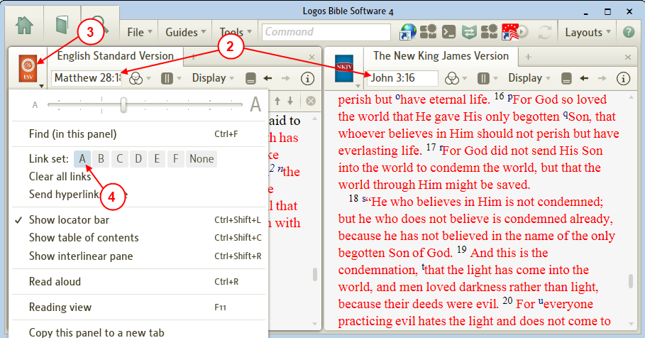

- Click on the first Bible's window icon.
- Click on link A to the right of Link set in the window's drop down menu.
- Notice in the first Bible window's icon the letter A appears under the icon image. This indicates that this resource is using link A.
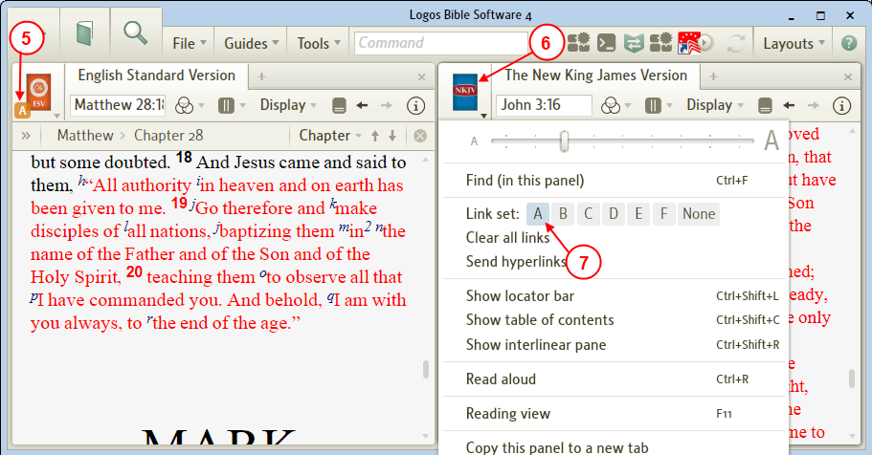

- Click on the second Bible's window icon.
- Click on link A to the right of Link set in the window's drop down menu.
- Now these Bibles are linked using link A.

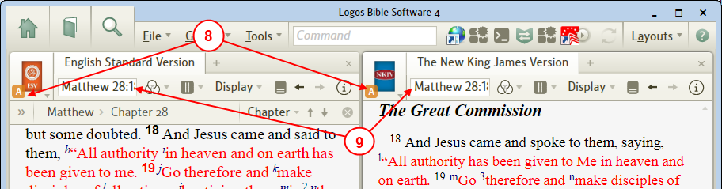

- Notice that the Bible passage of the second Bible changed to that of the first Bible.
- Now scroll (or change the passage in the passage box) in either Bible and notice that both Bibles track each other.
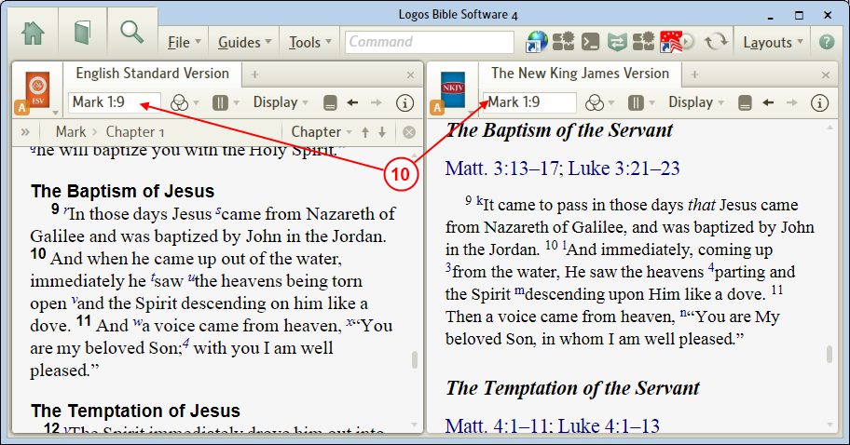

- The Bibles are linked. You may link other Bibles together using this same link (A) or link others using a different link letter.
- To disable a link see How do I turn Off a Link on a single resource?

Using links to link different resource types
[[@Headword:Linking Resources – Examples [Using links to link different resource types] ]]
- The NIV and the Bible Knowledge Commentary are linked together using link A.
(this could be your primary Bible/Commentary for your Bible study)
- The NKJV and the ESV are linked together using link B.
(this could be your reference Bibles, when looking up other passages)
- The Enhanced Strong's Lexicon and the TDNT and the TWOT are linked together using link C.
(this could be your lexicon/dictionary for looking up original language words)
- The Tyndale Bible Dictionary and Nelson's New Illustrated Bible Dictionary are linked together using link D.
(this could be your Bible dictionaries for looking up Bible words)
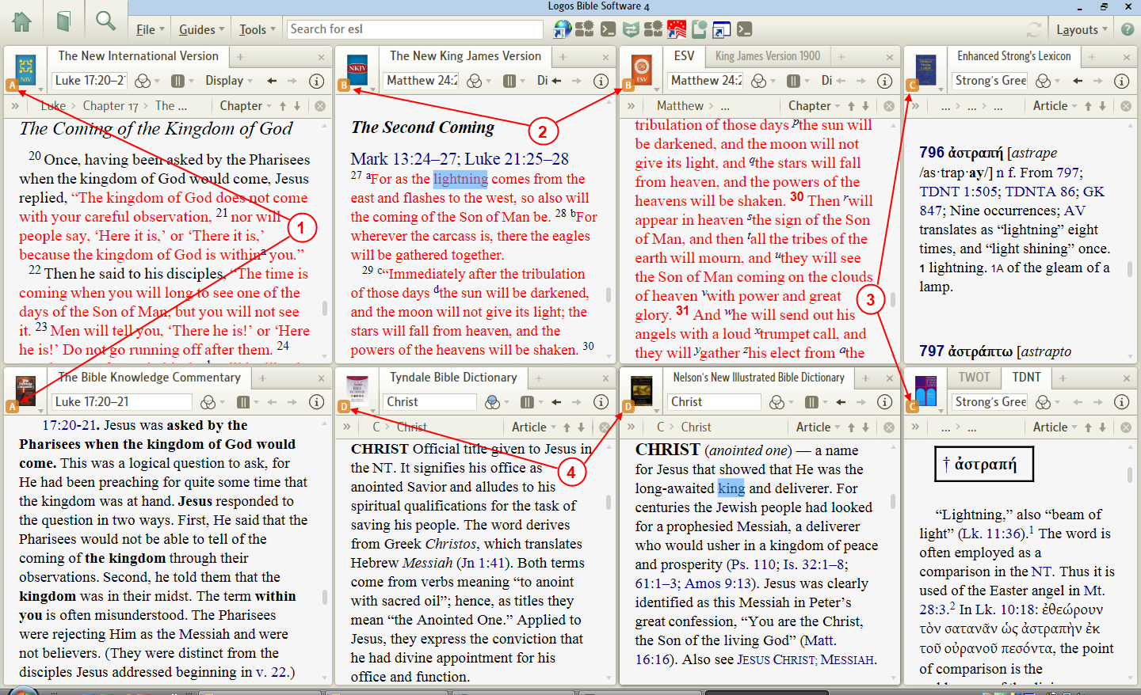

Send Hyperlinks here
[[@Headword:Send Hyperlinks here ]] Wiki page: Revision 16 Link

Video
Mark Barnes video
Logos Tutorial Video #14 – Layouts

What is Send Hyperlinks here ?
[[@Headword:Send Hyperlinks here – What is it ]]
- This allows you to direct links to be opened in specific book(s).
- For Bible references you can have a 2nd copy of your Bible open and set to Send Hyperlinks here. Then when you click on a Bible reference in another book, it will set the 2nd Bible to that Bible reference. Thus leaving your 1st copy of that Bible where you were reading before clicking on the Bible reference.
- If you want to have Bible reference opened in a Bible other than your Preferred Bible, then using a different version of a Bible and setting it to Send Hyperlinks here will direct Bible reference links you click on use this Bible.
- Please watch Mark Barnes video Logos Tutorial Video #14 - Layouts, he covers this in his video.

How do I turn On/Off Send Hyperlinks here?
[[@Headword:Send Hyperlinks here – Turning ON/OFF Send Hyperlinks here ]]
- Open the book that you want to have links sent to in a new Tab.
- Click on the book's window icon. A drop down window will appear.
- Click on Send hyperlinks here. (when it is checked, it is turned On. When unchecked it is Off)
- When Send hyperlinks here is turned On for a book, you will see the red concentric circles in the book's window icon.

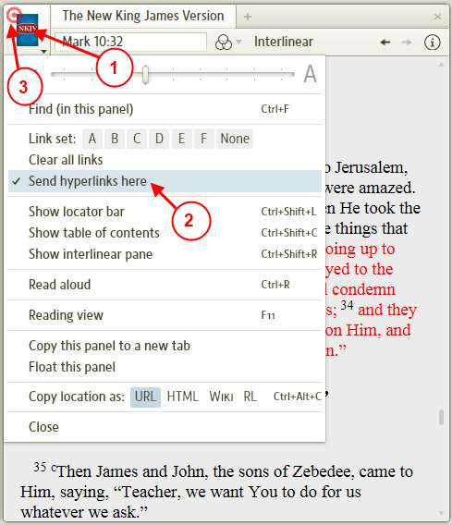

Examples of using Send Hyperlinks Here
[[@Headword:Send Hyperlinks here - Examples ]]

Sending links to Bible other than your Preferred Bible
[[@Headword:Send Hyperlinks here – Examples [Sending links to Bible other than your Preferred Bible] ]]
- The NIV here is my Preferred Bible. (see [[Choose preferred Bible >> Choose preferred Bible ]])

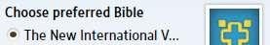

- The NKJV has been set to Send hyperlinks here.
- Click on the reference ^{r} in the ESV.
- The pop-up Bible references appear.

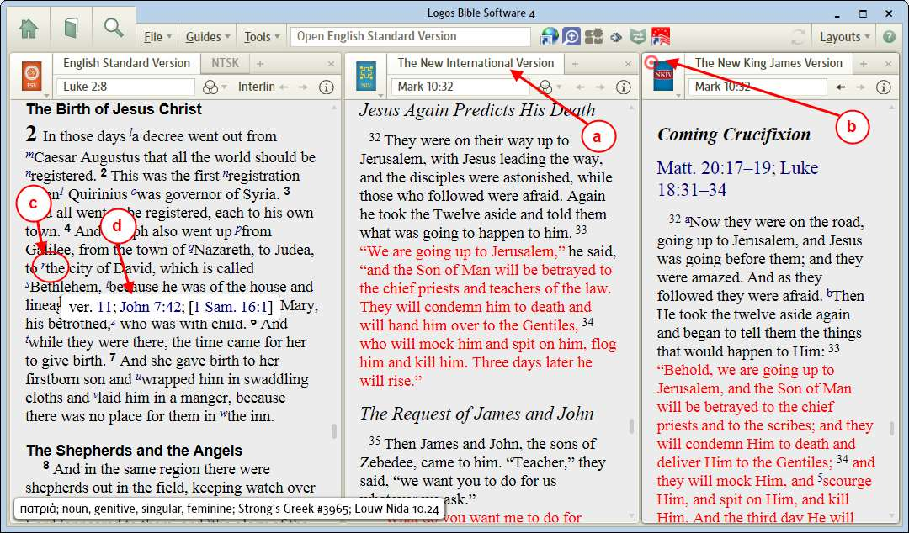

- If you click on John 7:42 in the pop-up reference... (see above image)
- Notice that the NIV remained on its location. (see image below)
- Notice that the NKJV went to John 7:42

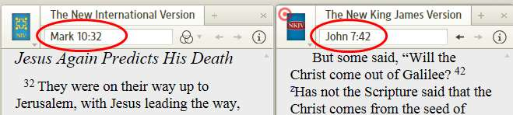

Sending links to a 2nd copy of a Bible, while reading in the 1st copy
[[@Headword:Send Hyperlinks here – Example [Sending to a 2nd copy of a Bible] ]]
- This is the Bible that I am reading from in Mark 10:13.
- This is the Bible that I want links sent to, it has been set for Send hyperlinks here (notice the red concentric circles).
- In the Passage Guide I want to view Matt 19:13 in the 2nd Bible.

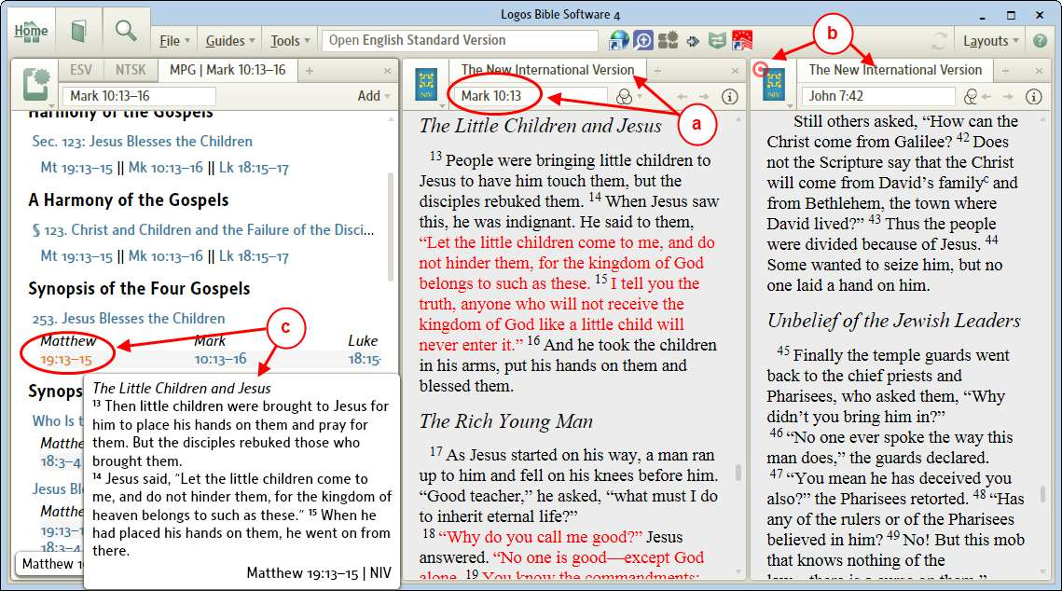

- Notice that my reading Bible is still locate on Mark 10:13 (see image below)
- Notice that my 2nd Bible is now located on Matt 19:13
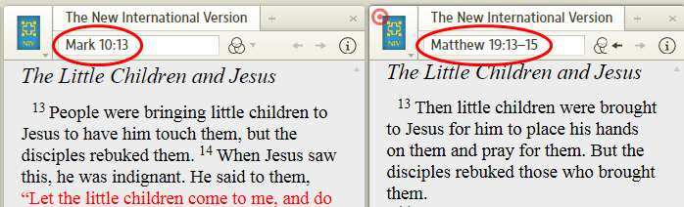

- This would allow you use the 2nd Bible to view many references without disturbing your Bible that you were reading from.

Read Aloud
[[@Headword:Read Aloud ]] Wiki page: Revision 13 Link

See also
Pronunciation

Introduction
[[@Headword:Read Aloud - Introduction ]]
Logos 4 allows you to have your computer read your book to you with a computer generated voice. Not all books will have this function. Logos 4 uses your computer's operating system (e.g. Windows or Mac's OS X) to actually output the voice, so it is not Logos 4 which controls which voice that is used or the speed that the voice reads the text. Also Logos 4 does not directly read from original languages like Aramaic, Hebrew, or Greek (but with Greek you can buy an additional resource, see below).

Starting Read Aloud
[[@Headword:Read Aloud - Starting ]]
You can start/stop Read Aloud feature from the resource's menu (see image below) OR use keyboard shortcut (PC = Ctrl + R, Mac = Cmd + R).

PC | Mac
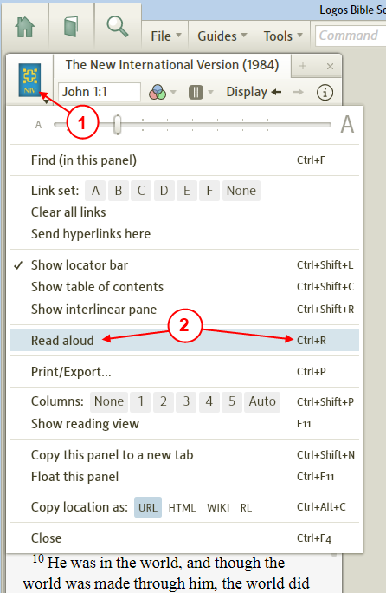 | 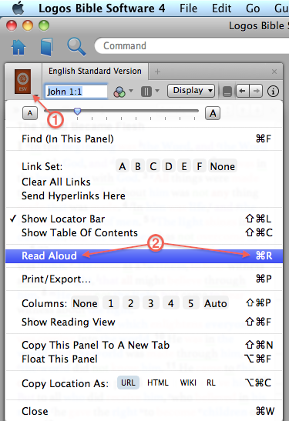

- Click on the resource's icon to open the resource's menu.
- In the drop down menu click on Read aloud. Logos4 will start reading from your resource. Make sure that you do not have your volume muted.

- You should position your resource's starting point at the top of its window before starting Read Aloud
- You should not scroll while Read Aloud is running, this stops the reading.
- You can stop Read Aloud by using keyboard shortcut Ctrl + R on PC, Cmd + R on Mac OR use resource menu to Stop reading aloud OR close Read Aloud audio player.

Read Aloud Player
[[@Headword:Read Aloud – Read Aloud Player ]]
When Read Aloud is active (started), audio player appears on right side of toolbar. When Read Aloud is stopped (or X clicked to close audio player), audio player disappears.

PC (paused) | Mac (playing)
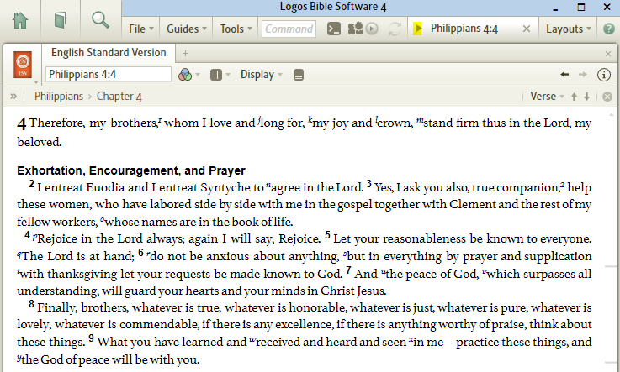 | 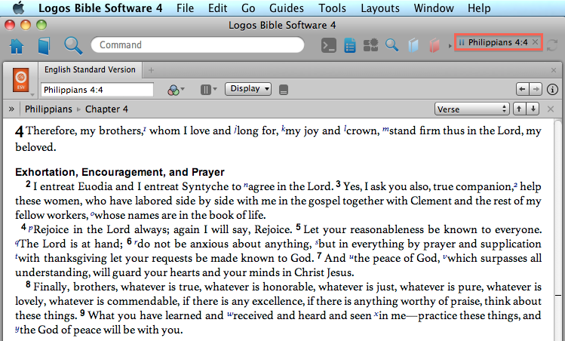

Can pause and resume Read Aloud using audio player on toolbar.

Page turning
[[@Headword:Read Aloud – Page turning ]]
Logos4's Read Aloud reads a page as found in the paper version of your book (for many resources anyway). So if you scroll or try to change the page as viewed on the screen Logos4 will stop and when you start Read Aloud again it will start at the top of that page (print version). You can turn On page numbering in Visual Filter Menu so that you can see where the paper version page numbers are located. Then if you size you resource's window so that it fits the paper version's page you will see Logos4 change the page being viewed when the Read Aloud feature finishes a page from the paper version.

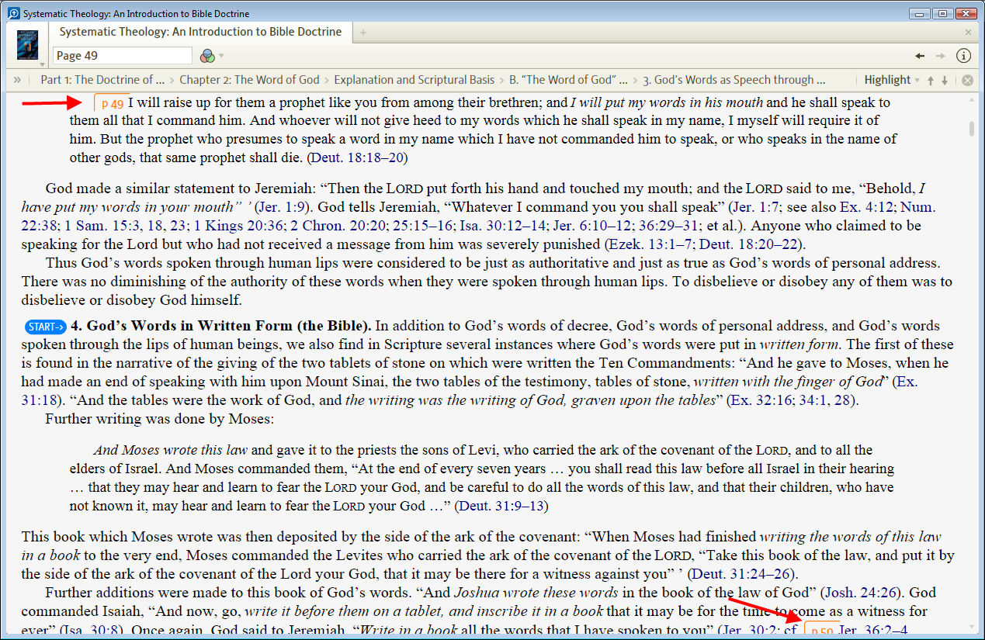
- Notice the page numbers in the above image. This shows where pages are divided in the paper version.
- To show the paper version's page numbers:

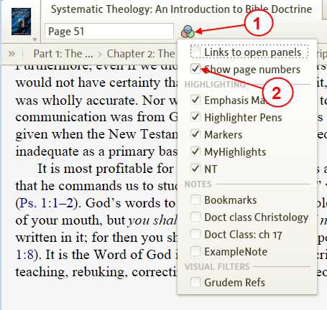
- Click on the Visual Filter Menu icon.
- In the drop down menu click on Show page numbers to check it.

Changing the Voice or Speed
[[@Headword:Read Aloud – Changing Voice or Speed ]]
To change the voice or the reading speed you will need to do this through controls in your computer's operating system.

Windows Vista/7
[[@Headword:Read Aloud – Changing Voice or Speed [Windows Vista/7] ]]
Windows Control Panel has Text to Speech. Your control panel may look different than these images:

Vista Text to Speech | Windows 7 Ease of Access * Speech Recognition
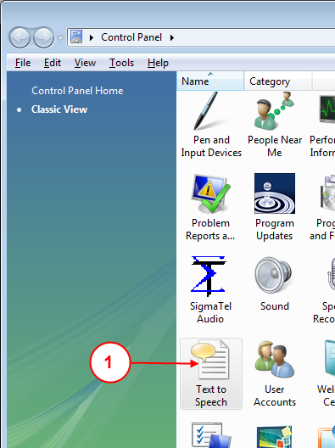 | 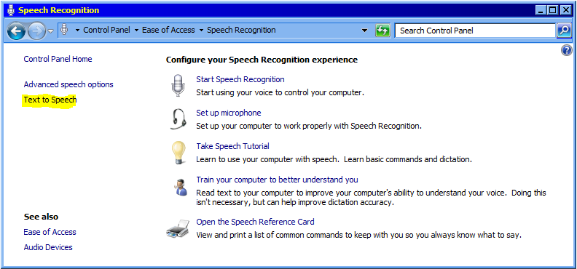

- Open the Window's Control Panel, locate Text to Speech then click it (Vista is double click, Windows 7 is single click).
- When the Speech Properties window opens make sure Text to Speech tab is selected.
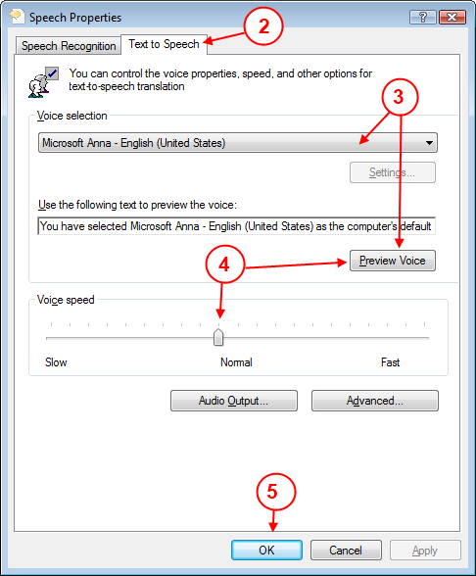

- From here you can change which voice that you want to use. You may need to press the Preview button to hear it.
- From here you can change the speed at which the voice reads. You may need to press the Preview button to hear it.
- When you are satisfied with the voice and its speed, click the OK button.
- Now in Logos4 if you had a resource open prior to the above steps, you will probably need to close that resource and reopen it for the above changes to take effect.
- On your keyboard press the key combination Ctrl R (first make sure your resource is the active panel). Logos4 will start to read from your resource using the changes you made.

Note: Windows Vista/7 includes one SAPI5 voice: Microsoft Anna. Forum has Read Aloud voice discussion

Mac OS X Leopard (10.5) and Snow Leopard (10.6)
[[@Headword:Read Aloud Aloud – Changing Voice or Speed [Mac OS X Leopard & Snow Leopard] ]]
System Preferences has Speech that has Text to Speech settings that are copied by Logos 4 Mac when program launched.

- Open System Preferences - click on Apple Logo to display menu - click System Preferences
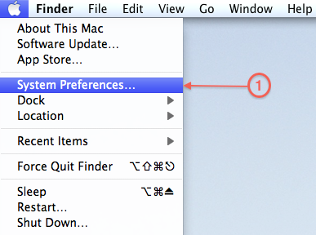

- Click Speech
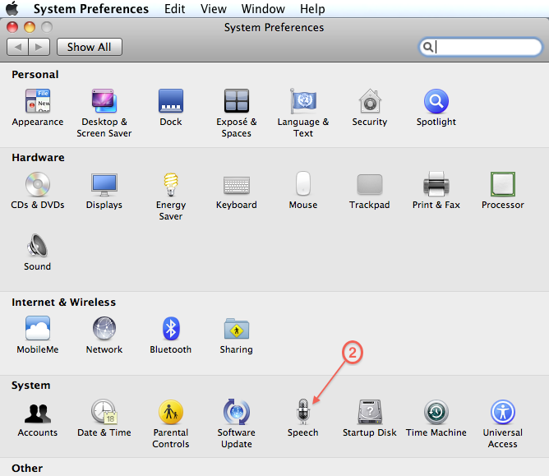

- Click Text to Speech
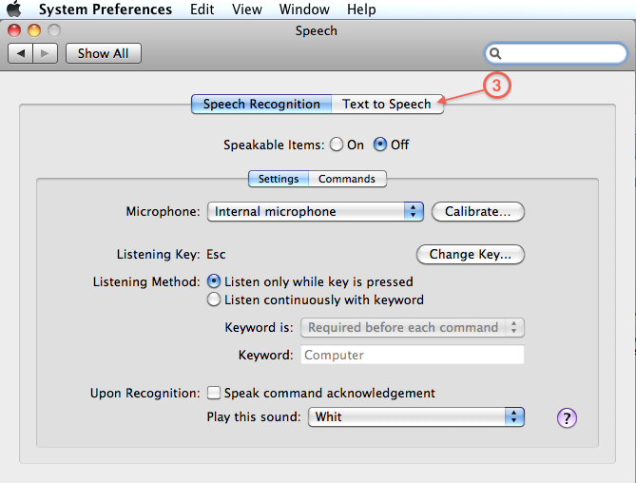

- Click System Voice to choose which voice you prefer - click Play button for sample speech
- Click in Speaking Rate selector to change voice speed (or drag indicator to desired speaking rate) - click Play button for sample speech
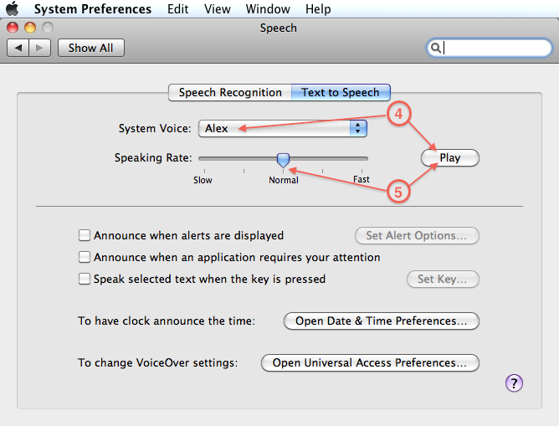

- Launch Logos 4 Mac and open desired resource for reading (or open a layout, then click in resource to focus for reading). If Logos 4 Mac already open, close and relaunch, then choose resource for reading.
- On your keyboard press key combination Cmd R (if USB PC keyboard connected to Mac, press Windows R) to start OR stop reading. Optionally, can click resource menu to start OR stop reading.

Note: Apple's Mac OS X includes many voices plus OS X Lion has more high quality free voices

Read Aloud Greek from Logos
[[@Headword:Read Aloud – Read Aloud Greek ]]
You can buy a resource from Logos which will allow Read Aloud to work from the NA27 according to this post Can Logos 4 Read Aloud in Hebrew & Greek?.

Tip: to hear the lemma form of a word, you can use the Right click menu (see item #8 under Lemma).

Third party Voices or Tools
[[@Headword:Read Aloud – Third party Voices or Tools ]]
You can find several posts which discuss third party vendors which offer different voices for your operating system or different tools which can work with your operating system.

- See this post
- Try using Google to search for some of the posts: Google search

Selecting a voice on 64 bit Windows Computers like Windows 7
[[@Headword:Read Aloud – on 65 bit Windows computer ]]
For those who are running Logos 4 on Windows 7 64-bit and do not like the default Microsoft Anna voice, here is how to select and use other voices (e.g. Paul and Kate from Neospeech / Nextup):

Run C:\Windows\sysWOW64\speech\SpeechUX\SAPI.cpl

This brings up a window that looks just like the Text to Speech window in Control Panel, except that your third-party vendor's voices will also show up there and can be selected as Windows 7's default voice. You will have to restart Logos 4 for the new voice to take effect.

Print/Export
[[@Headword:Print Export ]] Wiki page: Revision 32 Link

Video
Mark Barnes
Logos Tutorial Video #12 – Printing
Logos Tutorial Video #13 – Export

Please watch Mark Barnes video: Logos Tutorial Video #12 - Printing

How to select Printing/Export
[[@Headword:Print Export -- How to select Print/Export ]]
- New with Logos4 version 4.1, you can print most of the items.
  - From: resources, tools, documents, etc.
- There are 2 methods to open the Print/Export window for printing from Logos4.
  - From your resource's menu
  - Using a keyboard shortcut

From a resource's menu
[[@Headword: PrintExport -- How to select Print/Export [From resource menu] ]]
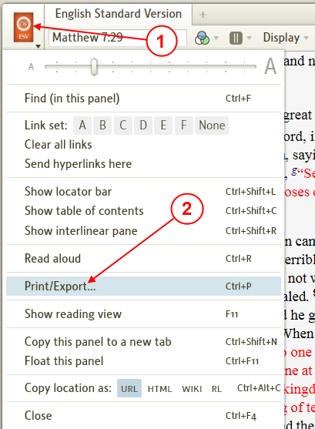
- In the resource that you want to print from, click on the resource's icon.
- In the drop down menu, click on Print/Export.
- The Print window will open.
Logos4 will only allow 1 Print/Export window to be open at a time.

Using keyboard shortcut
[[@Headword:Print Export -- How to select Print/Export [Using keyboard ] ]]
- Click in the resource that you want to print from.
- On your keyboard use the keyboard shortcut Ctrl P to open the Print/Export window.

Selecting what to print
[[@Headword:Print Export -- Selecting what to print ]]
- There are a few ways to determine what will be printed from your resource.
It should be noted here that Logos4 handles this differently depending on the resource or tool type.
- So this wiki subTopic is broken up into 3 minorTopics to try and cover these situations.
  - From text resources
  - From some tools
  - From other tools
  - These may not be fully inclusive of all resources or tools. But in these examples you can see what you might expect in the Print window when trying to set what will be printed.
- Another item to make you aware of is that you can select in your resource (by click & drag with your mouse) what you desire to print. This method may not be available in many of the tools areas.
- Changing the text size in the Print/Export preview is dependent on the text size that you had setup in the resource. (see Print Preview)
- One tool which you might not think of printing from is the Help tool. Printing from this tool might come in very handy for lengthy help sections that you don't want to view in a narrow window pane.
- When printing from a Guide you will need to open the individual tool headings within the Guide that you want printed.
- If you have the Print/Export window open and then change the Guide view, then you might need to use the keyboard shortcut Ctrl P (while in the guide) to have the Print window update.
- When printing Notes or Clippings, Logos4 does not permit printing individual notes or clippings within a Note or Clipping file.
- When printing a Passage List and you have multiple Bibles selected, Logos4 will print it vertically or horizontally depending on how it is showing on your screen. (so adjust your Passage List window for the view you want)
- Under the Tools menu, you can print from each of them except the Favorites and Copy Bible Verse.
- From the Search tool you can print from all the various views except the Analysis views.

From text resources
[[@Headword:Print Export -- Selecting what to print [From text resources] ]]
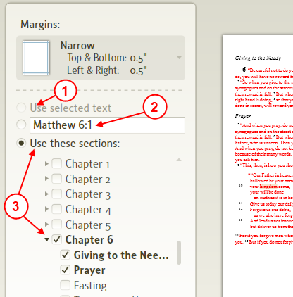

- In your resource you can select what you want printed.
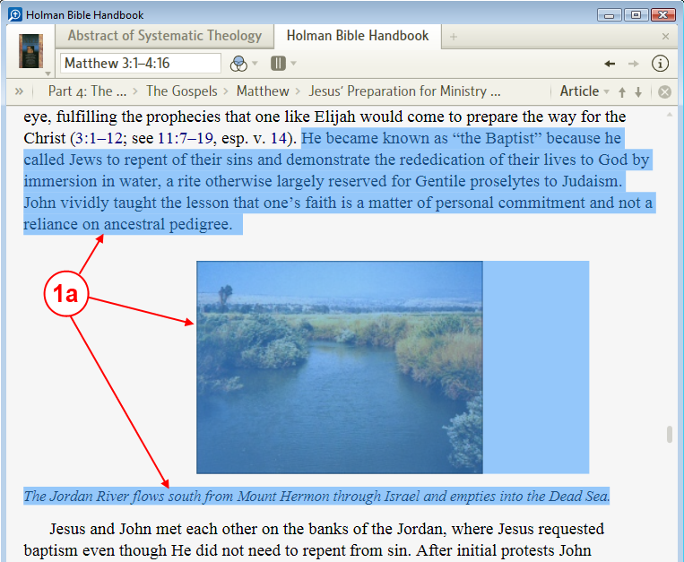

  - Select what you want printed (including text and pictures or charts) in your resource. (by click and dragging with your mouse).
  - Open the Print/Export window using the keyboard shortcut or menu.

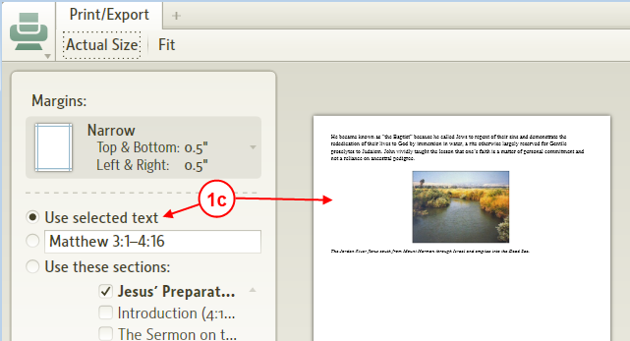
  - When your Print window appears, notice that Use selected text is chosen and you see your selected items appear in the preview page.

- Depending on your resource type you may see a scripture reference or page number here. You can click in here to change the range to suit you.
  - Note: page numbers must be consecutive (e.g. Page 544-546). Use the hyphen (minus sign) to separate the page range. After entering your page range click on the blue arrow (appears when editing in the box) to the right of this box to update the preview page.
Also be aware that the number of pages that you select may be different than the number of pages printed (look under the preview page for the number of pages to be printed).
  - For scripture reference range, enter it like you would in your Bible resource (e.g. Mt 6:1-8) then click on the blue arrow (appears when editing in the box) to the right of this box to update the preview page.

- You can use choose Use these section to customize what will be included in your printed page(s). The items that appear here are what you would see in the Table of Contents for the resource that you are printing from. Be aware that not all Bibles (or other resources) show every heading (e.g. the NIV shows headings within a chapter, while the ESV table of contents only shows chapters). The example below is from the Bible Knowledge Commentary:
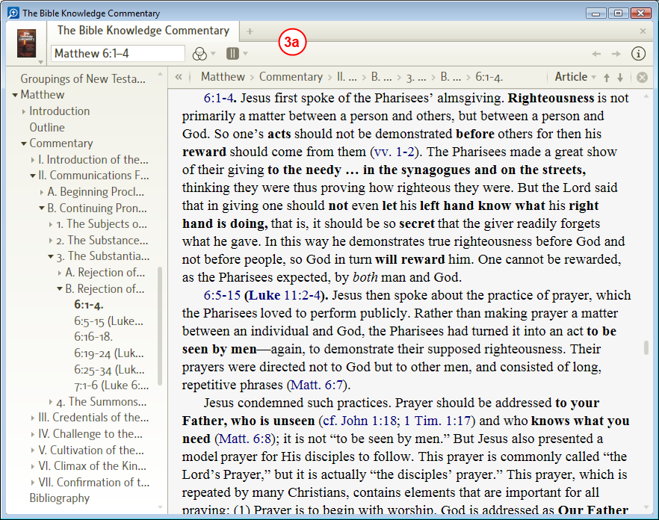

- Notice that we have the BKC open to Matthew chapter 6. Also notice that we are showing the Table of Contents on the left.
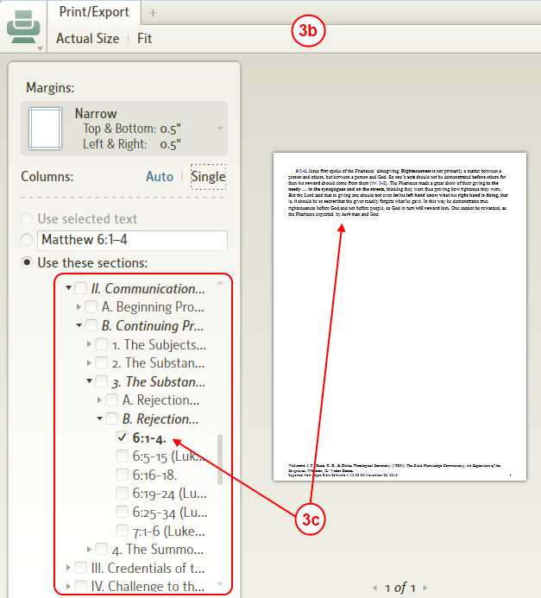

- Now open the Print/Export window using the keyboard shortcut or menu.
- Notice that the sections column looks just like the Table of Contents column in our resource. Notice that only a single subsection is checked (since we did not select anything in the BKC before opening the Print/Export window). Here you can check whichever sections that you want included in your printout. Unlike the other two method, you can print non-continuous sections using this method.
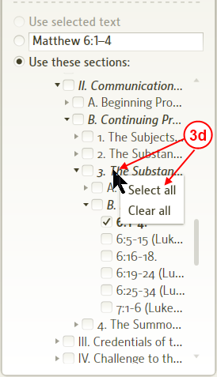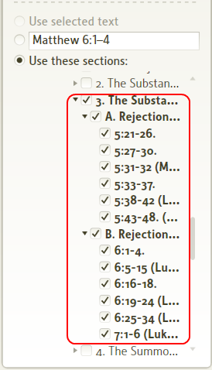

- Instead of checking every subsection you can right click on a subsection that you want printed and a pop-up menu appears allowing you to Select all or Clear all appears. This may come in handy when there are numerous subsections. The image on the right shows how Logos4 selected this whole subsection after clicking on Select all.

From some tools
[[@Headword:Print Export -- Selecting what to print [From some tools] ]]
- Many Logos4 tools and some resources may give you a more limited set of options for selecting what you want to print.
- Some tools where this may happen: Information, Cited By, Power Lookup, Text Comparison, etc.
The view below shows the Print/Export window already open.
To open the Print/Export window see How to select Printing/Export

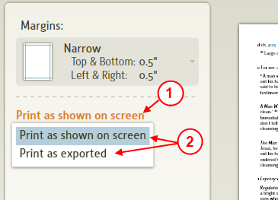

- Click on the current print selections.
- A drop down list appears, select the method that you want and then view it in the preview page.
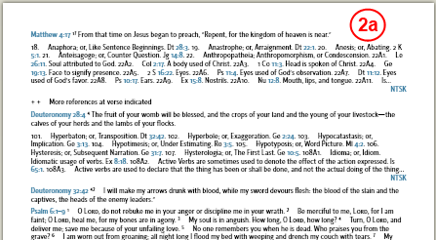

- From Power Lookup this is what Logo4 shows for Print as shown on screen.
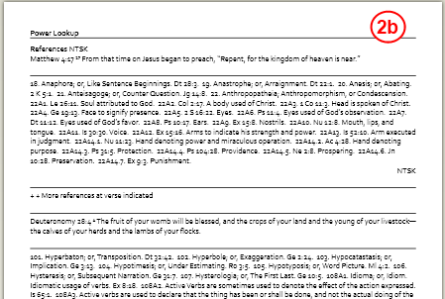

- And this is what is shown for Print as exported.

From other tools
[[@Headword:Print Export -- Selecting what to print [From other tools] ]]
- When opening the Print/Export window for some tools or resources you may notice that print selection methods are missing.
- Some examples where this might happen: Biblical People/Places/Things.
- So Logos4 will only give you What You See Is What You Get in the preview page.

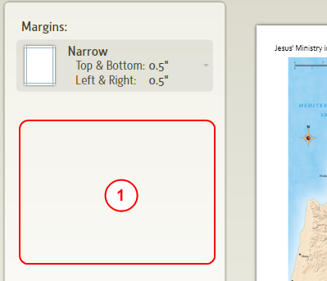

- Notice there are no print selections available. If you find that your preview page is insufficient, then:
  - Try using the Export method(s) along with a word processor or a browser.
  - Or bypass using the Print window and use Copy/Paste from your resource into a word processor.
- From Biblical People/Places/Things, Print/Export will print the contents of the Information panel and the image to your printout. It will not printout the ribbon of images found at the bottom of the tool.

Print Preview
[[@Headword:Print Export -- Print Preview ]]
- Logos4 provides a condensed view and a zoomed view to preview your document.
  - The buttons to control this are found on the Print window's toolbar. (Actual Size for zoom and Fit for condensed)
- You can scale the size of text in the print window. But it will not effect the size of text in your documents print preview.
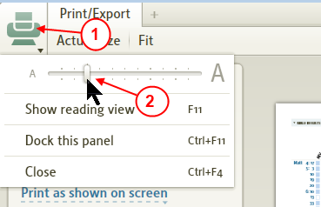

- Click on the Print window's menu icon.
- Use the slider to adjust the window's text size.
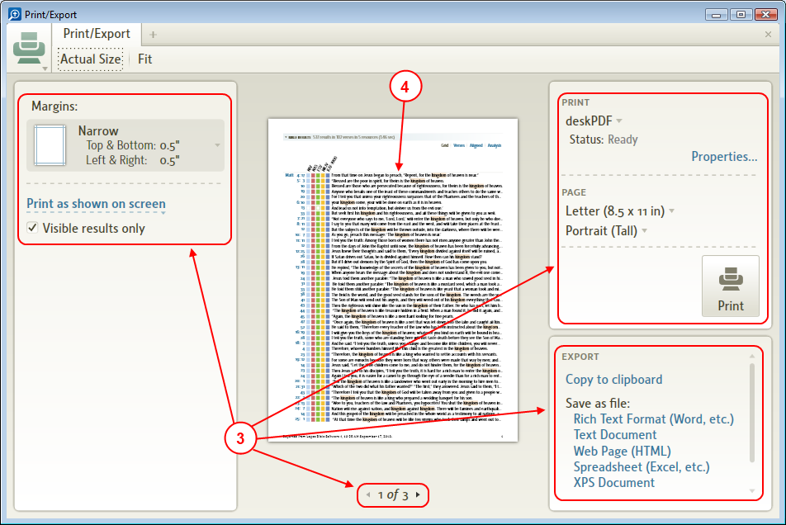

- Logos4 will adjust text per your scaling in step #2 for these areas.
- It will not change the size of the previewed document. (see Changing the Font size)

Number of pages to print
[[@Headword:Print Export -- Print Preview [Number of pages to print] ]]

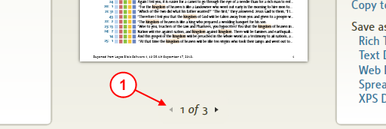

- Notice the page number under the document preview.
- This shows you the number of printed pages that you can expect.
- You can click on the arrows to change the preview page of the document.
  - Or you can use the arrows on your keyboard to change the preview page.
  - Or you can use Page Up and Page Down on your keyboard to change the preview page.
  - Or you can use the wheel on your mouse to change the preview page.

Default View (Fit)
[[@Headword:Print Export -- Print Preview [Default View (Fit)] ]]

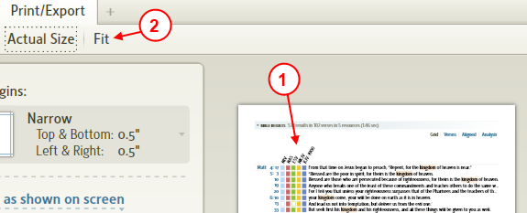

- The Fit or condensed view is the default view when you open the Print window. It allows you to view at a glance how your document should look when printed.
- If you have used the zoomed view, you can press the Fit button on the toolbar to return to the condensed view.

Zoomed (Actual Size)
[[@Headword:Print Export -- Print Preview [Zoomed (Actual Size)] ]]
- You probably will want to zoom in to preview how your document will look before printing.

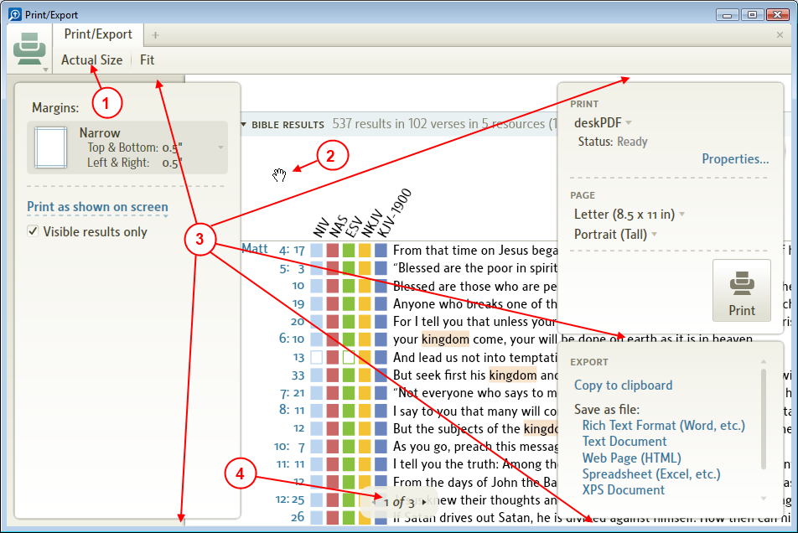

- Click on the Actual Size button on the toolbar to show the zoomed view.
- Notice that your cursor changes to an open hand when over the document. By using the hand and the left mouse button you can grab and drag the position of the zoomed document into position for viewing (similar to how you move your map in the Biblical Places tool).
- Logos4 has provided gaps around its panels to allow you to see the position of your zoomed document.
- Also notice the preview page number changer is hovering over your document. You can use this to change to a different page while zoomed.

Setting up the printed page
[[@Headword:Print Export -- Setting up the printed page ]]
- You will want to setup how you want your document printed before you actually print your page.
- This section will help you use the selections in the Print/Export window to do this.
  - Changing the Font size (done before entering Print/Export window)
  - Selecting the page orientation
  - Setting the page margins
  - Selecting the printer
  - Setting the paper size
  - Setting printer properties

Changing the Font size
[[@Headword: Setting up the printed page [Changing Font Size] ]]
- To change the size of text for your document within your print preview window you need to change the size of text for the resource it comes from prior to opening the Print/Export window.
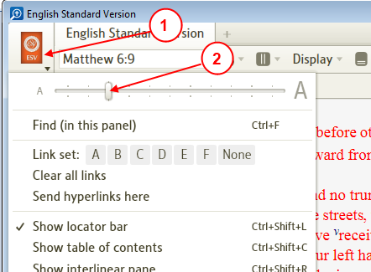

- In your resource that you want to print from, click on the icon in the upper left corner of its window.
- In the drop down menu, adjust the text size slider to enlarge text view in your resource.
(the larger the text in your resource the larger it will be in your printout)
- In that same drop down menu, click on Print/Export.
- Now the text is larger in your preview page in the Print/Export window. (see image below)
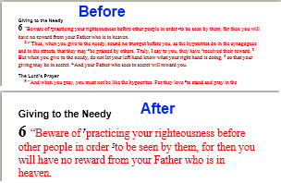

- Once that you have printed your page, repeat steps 1 & 2 to restore your normal viewing size for your resource.

Selecting the page orientation
[[@Headword:Print Export -- Setting up the printed page [Selecting page orientation] ]]

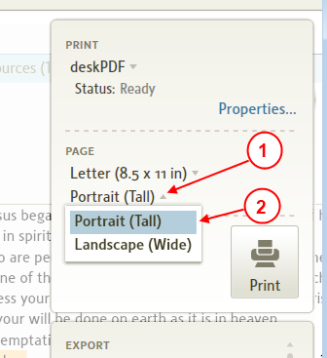

- In the top right panel, click on the arrow next to the Portrait/Landscape selector.
- A drop down menu will appear, select the page orientation that you want.

Setting the page margins
[[@Headword:Print Export -- Setting up the printed page [Setting page margins] ]]

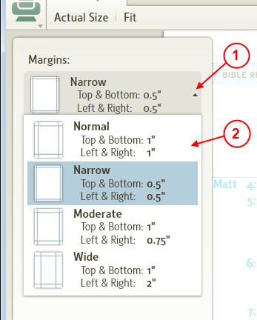

- In the top left panel, click on the arrow next to the Margins selector.
- A drop down menu will appear with 4 margin choices.
- Select the margin choice that you want your document to be printed with.

Selecting the printer
[[@Headword:Print Export -- Setting up the printed page [Selecting printer] ]]
- Before you set other print settings you should select which printer that you want to use as the other print settings may vary with printer.

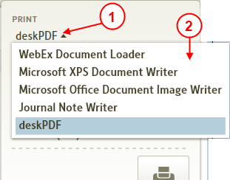

- In the top right panel, click on the current printer name.
- A drop down list of printers for your computer will appear.
  - Select the printer that you want to use.

Setting the paper size
[[@Headword:Print Export -- Setting up the printed page [Setting paper size] ]]

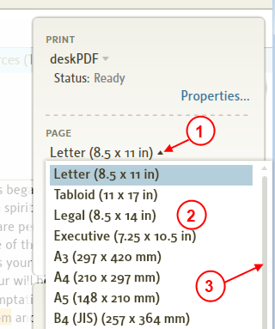

- In the top right panel, click on the arrow next to the Paper size (the default is Letter).
- A drop down menu for available paper sizes for your selected printer will appear.
- You may not see all the available paper sizes, so use the scrollbar to view the others.
- Select your desired paper size.

Setting printer properties
[[@Headword:Print Export -- Setting up the printed page [Setting printer properties] ]]
- You can also adjust some properties for your printer from the Print/Export window. Since the properties for this method are printer dependent and can greatly vary, this wiki will not attempt to show these here.

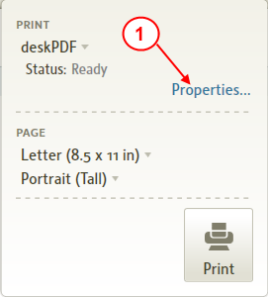

- In the top right panel, click on the link Properties.

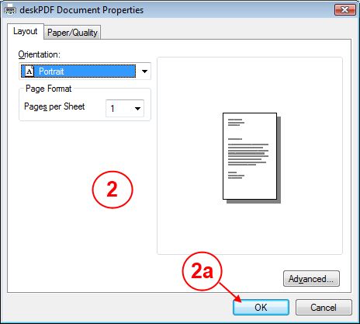

- A pop-up window will appear. You can change the properties for how you want your printer to print here. Notice that there may be other tabs in this window for setting other properties.
  - When you are done, press the OK button to set these properties or the Cancel button to leave the properties as they were.

Sending to the printer
[[@Headword:Print Export -- Sending to Printer ]]
- Sending your document to the printer.

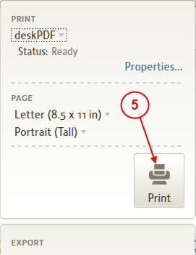

- Setup your printer and print settings.
  - see Setting up the printed page
- Preview your document before you print.
  - see Selecting what to print
  - see Print Preview
- Make sure that you have paper in your printer.
- Make sure that your printer is turned ON.
- In the top right panel, click on the Print button.

Exporting
[[@Headword:Print Export -- Exporting ]]
Logos4 has embedded this feature in its Print/Export window. It allows you to export whatever you could send to the printer to the clipboard or one of the specified files. Mark Barnes has made an excellent video showing in detail how to export: Logos Tutorial Video #13 - Export.

Copy to clipboard
[[@Headword:Print Export -- Exporting [Copy to Clipboard] ]]
- You can export your document to the windows clipboard for pasting elsewhere.
- Once in the clipboard you can paste it into Word, Excel, PowerPoint or some other editing software.
- Graphic images are not copied using this method. See the Right Click menu for copying images.
  - An exception to this is from Biblical People/Place/Things. Logos4 will include the primary image (not the ribbon of images at the bottom of the tool) from these in your clipboard.
- Footnotes are not included like when using Copy from the Right Click method. The slide below from Mark's video shows what you can expect from these 2 methods (Right Click vs Export):

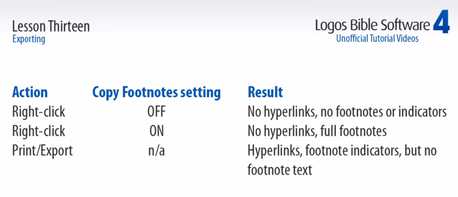

Rich Text Format
[[@Headword:Print Export -- Exporting [Rich Text Format] ]]
- You can export your document to a RTF file.
- This file type supports text with font styles, sizing and other attributes. It also supports embedded charts, but not pictures.
- This is useful when you want to open it with a word processor (e.g. Microsoft Word) and edit it. Other software tools also may import RTF files.

Text Document
[[@Headword:Print Export -- Exporting [Text document] ]]
- You can export text documents to a .txt file. You can open or edit these files with microsoft NotePad or similar text based editor.
- You will not find graphic items in a text file.

Web Page (HTML)
[[@Headword:Print Export -- Exporting [Web Page (HTML)] ]]
- You can export your document to a web page on your computer. Then use your browser to open that web page using File from the browser's menu.
- This sometimes can be useful when printing from a browser works better than printing from Logos4.
- This can also be useful when you want to create web based pages for a study in which you want to share with others.

XPS Document
[[@Headword:Print Export -- Exporting [XPS Document] ]]
- This file type works well with windows Vista and newer. You may find tools that will do this for older versions of windows.
- When saving in this file type, you can use windows Internet Explorer to open the document.
- Your browser may print this document more to your liking.

Hyperlinks
[[@Headword:Hyperlinks ]] Wiki page: Revision 36 Link

Video
Logos4 Videos

What are Hyperlinks?
[[@Headword:Hyperlinks – What is it ]]
- Hyperlinks are code that instructs Logos 4 to navigate to a specific place within a book or to open a file.
- Logos 4 can format hyperlink code for use as URL, HTML, Wiki, and Logos Reading Lists.
- You can create links to
  - Resources
  - Searches
  - Guides
  - User Files
  - Collections
  - Biblical People, Places, and Things
  - Copy Bible Verses.

Creating
[[@Headword:Hyperlinks - Creating ]]
- You can tell if you can create a hyperlink by clicking on the panel menu. If "Copy Location as:" is in the list then you can create one. You can choose from URL, HTML, Wiki, and RL. Choosing URL will be right for local uses. Ctl+Alt+C will also copy the code to your clipboard using the last used hyperlink style.

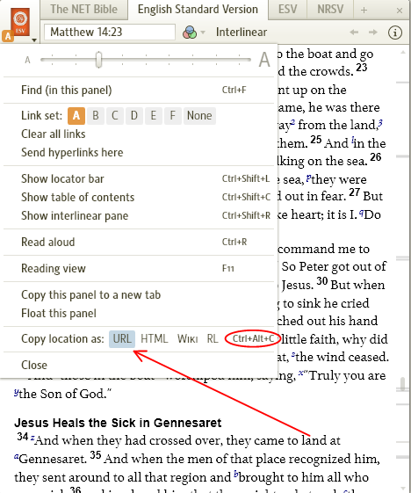

- For use in a Logos Note file: Highlight a word and past the hyperlink code in the Hyperlink textbox (see illustration below). Or, simply paste the raw code into the note file and hit space. The note file also automatically recognizes Bible references and creates a link to your top prioritized Bible.

An unused hyperlink box
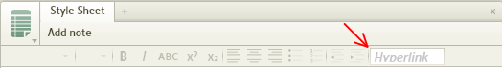

The instructions in action
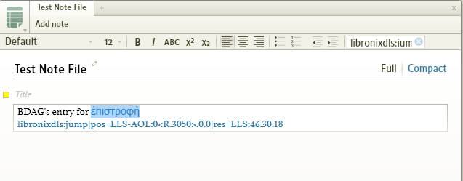
- For use outside of Logos: Embed the link using your word processor, etc. See below: Adding Hyperlinks in PowerPoint

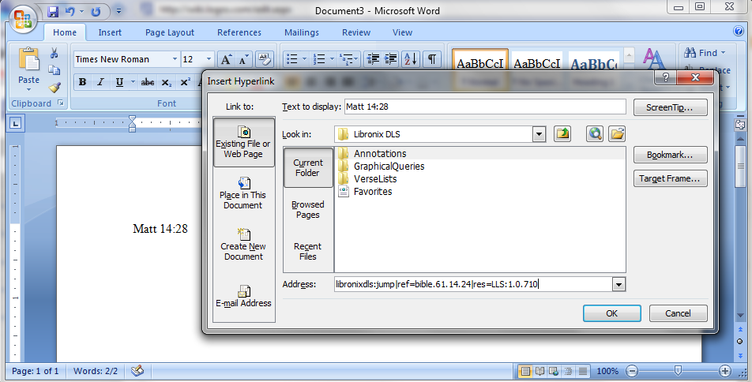
- To use the link Ctrl + click on it to open Logos to the spot where the link was generated.

The Anatomy of a Link
[[@Headword:Hyperlinks – Anatomy of a Link ]]
Understanding the components of a hyperlink are will allow you to customize links or create them from scratch.
Bible Links
Prioritized Bible
logosref:Bible.Jn1.1
- logosref: - hyperlink protocol for a datatype
- Bible. - Specific datatype to be used
  - Your prioritization list will determine which resource this opens, this type of link can be adjusted for any datatype
  - You can specify the versemap to be used i.e. logosref:BibleBHS.Jonah2.5 will open Jonah 2:4 in most English Bibles
  - Jn1.1 - Verse reference
  - The protocol recognizes full book names and most abbreviation schemes for the Bible books

Specific Bible
logosres:esv;ref=BibleESV.Jn1.1
- logosres: - hyperlink protocol for resource
- esv; - version used
- ref=BibleESV - Verse map to be followed in link's execution
- Jn1.1 - Bible Reference

Dictionary Links
logosres:anch;hw=Moab
- logosres: - hyperlink protocol for resource
- anch; - resource to be used
- hw=Moab - headword to be opened, this should work for any dictionary.
- Note that Greek/Hebrew headwords in lexicons are not encoded with unicode characters. Here's an example BDAG link: logosres:bdag;hw=$CE$B1$CC$93$CC$81$CE$BD$CE$B5$CE$BC$CE$BF$CF$82

Other Resource Links
logosres:1000illsprchtch;ref=Page.p_45;off=663
- logosres: - hyperlink protocol for resource
- 1000illsprchtch; - resource to be used
- ref=Page.p_45; - page to be opened
- off=663 - Offset, tells Logos how far down the page to open the resource
- If you delete the offset then Logos will open to the top of the page.
- If you delete ref=Page and everything after it then Logos will open the resource to its last used location. This can be used to create a local reading list in a note file.

Logos 4 Feature Links
The logos4 protocol covers specific features of the software, including Biblical People/Places/Things, Cited By, Explorer, and Text Comparison.
logos4:Places;id=BethanyBeyondTheJordan;map=BiblicalWorldRelief
- logos4: - hyperlink protocol for resource
- Places; - open the Biblical Places panel
- id=BethanyBeyondTheJordan; - show information for the Biblical Place with this identifier, namely, "Bethany (Beyond the Jordan)"
- map=BiblicalWorldRelief - which map to display. This might also be a media object in a resource (like a photograph from a Bible dictionary).

Without the last element, the link will open to the last map if relevant to this place, otherwise the first choice.

Problem: Libronix DLS executes the protocol instead of Logos 4
[[@Headword:Hyperlinks – Problem [L3 executes the protocol instead of L4] ]]
Some users have reported this after running the scripts to download Logos 4 resources into LDLS 3 or installing/updating Libronix after Logos 4.

To repair this, run Logos 4 with the "/register" command line option. The easiest way to do this is choose Start > Run, and enter

%LOCALAPPDATA%\Logos4\Logos4.exe /register

(On Windows XP, run "%USERPROFILE%\Local Settings\Application Data\Logos4\Logos4.exe" /register

Note 1: Logos 4 installs on a single user account in your system. If you have multiple installs on different user accounts you will need to run this command under each separate user account.

Note 2: If you have a custom installation run drive:\<path>\Logos4\Logos4.exe /register

Adding Hyperlinks in PowerPoint
[[@Headword:Hyperlinks – Adding Hyperlinks in PowerPoint ]]
- Frank Fenby has made a great video on this, please watch it: Hyperlinks between Logos and PowerPoint
  - Frank's video shows you step by step how to use Hyperlinks with PowerPoint, he also shows nice practical applications as used in a classroom.
  - Added this from forum post
- This will guide you through the steps to add links to your PowerPoint files.
  - For this example you should use a resource in your Main Logos4 window.
  - Its also best to have only one copy of that specific resource showing in your Main Logos4 window.
    - Otherwise which ever copy of your resource that was left active is the one that Logos4 will navigate to when a link is clicked.
  - In this example we used Luke 24:1, 24:13, 24:36 for our links in the NIV resource.

- In L4, click on the window icon of the resource that you want to link to
- In the drop down menu select URL. (this is a one time action, it tells L4 that you want links in the URL format. Just need to do it in one of your resources.)
- Notice the keyboard command for creating a link, we will be using it later.

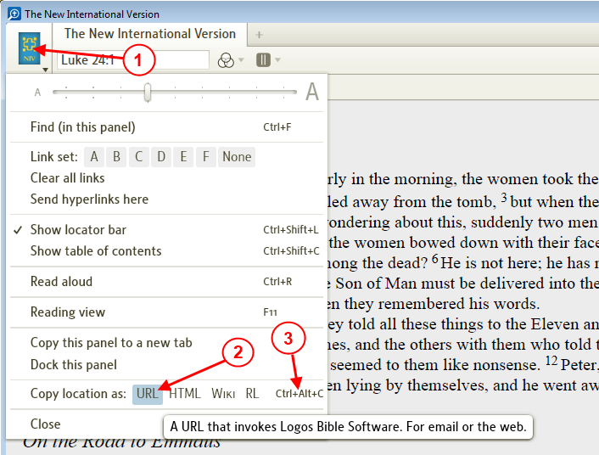

- Now in PowerPoint, enter the text that you want to show for your hyperlink
(we have entered 4 lines which we will create 3 different links for the first 3 lines)
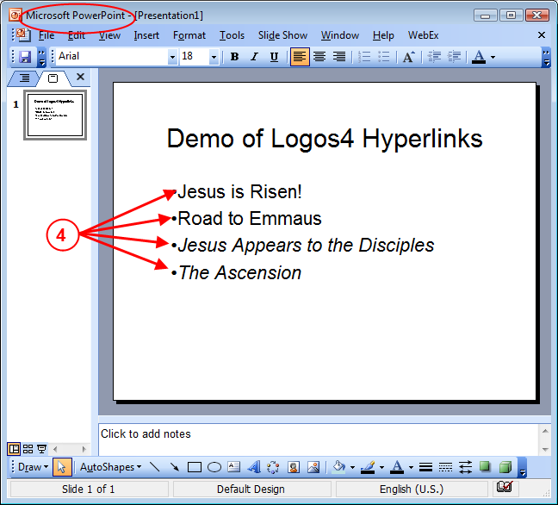

- Back in L4, position the resource to the location that you want your hyperlink to take you
(e.g. the right resource and location, the location in the reference box is the precise location for the hyperlink. We used Luke 24:1)
- Now on the keyboard press the key combination Ctrl + ALT + C. (Logos4 will create the hyperlink address in your clipboard)
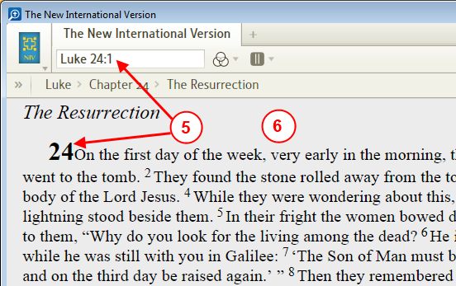

- In PowerPoint, select the 1st line of text that you typed.
(click at beginning of your text and drag the mouse with the left button down)
- Hold the mouse over the highlighted text and right click (a pop-up menu will appear)
- In the pop-up menu click on Hyperlink.
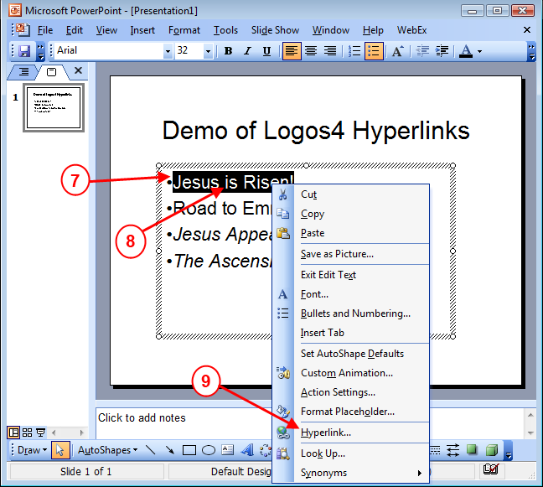

- When the dialog box appears (as shown below), click in the address box.
Then on your keyboard press the key combination Ctrl + V. (this is windows standard Paste command)
- Now press the OK button. (your hyperlink is built now)
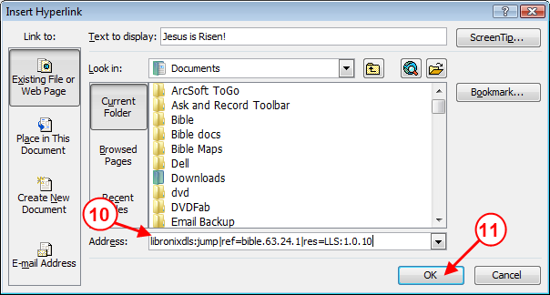

- Now we will repeat the last 6 steps for 2 other links in our PowerPoint file

- Back in Logos4, position the resource to the location that you want your hyperlink to take you (move Luke 24:13 to top of screen)
- Now on the keyboard press the key combination Ctrl + ALT + C.
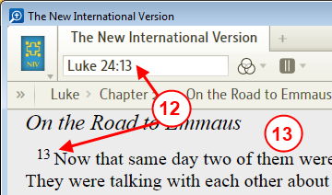

- In PowerPoint, select the 2nd line of text you typed.
(click at beginning of your text and drag the mouse with the left button down)
- Hold the mouse over the highlighted text and right click (a pop-up menu will appear)
- In the pop-up menu click on Hyperlink.
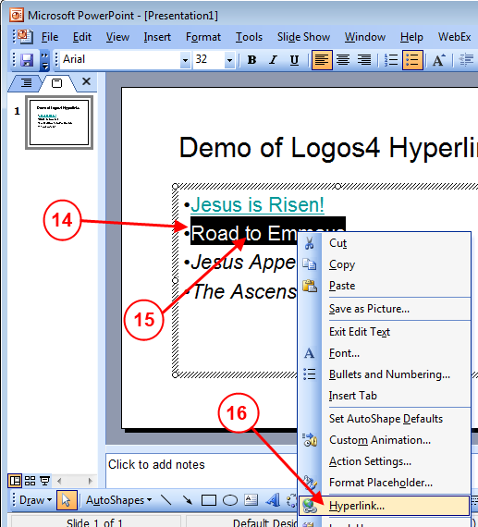

- When the dialog box appears, click in the address box.
Then on your keyboard press the key combination Ctrl + V.
- Now press the OK button.
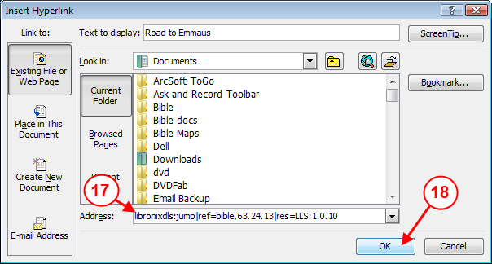

- Back in Logos4, position the resource to the location that you want your hyperlink to take you (move Luke 24:36 to top of screen)
- Now on the keyboard press the key combination Ctrl + ALT + C.
- In PowerPoint, select the 3rd line of text you typed.
- Hold the mouse over the highlighted text and right click (a pop-up menu will appear)
- In the pop-up menu click on Hyperlink.
- When the dialog box appears, click in the address box.
Then on your keyboard press the key combination Ctrl + V.
- Now press the OK button.

- Now we have 3 links created in our PowerPoint file.
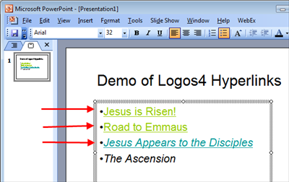

- Now we will test our new links.
- While still in the edit mode in PowerPoint
  - Hold your mouse over the 1st link (Jesus is Risen!) and right click. (a pop-up menu will appear)
  - In the pop-up menu click on Open Hyperlink.

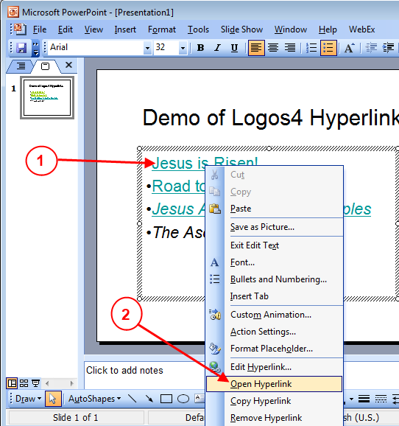

- Now Logos4 is brought to the front of your desktop and you should see your resource active and at the location you set in your first link.
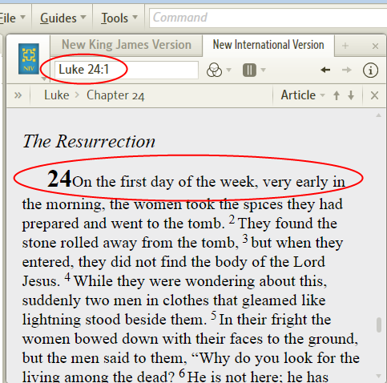

- [This works best if you had your resource in your Main Logos4 window.]
- [If your resource was in a floating window, you will have to manually activate (click on that window in your taskbar) that window.]

- Try repeating the first 3 steps for the other links.

- Now if you run this PowerPoint slide, you will see the links.
Simply click on a link and it will take you to the your resource in Logos4.
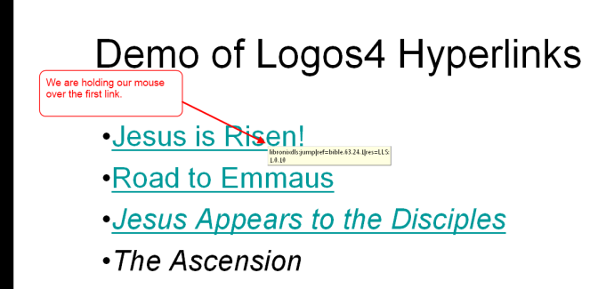

Security Warnings in Office 2007
The default security settings in Office 2007 will warn you that the hyperlink could pose a security risk when you click on a link. this behavior can be stopped by a registry edit. Microsoft has instructions about how to add the appropriate registry key to change this behavior. http://support.microsoft.com/kb/925757

